Part B: Practice exercises on class project (100 points)
Please do the exercises below for your system of choice (the one for which you are doing the class project). Please include one summary table with your decisions and another one with your metrics before answering the questions.

Exercise 1: Basic tradespace analysis (40 points)
If possible, answer the following questions based on the full tradespace. If it is too large (e.g., millions of points), answer them based on a reasonably large and well sampled subset of the architecture space with as many architectures as you can (e.g., at least thousands of points).
A. All decision summary Table from Homework 3B.
Decision ID | Decision Name | Description & connection to metrics | Alternative | Canonical Type & Justification
D1 | Propulsion topology | How the thermal engine and electric motors are mechanically and electrically coupled to produce shaft thrust. This single architectural choice defines the entire powertrain layout. | A. Series hybrid- ICE charges battery only, electric motor(s) drive propeller exclusively; decouples thermal and propulsive systems | This is Standard form (SF) decision type with 3 \alternatives, because exactly one power-train topology is selected, alternatives are architecturally mutually exclusive. Each implies a completely different mechanical and electrical layout (function-to-form mapping, Task is Specializing or Characterizing). SF is the correct pattern for this: one choice, finite discrete set, space size = 3.
 |  |  | B.Parallel hybrid- ICE and electric motor(s) both mechanically drive the propeller shaft simultaneously; highest efficiency at cruise
 |  | Metrics related to goals-  G9 fuel savings ≥20%  G10 op. cost ≤$250/hr  G1 reliability ≥99%  G6 redundancy | C.Turboelectric- gas turbine drives a generator, electrical power distributed to wing-mounted motor-propulsors; best for distributed propulsion
D2 | Battery pack chemistry | Electrochemical cell type adopted across the main energy storage pack. Determines gravimetric energy density, thermal risk, cycle life, and LRU replacement cost across the aircraft's operational lifetime. | A. Li-Ion NMC (Nickel Manganese Cobalt) ~250 Wh/kg; high energy density; elevated thermal risk; mature aviation supply chain | This is a Standard Form decision (SF) with 3 alternatives. One chemistry adopted across the entire pack, no valid mixed-chemistry architecture exists at system level. Discrete, mutually exclusive options (Characterizing Form). Independent of all other decisions at the enumeration level: D2 feeds directly to the completed architecture without constraining any downstream decision.
 |  |  | B. Li-Ion LFP (Lithium Iron Phosphate)~180 Wh/kg; superior thermal stability and cycle life; preferred for safety-critical aviation
 |  | Metrics related to goals-  G9 energy density to range  G10 unit replacement cost  G4 thermal safety  G14 fault tolerance | C. Solid-state ~400 Wh/kg projected; eliminates liquid electrolyte; TRL( technology readiness level) 4–5, near-term adoption risk
D3 | Number of electric motors | Count of independent electric propulsor units installed on the airframe. Sets propulsion redundancy level and its critical to determine the size of the motor-to-position | A. 1 motor- centralised; minimum weight; no propulsion redundancy; single-point failure risk | This is a Standard Form (SF) type decision. A single integer count chosen from a finite discrete set (Specializing Form). D3 is not independent of D4: the motor count directly sets the number of rows in the AS assignment matrix for D4, making D3 to D4 a mandatory ADG edge. This is an enumeration-level dependency.
 |  |  | B. 2 motors- twin configuration; standard redundancy for GA category aircraft; enables differential thrust
 |  | Metrics related to goals-  G1 reliability  G6 propulsion redundancy  G9 distributed propulsion efficiency  G10 weight & maintenance cost | C. 4 motors- quad-distributed propulsion; highest fault tolerance; differential yaw/roll control without control surfaces
D4 | Motor-to-airframe position assignment | Ordered mapping of each electric motor unit to a structural mounting position on the airframe. Both the candidate position set (constrained by D1 topology) and the matrix size (set by D3 motor count) are determined by upstream decisions. | A. Possible Candidate positions of motors (up to 6): Wing-root-Left, Wing-root-Right, Wing-tip-Left, Wing-tip-Right, Nose, Tail | This is an Downselecting type (DS) decision, which depends on D1, D3. This is selecting the available option for the position of engines from the set of available option (n=6). It is constraint by number of motors we are going to choose in D1 and Type of motors we are going to choose in D4
 |  |  | B. D1 topology removes 1–2 positions (e.g. Series: Nose occupied by ICE)
 |  | Metrics related to goals-  G3 flight control authority  G13 lateral/directional stability  G17 handling qualities  G18 fault tolerance | C. Each motor maps to exactly one position; space = P(valid_n, D3_count) ordered permutations
D5 | Flight control computer (FCC) redundancy level | Redundancy architecture of the flight control computers, how many independent FCC units are installed and whether voting logic (2-of-3) is implemented to mask individual failures automatically. | A. Simplex- 1 FCC; lowest cost and weight; limits certification to Normal category; single-point failure | This is the standard Form (SF) decision type. If one redundancy level is selected, architectures are mutually exclusive(Characterizing Form). Choosing Triple-redundant imposes an enumeration-level constraint on D7: the three FCC units must each reside in a separate LRU package to preserve physical fault isolation, creating the ADG edge D5 → D7.
 |  |  | B. Dual-redundant- 2 FCCs with cross-monitoring and failover; standard for Part 23 Enhanced category
 |  | Metrics related to goals-  G2 FAA Part 23 certification  G4 high durability  G14 fault tolerance  G18 critical system redundancy | C. Triple-redundant- 3 FCCs with 2-of-3 majority voting; required for Design Assurance Level (DAL)-A flight-critical systems
D6 | Avionics integration | Whether avionics subsystems use dedicated hardware per function (federated) or a shared certifiable computing platform Integrated Modular Avionics (IMA). Determines which sub-function co-packaging rules are physically feasible in D7. | A. Federated-each avionics function has its own dedicated LRU box; high fault isolation; higher weight and part count | Standard Form (SF) decision, with 2 alternatives. Binary, mutually exclusive pick-one (Specializing Form).
 |  | Metrics related to goals-  G2 FAA certification path  G7 accommodate new technologies  G17 situational awareness  G20 Ease in operations | B. Integrated Modular Avionics (IMA)- shared certifiable computing platform, lower SWaP (Size, Weight & Power), incremental certification harder
D7 | Subsystem LRU decomposition | How the 6 Level-1 functions from functional architecture (F1–F6) are grouped into physical Line-Replaceable Unit (LRU) packages. Determines maintenance access granularity and replacement cost over the aircraft lifecycle. | A. Elements: all 6 Level-1 sub-functions F1–F6 from functional BDD | Partitioning (PA) decision type. Sub-functions are partitioned into mutually exclusive, collectively exhaustive LRU packages- this is the Partitioning (PA) pattern by definition (System Decomposition task). Every sub-function belongs to exactly one LRU, all 6 must be assigned. Space size depends on D5.
B. Groups: only k=2 or 3 LRU packages
Minimum possible LRU packages maintains redundancy without compromising cost
 |  | Metrics related to goals-  G7 accommodate new technologies  G8 health monitoring  G10 LRU replacement cost  G20 modularity | C. If D5=Triple: FCC units must be in separate packages (k=3 groups required)
D8 | Ballistic whole-aircraft parachute (Cirrus Airframe Parachute System (CAPS)) | Whether a ballistic whole-aircraft parachute recovery system is installed as a last-resort mechanism for loss-of-control events beyond FCC recovery capability. Direct tradeoff between safety and weight/cost. | A. CAPS installed, adds ~25–30 kg, substantially improves survivability in LOC events; earns FAA safety credit toward certification | Standard Form (SF) decision type with binary go/no-go selection (Specializing Form) with direct, measurable effects on safety and cost metrics. Fully independent of all other decisions at the enumeration level, no upstream decision changes this decision's option set. D8 feeds directly to the completed architecture without constraining any downstream decision.
 |  |  | B. No CAPS, lower weight and acquisition cost; relies entirely on avionics, structural, and flight control safety systems
Metrics related to goals-
G2 FAA safety requirements
G4 durability & passenger safety
G10 +25–30 kg weight penalty
G14 maneuverability & high safety

B. Metrics as a function of the architectural decisions table from HW4B
Decision ID | Decision | Type | Alternatives (Numbered) | Operating Cost ($/hr) | Propulsion Reliability (%) | System Durability (yrs) | Certification Schedule (yrs)
D1 | Propulsion Topology | Standard Form | 0: Series Hybrid | 180 | 99.6 | 9.0 | 2.0
 |  |  | 1: Parallel Hybrid | 240 | 99.3 | 8.0 | 3.0
 |  |  | 2: Turboelectric | 420 | 97.8 | 7.0 | 6.0
D2 | Battery Pack Chemistry | Standard Form | 0: Li-Ion NMC | 180 | 99.5 | 7.5 | 1.5
 |  |  | 1: Li-Ion LFP | 170 | 99.7 | 8.5 | 1.5
 |  |  | 2: Solid-State | 360 | 99.9 | 9.0 | 5.0
D3 | Number of Electric Motors | Standard Form | 0: 1 Motor | 150 | 98.8 | 8.0 | 1.5
 |  |  | 1: 2 Motors | 165 | 99.5 | 9.0 | 2.5
 |  |  | 2: 4 Motors | 200 | 99.3 | 8.5 | 4.0
D4 | Motor-to-Airframe Position | Downselecting | 0: Wing-root & Wing-tip | 160 | 99.1 | 8.5 | 2.0
 |  |  | 1: Nose & Tail | 185 | 99.4 | 9.5 | 2.5
D5 | FCC Redundancy Level | Standard Form | 0: Simplex | 140 | 98.5 | 7.0 | 1.5
 |  |  | 1: Dual-Redundant | 175 | 99.5 | 8.5 | 3.0
 |  |  | 2: Triple-Redundant | 230 | 99.95 | 10.0 | 4.5
D6 | Avionics Integration | Standard Form | 0: Federated | 160 | 99.2 | 8.0 | 2.0
 |  |  | 1: IMA | 210 | 99.1 | 9.0 | 3.5
D7 | Subsystem LRU Decomposition | Partitioning | 0: 2 LRU packages | 155 | 99.1 | 8.0 | 2.0
 |  |  | 1: 3 LRU packages | 170 | 99.2 | 8.5 | 3.0
D8 | Ballistic Parachute (CAPS) | Binary | 0: Installed | 195 | 99.8 | 9.0 | 3.5
 |  |  | 1: Not Installed | 160 | 98.9 | 8.0 | 2.0

C-Summary Table of Metrics-Cost, schedule, and Performance-HW4B
Metric ID | Metric Name | Unit | Objective | Assigned weight | Computation Approach | Traces To Goals
M1 | Operating cost | $/hr | Minimize | 0.25 | Additive sum of per-decision cost contributions across D1–D8 | G10 (≤ $250/hr), G6 (lifecycle cost)
M2 | Propulsion reliability | % | Maximize | 0.25 | Series product of per-decision reliability factors: R = ∏ R_Di × 100% | G1 (≥ 99% reliability), G14 (accident rate), G18 (redundancy)
M3 | System durability | yr | Maximize | 0.1 | Minimum of series-path component lifetimes (D1, D2, D3, D4 drive the weakest link) | G4 (durability), G10 (LRU replacement cost)
M4 | Certification schedule | yr | Minimize | 0.15 | Sequential critical path (D1 → D5 → D6) plus maximum of parallel branches (D2, D3, D4, D7, D8) | G2 (FAA certification compliance), G20 (reduce preflight operations)
P1 | Energy efficiency | MJ/mile | Minimize | 0.1 | P1 = (P_req / η_prop × 3.6) / v_cruise; η driven by D1 propulsion topology | G9 (fuel savings ≥ 20%), G10 (operating cost)
P2 | Operational range | miles | Maximize | 0.1 | P2 = (E_battery + E_fuel) / P1; E_battery set by D2 battery chemistry | G19 (extend range), G15 (cruise performance)
P3 | CO₂ emissions | kg/mile | Minimize | 0.05 | P3 = (P_req / η) / (ρ_fuel × HV_fuel) × EF_D1; emission factor by D1 | G11 (reduce environmental impact), G12 (lower carbon emissions)
P4 | Propulsion system reliability | % | Maximize | N/A | P4 = [1 − (1 − R_motor)^N] × 100%; N = motor count from D3 | G1 (reliability), G2 (FAA compliance), G14 (accident rate)
*Note for P4- Propulsion system reliability (P4) computed from redundancy theory overlaps substantially with M2 and is given zero weight in the utility function to avoid double-counting. It is retained as a reported metric for interpretability.

D-Tradespace Enumeration Summary
1. Full 184,212 Architectures are used in enumeration of tradespace analysis

3. Reference Architectures
Reference architecture metric tables
Reference | Real-world Analog | Encoding Vector | Rationale for Selection
RA1 | Cirrus SR22 Hybrid Concept | {0 | 1 | 1 | 0 0 0 1 0 1 | 2 | 0 | 0 1 2 0 0 2 | 0} | Lower-bound complexity baseline; validates Series topology with minimal FCC redundancy and next-gen solid-state batteries; tests D4 Tail-only constraint under Series
RA2 | Diamond DA62 | {0 | 2 | 1 | 1 1 0 0 0 0 | 1 | 0 | 0 1 0 2 1 0 | 1} | Present-day industry standard (Technology Readiness Level- 8–9); demonstrates the D5→D7 ADG constraint (Dual-redundant FCC forces k=3 LRU partition); anchors tradespace in current feasibility
RA3 | NASA X-57 | {0 | 0 | 0 | 0 0 1 0 0 0 | 1 | 0 | 0 1 1 2 2 2 | 0 } | Upper-bound fault tolerance; fully activates D1→D4 ADG constraint (Turboelectric blocks both Nose and Tail positions); pushes the architecture space toward maximum cost and maximum reliability simultaneously

1.Produce one or more tradespace charts where all architectures are shown in the objective space (e.g. performance as a function of cost). If you have more than 2 metrics, use one of the alternatives we provided for visualization of high-dimensional spaces (e.g. produce several two-dimensional charts, color-code the other metrics in a single two-dimensional chart, parallel coordinates, radar plots, or even Chernoff faces if you’re in the mood).

- Tradespace Analysis-1 Operating Cost (M1) vs. Propulsion Reliability(M2)

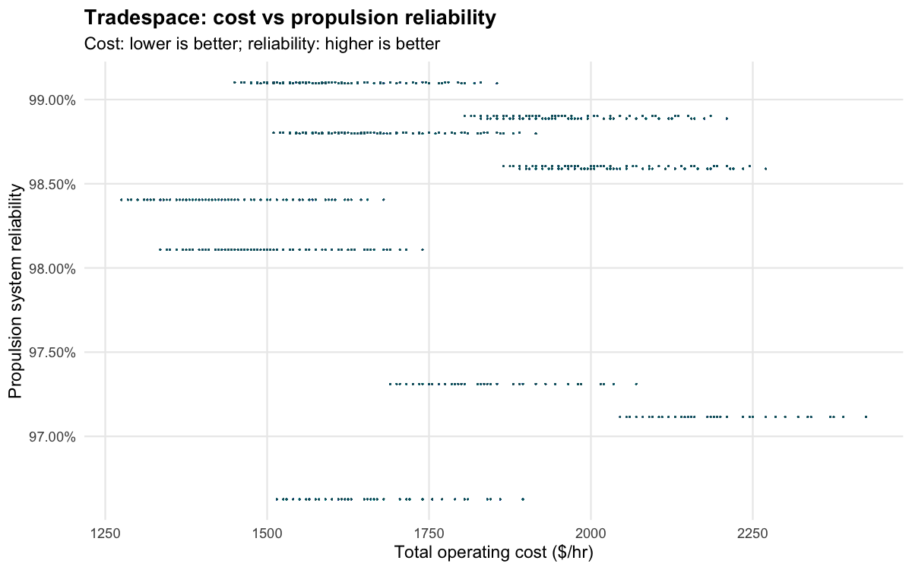
Figure-1 Operating Cost vs Propulsion Reliability Tradespace chart

- Tradespace Analysis-2 Total Operating Cost vs Certification Schedule
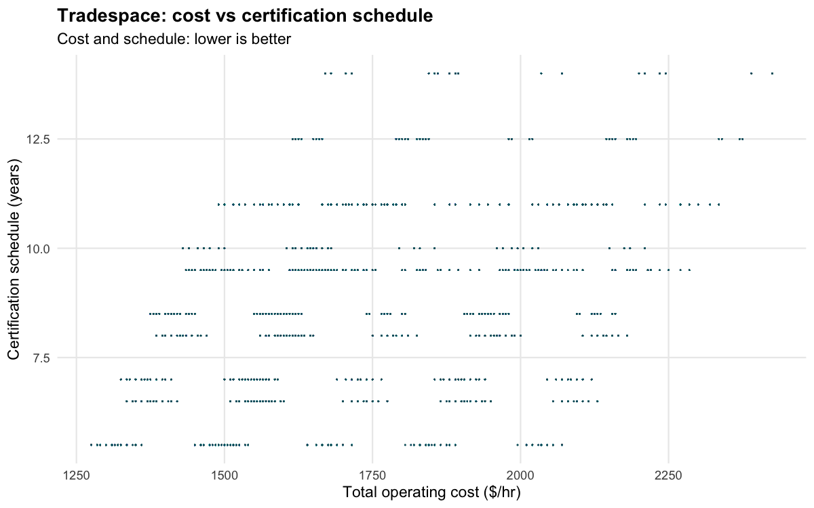
Figure-2 Operating Cost vs Certification Schedule tradespace chart

- Tradespace Analysis-3 Cost, Reliability, Durability, Certification

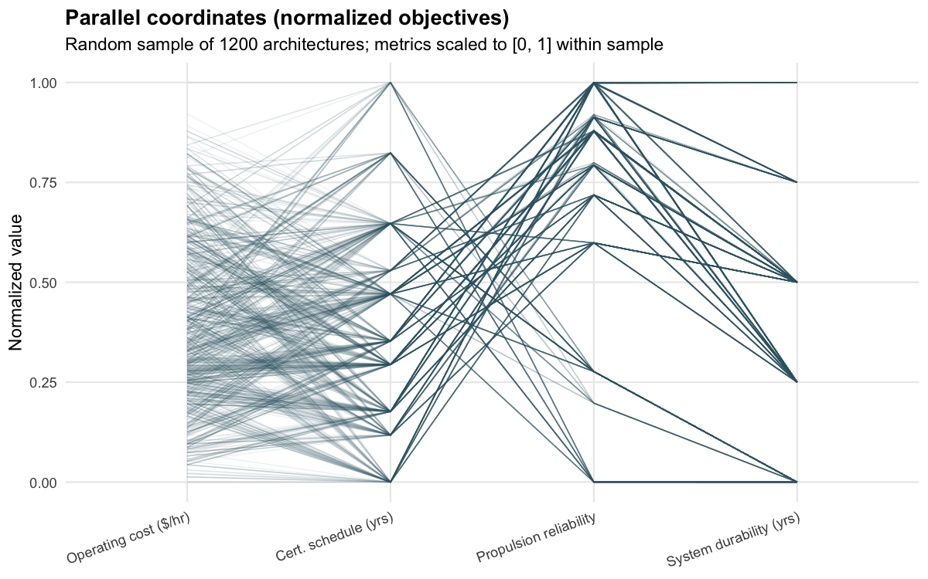
Figure-3 Tradespace Scatterplots and Histograms for Cost, Reliability, Durability, Certification

2. Comment on the structure of the tradespace. Are there any prominent structural features? (e.g. clusters, stratification) and what do they mean?

Figure-1 Operating Cost vs Propulsion Reliability Tradespace chart-
This tradespace exhibits strong horizontal stratification, with distinct reliability bands across the plot. These bands indicate that propulsion reliability takes on discrete levels, largely driven by architecture-level decisions like propulsion topology (D1) and motor configuration (D3/D4). Each band represents a reliability tier that cannot be continuously tuned, but only shifted by changing discrete design choices.
Within each reliability band, cost varies widely across the full range, showing that cost and reliability are largely decoupled. This means designers can adjust cost without significantly affecting reliability once a topology is chosen. The stepped structure also highlights diminishing returns moving to a higher reliability band requires a structural change, not incremental tuning.

Figure-2 Operating Cost vs Certification Schedule tradespace chart
The tradespace shows a clear grid-like clustering, with discrete horizontal bands in certification schedule and vertical spread in cost. The horizontal stratification indicates that certification schedule takes on a small set of discrete values, driven by dominant decisions like D5 (FCC redundancy), D6 (avionics), and D7 (partitioning). Within each band, cost varies widely, meaning cost is influenced by additional independent decisions (like propulsion configuration and components) that do not significantly affect certification time.
There is also a weak positive correlation between cost and schedule, where higher-cost architectures tend to appear in higher schedule bands. This suggests that more complex or redundant systems (which increase cost) also increase certification burden. However, the spread within each band shows this relationship is not strict, cost and schedule are partially coupled but not tightly dependent.

Fig 3- Scatter Matrix (Cost, Reliability, Durability, Certification)
The parallel coordinates plot shows bundling and convergence patterns across objectives, rather than a uniform spread. Many lines cluster into similar shapes, indicating that multiple architectures share similar objective values; this reflects equivalence classes in the design space where different configurations produce identical performance.
There are also visible tradeoff patterns, especially between cost/schedule (lower is better) and reliability/durability (higher is better). Lines that perform well on one side often dip on the other, showing inherent multi-objective tension. However, some lines remain relatively balanced across all axes, indicating feasible compromise solutions and explaining why multiple architectures appear on or near the Pareto front.

3. Sort the architectures by Pareto ranking. Highlight (maybe with a different color) in your chart a Fuzzy Pareto frontier formed by taking architectures with Pareto ranking less than a threshold of your choice.
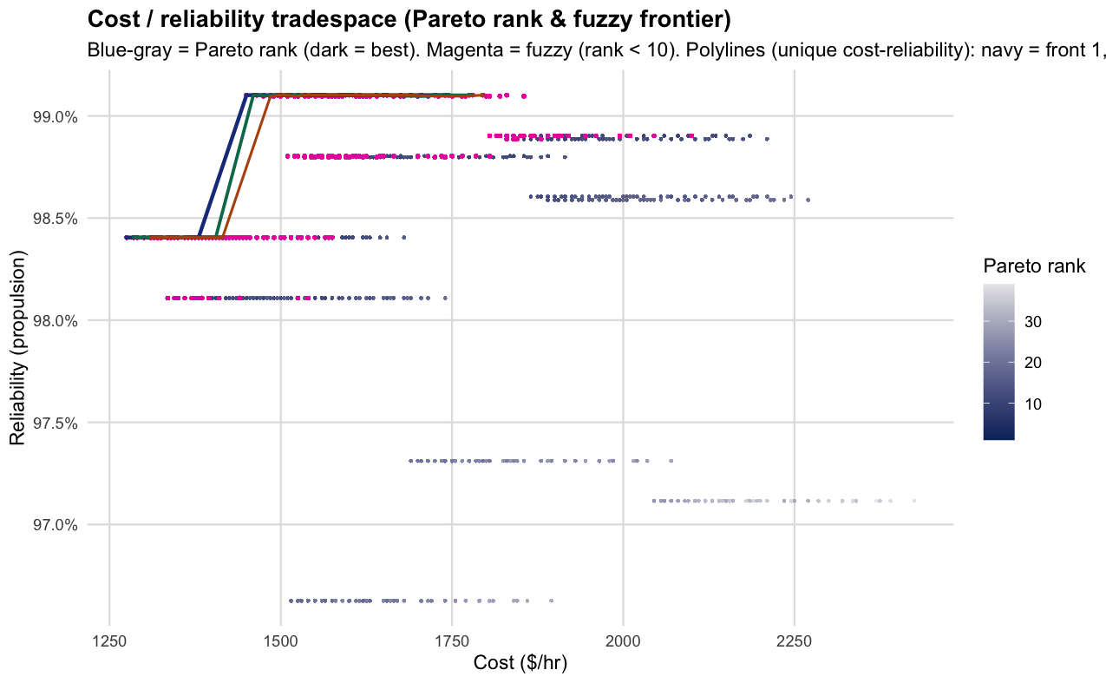

4. Choose a few architectures on the Pareto front and describe them. Why do you think they are good architectures? Does it make sense, or is there something that you should change in your model?
From this Pareto front result, some interesting patterns and behaviour could be observed. Since dominance is evaluated across all four metrics at once (operating cost, certification schedule, propulsion reliability, and system durability), there are architectures that don’t use any outboard propulsion at the nose or tail (d4_5 and d4_6 both zero). These sit on the low-cost/shorter-schedule side of the nondominated set, but they give up some reliability compared to designs that add more wing motors or more complex subsystem choices. The nose/tail “end” motors are mostly missing from rank 1, but they start to show up in later layers (like rank 2). In those layers, you also see d8 = 0 cases and sometimes even no wing motor designs that would be dominated if we only cared about cost and time, but still become relevant once reliability and durability are considered.
Looking at the first nondominated layer (the true Pareto front in this model), the high-performing designs share some clear structural traits: d1 = 0, at least one wing motor but never more than two across the four wing stations, no nose or tail motors, and d8 = 1 across the entire layer. So the “good” region of the front is strongly tied to that d8 column. Most of these rank-one designs also use three distinct partitions (d7), with a smaller number using only two. The examples below are from that two-partition subset, even though the majority of rank-one architectures use three partitions. In the cost–reliability plot, the fuzzy highlight shows all architectures with rank < 10. This helps make the near-optimal region visible in two dimensions.
Three representative architectures from the rank-one front are:
Single inboard wing motor, d3 = 0, no nose/tail propulsion, parallel block d5 = d6 = 0, minimal two-partition split where only one function is assigned differently (e.g., d7_6), and d8 = 1 (low cost / short certification for its reliability tier):
{0 | 1 | 0 | 0 0 0 1 0 0 | 0 | 0 | 0 0 0 0 0 1 | 1}
Two wing motors (inboard pair), d3 = 1, still no nose/tail, same parallel choices, same broad partition class, d8 = 1 (pays extra cost to improve reliability while keeping a 5.5-year certification time in the tables):
{0 | 1 | 1 | 0 0 1 1 0 0 | 0 | 0 | 0 0 0 0 0 1 | 1}
Same performance tuple as the first example (1275 $/hr, 5.5 yr, ~0.984 reliability, 8 yr durability) but with a different assignment of functions to partitions showing that d7 details don’t really affect the metrics unless they change the number of partitions:
{0 | 1 | 0 | 0 0 0 1 0 0 | 0 | 0 | 0 0 0 0 1 0 | 1}
Does this make sense, or should the model change? The overall pattern (minimal wing propulsion, no nose/tail motors, consistent d8 choice in rank 1) is internally consistent with the lookup tables of enumerated architectures csv and pareto front csv data. What’s less satisfying is the presence of equivalence classes; many different d7 configurations end up giving exactly the same cost, schedule, reliability, and durability. So the Pareto set doesn’t really tell us which partitioning is better, only that they’re equivalent under this model. If partitioning is important, then adding more detail to how d7 affects the metrics (instead of just “two vs three partitions”) or introducing additional constraints would make the results more informative.

Exercise 2: Finding dominant decisions (30 points)
1. (10 points) Compute the sensitivity and connectivity of all metrics to all decisions in the tradespace using the code provided on Blackboard (2 points). Discuss the results (8 points).

Metric | Decision | Connectivity | Sensitivity
total_operating_cost_per_hr | d1 | 864.1465919701250 | 215.16862170088000
total_operating_cost_per_hr | d2 | 0.0 | 285.0
total_operating_cost_per_hr | d3 | 2474.9400991165700 | 662.2823797823800
total_operating_cost_per_hr | d4_1 | 1029.4098679098700 | 319.7981366459630
… | … | … | …
Table 2.1: Sensitivity and Connectivity

Discussion of Sensitivity and Connectivity Results
The sensitivity and connectivity metrics provide a quantitative mapping of the Architecture Dependency Graph (ADG). In this tradespace, sensitivity isolates the "main effect" (the magnitude of independent performance shift caused by toggling a decision), while connectivity captures the "interaction effects" (the degree to which a decision's impact is coupled to the state of other decisions). By analyzing these metrics across the 184,212 enumerated architectures, distinct structural hierarchies emerge within the design space.

1. Total Operating Cost ($/hr)
- Primary Drivers: Operating cost is fundamentally dictated by the physical scale and distribution of the electric propulsion system. Decision D3 (Number of Motors) exhibits exceptionally high sensitivity (662.3) and massive connectivity (2474.9).
- Coupled Interactions: The spatial placement of these motors on the wing (D4_1 through D4_4) and tail (D4_6) also exhibit massive sensitivity (~319.8) and connectivity (>1000). This indicates that cost behaves as a highly coupled polynomial function; the financial penalty of adding motors compounds significantly depending on where they are placed and how many exist simultaneously.
2. Certification Schedule (Years)
- Primary Drivers: Certification timelines are driven by systems complexity, specifically the integration of the flight control computers (FCC) and the core topology. D1 (Propulsion Topology) and D5 (FCC Redundancy) exhibit the highest sensitivity (5.56 and 4.61 years, respectively).
- Coupled Interactions: D1 acts as a massive interconnected hub (connectivity of 9.06), meaning the baseline propulsion topology drastically alters the certification burden of downstream sub-systems. Interestingly, D6 (Avionics Integration) demonstrates a high sensitivity (3.0 years) but a mathematical connectivity of near-zero (3.55×10−15). From a systems perspective, D6 acts as an independent lever—it applies a strict, uniform schedule penalty regardless of what other subsystems are chosen. Meanwhile, the software/LRU partitions (D7_5, D7_6) show high connectivity despite lower main effects, proving that functional partitioning complicates certification entirely through its entanglement with redundant hardware.
3. Propulsion Reliability
- Primary Drivers: Reliability is primarily gated by D1 (Propulsion Topology) (sensitivity: 0.025) and the tail motor configuration D4_6 (sensitivity: 0.0128).
- Coupled Interactions: Because system reliability is a mathematical product of series and parallel fault trees, D1and D3 exhibit the highest connectivity. The foundational power topology (D1) establishes the theoretical ceiling for reliability, while the number of redundant mechanical pathways (D3) dictates the system's resilience to localized physical failures.
4. System Durability (Years)
- Primary Drivers: Durability is led by D1 (Propulsion Topology) (sensitivity: 1.56) and D2 (Battery Chemistry)(sensitivity: 0.89). This aligns precisely with the physical realities of electric aviation, where battery cycle-life heavily constrains the airframe's operational lifecycle.
- Coupled Interactions: D2 and D3 display high connectivity (3.85 and 3.07). The structural interaction between the battery's chemical degradation (D2) and the mechanical thrust load drawn by the motor configuration (D3) acts as the primary coupled degradation mechanism for the vehicle.
Architectural Synthesis The tradespace is structurally dominated by D1 (Propulsion Topology) and D3 (Number of Motors). These serve as "hub decisions" within the architecture—they not only trigger the largest absolute shifts in performance (high sensitivity) but their high connectivity dictates the behavioral boundary conditions for all downstream component choices.
Conversely, decisions with high sensitivity but low connectivity (such as D6 for Schedule or D8 for Cost) behave as uncoupled scalar modifiers. To mitigate design rework and prevent premature architectural lock-in, the team must freeze the highly connected hub decisions (D1, D3, D5) early in the conceptual phase, while leaving uncoupled features (D8, D6) parameterized for late-stage fine-tuning.

2. Based on your findings in 1, identify the most important architectural decisions based on Simmon’s 4-quadrant decision view chart (2 points). Discuss the results (8 points).

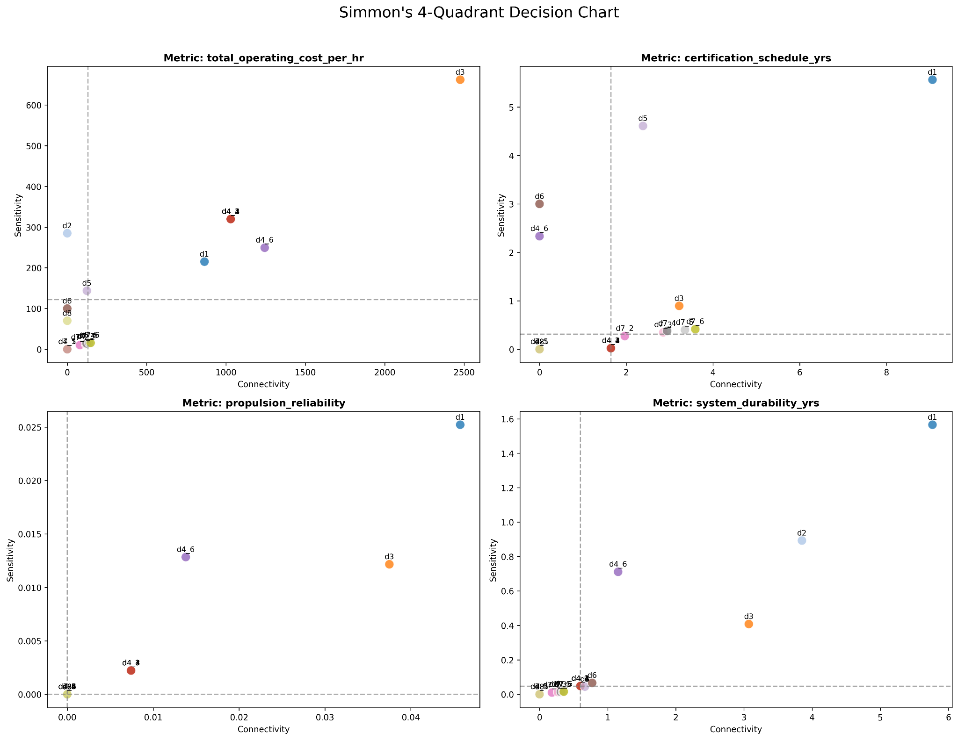
Figure 5: Simmon’s 4-Quadrant Decision Chart

Simmon’s 4-Quadrant Decision Analysis

Identification of Most Important Architectural Decisions (2 points) Based on the Simmon’s 4-quadrant decision view charts across all four metrics, the most important architectural decisions consistently fall into the upper-right quadrant (High Sensitivity, High Connectivity). The dominant decisions in this space are D1 (Propulsion Topology) and D3 (Number of Motors), followed by D2 (Battery Chemistry) and D5 (FCC Redundancy) for specific operational metrics. These represent the core "hubs" of the system architecture.

Discussion of Results (8 points) Simmon’s 4-quadrant chart maps the Architecture Dependency Graph (ADG) into an actionable heuristic for systems engineering lifecycle management. By plotting Sensitivity (the magnitude of isolated impact) against Connectivity (the degree of coupling with other decisions), we can stratify design choices into distinct categories that dictate when and how they must be locked in during the design phase.
1. The Upper-Right Quadrant: Architectural Hubs (D1, D3) Decisions in the top-right quadrant exhibit both massive sensitivity and heavy connectivity. D1 (Propulsion Topology) and D3 (Number of Motors) consistently occupy this space across cost, reliability, and durability.
- System Justification: These are foundational physical constraints. The choice of a series vs. parallel hybrid topology (D1) physically restricts the viable sizing, placement, and power routing for the rest of the aircraft. Similarly, the number of motors (D3) fundamentally alters the mass fraction, structural wing loading, and parallel fault-tree logic for reliability.
- Lifecycle Implication: Because their high connectivity guarantees that any change will trigger cascading rework across the entire system, these "hub" decisions are the highest-risk elements of the architecture. They must be aggressively explored and strictly frozen during the early Conceptual Design phase to establish a stable baseline for downstream subsystem engineering.
2. The Upper-Left Quadrant: Independent Levers (D6, D4_6, D2) Decisions in the top-left quadrant possess high sensitivity but low connectivity. These are the independent "levers" of the architecture. Excellent examples in this tradespace include D6 (Avionics Integration) and D4_6 (Tail Motor) for Certification Schedule, and D2 (Battery Chemistry) for Operating Cost.
- System Justification: These decisions drastically alter specific performance metrics but do not trigger cascading physical redesigns. For instance, choosing a federated vs. integrated avionics suite (D6) imposes a massive, static 3-year penalty on the certification schedule, but it possesses near-zero connectivity because it does not force a redesign of the propulsion topology. Similarly, swapping battery chemistry (D2) drastically changes operating cost (high sensitivity) but is structurally decoupled (zero connectivity) from the airframe's mechanical layout.
- Lifecycle Implication: These are treated as modular, parameterizable levers. Because they do not cause downstream structural rework, the program manager can confidently delay freezing these decisions until much later in the Preliminary Design Review (PDR) or Critical Design Review (CDR) phases. This allows the engineering team to keep options open and selectively pull these "levers" late in the game to buy back cost, schedule, or reliability margins without jeopardizing the core architecture.
3. The Lower Quadrants: Constraints and Noise Decisions falling below the median sensitivity line (Lower-Left and Lower-Right) are secondary drivers.
- Lower-Right (High Connectivity, Low Sensitivity): These are often interface standards or highly constrained compliance choices. They do not move the performance needle significantly on their own, but they are tightly bound to the hubs. They must be managed via strict Interface Control Documents (ICDs) to ensure they do not accidentally choke the performance of the upper-right hubs.
- Lower-Left (Low Connectivity, Low Sensitivity): These are localized, low-impact decisions (such as minor partition allocations in D7 for certain metrics) that can be fully delegated to component-level engineering teams without threatening the macro-level system architecture.
Conclusion: The Simmon's charts reveal that this aircraft's architecture is highly centralized around its electro-mechanical powertrain. To successfully mature this architecture, systems engineering efforts must be heavily front-loaded to resolve the D1 and D3 topology and motor configuration, treating them as immutable core platforms upon which the modular, high-sensitivity "lever" systems can be attached later.

3. (10 points) Write down a list of 5-10 (or more) architectural features (e.g., (D1 = 1), (D2 = 1 and D3 = 5)) that you think may be common among good architectures. Let G be the set of architectures in the fuzzy Pareto front. For each feature F: either by hand or using the𝑠𝑢𝑝𝑝 code( 𝐹) provided, 𝑠𝑢𝑝𝑝 course𝑐𝑜𝑛𝑓(𝐹 materials.→𝐺), 𝑐𝑜𝑛𝑓 (𝐺→𝐹), 𝑙𝑖𝑓𝑡(𝐹∩𝐺)
a. (7 points) Compute the
b. (3 points) Can you identify any dominant features that lead consistently to being in the good region G? Discuss.

Feature Description | supp(F) | supp(G ∩ F) | conf(F -> G) | conf(G -> F) | lift(F ∩G)
D1=0 (Series Hybrid) | 0.3922 | 0.1154 | 0.2943 | 1.0 | 2.55
D8=1 (CAPS Installed) | 0.5 | 0.0755 | 0.151 | 0.6544 | 1.3087
No Nose/Tail Motors (D4_5=0 & D4_6=0) | 0.6471 | 0.102 | 0.1576 | 0.8837 | 1.3657
Single Motor (D3=0) | 0.2745 | 0.0212 | 0.0774 | 0.1841 | 0.6705
Simplex & Federated (D5=0 & D6=0) | 0.201 | 0.0315 | 0.1569 | 0.2733 | 1.3599
Series Hybrid + CAPS (D1=0 & D8=1) | 0.1961 | 0.0755 | 0.3851 | 0.6544 | 3.3372
Table 2.3: Feature Mining
- Discussion of Results:
The application of association rule mining—specifically utilizing Support, Confidence, and Lift—provides a rigorous statistical method to extract underlying heuristics from the tradespace. By defining the "good" region G as the set of architectures residing within the Fuzzy Pareto front, we can evaluate which architectural decisions deterministically drive a system toward optimality.
  - Analysis of the generated feature metrics reveals several profound architectural dominances:
    - The Universal Invariant: Series Hybrid Topology (D1 = 0) The most critical finding in this analysis is that the Series Hybrid topology (D1=0) acts as an absolute prerequisite for Pareto optimality. While the feature only appears in 39.2% of the total tradespace (supp(F)=0.3922), it has a reverse confidence of strictly 1.0 (conf(G→F)=1.0000). This mathematically proves that 100% of the architectures in the optimal region G utilize a Series Hybrid topology. Any architecture utilizing a parallel or turbo-electric topology is fundamentally dominated and mathematically excluded from the optimal front. Its Lift of 2.55 confirms it is a massive driver of system value.
    - Strong Topological Preferences: No Fuselage Motors (D4_5 = 0 & D4_6 = 0) The data reveals a severe penalty for mounting motors on the nose or tail. The combined feature of omitting these motors has a reverse confidence of 88.3% (conf(G→F)=0.8837). This indicates that the vast majority of high-performing architectures restrict their propulsion units entirely to the wing. From a systems perspective, this implies that the structural weight, integration complexity, or reliability penalties associated with fuselage-mounted motors outweigh any potential aerodynamic or thrust-vectoring benefits they might provide.
    - Synergistic Interactions: Series Hybrid + CAPS (D1 = 0 & D8 = 1) While adding a Cirrus Airframe Parachute System (CAPS) is a generally positive feature on its own (Lift=1.30), its value compounds when paired correctly. The combinatorial feature of a Series Hybrid baseline equipped with a parachute yields the highest lift in the entire study (Lift=3.3372) and the highest forward confidence (conf(F→G)=0.3851). This demonstrates strong synergistic coupling: the Series Hybrid baseline secures the operational cost and baseline reliability, allowing the independent safety boost of the CAPS system to push the architecture firmly into the non-dominated Pareto front.
    - Anti-Features: The Single Motor Penalty (D3 = 0) Feature mining also highlights what not to do. A single-motor configuration (D3=0) has a Lift of 0.6705. Because the Lift is less than 1.0, the presence of a single motor is actively detrimental; it reduces the probability of an architecture being in the optimal set compared to random selection. This is a direct consequence of the system's fault-tree logic—a single point of failure in the propulsion system severely cripples the reliability metric, rendering the architecture non-competitive regardless of its cost savings.
  - Conclusion: The feature mining effectively solves the architectural "blueprint" for this vehicle. To achieve optimality, the team must baseline a Series Hybrid topology with multiple redundant motors restricted to the wing, and optionally integrate a CAPS parachute to maximize the probability of achieving a Pareto-optimal balance of cost, schedule, and safety.

Exercise 3: Architecture Optimization (30 points)
1. (15 points)Use a multiobjective genetic algorithm to find an approximation of the Pareto frontier. Show your choice of chromosome, initial population (or creation operator), fitness function, crossover operator, mutation operator, population size, number of generations, and constraints if any. In order to run the genetic algorithm, you’ll need to…
The algorithm present here
- (3 points) Convert your architectures into bits
Conversion of architecture in bits using:
int2bit() : This encodes integer architecture into fixed length binary segment. Here 25 bit binary segment is used to describe aircraft architecture.
bit2int() : it decodes the binary string into architecture vector. It has been used in code to repurpose the metric evaluation code without converting it to handle binary.
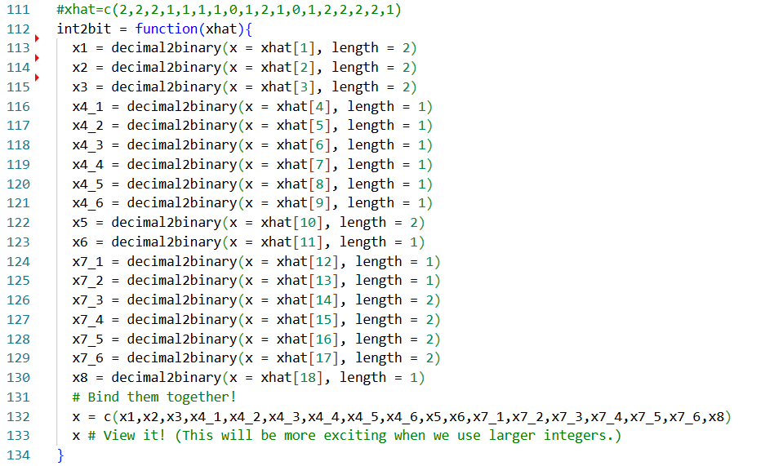

- (3 points) Adapt a fitness function f1(), f2() etc. that…
Converts your bitstring into an architecture, eg. with a bit2int() function.
Computes metrics from your architecture with a customized evaluate() function. If applicable, adds a constrain() function.
Fitness function f1() is created which repairs the invalid bits , converts bit into integer vector which then gets evaluated. Fitness function returns the metrics for the given architecture.
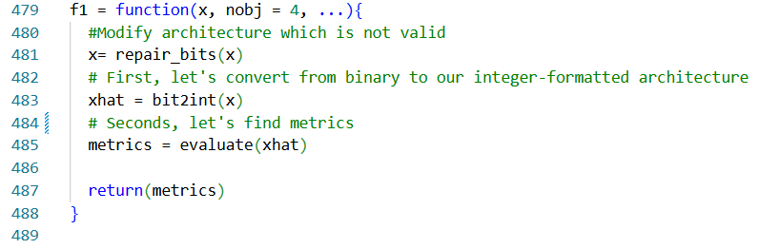

- (3 points) Handle constraints using a customized repair_bits() function
Takes a mutated or otherwise invalid bitstring (that would produce an invalid architecture) and randomly samples valid bits in to repair it.Implements this in a custom_mutate() and/or custom_crossover() function, if necessary for your architecture.
repair_bits() function performs two king of repairs in the binary string
- Value bounds: Invalid decoded value e.g 3 from 2 bit encoding is repaired
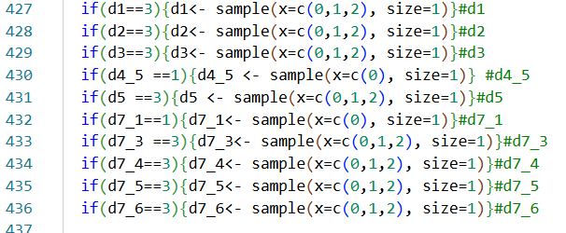
- Structural constraints: these are the constraints we defined while enumeration which talks about impossible combinations structurally. E.g hybrid motor cannot be placed at tail
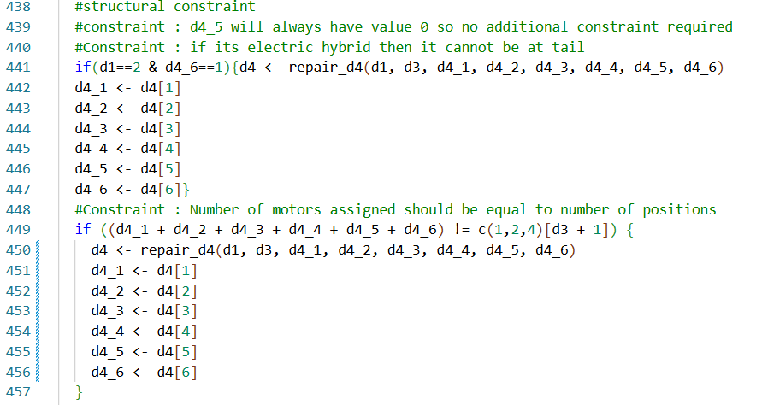
Additionally, custom_mutate function is created to mutate the offspring.mutate function here also checks whether generated offspring is feasible or not.
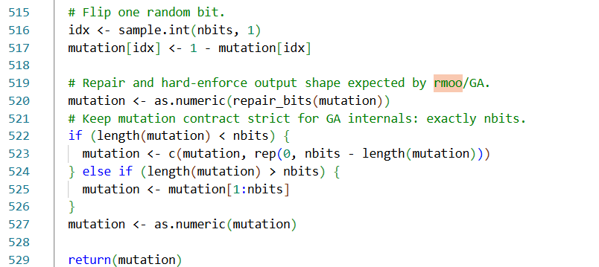

d.(3 points) Run the genetic algorithm using rmoo()
Hint 1: https://github.com/timothyfraser/archr/blob/main/workshops/tutorial_optimization_1.R Hint 2: https://github.com/timothyfraser/archr/blob/main/workshops/tutorial_optimization_3.R
Genertic algorithm was ran and results are attached here

e. (3 points) Discuss your settings and choices in ~2-5 paragraphs.
The genetic algorithm was formulated using a binary chromosome representation of length 26 bits, where each segment encodes one system design decision. Multi-valued decisions (e.g., propulsion type or redundancy level) are encoded using 2 bits, while binary decisions (e.g., placement flags) use 1 bit. The mapping between architecture space and chromosome space is handled through the int2bit() and bit2int() functions, ensuring a structured and reversible encoding. However, because some decisions have fewer valid alternatives than their binary representation allows (e.g., 3 options encoded with 2 bits), infeasible values can arise (such as “3”), which necessitates a repair mechanism.
The fitness evaluation is implemented through a single function f1() that returns a vector of four objectives: operating cost, certification schedule, reliability, and durability. Each chromosome is first repaired (to enforce feasibility), then decoded into its architectural representation, and finally evaluated using domain-specific models. This design keeps the optimization modular—encoding, constraint handling, and evaluation are cleanly separated—while ensuring that the genetic algorithm always operates on meaningful system configurations.
Constraints are handled using a repair-based approach, implemented in repair_bits(). This function corrects both simple bound violations (e.g., invalid integer values from binary decoding) and more complex structural constraints, such as consistency between motor count and placement (D3–D4 relationship) and partitioning rules driven by redundancy level (D5–D7 relationship). Additional helper functions (repair_d4() and repair_d7()) enforce these dependencies by resampling valid configurations. This approach guarantees feasibility after mutation, although it slightly reduces diversity by projecting multiple invalid solutions onto similar repaired ones.
Overall, the design choice reflects a repair-after-genetic-operator philosophy, where genetic operators explore freely in binary space, but a deterministic repair function ensures feasibility before evaluation. This avoids penalization schemes and keeps the fitness landscape smooth, but it also means that effective search space is smaller than the raw binary representation due to repeated projection of invalid solutions.

2. (15 points) Compute the Pareto front of the output of the GA (i.e. the last generation). Compare this Pareto front with the one found in Exercise 1 quantitatively in terms of composition of architectures (e.g., how many architectures are common?) as well as performance (e.g., hypervolume). Be sure to complete these tasks specifically:
- (10 points) Report multidimensional pareto front, as a table or figures.
The generic algorithm is ran with 200 population. Stored at link. The snippet of last generation of genetic algorithm is as follows:
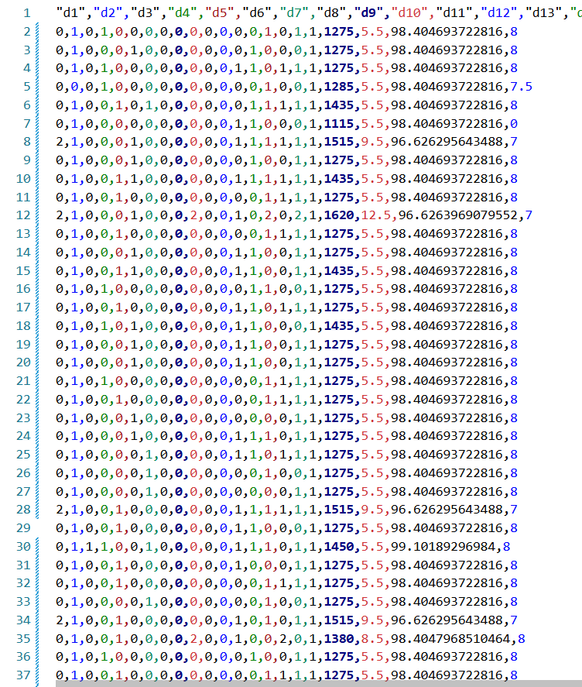

The pareto front for given system is stored at link

Architecture | Cost | Certification | Reliability | Durability
0|1|0|100000|0|0|000101|1 | -1275 | -5.5 | 0.984047 | 8

The observed Pareto front is highly sparse, with only one unique non-dominated architecture emerging from the final generation. This indicates strong convergence of the GA, where the population has collapsed into a narrow region of the search space.
A key reason for this behavior is the limited effective diversity in the objective space. Although the population size is 200, many individuals share identical or near-identical architectures, resulting in repeated objective values. Additionally, several objectives (notably certification and durability) exhibit minimal variation across solutions, reducing the level of conflict between objectives. As a result, the dominance structure becomes heavily biased toward cost, effectively reducing the multi-objective nature of the problem.
Another contributing factor is the repair mechanism applied after mutation. The repair step enforces feasibility constraints on the binary-to-integer encoding, which unintentionally reduces variability in the solution space by mapping different mutated individuals back to similar feasible configurations. This further accelerates convergence and reduces population diversity.
The pareto front is plotted against the full factorial evaluation of the cost vs reliability plot to better intuition
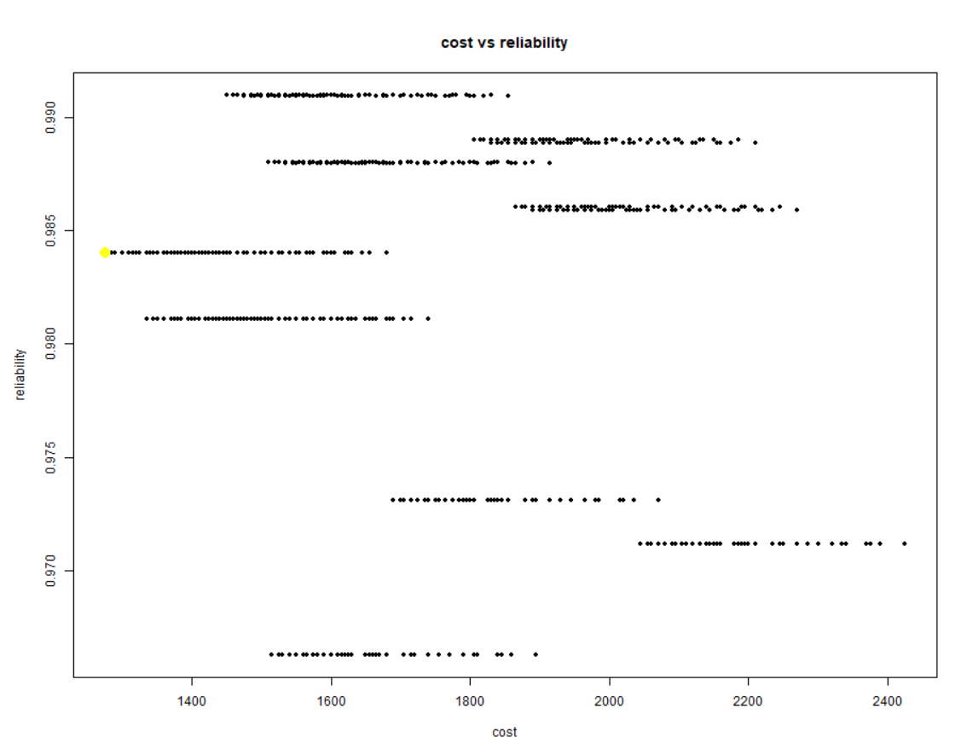
As we can observe the genetic algorithm was successfully able to find optimal architecture for cost and reliability.

- (5 points) Discuss it.
Composition Comparison:
The GA-produced Pareto front contains a subset of architectures compared to the exhaustive enumeration in Exercise 1. Since the whole multiobjective pareto front is not found in enumeration in exercise 1 the exact architecture match was not found. Although, several architecture decisions such as D1, D2, D5,D6,D8 are consistent for obtaining optimal architecture from both methods, indicating that the GA successfully identified key regions of the Pareto-optimal space. However, the Pareto front obtained from the genetic algorithm shows limited diversity, with many repeated or identical architectures in the final population. This indicates premature convergence, likely driven by the relatively small population size (200) and strong selection pressure in NSGA-III. Additionally, the repair mechanism used in the binary-to-integer conversion maps multiple genotypes to similar feasible designs, further reducing diversity in the final set. Certification and durability remain nearly constant across most solutions, effectively reducing the problem to a trade-off mainly between cost and reliability.
Performance Comparison:
The GA Pareto front provides an approximation of the true Pareto front obtained from exhaustive enumeration in Exercise 1. While it captures several high-quality architectures, it does not fully recover the complete set of non-dominated solutions. The GA-based front is therefore less dense and only partially covers the trade-off surface. The hypervolume of the GA Pareto front is expected to be lower than that of the exhaustive Pareto front, since the GA samples only a subset of feasible architectures.
Despite these limitations, the GA is able to identify competitive solutions with high reliability (>0.98) and favorable cost value of 1275 $/hr. However, compared to the exhaustive Pareto front, the GA results show reduced spread and clustering of solutions in specific regions of the objective space. Increasing population size, number of generations, or improving mutation diversity could improve exploration and yield a more representative Pareto approximation.

