Extended Kalman Filter Based Gas Turbine Health Monitoring System.
Abstract:
This project presents the development of a reduced-order nonlinear gas turbine model integrated with an Extended Kalman Filter (EKF) for engine health monitoring applications. The primary objective was to estimate internal thermodynamic states and component efficiencies during cruise operation using noisy sensor measurements. A nonlinear thermodynamic model was developed using simplified compressor, combustor, turbine, and shaft dynamics. The EKF was implemented to estimate turbine outlet temperature, compressor efficiency, burner efficiency, turbine efficiency, and shaft speed. Cruise operating conditions were simulated using stochastic perturbations around steady-state operating points to better represent realistic engine behavior. Analytical Jacobians were derived for the EKF prediction and update stages, and local observability analysis was performed using the observability matrix rank. Simulation results demonstrated stable estimation performance with bounded covariance and acceptable estimation accuracy despite nonlinear coupling and measurement noise. The project highlights both the strengths and limitations of reduced-order nonlinear estimation methods for gas turbine health monitoring.

Goal
Gas turbine engines operate under highly nonlinear thermodynamic conditions and are subject to gradual degradation due to wear, thermal stresses, fouling, and component aging. Different engine operates under different conditions like cold, desert hence predictive maintenance is essential. Monitoring the health of engine components is important for maintaining efficiency, reliability, and safety. However, many important internal engine variables such as component efficiencies and intermediate temperatures cannot be directly measured during operation. State estimation methods provide a practical solution by combining physical models with available measurements to estimate hidden states.
The goal of this project is to develop a nonlinear state estimation framework capable of estimating gas turbine thermodynamic states and component efficiencies during steady cruise operation using an Extended Kalman Filter (EKF). Cruise conditions were specifically selected because aircraft engines spend a significant portion of their operational life in cruise, making this regime particularly important for long-term health monitoring and efficiency assessment. In addition, engine degradation and performance trends are more meaningful and easier to analyze under relatively stable cruise conditions compared to highly transient phases such as takeoff or landing. The EKF was selected because it can handle nonlinear thermodynamic dynamics while incorporating noisy sensor measurements to estimate unmeasured internal states and slowly varying efficiencies in real time. The project focuses on a reduced-order physics-inspired thermodynamic model rather than a high-fidelity engine simulation. The emphasis of the work is on estimator formulation, observability, covariance tuning, and estimation performance under realistic noisy operating conditions.

Technical Approach

System Modeling

2.1 State Definition
The state vector was defined as:
$$x=[T_{2}, T_{3}, T_{4}, η_{c}, η_{b}, η_{t}, N]^{T}$$
where:
- $T_{2}$: compressor outlet temperature
- $T_{3}$: combustor outlet temperature
- $T_{4}$: turbine outlet temperature
- $η_{c}$: compressor efficiency
- $η_{b}$: burner efficiency
- $η_{t}$: turbine efficiency
- $N$: shaft rotational speed
The efficiency states were modeled as slowly varying quantities using a small random walk process to represent gradual changes in operating conditions.

2.2 Input Definition
The input vector was defined as:
$$u=[T_{1}, {\dot{m}}_{f}, {\dot{m}}_{a}]^{T}$$
where:
- $T_{1}$: inlet temperature
- ${\dot{m}}_{f}$: fuel mass flow rate
- ${\dot{m}}_{a}$: air mass flow rate
Cruise operation was simulated using stochastic perturbations around nominal operating conditions. Instead of using large sinusoidal forcing functions, low-amplitude filtered random variations were introduced to represent realistic cruise fluctuations while maintaining estimator stability.
Nominal cruise operating conditions used in the simulation were:
- $T_{1}=490 K$
- ${\dot{m}}_{a}=25 kg/s$
- ${\dot{m}}_{f}=0.09 kg/s$

2.3 Nonlinear Thermodynamic Model
The gas turbine dynamics were represented using simplified nonlinear thermodynamic equations.
The compressor pressure ratio was modeled using an empirical compressor map relationship:
$$PR_{c}=1+p_{c}\frac{N^{2}}{T_{1}}$$
The shaft work term was modeled as:
$$W_{sh}=w_{c}\frac{N^{2}}{T_{1}}$$
The state dynamics were defined as:
$${\dot{T}}_{2}=\frac{T_{1}\left(1 + \frac{PR_{c}^{(γ-1)/γ}-1}{η_{c}}\right)-T_{2}}{τ_{c}}$$
$${\dot{T}}_{3}=\frac{T_{2}+\frac{{\dot{m}}_{f}LHVη_{b}}{c_{p}{\dot{m}}_{a}}-T_{3}}{τ_{b}}$$
$${\dot{T}}_{4}=\frac{T_{3}-\frac{W_{sh}}{{\dot{m}}_{a}c_{p}η_{t}}-T_{4}}{τ_{t}}$$
$$\dot{N}=n_{c}{\dot{m}}_{a}c_{p}(T_{3}-T_{4}-T_{2}+T_{1})$$
where:
- $LHV$: fuel lower heating value
- $c_{p}$: specific heat capacity
- $γ$: ratio of specific heats
- $τ_{c},τ_{b},τ_{t}$: compressor, burner, and turbine time constants
The model was intentionally kept reduced-order to maintain computational simplicity and estimator tractability.

Measurement Model
The measurement vector was defined as:
$$z=[T_{2}, T_{3}, T_{5}, N]^{T}$$
where:
- $T_{2}$: compressor outlet temperature measurement
- $T_{3}$: combustor outlet temperature measurement
- $T_{5}$: exhaust temperature measurement
- $N$: shaft rotational speed measurement
The exhaust temperature $T_{5}$was computed using a nozzle relation:
$$T_{5}=T_{4}\left(1 − η_{n}\left(1 − PR_{n}^{(γ-1)/γ}\right)\right)$$
Gaussian sensor noise was added to all measurements to simulate realistic sensor uncertainty. The measurement covariance matrix was defined as:
$$R=diag([{1.5}^{2}, {2.5}^{2}, 4^{2}, {100}^{2}])$$

EKF Formulation
The Extended Kalman Filter was implemented using nonlinear prediction and measurement update equations.

4.1 Prediction Step
The predicted state estimate was computed using:
$${\hat{x}}_{k+1}^{-}=f({\hat{x}}_{k},u_{k})$$
The covariance prediction equation was:
$$P_{k+1}^{-}=F_{k}P_{k}F_{k}^{T}+Q$$
where:
- $F_{k}$: Jacobian of the nonlinear state dynamics
- $Q$: process noise covariance matrix
Analytical Jacobians were derived manually for improved numerical consistency and computational efficiency.

4.2 Update Step
The Kalman gain was computed using:
$$K_{k}=P_{k}^{-}H_{k}^{T}(H_{k}P_{k}^{-}H_{k}^{T}+R)^{-1}$$
The updated state estimate was:
$${\hat{x}}_{k}={\hat{x}}_{k}^{-}+K_{k}(z_{k}-h({\hat{x}}_{k}^{-}))$$
The covariance update equation was:
$$P_{k}=(I-K_{k}H_{k})P_{k}^{-}(I-K_{k}H_{k})^{T}+K_{k}RK_{k}^{T}$$

4.3 Observability Analysis
Local observability analysis was performed using the linearized observability matrix:
$$O=\left[\begin{aligned}H \\ HF \\ HF^{2} \\ ⋮\end{aligned}\right]$$
The observability rank was computed throughout the simulation which acted as a debugger to help understand whether all states were observed or not. This helps understand rearrange the variables among states and measurements and add any additional measurements to estimate the states properly.
The final estimator configuration achieved full local observability for the seven-state system.

Results
The EKF successfully estimated the thermodynamic states and efficiencies under noisy cruise operating conditions and moderately harsh initial conditions for few variables.
Temperature Estimation:
As observed in image, Compressor inlet temperature (T₂) tracks the truth very well. The error stays close to zero and inside the ±2σ band for almost the whole run. That makes sense because T₂ is measured directly, so the filter gets a strong correction every step. The red dots show the raw T₂ measurement noise. The error estimate is much smoother, which shows the filter is reducing noise while following the true state.
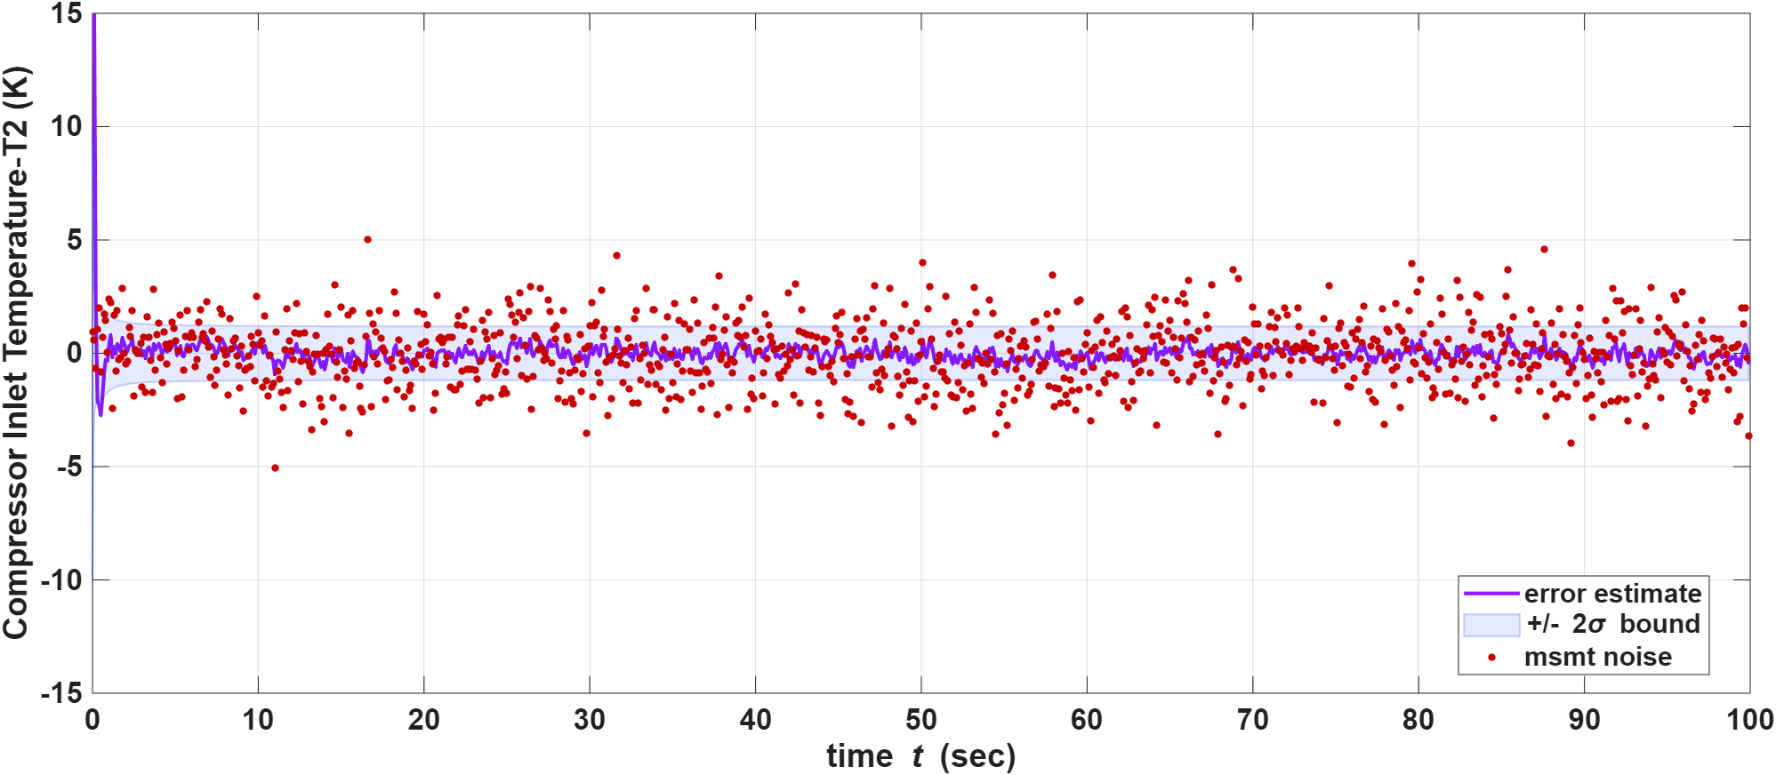
T₃ has a large spike at the start (since initial guess was pretty far from the true cruise point), but the error drops quickly in the first few seconds and then stays mostly near zero. After that, it mostly stays inside the ±2σ region. The early spike is basically the filter “figuring out” the right T₃ once measurements start coming in.
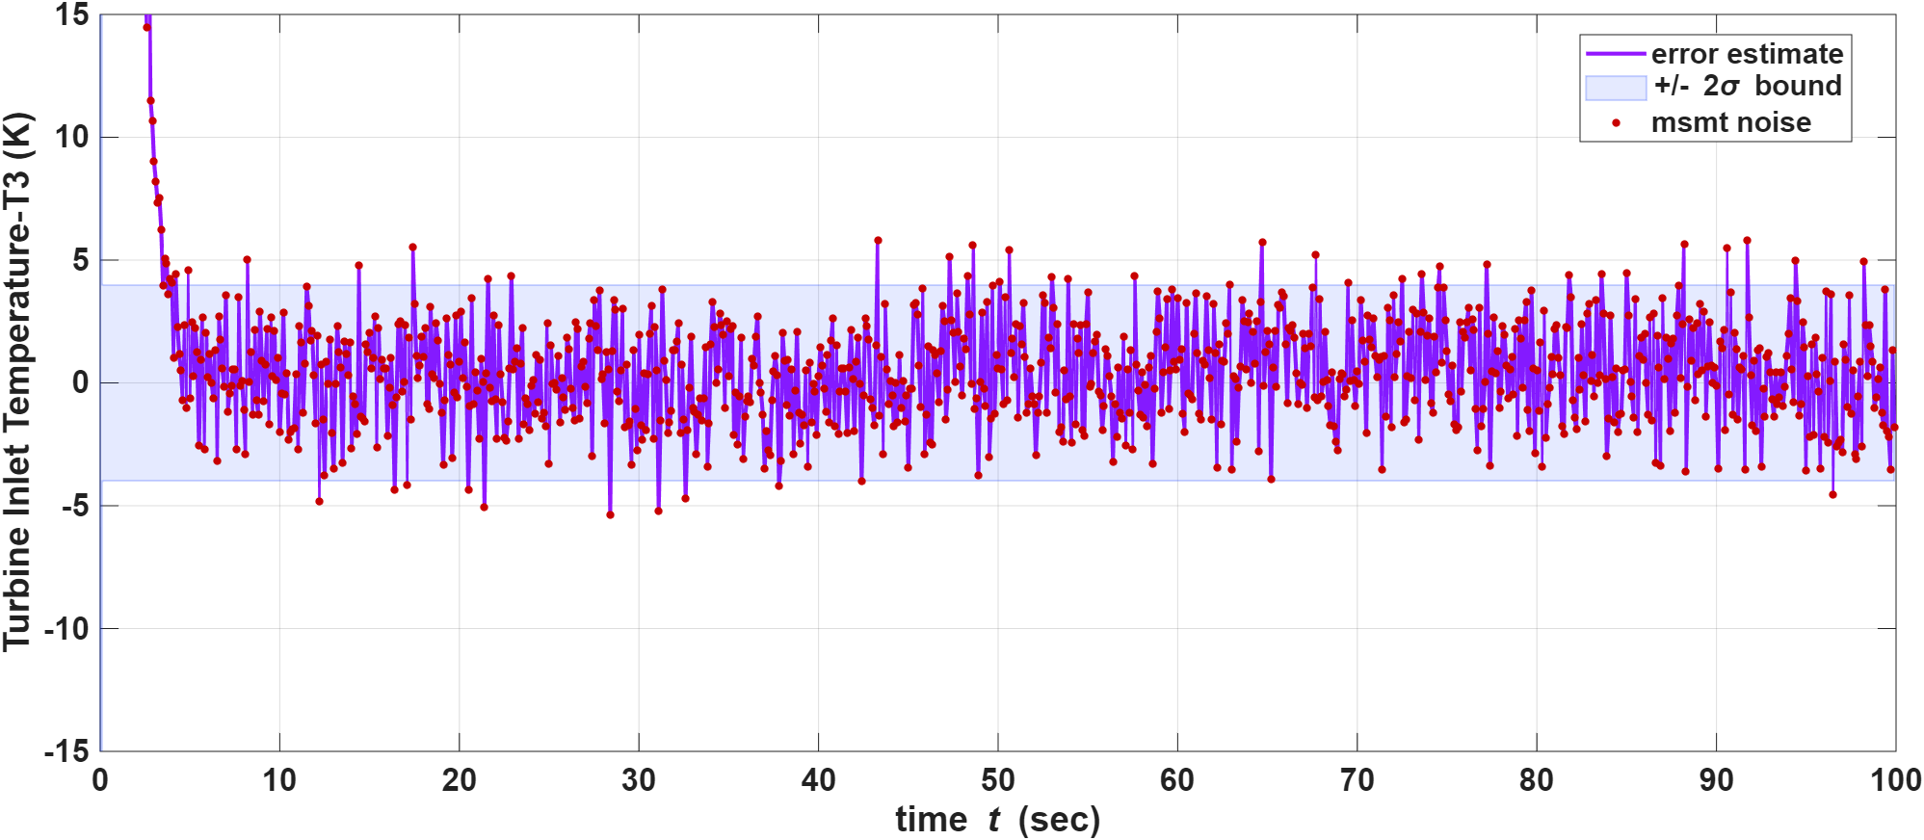
T₄ is harder. The error wiggles more than for T₂ and T₃, and more points go outside the ±2σ band. Since, we never measure T₄ directly; we only get information about it through the T₅ st measurement (which depends on T₄) and through how T₄ couples into the dynamics with T₃, T₂, and N. So the filter’s uncertainty on T₄ is easier to get wrong, and the 2σ band from the covariance matrix does not always match how big the real error is hence the jiggered pattern.
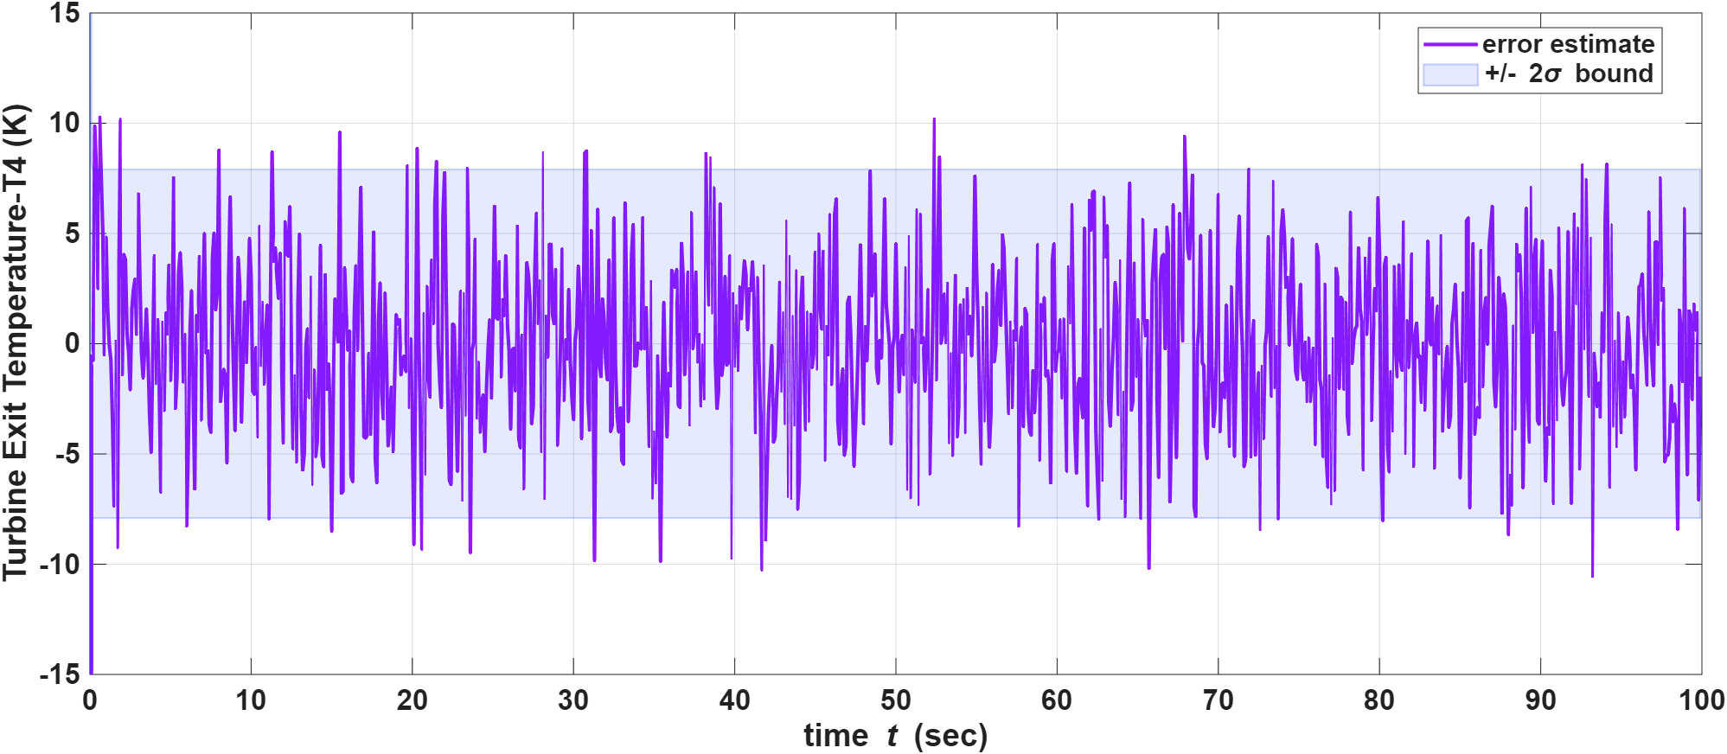

Shaft speed N
The red dots (measurement noise) are very spread out (roughly ±100 RPM), but the estimation error (purple) becomes much smaller after the first ~10–20 s and then stays mostly inside the ±2σ band. So the EKF is successfully combining the N measurement with the temperature measurements and the model. There is still a noticeable startup transient because our initial N guess was far from the true value.
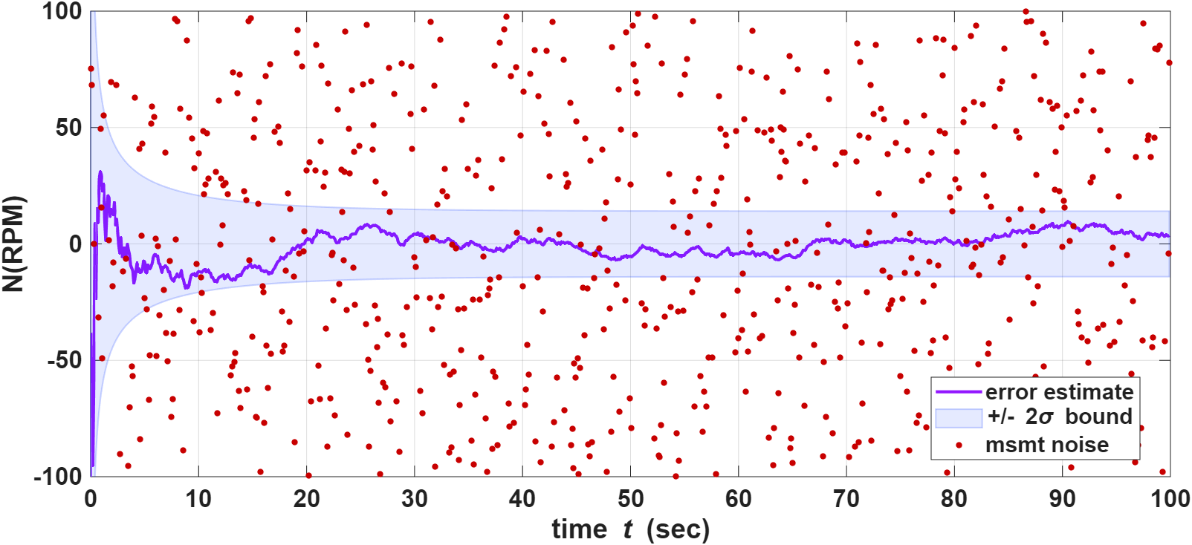
Efficiency Estimation:
Compressor efficiency ($η_{c}$)
As observed, comparatively compressor efficiency converges fast: big error at first, then it collapses and the 2σ band gets very tight. The dynamics put $η_{c}$ strongly into the T₂ equation, and we measure T₂, so the filter can fix $η_{c}$ relatively quickly.
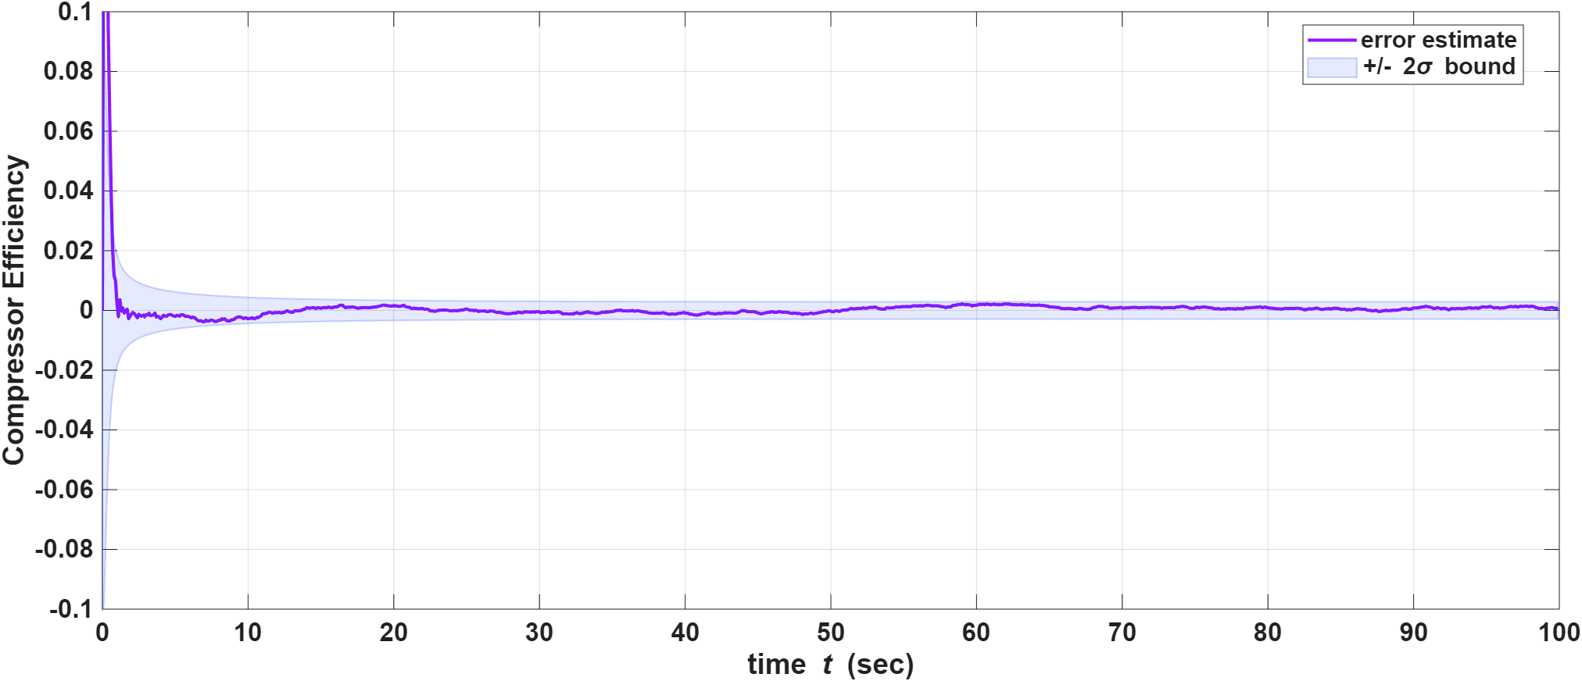
Burner efficiency ($η_{b}$) also goes toward zero error, but more slowly. The 2σ region shrinks over time but is still fairly wide at t = 100 s. So the filter is learning $η_{b}$, but not as strongly as $η_{c}$. That matches the idea that $η_{b}$ mainly shows up in the T₃ path and is mixed with fuel flow and other states.
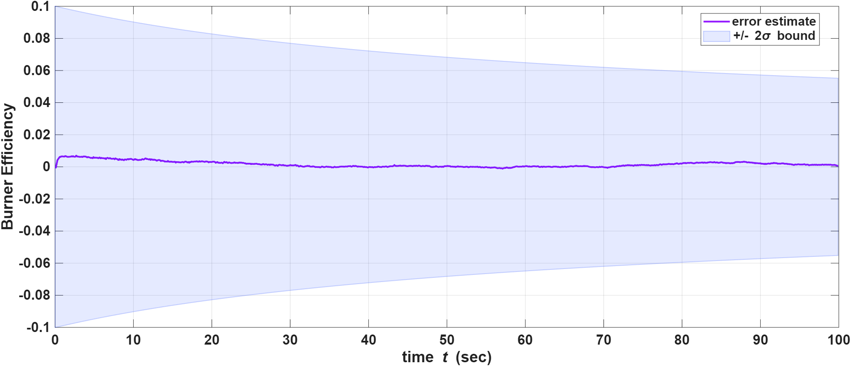
Turbine efficiency ($η_{t}$)
The efficiency error settles near zero for most of the run, but the ±2σ uncertainty band stays wide and changes little over time. That combination suggests the measurements tighten the estimate in the mean, but do not strongly reduce the reported variance on $η_{t}$ under this model and EKF formulation (since $η_{t}$ is not measured directly and only enters through the dynamics). We therefore describe $η_{t}$as a weaker result in the sense that the uncertainty interval remains large, even when the error trace looks good.
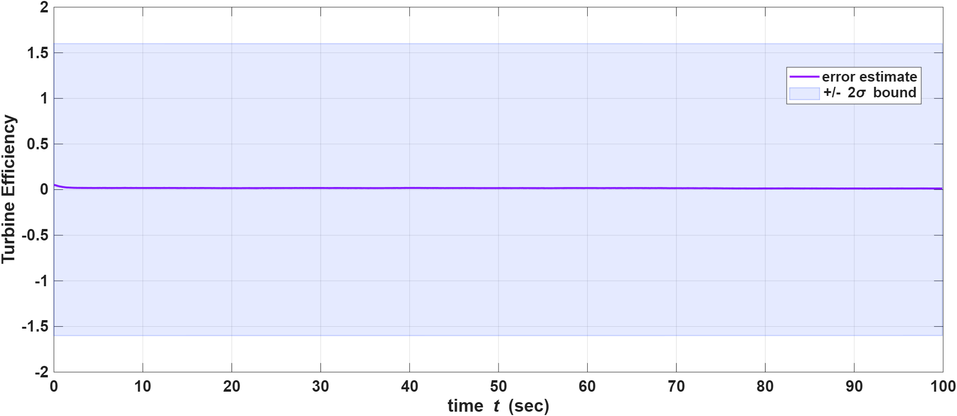

Lesson Learned
Observability, coupling:
I learned that observability is not automatic just because a variable is in the state vector. When several states enter the dynamics through products, ratios, or shared maps (for example temperatures, shaft-related work terms, and efficiencies), the measurements can fit more than one combination of hidden states about equally well. In those situations, one measurement equation effectively tying two unknowns can leave ambiguity unless something else breaks the symmetry (extra measurements, fixed nominal parameters, or a model simplification). I also saw how cyclic or tight feedback between states (temperatures affecting N, and N feeding back through maps into temperatures) can make it harder for the filter to separate parameters cleanly over short horizons.
Moving from given problem to design choices
Earlier coursework often gave the states, inputs, and measurements explicitly. In this project, I had to choose what should be an input, what should be a state, and what should be a measurement so the model stayed physically plausible but still runnable as an EKF. That meant learning to justify choices like: which signals are truly available in operation, which quantities must be estimated, and which simplifications (for example a fixed nozzle efficiency in a T₅ proxy) are acceptable for a first EKF prototype.
Numerical and scaling issues are part of the work
During development I hit numerical challenges where inconsistent or wrong unit scaling (especially treating fuel flow consistently as mass flow and keeping thermodynamic terms consistent with c_p, LHV, and work terms) produced non-physical temperatures. Fixing the physical scaling of fuel and shaft-related terms was not “optional polish”—it was required to get a stable, interpretable estimator.
Overall, the biggest takeaway for me was that a working EKF is the intersection of correct modeling, careful scaling, and honest choices about what the data can actually constrain.

References:
- A Comparison of Filtering Approaches for Aircraft Engine Health Estimation Daniel J. Simon Cleveland State University
- Estimating In-Flight Engine Performance Variations Using Kalman Filter Conc·epts R. H. Luppold J. R. Roman United Technologies Optics and Applied Technology Laboratory West Palm Beach, Florida
- SYSTEM IDENTIFICATION OF JET ENGINES, NanahIsa Sugiyama, National Aerospace Laboratory 7-44-1 Jindaiji Higashi, Chat u, Tokyo 182-8522, JAPAN
- M. Campbell, “MAE 6760 Model Based Estimation,” lecture notes / course materials, Cornell University, Ithaca, NY, USA, 2026.
- P. P. Walsh and P. Fletcher, Gas Turbine Performance, 2nd ed. Oxford, UK: Blackwell Science, 2004.
Appendix:
MATLAB code
%This is the code I will fall back to
%% MAE 6760 Model Based Estimation
% Cornell University
% M Campbell
%
% Final Project - 7 state EKF; PRc and W_sh are computed each step from N,T1 (not extra states)
%It has modelled efficiency estimation with random walk
%
close all; clear all;
MAE6760startup;
global MCcolors;
rng(100);

%% Simulation
dt = 0.1;
nt = 1000;
t = 0:dt:(nt-1)*dt;

% STATE VECTOR nx=7:
% x = [T2; T3; T4; ec; eb; et; N]
nx = 7;
x_true = zeros(nx, nt);

% Initial true state
x_true(:,1) = [
300; % T2
400; % T3
900; % T4
0.85; % ec - compressor efficiency
0.98; % eb - burner efficiency
0.90; % et - turbine efficiency
30000; % N
];

sigma_eff = 1e-4;
global gam LHV cp tc tb tt prn p_c n_c w_c en_nom
gam = 1.4;
LHV = 43e6;
cp = 1005;
tc = 0.3;
tb = 0.8;
tt = 0.5;
prn = 0.92;
n_c = 1e-6;%4.77;% 60/J*2*pi..where J=0.5
p_c = 3.6e-7; %prc constat
w_c =1.1e-3;%shaft const
en_nom = 0.95; % fixed nozzle efficiency

% INPUT SCHEDULE — SI UNITS (explicit)
% u(:,k) = [ T1 ; u_fuel ; mdot_air ]
% T1 [K] (define in your report what it represents)
% u_fuel [kg/s] fuel MASS flow (NOT kg/h; if datasheet is kg/h, /3600)
% mdot_air [kg/s] air MASS flow into the modeled volume (core vs fan: pick one)
u = zeros(3, nt);

% --- Nominal cruise (tune from a datasheet or a chosen design point) ---
T1_nom = 490; % [K] NOTE: if you want literal cold cruise OAT, use ~220–260 K instead (retune map constants if you change this a lot).
mdot_air_nom = 25; % [kg/s] ballpark SMALL turbofan core / gas-path level — tune to your engine story
fuel_nom = 0.09; % [kg/s] ballpark cruise fuel — tune

% --- Small stochastic perturbations (SI) ---
sigma_T1 = 1.0; % [K]
sigma_mdot = 0.20; % [kg/s]
sigma_fuel = 0.004; % [kg/s]

% --- Feasibility guards ---
mdot_min = 0.50; % [kg/s] floor to avoid mdot -> 0 in divisions
fuel_min = 0.0; % [kg/s]
T1_min = 180; % [K] crude lower sanity bound (tune/remove)

% --- Optional low-pass (same role as your alpha smoothing) ---
alpha = 0.995;
T1_prev = T1_nom;
mdot_prev = mdot_air_nom;
fuel_prev = fuel_nom;

for k = 1:nt
% Raw draws
T1_inst = T1_nom + sigma_T1 * randn();
mdot_inst = mdot_air_nom + sigma_mdot * randn();
fuel_inst = fuel_nom + sigma_fuel * randn();

% Low-pass
T1 = alpha*T1_prev + (1-alpha)*T1_inst;
mdot_air = alpha*mdot_prev + (1-alpha)*mdot_inst;
u_fuel = alpha*fuel_prev + (1-alpha)*fuel_inst;

% SI clamps (feasibility)
T1 = max(T1, T1_min);
mdot_air = max(mdot_air, mdot_min);
u_fuel = max(u_fuel, fuel_min);

% Memory + pack
T1_prev = T1;
mdot_prev = mdot_air;
fuel_prev = u_fuel;

u(:,k) = [T1; u_fuel; mdot_air];
end
%% True state simulation
for k = 1:nt-1

xk = x_true(:,k);
uk = u(:,k);

T2 = xk(1);
T3 = xk(2);
T4 = xk(3);
ec = xk(4);
eb = xk(5);
et = xk(6);
N = xk(7); % now from state

T1 = uk(1);
u_fuel = uk(2);
mdot_air = uk(3);

% Thermodynamic equilibrium targets (from compressor/turbine physics)
PRc = (1 + p_c*(N^2)/T1); % compressor map
W_sh = w_c*(N^2)/T1; % turbine - compressor power

% Thermodynamic dynamics (uses PRc and W_sh from maps above in the xdot terms)
xdot = [
(T1*(1 + (PRc^((gam-1)/gam) - 1)/ec) - T2) / tc; % T2 dot
(T2 + (u_fuel*LHV*eb / (cp*mdot_air)) - T3) / tb; % T3 dot
(T3 - W_sh/(mdot_air*cp*et) - T4) / tt; % T4 dot
0; % ec no term in ODE (truth adds rw after step)
0; % eb no term in ODE (truth adds rw after step)
0; % et no term in ODE (truth adds rw after step)
n_c*mdot_air*cp*(T3-T4-T2+T1)
];

x_true(:,k+1) = xk + dt*xdot;
%add random walk for efficiency
x_true(4:6, k+1) = x_true(4:6, k+1) + sigma_eff * randn(3,1);

end

%% Measurement simulation
% z = [T2; T3; T5; N]
nz = 4;
z = zeros(nz, nt);

R = diag([
1.5^2, % T2 sensor noise
2^2, % T3
4^2, % T5
100^2 % N
]);

for k = 1:nt

T1 = u(1,k);
T2 = x_true(1,k);
T4 = x_true(3,k);
N = x_true(7,k);
ufuel = u(2,k);

z(:,k) = [
T2; % z2: T2 measured
T3;
T4*(1 - en_nom*(1 - prn^((gam-1)/gam))); % z3: T5
N;
] + sqrtm(R)*randn(nz,1);
end

%% Run the EKF
x0 = [
500; % T2
700; % T3
900; % T4
0.80; % ec
0.97; % eb
0.95; % et
15000; % N
];

% Initial covariance
P0 = diag([
5^2, % T2
150^2, % T3
70^2, % T4
0.05^2, % ec
0.05^2, % eb
0.8^2, % et
20000^2 % N
]);

xhatu = zeros(nx, nt); xhatu(:,1) = x0;
Pu = zeros(nx, nx, nt); Pu(:,:,1) = P0;
xhatp = xhatu;
Pp = Pu;
G = eye(nx);

% process noise Q
Q = diag([0.5^2, 20^2, 15^2, sigma_eff^2, sigma_eff^2, sigma_eff^2, 0.5^2]);

% Measurement noise --Declared above
%R = diag([2^2, 0.01^2, 3^2, 0.02^2, 500^2, 0.05^2]);
innov_T3_log = zeros(1, nt);
for k = 1:nt-1

% --- Predict ---
xhatp(:,k+1) = predict_state_engine(xhatu(:,k), u(:,k), dt);
F = getF_engine(xhatu(:,k), u(:,k), dt);
Pp(:,:,k+1) = F*Pu(:,:,k)*F' + G*Q*G';

% --- Update ---
H = getH_engine(xhatp(:,k+1), u(:,k+1), dt);
K = Pp(:,:,k+1)*H' / (H*Pp(:,:,k+1)*H' + R);
xhatu(:,k+1) = xhatp(:,k+1) + K*(z(:,k+1) - H*xhatp(:,k+1));
Pu(:,:,k+1) = (eye(nx) - K*H)*Pp(:,:,k+1)*(eye(nx) - K*H)' + K*R*K';

obs_rank(k+1) = compute_observability_rank(F, H);
end

%% Functions

function Xkp1 = predict_state_engine(Xk, U, dt)
% State: [T2; T3; T4; ec; eb; et; N]
% Input: [T1; u_fuel; mdot_air]
global gam LHV cp tc tb tt n_c p_c w_c

T2 = Xk(1);
T3 = Xk(2);
T4 = Xk(3);
ec = Xk(4);
eb = Xk(5);
et = Xk(6);
N = Xk(7);

T1 = U(1);
u_fuel = U(2);
mdot_air = U(3);

% Physical equilibrium targets
PRc = (1 + p_c*(N^2)/T1); % compressor map
W_sh = w_c*(N^2)/T1; % turbine - compressor power

Xkp1 = Xk + dt*[
(T1*(1 + (PRc^((gam-1)/gam) - 1)/ec) - T2) / tc; % T2 dot
(T2 + (u_fuel*LHV*eb / (cp*mdot_air)) - T3) / tb; % T3 dot
(T3 - W_sh/(mdot_air*cp*et) - T4) / tt; % T4 dot
0; % ec 0 in f (cov still gets Q on effs)
0; % eb 0 in f
0; % et 0 in f
n_c*mdot_air*cp*(T3-T4-T2+T1)
];
end

function F = getF_engine(Xk, U, dt)
% Jacobian df/dx (7*7)
% State: [T2; T3; T4; ec; eb; et; N]
% Input: [T1; u_fuel; mdot_air]
global gam LHV cp tc tb tt p_c n_c w_c

T2 = Xk(1);
T3 = Xk(2);
T4 = Xk(3);
ec = Xk(4);
eb = Xk(5);
et = Xk(6);
N = Xk(7);

T1 = U(1);
u_fuel = U(2);
mdot_air = U(3);
%Intermediate calculation
PRc = (1 + p_c*(N^2)/T1); % compressor map
W_sh = w_c*(N^2)/T1; % turbine - compressor power

% --- Partials of T2_dot = (T1*(1+(PRc^a-1)/ec) - T2)/tc ---
dT2_dT2 = 1-(dt/tc);
dT2_dec = -dt*T1*(PRc^((gam-1)/gam) - 1) / (tc*ec^2);
dT2_dN = dt*T1*(gam-1)*2*p_c*N*(PRc^(-1/gam))/(tc*ec*gam*T1);

% --- Partials of T3_dot = (T2 + fuel*LHV*eb/(cp*mdot) - T3)/tb ---
dT3_dT2 = dt/tb;
dT3_dT3 = 1-(dt/tb);
dT3_deb = dt*u_fuel*LHV / (tb*cp*mdot_air);

% --- Partials of T4_dot = (T3 - W_sh/(mdot*cp*et) - T4)/tt ---
dT4_dT3 = dt/tt;
dT4_dT4 = 1-(dt/tt);
dT4_det = dt*W_sh/ (tt*mdot_air*cp*et^2);
dt4_dN = -dt*w_c*2*N/(tt*mdot_air*cp*et*T1);

% --- Partials of N_dot=n_c*mdot*cp*(T3-T4-T2+T1)
dN_dT2 = -dt*n_c*mdot_air*cp;
dN_dT3 = dt*n_c*mdot_air*cp;
dN_dT4 = -dt*n_c*mdot_air*cp;

% T2 T3 T4 ec eb et N --
F = [
dT2_dT2, 0, 0, dT2_dec, 0, 0, dT2_dN;
dT3_dT2, dT3_dT3, 0, 0, dT3_deb, 0, 0;
0, dT4_dT3, dT4_dT4, 0, 0, dT4_det,dt4_dN;
0, 0, 0, 1, 0, 0, 0;
0, 0, 0, 0, 1, 0, 0;
0, 0, 0, 0, 0, 1, 0;
dN_dT2, dN_dT3, dN_dT4, 0, 0, 0, 1;
];
end

function H = getH_engine(Xk, U, dt)
% Measurement Jacobian dh/dx (4x7)
% z = [T2; T3; T5; N]
% x = [T2; T3; T4; ec; eb; et; N]
global gam prn en_nom
%T5 = T4(1-en(1-(prn^((gam-1)/gam))))
dT5_dT4 = 1-en_nom*(1-(prn^((gam-1)/gam)));

% T2 T3 T4 ec eb et N --
H = [
1, 0, 0, 0, 0, 0, 0;
0, 1, 0, 0, 0, 0, 0;
0, 0, dT5_dT4, 0, 0, 0, 0;
0, 0, 0, 0, 0, 0, 1;
];

end

function obs_rank = compute_observability_rank(F, H)
n = size(F,1);
O = H;
F_power = eye(n);
for i = 1:n-1
F_power = F_power * F;
O = [O; H * F_power];
end
obs_rank = rank(O);
end

%% Plotting
% Temperature estimation errors and 2-sigma bounds
figure('Position',[100 100 1600 600]);
tiledlayout(1,3,'TileSpacing','compact','Padding','tight');
nexttile;
plot_estimator(t, xhatu(1,:), Pu(1,1,:), x_true(1,:), 'error',z(1,:))
ylabel('Compressor Inlet Temperature-T2 (K)');
axis([0 100 -15 15]);

nexttile;
plot_estimator(t, xhatu(2,:), Pu(2,2,:), x_true(2,:), 'error',z(2,:))
ylabel('Turbine Inlet Temperature-T3 (K)');
axis([0 100 -15 15]);

nexttile;
plot_estimator(t, xhatu(3,:), Pu(3,3,:), x_true(3,:), 'error')
ylabel('Turbine Exit Temperature-T4 (K)');
axis([0 100 -15 15]);

% Efficiency estimation errors and 2-sigma bounds
figure('Position',[100 100 1600 600]);
tiledlayout(1,3,'TileSpacing','compact','Padding','tight');
nexttile;
plot_estimator(t, xhatu(4,:), Pu(4,4,:), x_true(4,:), 'error')
ylabel('Compressor Efficiency');
axis([0 100 -0.1 0.1]);

nexttile;
plot_estimator(t, xhatu(5,:), Pu(5,5,:), x_true(5,:), 'error')
ylabel('Burner Efficiency');
axis([0 100 -0.1 0.1]);

nexttile;
plot_estimator(t, xhatu(6,:), Pu(6,6,:), x_true(6,:), 'error')
ylabel('Turbine Efficiency');

% RPM
figure('Position',[100 100 1200 500]);
tiledlayout(1,1,'TileSpacing','compact','Padding','tight');
plot_estimator(t, xhatu(7,:), Pu(7,7,:), x_true(7,:), 'error',z(4,:))
ylabel('N(RPM)');
axis([0 100 -100 100]);

%% Startup
function MAE6760startup(font_size)
global MCcolors;
MCcolors.red = [200,0,0]/255;
MCcolors.blue = [4,51,255]/255;
MCcolors.purple = [147,23,255]/255;
MCcolors.green = [0,160,0]/255;
MCcolors.orange = [253,128,8]/255;
MCcolors.mag = [255,64,255]/255;
MCcolors.cyan = [0,230,255]/255;

set(groot,'DefaultFigureUnits','pixels');
set(groot,'DefaultFigurePosition',[100 100 1600 600]);
set(groot,'DefaultFigureWindowStyle','normal');
set(groot,'DefaultAxesFontSize',16);
set(groot,'DefaultAxesFontWeight','bold');
set(groot,'DefaultLineLineWidth',2);
end

