3.2 Enumeration
The aircraft architecture space is generated using a structured enumeration framework combining full factorial enumeration within given constraints, implemented in R using archr package. The objective is to construct complete , feasible trade space that captures all valid system architecture while explicitly respecting physical integration constraints.
Enumeration Algorithm:
The enumeration process consist of two main stages
- Enumeration:
The architecture tradespace is first created with naïve full factorial over all decisions. In the given architecture space the decisions were enumerated at following order:
- Independent full factorial decisions:
Standard Form (SF) decisions are enumerated using function enumerate_sf():
- D1 (Propulsion topology): 3 alternatives
- D2 (Battery chemistry): 3 alternatives
- D3 (Motor count): 3 alternatives
- D5 (FCC redundancy): 3 alternatives
- D6 (Avionics integration): 2 alternatives
- D8 (CAPS): 2 alternatives
This forms the initial Cartesian product space:
$$A_{0}=D_{1}×D_{2}×D_{3}×D_{5}×D_{6}×D_{8}=324$$This initial space represents the independent decision backbone of the architecture and forms the basis for full factorial expansion. At this stage, all combinations are considered equally and no feasibility constraints are imposed, ensuring complete coverage of the independent design dimensions.
- Down select decision enumeration:
D4 represents a down-select combinatorial structure, where 6 candidate motor installation positions are encoded as a binary selection vector.
Each architecture is represented as a 6-dimensional binary string:
- Wing root (L/R)
- Wing tip (L/R)
- Nose
- Tail
This produces a raw space of:
$$2^{6}=64\text{ possible configurations}$$However, this space is not fully independent and is later reduced through structural and symmetry constraints, as well as coupling with motor count (D3). Thus, D4 acts as a constrained combinatorial expansion rather than a pure factorial decision.
- Partition decision enumeration :
D7 represents the most structurally complex decision, formulated as a set partitioning problem over 6 functional aircraft subsystems into Line Replaceable Unit (LRU) groupings.
Two partition regimes were enumerated:
- k = 2 partitions
- k = 3 partitions
The enumeration was performed using:
- enumerate_partition(n = 6, k = {2,3})
- minimum group size constraints: each group ≥ 1 subsystem
- maximum group size constraints: bounded feasibility (≤ 4–5 elements per group)
This produces a Bell-number–type partition space, heavily pruned via symmetry removal filters:
- removal of label permutations (e.g., d7_1 == 0)
- elimination of duplicate group assignments
- structural pruning for canonical representation
D7 is therefore a constrained partition lattice, not a simple combinatorial product space.
- Constraint Based filtering:
Once all decision space were generated the full architecture set was constructed using a sequential constraint as follows:
- Propulsion contraints (D1 → D4, D3 → D4)
These constraints enforce physical feasibility:
- Propulsion topology determines unavailable installation locations
- Motor count (D3) must match number of selected positions in D4
This ensures consistent propulsion integration and physically valid motor-airframe coupling

- FCC constraints (D5 → D7)
FCC redundancy level (D5) directly constrains partition feasibility:
- Higher redundancy levels require stricter separation of FCC units across LRUs
- Certain partition sizes (k=2) are infeasible under Dual and Triple redundancy cases
This introduces hierarchical dependency between system redundancy and maintainability architecture.
After full enumeration and constraint propagation the total architecture was found 184,212. The final space represents a fully feasible tradespace suitable for downstream operation like evaluation.
From a design space perspective, the total architectural space size prior to constraint filtering is significantly larger (on the order of millions when combining D4 and D7 expansions), but constraint-based pruning reduces it to 184,212 feasible architectures. This highlights the importance of embedding domain knowledge early in the enumeration process.
No sampling strategy was used in this work, as a full enumeration approach was computationally tractable. Therefore, the sample size is equal to the total feasible architecture count (184,212), ensuring complete representativeness of the design space. This guarantees that all feasible architectures are evaluated in later stages, enabling robust identification of optimal and Pareto-efficient solutions without risk of missing critical regions of the tradespace.

3.3 Evaluation
The evaluation stage of the system architecture framework translates each enumerated design configuration into a set of quantitative, system-level performance metrics. This step forms the critical bridge between architectural design space generation and decision-making under multi-dimensional trade-offs. Each candidate architecture—defined by a unique combination of decisions $D_{1}$through $D_{8}$—is evaluated using a structured set of value functions.
These value functions map discrete architectural choices into four key performance indicators:
- Operating Cost ($/hr)
- Certification Schedule (years)
- Propulsion System Reliability (probability)
- System Durability (years)
The evaluation model is intentionally deterministic to support tractable tradespace exploration. Each metric is constructed using physically motivated aggregation rules, including additive, series, parallel, min–max, and hybrid formulations, depending on subsystem interactions.

3.3.1 Decision-to-Metric Mapping Framework:
Each decision variable $D_{i}$represents a design choice within the system architecture. The evaluation framework assigns numerical performance attributes to each discrete option.
The full decision matrix is summarized below:
Decision ID | Decision | Type | Alternatives (Numbered) | Operating Cost ($/hr) | Propulsion Reliability (%) | System Durability (yrs) | Certification Schedule (yrs)
D1 | Propulsion Topology | Standard Form | 0: Series Hybrid | 180 | 99.6 | 9.0 | 2.0
 |  |  | 1: Parallel Hybrid | 240 | 99.3 | 8.0 | 3.0
 |  |  | 2: Turboelectric | 420 | 97.8 | 7.0 | 6.0
D2 | Battery Pack Chemistry | Standard Form | 0: Li-Ion NMC | 180 | 99.5 | 7.5 | 1.5
 |  |  | 1: Li-Ion LFP | 170 | 99.7 | 8.5 | 1.5
 |  |  | 2: Solid-State | 360 | 99.9 | 9.0 | 5.0
D3 | Number of Electric Motors | Standard Form | 0: 1 Motor | 150 | 98.8 | 8.0 | 1.5
 |  |  | 1: 2 Motors | 165 | 99.5 | 9.0 | 2.5
 |  |  | 2: 4 Motors | 200 | 99.3 | 8.5 | 4.0
D4 | Motor-to-Airframe Position | Downselecting | 0: Wing-root & Wing-tip | 160 | 99.1 | 8.5 | 2.0
 |  |  | 1: Nose & Tail | 185 | 99.4 | 9.5 | 2.5
D5 | FCC Redundancy Level | Standard Form | 0: Simplex | 140 | 98.5 | 7.0 | 1.5
 |  |  | 1: Dual-Redundant | 175 | 99.5 | 8.5 | 3.0
 |  |  | 2: Triple-Redundant | 230 | 99.95 | 10.0 | 4.5
D6 | Avionics Integration | Standard Form | 0: Federated | 160 | 99.2 | 8.0 | 2.0
 |  |  | 1: IMA | 210 | 99.1 | 9.0 | 3.5
D7 | Subsystem LRU Decomposition | Partitioning | 0: 2 LRU packages | 155 | 99.1 | 8.0 | 2.0
 |  |  | 1: 3 LRU packages | 170 | 99.2 | 8.5 | 3.0
D8 | Ballistic Parachute (CAPS) | Binary | 0: Installed | 195 | 99.8 | 9.0 | 3.5
 |  |  | 1: Not Installed | 160 | 98.9 | 8.0 | 2.0

The values presented in Table 3.3.1 are derived from a combination of:
- Engineering design heuristics from aerospace subsystem modeling
- Simplified reliability and cost scaling laws
- Assumed certification and operational benchmarks
- Structural decomposition of system-level architectures
No stochastic uncertainty modeling is included at this stage to maintain tractability in early tradespace exploration.

3.3.2 Value function Model
Each metric is modeled as a deterministic function of architectural decisions, using a combination of additive, series, and parallel system representations, depending on the underlying physical and operational relationships as follows:
Operating Cost Model:
Operating cost is modeled as a fully additive function under a first-order approximation, assuming that subsystem-level costs are separable and independent. This formulation is commonly used in early-stage system architecture studies where interaction effects between subsystems are either second-order or not sufficiently characterized.
$$C=C(D_{1})+C(D_{2})+C(D_{3})+C(D_{4})+C(D_{5})+C(D_{6})+C(D_{7})+C(D_{8})$$
While real aerospace cost structures exhibit nonlinear interactions (e.g., integration coupling and certification-driven cost escalation), a linear additive formulation is adopted here to preserve interpretability and enable tractable tradespace enumeration.
Here,
- $C\left(D_{1}\right), C\left(D_{2}\right),C\left(D_{3}\right),C\left(D_{5}\right),C\left(D_{6}\right),C\left(D_{8}\right) :$
Directly mapped from the subsystem cost table, which embeds relative scaling effects of complexity, redundancy, and integration overhead across different architectural choices
- $C\left(D_{4}\right)$ :
Wing mounted motors and the nose/tail mounted motors have different costs. Hence total cost is computed as : number of position(wing/nose/tail)* cost for that position
- $C\left(D_{7}\right)$ :
For this partitioning decision , it is simplified to binary decision where we have different cost based on the number of partitions.
In general,
Evaluation is simplified by making costs linearly additive across subsystem. No interaction effect or NPV is modelled in this cost modelling.
The cost model does not include non-recurring engineering (NRE) costs, learning-curve effects, or time-discounted financial impacts. Additionally, economies of scale, procurement variability, and supplier-dependent pricing effects are neglected. The model therefore represents a relative cost comparison framework rather than an absolute life-cycle cost prediction tool.
Certification Schedule Model:
The certification schedule is modeled using a hybrid series–parallel critical path formulation to capture dependencies between regulatory certification activities and parallelizable subsystem certification processes. This approach approximates certification as a structured project scheduling problem rather than a stochastic workflows
$$S=max⁡(S_{seq}, S_{par})$$
Where,
$S_{seq}$: Represents certification activities that must occur in a fixed regulatory order due to system-level integration dependencies. In this model, propulsion, control systems, and avionics certification form a strict dependency chain
Propulsion → Control systems → Avionics
$$S_{seq}=S(D_{1})+S(D_{5})+S(D_{6})$$
$S_{par}$: Represents certification activities that can proceed concurrently once system-level interfaces are defined. These activities are assumed to be independent certification tracks governed by different regulatory or testing pathways.
$$S_{par}=max⁡(S\left(D_{2}\right),S\left(D_{3}\right),S\left(D_{4}\right),S\left(D_{7}\right),S\left(D_{8}\right))$$
Here,
- $S\left(D_{1}\right), S\left(D_{2}\right),S\left(D_{3}\right),S\left(D_{5}\right),S\left(D_{6}\right),S\left(D_{8}\right) :$
Directly obtained from cost table
- $S\left(D_{4}\right)$ :
For this assigning decision certification time is maximum of the all selected motor positions.
- $S\left(D_{7}\right)$ :
For this partition decision , the certification time is based on number of partitions chosen. Higher number of partition accounts for higher time.
In general,
The certification model is based on several simplifying assumptions. First, certification activities are assumed to be perfectly decoupled across parallel streams, with no resource contention or regulatory coupling. Second, no iteration loops, re-certification cycles, or design rework are included. Third, certification durations are assumed deterministic and invariant with respect to project execution strategy. Finally, learning effects or regulatory adaptation over time are not modeled..

Propulsion Reliability Model:
Propulsion system reliability is modeled using a series–parallel Reliability formulation to capture failure propagation pathways and redundancy effects within the architectural space. The formulation maps subsystem-level reliability into system-level reliability using structural logic rather than time-dependent stochastic degradation..
$$R=R_{series}×R_{parallel}$$
Where,
$R_{series}:$ Represent components for the series subsystem. The failure in these components cause failure in overall system. Propulsion topology, motor count and motor placement are critical decisions to reliability
$$R_{series}=R\left(D_{1}\right)*R\left(D_{3}\right)*R\left(D_{4}\right)$$
$R_{parallel}:$Represent parallel subsystems. The failure in either of these component doesn’t cause failure in overall system. Usually represent redundancy in system
$$R_{parallel}=1-(1-R\left(D_{5}\right))*(1-R\left(D_{6}\right))*(1-R\left(D_{7}\right))$$
This decomposition reflect two fundamental physical behaviour. Series structures are critical since failure propagates directly. While parallel structure incorporate redundancy hence failure can be tolerated.
The above is consistent with the aerospace system where propulsion topology, motor count, and motor placement form a failure-sensitive chain, while motor placement itself contains internal redundancy through spatial distribution across wing and nose/tail configurations.
Here,
- $R\left(D_{1}\right), R\left(D_{2}\right),R\left(D_{3}\right),R\left(D_{5}\right),R\left(D_{6}\right),R\left(D_{8}\right) :$
Obtained from the subsystem reliability database defined in Table 3.3.1, which encodes estimated failure probabilities based on historical aerospace subsystem performance and engineering heuristics.
- $R\left(D_{4}\right)$ :
Motor placement is modeled as a spatial redundancy system. Wing-mounted and nose/tail-mounted motors are treated as partially independent reliability contributors due to physical separation and failure isolation effects. The effective reliability is computed using a parallel redundancy formulation.
$$R_{D4}=1-(1-R_{wing})(1-R_{nose/tail})$$
- $R\left(D_{7}\right)$ :
For this partition decision , the certification time is based on number of partitions chosen. Higher number of partition accounts for higher time.
In general,
We have assumed that all subsystem failures are independent and there is no time dependent degradation to simplify the enumeration.
The reliability model is based on several simplifying assumptions. First, all subsystem failures are assumed to be statistically independent. Second, time-dependent degradation mechanisms such as fatigue, wear-out, and environmental aging are not modeled. Third, redundancy is assumed to provide instantaneous failover without transition delays. Finally, all reliability values are treated as static probabilities at the system design stage.
System Durability Model :
Durability is modeled using a min–max formulation, capturing the interaction between weak link failure mechanism (i.e, series behaviour) and redundancy driven life extension (i.e, parallel behaviour).
The effective system lifetime is governed by the most limiting structural pathway, whether it arises from serial dependencies or insufficient redundancy.
$$L=min⁡(L_{series},L_{parallel})$$
Where,
$L_{series}$ : Represent the weakest link failure model where system reliability is constrained by the least durable critical system.The system cannot outlive its weakest component
$$L_{series}=min⁡({L(D}_{1}),{L(D}_{2}),{L(D}_{3}),{L(D}_{4}))$$
$L_{parallel} :$ Represent life extension through architectural redundancy and subsystem diversity. The system durability here can be increased by either increasing FCC redundancy, or by changing avionics integration strategy or by changing LRU partitioning structure.
$$L_{parallel}=max⁡({L(D}_{5}),{L(D}_{6}),{L(D}_{7}))$$
The above is consistent with aerospace system where redundant control system improves operational lifetime, modular avionics reduce the replacement cycle and partitioned LRU introduces redundancy. So unlike series subsystem they do not collectiovely constraint life instead they provide alternative pathways for increasing durability.
Here,
- $L\left(D_{1}\right), L\left(D_{2}\right),L\left(D_{3}\right),L\left(D_{5}\right),L\left(D_{6}\right),L\left(D_{8}\right) :$
Directly obtained from cost table
- $L\left(D_{4}\right)$ :
For this assigning decision durability is maximum of the all selected motor positions due to redundancy effect.
- $L\left(D_{7}\right)$ :
For this partition decision , durability is based on number of partitions chosen. Higher number of partition accounts for higher durability.
In general,
Durability is treated as static lifetimes. Parallel subsystem extend system life through redundancy. Although this durability modeling doesn’t include maintenance or repair modeling to maintain simplicity.
The evaluation model is built on several simplifying assumptions to ensure tractability during early-stage tradespace exploration. First, subsystem contributions to operating cost, reliability, and durability are assumed to be independent unless explicitly modeled through series–parallel structures. Second, all performance metrics are treated as time-invariant and static, with no degradation or maintenance effects included. Third, interactions such as cost–reliability coupling and cross-subsystem physical dependencies (e.g., thermal or electrical coupling) are neglected. Finally, the model is fully deterministic, and uncertainty in subsystem performance is not propagated at this stage.

3.3.3 Evaluation Framework Summary and Modeling Rationale
The evaluation framework provides a structured method to convert each enumerated aircraft architecture into quantitative system-level performance measures, enabling consistent comparison across the entire tradespace. Each architecture, defined by a unique combination of decisions $D_{1}$–$D_{8}$, is mapped into four key metrics: operating cost, certification schedule, propulsion system reliability, and system durability. The formulation is intentionally deterministic to maintain tractability during early-stage tradespace exploration while preserving key physical relationships between subsystems.
The choice of modeling structures is driven by the underlying engineering interpretation of each metric. Operating cost is treated as a fully additive function because each subsystem contributes independently to lifecycle cost, and first-order estimation is sufficient at this stage without introducing interaction or financial discounting effects. This distinction between additive and non-additive formulations reflects fundamental system engineering behavior. Additive models are appropriate where subsystem contributions are independent and linearly separable, while non-additive formulations are required when system behavior is governed by interaction effects such as failure propagation, redundancy, or critical path dependencies. Certification schedule is modeled using a hybrid series–parallel structure because certification activities follow a logical dependency chain where propulsion, control, and avionics systems must be certified sequentially, while several subsystem-level certifications can proceed in parallel. This justifies the use of a critical path formulation, where total schedule is governed by the longest parallel activity combined with sequential dependencies.
Propulsion reliability is represented using a series–parallel reliability block diagram because certain subsystems such as propulsion topology, motor count, and motor placement form a tightly coupled failure chain, where failure in any element directly impacts system-level success. In contrast, redundancy-related decisions such as FCC architecture, avionics integration, and LRU partitioning introduce parallel reliability pathways that improve system robustness, justifying their treatment as parallel components in the reliability model. System durability is modeled using a min–max formulation to capture the weakest-link behavior of structural and propulsion-critical components while also accounting for redundancy-driven life extension in control, avionics, and modular subsystem design. This reflects the fact that system lifetime is constrained both by the most limiting component and by architectural redundancy that can extend operational life.
Overall, the evaluation framework is designed to preserve interpretability while reflecting key system engineering principles such as additivity, critical path scheduling, reliability propagation, and redundancy effects. It provides a consistent and computationally efficient basis for comparing architectures and supports downstream tradespace visualization and multi-objective decision-making.

3.3.4 Tradespace
The evaluated architectures define a high-dimensional tradespace, where each design configuration corresponds to a unique point in a four-dimensional performance space: cost, certification schedule, reliability, and durability. These outputs enable systematic exploration of trade-offs inherent in the system architecture.

Since direct visualization of four-dimensional space is not possible, pairwise projections are used to interpret system trade-offs. The following tradespace plots are generated:
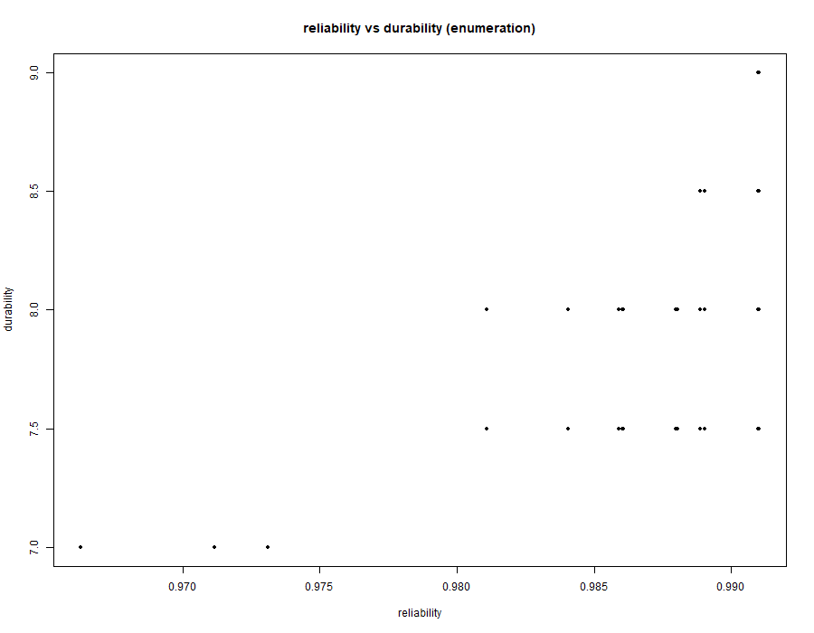
Reliability vs. Durability

Certification Schedule vs. Reliability
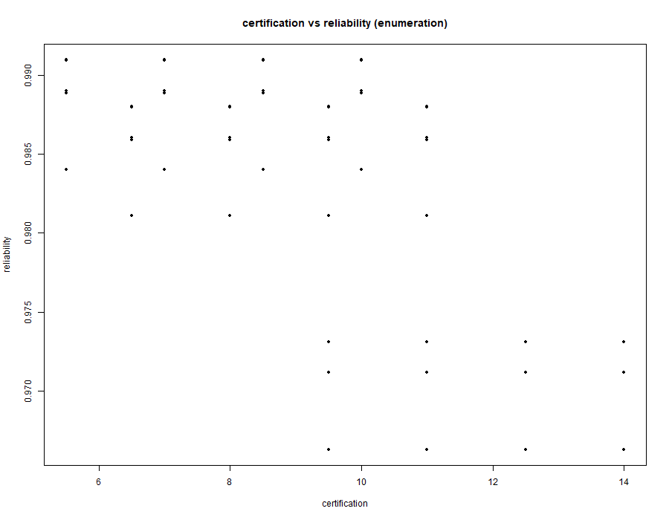
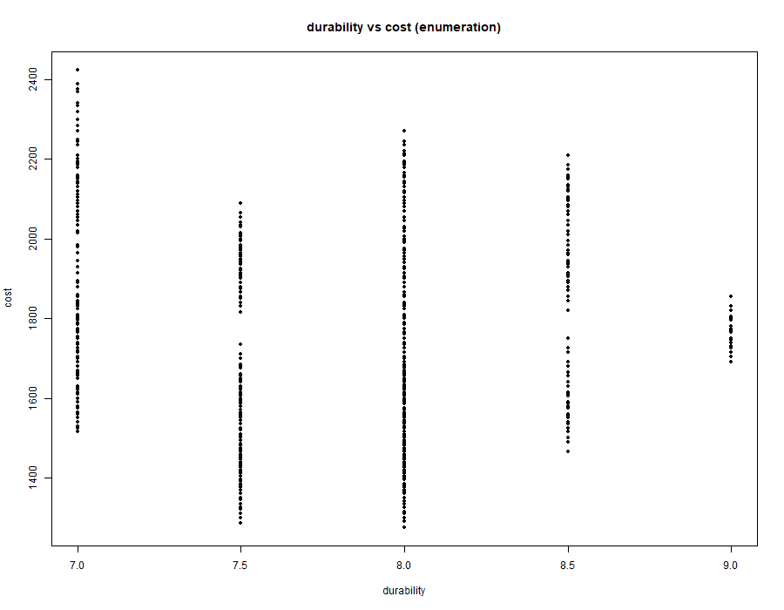
Durability vs. Cost
Cost vs. Reliability
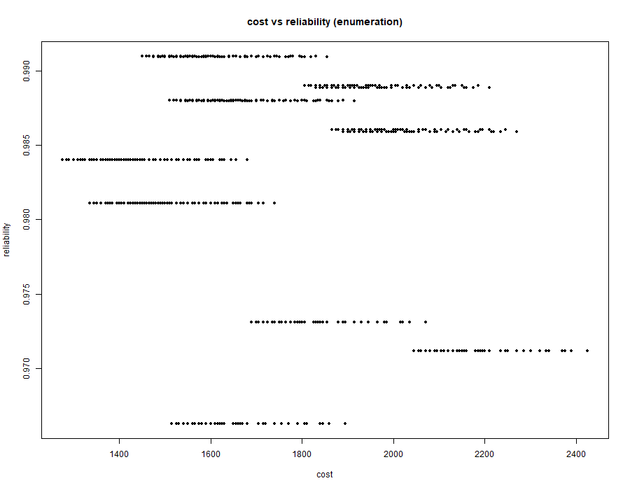
Cost vs. Certification Schedule
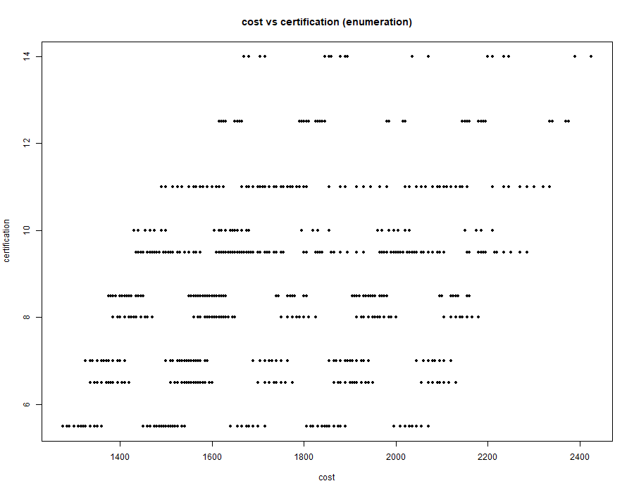

Each plot represents a projection of the full design space, allowing insight into dominant trade-offs between competing objectives.
It should be noted that the tradespace results are dependent on the assumed subsystem mappings and heuristic parameter values. A full uncertainty and sensitivity analysis is outside the scope of this stage but represents an important extension for future work.

3.5 Optimization and Selection

3.5.1. Optimization Setup (Multi-Objective Genetic Algorithm)
The architectural selection problem was formulated as a constrained multi-objective optimization problem and solved using a Multi-Objective Genetic Algorithm (MOGA), consistent with the NSGA-II framework applied in HW#5. The objective of the optimizer is to approximate the Pareto-optimal frontier of a discrete tradespace consisting of 184,212 feasible aircraft architectures, while simultaneously balancing four competing system-level objectives: operating cost, certification schedule, propulsion system reliability, and system durability.

Representation (Encoding)
Each architecture is initially defined as a mixed-integer decision vector spanning design variables D1–D8, where decisions include binary, categorical, and partition-based variables representing propulsion, energy storage, avionics architecture, redundancy allocation, and subsystem decomposition.
To interface with the genetic algorithm implementation, this integer-based representation is further transformed into a fixed-length binary chromosome using an int2bit encoding function. In this process, the full decision vector (18 discrete decision elements) is mapped into a binary string of length 26, ensuring compatibility with the binary genetic algorithm structure while preserving one-to-one correspondence with the original architectural variables.
This binary encoding enables the GA to perform crossover and mutation operations at the bit level, while a decoding step is applied during evaluation to reconstruct the original integer decision vector before computing system-level performance metrics. This ensures that genetic operators operate in a standardized search space while maintaining interpretability at the system architecture level.

Genetic algorithm configurations
The algorithm operates with a fixed population size of 200 individuals and is executed for 200 generations, providing a balance between solution quality and computational cost. A binary tournament selection strategy is used to preferentially select non-dominated and high-crowding-distance individuals, ensuring convergence toward the Pareto front while maintaining diversity.
A uniform crossover operator is applied to recombine parental solutions at the bit level, enabling structured exchange of architectural features across designs. This is complemented by a low-probability mutation operator, which introduces stochastic variation to prevent premature convergence and maintain exploration of underrepresented regions of the design space.
NSGA-II’s non-dominated sorting mechanism is used to classify solutions into Pareto fronts, while crowding distance sorting ensures diversity preservation within each front.

Population Initialization
The initial population is generated using uniform random sampling over the feasible design space. This ensures broad coverage of propulsion, electrical, and avionics configurations while maintaining diversity across early-generation solutions.

Mutation Operator
A low-probability, type-aware mutation strategy is used. Binary variables (e.g., CAPS installation) are flipped probabilistically, while categorical variables (e.g., propulsion topology) are reassigned within feasible alternatives. This ensures controlled exploration without disrupting convergence stability.

Constraint Handling
Feasibility constraints arising from architectural dependencies (notably D3–D4 coupling and subsystem compatibility rules) are enforced through a repair-based mechanism within the GA loop. Infeasible offspring are corrected before evaluation. Additionally, heavily penalized fitness values are assigned to any residual infeasible architectures, ensuring exclusion from the Pareto set.

Termination Criteria
The algorithm is executed for a fixed number of generations. Convergence is assessed through stabilization of Pareto dominance structure and diminishing improvement in hypervolume across successive generations.

3.5.2. Pareto Front Structure and GA Convergence Behavior
The full factorial tradespace exhibits strong stratification in both operating cost and certification schedule, driven primarily by discrete architectural decisions such as propulsion topology (D1) and FCC redundancy (D5). As a result, the Pareto front is not smooth but forms a discrete, clustered surface reflecting the combinatorial nature of the design space.
The genetic algorithm (population = 200, generations = 200, crossover = 0.8, mutation = 0.1, elitism = 10) converges extremely rapidly, reaching its best solution within the first 10–20 iterations. After this initial phase, both the best and mean fitness values stabilize, indicating that the population collapses into a narrow region of the tradespace.
From iteration ~20 onwards, no further improvement in the best solution is observed (best fitness stabilizes at approximately -1450), while only oscillations in the mean fitness persist. This behavior indicates premature but stable convergence to a dominant feasible architecture rather than gradual Pareto-front exploration.
The resulting population contains multiple genotypically different architectures that map to identical objective values, suggesting redundancy in the encoding–fitness mapping and strong dominance of a small subset of high-impact decision variables (notably D1, D3, D5, and D7). Once these variables stabilize, remaining decisions only produce equivalent or near-equivalent designs without improving Pareto dominance.
Overall, the GA behaves as a fast-converging search that quickly identifies a flat region of the Pareto surface, after which exploration becomes ineffective due to limited mutation-driven diversity and strong constraint-driven feasibility pressure.

3.5.3. Selected Pareto-Optimal Architectures
Two representative architectures are selected from the Pareto frontier. These solutions are not globally optimal in any single objective but are non-dominated in the multi-objective sense and represent distinct engineering tradeoffs.

Architecture A: Balanced Efficiency–Certification Tradeoff Design
Decision vector:
0,1,1,0,0,1,1,0,0,0,0,0,0,1,0,0,0,1
Performance metrics:
- Operating Cost: 1450 $/hr
- Certification Schedule: 5.5 years
- Propulsion Reliability: 99.10%
- System Durability: 8 years
This architecture lies in the central region of the Pareto front and represents a balanced design configuration. It avoids excessive propulsion distribution complexity while maintaining high system-level redundancy in avionics and control systems.
Key characteristics:
- Moderate propulsion complexity, avoiding excessive certification penalties
- Efficient certification pathway due to reduced sequential dependencies
- High reliability achieved through balanced redundancy allocation
This architecture is attractive because it achieves near-frontier reliability without incurring disproportionate certification overhead associated with highly distributed propulsion systems.

Architecture B: High-Reliability Robust Design
Decision vector:
0,1,1,1,1,0,0,0,0,0,0,0,0,1,1,1,0,1
Performance metrics:
- Operating Cost: 1450 $/hr
- Certification Schedule: 5.5 years
- Propulsion Reliability: ~99.10%
- System Durability: 8 years
Although aggregate performance metrics are similar to Architecture A, this configuration differs significantly in internal redundancy allocation. Redundancy is concentrated within propulsion-adjacent and safety-critical subsystems rather than being distributed uniformly.
Key characteristics:
- Increased redundancy concentration in propulsion and control pathways
- Stronger fault tolerance at subsystem level
- Maintains certification efficiency without increasing schedule burden
This architecture is more suitable for high-risk operational environments where fault tolerance is prioritized over structural simplicity.

3.5.4. Rationale for Pareto Optimality
Both architectures are considered optimal because they lie on the non-dominated Pareto frontier. No alternative architecture in the explored tradespace can improve one objective without degrading at least one other objective.
They are optimal in the following multi-objective sense:
- High propulsion reliability (~99%) satisfies safety-critical constraints
- Moderate certification time (5.5 years) avoids excessive regulatory burden
- Controlled operating cost relative to high-complexity architectures
- Balanced structural redundancy without extreme propulsion distribution penalties
Importantly, both architectures reside in a stable region of the Pareto surface, where small perturbations in design variables do not result in large performance variations. This robustness is essential in practical systems engineering applications.

3.5.5. Model Interpretation and Limitations
While the genetic algorithm effectively identifies high-quality architectures, the results highlight structural limitations in the evaluation model. A significant number of distinct decision vectors map to nearly identical performance outcomes, indicating the presence of equivalence classes within the tradespace.
This behavior is primarily driven by:
- Linear additive cost modeling
- Deterministic certification schedule formulation
- Limited sensitivity of certain decisions (notably D7)
- Simplified independence assumptions in reliability aggregation
As a result, interaction effects between subsystems are underrepresented, particularly in integration-driven cost and certification dynamics.
Future model improvements could include:
- Stochastic modeling of certification delays
- Nonlinear coupling between propulsion and avionics integration
- Enhanced sensitivity modeling for partitioning decisions (D7)
- Explicit interaction terms for subsystem integration complexity

3.5.6. Summary
The multi-objective genetic algorithm successfully approximates the Pareto frontier of the aircraft architecture tradespace and identifies a structured set of high-performing system configurations.
The results demonstrate that optimal architectures are not extreme solutions but rather balanced configurations that trade moderate complexity for stability in certification, reliability, and durability. Furthermore, the optimization reveals that system performance is primarily governed by a small subset of high-impact architectural decisions, while the remaining variables act as secondary refinements within a constrained Pareto region.
Overall, the study confirms that meaningful architectural optimization in this system occurs within a structured and highly constrained subset of the full combinatorial design space.

