Experiment: 3rd

Aim:-To study about the SQL

* What is SQL:-
* SQL stands for Structured Query Language. It is used for storing and managing data in relational database management system (RDMS).
* It is a standard language for Relational Database System. It enables a user to create, read, update and delete relational databases and tables.
* All the RDBMS like MySQL, Informix, Oracle, MS Access and SQL Server use SQL as their standard database language.
* SQL allows users to query the database in a number of ways, using English-like statements
* Rules:
  + Structure query language is not case sensitive. Generally, keywords of SQL are written in uppercase.
  + Statements of SQL are dependent on text lines. We can use a single SQL statement on one or multiple text line.
  + Using the SQL statements, you can perform most of the actions in a database.
  + SQL depends on tuple relational calculus and relational algebra.
* SQL process:
  + When an SQL command is executing for any RDBMS, then the system figure out the best way to carry out the request and the SQL engine determines that how to interpret the task.
  + In the process, various components are included. These components can be optimization Engine, Query engine, Query dispatcher, classic, etc.
  + All the non-SQL queries are handled by the classic query engine, but SQL query engine won't handle logical files.

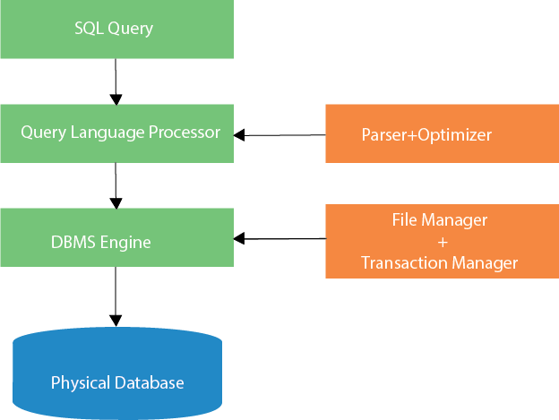

Next T

# Characteristics of SQL

* + SQL is easy to learn.
  + SQL is used to access data from relational database management systems.
  + SQL can execute queries against the database.
  + SQL is used to describe the data.
  + SQL is used to define the data in the database and manipulate it when needed.
  + SQL is used to create and drop the database and table.
  + SQL is used to create a view, stored procedure, function in a database.
  + SQL allows users to set permissions on tables, procedures, and views.
* Types of SQL:-

**1) DDL- Data Definition Language**

* The Data Definition Language is made up of SQL commands that can be used to design the database structure. It simply handles database schema descriptions and is used to construct and modify the structure of database objects in the database.
* It can be used to define the database schema. It allows adding/modifying/deleting the logical structures which contain the data or which would enable users to access/maintain the data

**2) DQL- Data Query Language**

* DQL statements are used to query the data contained in schema objects. The DQL Commands' goal is to return a schema relation depending on the query supplied to it. DQL can be defined as follows: It’s a part of a SQL statement that lets you get data from a database and put it in order.
* The most used code by Data scientists and analysts.
* 1. SELECT: It helps to do data analysis

**3) DML- Data Manipulation Language**

* The SQL commands that deal with manipulating data in a database are classified as DML (Data Manipulation Language), which covers the majority of SQL statements. It’s the part of the SQL statement that regulates who has access to the data and the database
* It helps us work with data that goes into the database such as
* SELECT - Retrieves data from a Table/Database
* INSERT - Insert data into a Table/Database
* UPDATE - Updates existing data within a Table/Database
* DELETE - Deletes all records from a database Table/Database

**4) DCL- Data Control Language**

* DCL (Data Controlling Language) is a query language that allows users to retrieve and edit data held in databases. The types of Data Controlling Language commands include Grant and Revoke.
* It allows us to give permission on a particular database or table such as GRANT & REVOKE
* ●GRANT – Allows users to access privileges to the database/table
* ●REVOKE - withdraw users' access privileges given by using the GRANT command

**5) TCL- Transaction Control Language**

* Transaction Control Language (TCL) instructions are used in the database to manage transactions. This command is used to handle the DML statements’ modifications. TCL allows you to combine your statements into logical transactions.
* It helps to commit and revoke changes in the server. Also, it allows us to save points wherever it is appropriate.
* ●COMMIT– Saves all the changes done in the last transaction permanently.
* ●ROLLBACK - Cancels all the modifications done in the last transaction.
* SAVEPOINTS - A rollback operation will be performed on a part of the transaction. The save points command sets a name transaction save-point by the name of the identifier

## ****How Does SQL Work?****

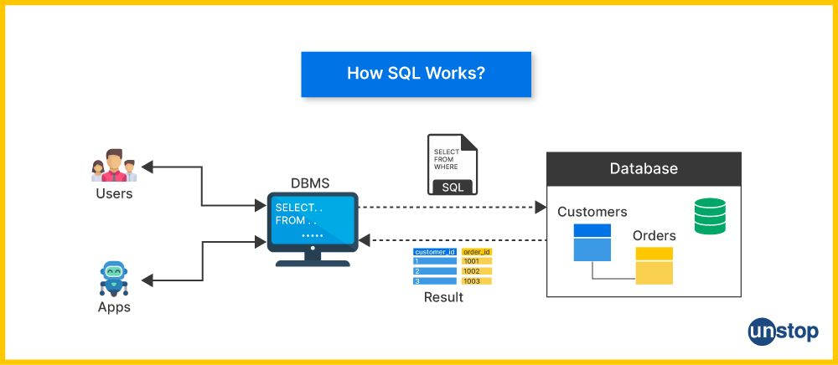

Structured Query Language (SQL) is a domain-specific language designed for the management, manipulation, and dynamic modification of relational databases. It serves as a standard interface for interacting with relational database management systems (RDBMS), allowing users to perform a variety of routine tasks and operations on data, such as querying, updating, inserting, and deleting records.

## ****Advantages And Disadvantages Of SQL****

| **Advantages of SQL** | **Disadvantages of SQL** |
| --- | --- |
| **1. Ease of Use:** SQL is a simple and easy-to-learn language with no complicated queries as such, making it accessible to both beginners and experienced developers. | **1. Limited Scalability:** SQL databases are enabled with vertical scaling by enhancing hardware investment. Hence, they may face challenges when it comes to horizontal scaling, especially with large datasets and high traffic. |
| **2. Standardization:** SQL is a standardized language that ensures consistency and compatibility across various [database management systems (DBMS)](https://unstop.com/blog/what-are-the-characteristics-of-a-modern-dbms). | **2. Complexity:** Complex queries and database designs can be challenging to optimize and maintain. |
| **3. Flexibility:** SQL provides flexibility in querying and manipulating database components, allowing for a wide range of operations on database schemas and systems. | **3. Lack of Real-time Processing:** SQL databases might not be the preferred choice for businesses and real-time applications due to potential latency in data processing. |
| **4. Data Integrity:** SQL databases enforce data integrity constraints (e.g., [primary keys](https://unstop.com/blog/difference-between-primary-key-and-candidate-key), foreign keys) to maintain accurate and reliable data relationships between tables. | **4. Cost:** Some commercial SQL databases can be expensive, especially for large enterprises requiring advanced features and support. |
| **5. Support for Transactions:** SQL supports ACID properties (Atomicity, Consistency, Isolation, Durability), ensuring the reliability of database transactions. | **5. Limited Support for Unstructured Database:** SQL is primarily designed for structured data, making it less suitable for handling unstructured database types like images or videos. |
| **6. Security:** SQL databases offer robust security features, including user authentication, authorization, and [encryption](https://unstop.com/blog/encryption-and-decryption). | **6. Learning Curve:** While the basics are easy to grasp, mastering advanced SQL concepts and optimization techniques can be challenging for some users. |
| **7. Powerful Query Language:** SQL's declarative nature allows users to express what they want to achieve without specifying how to achieve it, making queries powerful and expressive. | **7. Single Point of Failure:** If a central SQL database fails, it can lead to a complete system failure, impacting all applications relying on it. |
| **8. Community Support:** SQL has a large and active community, providing resources, forums, and documentation for developers. | **8. Vendor Lock-in:** Switching from one SQL database vendor to another may be challenging due to differences in implementations and features. |