Creative Artwork Generation using Stable Diffusion
Name: Janhvi Katakdhond
PNR: 22420013

Objective
To generate creative images using a Stable Diffusion model based on text prompts.

Introduction
Stable Diffusion is a deep learning model used for generating images from textual descriptions.

Methodology
We used the Hugging Face Diffusers library to load a pre-trained Stable Diffusion model and generate images from prompts.

Implementation
The implementation involves loading the model, defining prompts, and generating images using Python.

Results
The model successfully generated high-quality creative artwork based on the provided prompts.
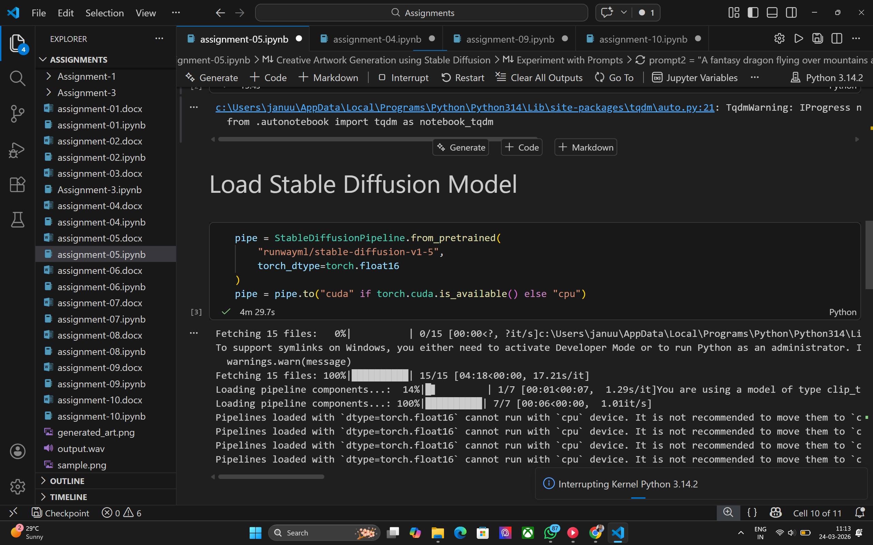
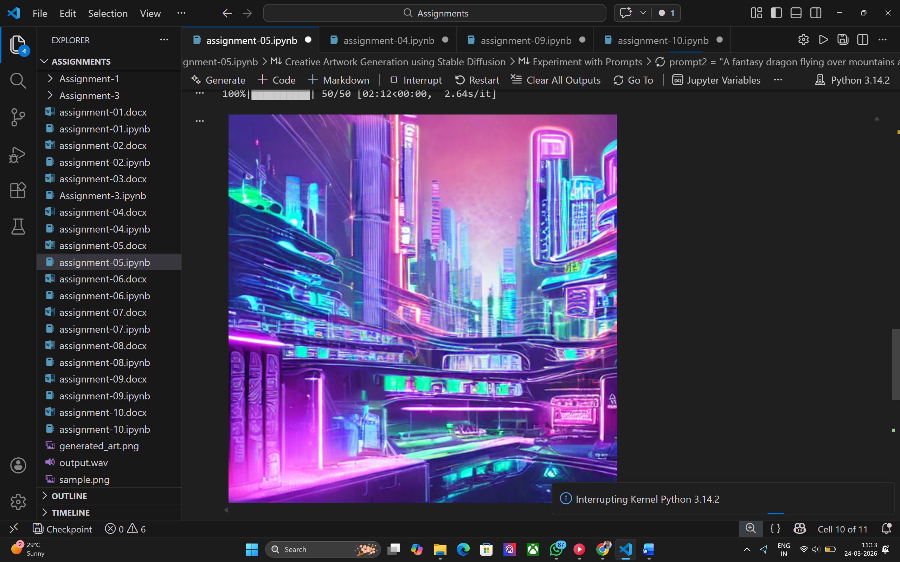

Conclusion
Stable Diffusion is a powerful tool for AI-based image generation and creative applications.

