Image Captioning using CLIP
Name: Janhvi Katakdhond
PNR: 22420013

Introduction
This assignment demonstrates a basic multimodal system for image captioning using CLIP. CLIP (Contrastive Language-Image Pretraining) is a model developed to understand images and text together.

Methodology
The CLIP model is used to compare an input image with a set of candidate captions. The model computes similarity scores and selects the caption with the highest probability.

Implementation
The implementation uses the Hugging Face Transformers library. An image is processed along with multiple text captions, and the best matching caption is selected.

Results
The system successfully generates a caption by selecting the most relevant text description for the image.
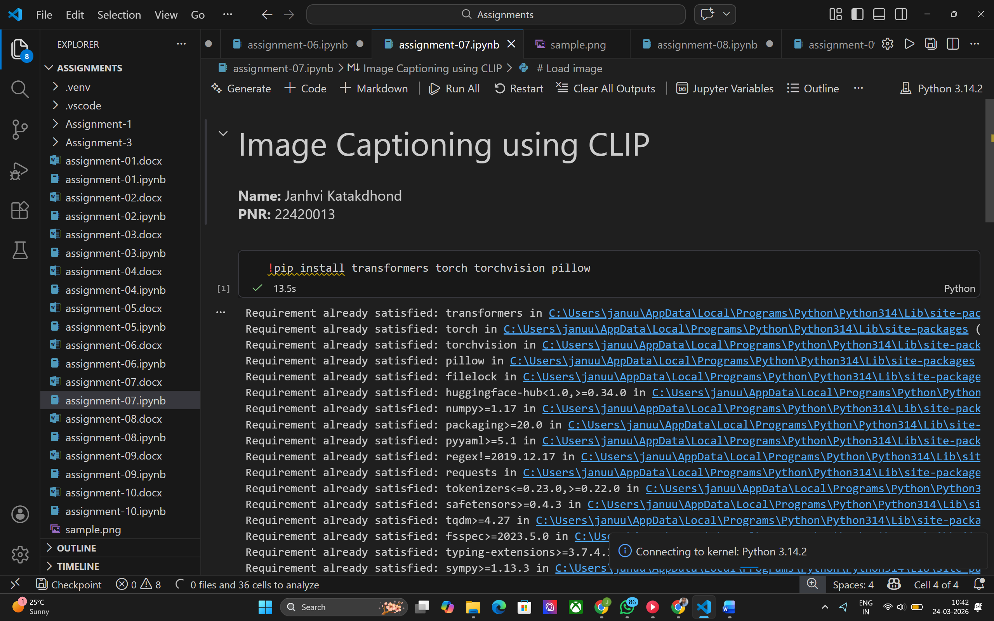
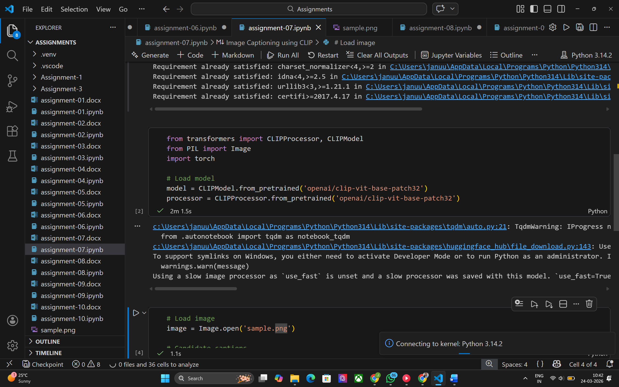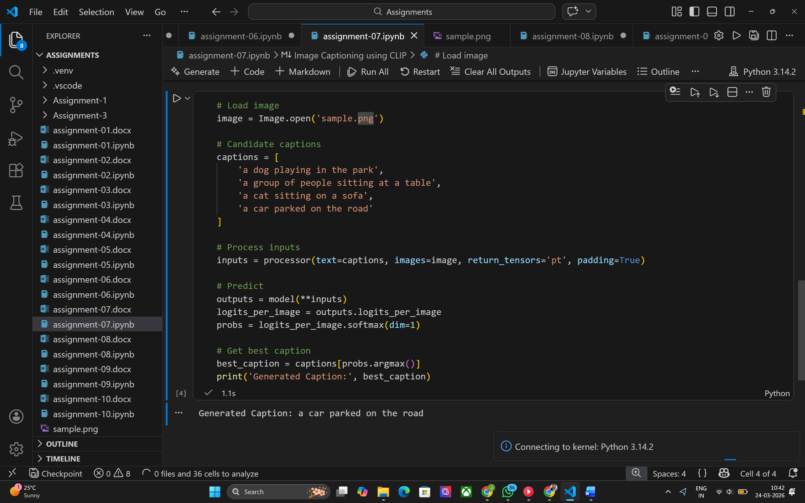

Conclusion
CLIP provides a simple and effective way to perform image captioning using multimodal understanding. However, this basic approach relies on predefined captions and can be improved using generative models.

