PrithviSaarthi - Dashboard Explanation

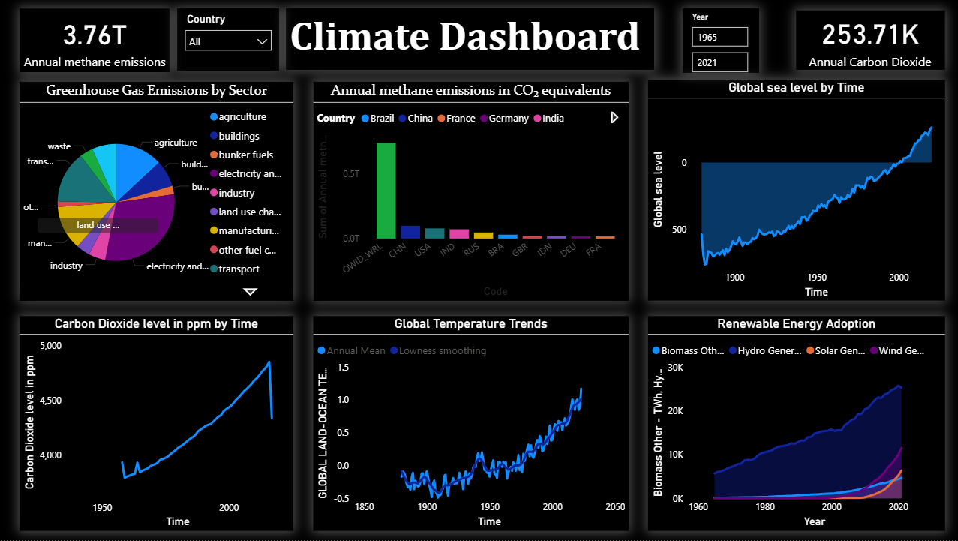

Overview :
The PrithviSaarthi Climate Analytics Dashboard is designed to analyze and visualize important climate indicators through interactive charts and reports. The dashboard helps users understand environmental changes and climate trends in a simple and visual manner.
Dashboard Components :
Greenhouse Gas Emissions Analysis
This section displays greenhouse gas emissions from different sectors. It helps identify major contributors to environmental pollution and provides insights into emission patterns over time.
Carbon Dioxide (CO₂) Analysis
The CO₂ analysis tracks changes in carbon dioxide concentration over the years. This visualization helps in understanding the impact of carbon emissions on climate change.
Global Temperature Analysis
This section shows global temperature trends using historical climate data. It helps users observe temperature variations and long-term warming patterns.
Renewable Energy Analysis
The renewable energy visualization highlights the growth and adoption of renewable energy sources. It provides insights into the transition towards sustainable energy solutions.
Sea Level Analysis
This section tracks changes in sea levels over time. The visualization helps understand the environmental impact of climate change on oceans and coastal regions.
Key Performance Indicators (KPIs)
The dashboard includes important climate-related KPIs such as:
- Carbon Dioxide Levels
- Methane Emissions
- Global Temperature Change
- Renewable Energy Growth
- Sea Level Variations
- Greenhouse Gas Emission Indicators
These KPIs provide a quick overview of climate conditions and support effective analysis.
Key Insights
Through the dashboard analysis, several important observations were identified:
- Carbon dioxide concentration has shown a steady increase over the years.
- Global temperatures continue to rise, indicating long-term climate change.
- Renewable energy adoption has increased significantly in recent years.
- Greenhouse gas emissions remain one of the major environmental concerns.
- Sea levels have gradually increased due to climate-related factors.
Benefits of the Dashboard
The dashboard simplifies complex climate datasets and presents them in an interactive format. It supports climate awareness, environmental analysis, and data-driven decision-making by providing meaningful insights through visual reporting.

Conclusion
The PrithviSaarthi Climate Analytics Dashboard demonstrates how data analytics and visualization can be used to better understand climate trends and environmental challenges. By transforming raw climate data into actionable insights, the project promotes awareness and supports informed discussions on sustainability and climate change.

