Spotify Music Analysis Dashboard – Explanation

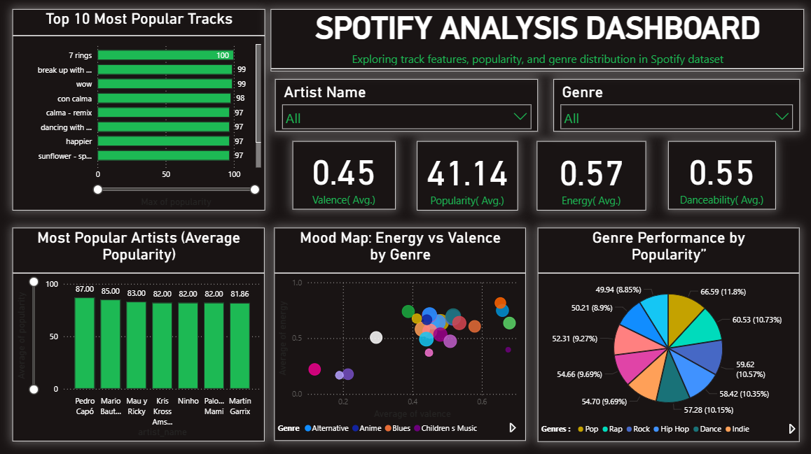
Overview
The Spotify Music Analysis Dashboard is an interactive Power BI dashboard designed to analyze music data from Spotify. The dashboard helps users understand track popularity, artist performance, genre distribution, and audio characteristics such as energy, valence, and danceability.
The purpose of this project is to transform raw music data into meaningful insights that can help identify trends in listener preferences and music characteristics.

Dashboard Components
1. Top 10 Most Popular Tracks
This visual displays the ten most popular songs in the dataset based on popularity scores.
Purpose:
- Identify trending tracks.
- Compare popularity among top-performing songs.
- Understand which songs receive the highest audience engagement.

2. Artist Analysis
This chart displays the average popularity of artists in the dataset.
Purpose:
- Compare artist performance.
- Identify the most popular artists.
- Analyze audience preferences for different artists.

3. Genre Performance Analysis
The genre distribution chart shows the popularity contribution of different music genres.
Purpose:
- Understand genre preferences.
- Compare popularity across genres.
- Identify high-performing music categories.

4. Mood Map (Energy vs Valence)
The scatter plot compares average energy and valence values for different genres.
Purpose:
- Analyze the emotional characteristics of music.
- Compare genres based on mood and intensity.
- Understand how energetic or positive different genres are.

5. KPI Cards
The dashboard includes key performance indicators that summarize important music attributes.
Average Valence
Measures the positivity or happiness level of tracks.
Average Popularity
Represents the average popularity score of songs.
Average Energy
Shows how energetic and intense the tracks are.
Average Danceability
Indicates how suitable songs are for dancing.
These KPIs provide a quick overview of the dataset.

Interactive Filters
The dashboard includes filters for:
Artist Name
Allows users to analyze specific artists.
Genre
Allows users to focus on specific music genres.
These filters make the dashboard interactive and enable detailed exploration of the data.

Key Insights
- Certain tracks achieve significantly higher popularity than others.
- Popularity varies across artists and genres.
- Danceability and energy are important characteristics in many popular songs.
- Different genres exhibit unique mood patterns based on energy and valence scores.
- Music analytics can be used to understand audience preferences and listening trends.

Business Value
This dashboard demonstrates how music data can be transformed into actionable insights using Power BI.
The analysis can help:
- Music streaming platforms understand listener preferences.
- Artists and producers identify popular music characteristics.
- Marketing teams analyze audience engagement trends.
- Researchers study patterns in music consumption.

Conclusion
The Spotify Music Analysis Dashboard provides an interactive platform for exploring music trends, artist performance, genre popularity, and audio features. By combining data visualization and analytics, the dashboard helps transform complex music datasets into meaningful insights that support better understanding of audience behavior and music trends.

