**MOTHERBOARD DEFINATION:**

The motherboard is the main [circuit board](https://techterms.com/definition/pcb) of your computer and is also known as the main board or logic board. If we open our computer, the biggest piece of silicon you see is the motherboard. Attached to the motherboard, we'll find the [CPU](https://techterms.com/definition/cpu), [ROM](https://techterms.com/definition/rom), memory [RAM](https://techterms.com/definition/ram) expansion slots, [PCI](https://techterms.com/definition/pci) slots, and [USB](https://techterms.com/definition/usb) ports. It also includes controllers for devices like the [hard drive](https://techterms.com/definition/harddrive), DVD drive, keyboard, and mouse. Basically, the motherboard is what makes everything in your computer work together.

Each motherboard has a collection of chips and controllers known as the [chipset](https://techterms.com/definition/chipset). When new motherboards are developed, they often use new chipsets. The good news is that these boards are typically more efficient and faster than their predecessors. The bad news is that older [components](https://techterms.com/definition/component) often do not work with new chipsets. Of course, if we are planning on upgrading multiple components, it may be more cost-effective to just buy a new computer.

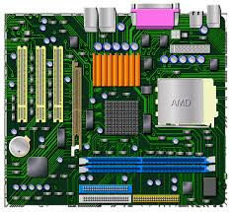

**Major Motherboard Components, Connectors and Their Functions**

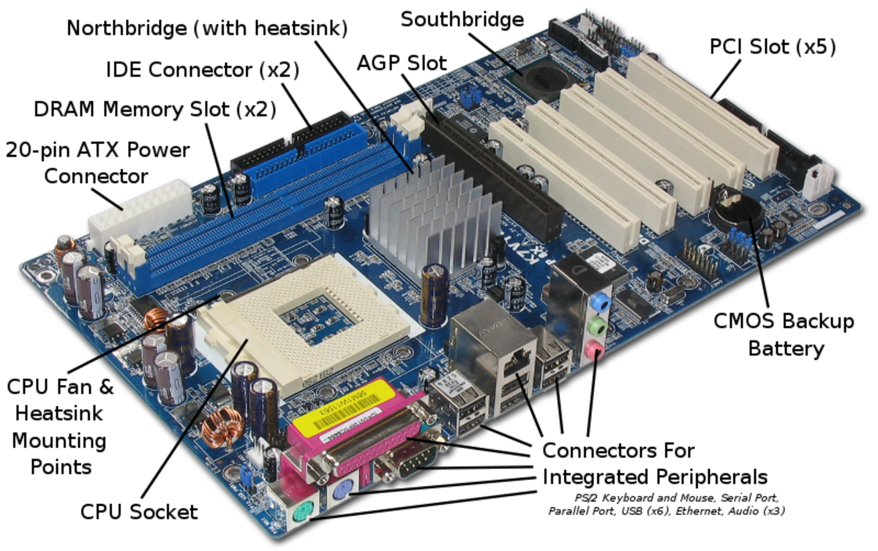

1.**Central Processing Unit (CPU)**

Also known as the microprocessor or the [**processor**](https://winstartechnologies.com/the-computer-processor/), the CPU is the computer's brain. It is responsible for fetching, decoding, and executing program instructions as well as performing mathematical and logical calculations.

The processor chip is identified by the processor type and the manufacturer. This information is usually inscribed on the chip itself. For example, Intel 386, Advanced Micro Devices (AMD) 386, Cyrix 486, Pentium MMX, Intel Core 2Duo, or Core i7.

If the processor chip is not on the motherboard, we can identify the processor socket as socket 1 to Socket 8, LGA 775 among others.

2.**[Random Access Memory](https://winstartechnologies.com/introduction-to-computer-memory/" \t "_blank)**, or RAM: usually refers to computer chips that temporarily store dynamic data to enhance computer performance while we are working. Random-Access Memory is volatile, meaning it loses its contents once power is turned off. This is different from non-volatile memory, such as hard disks and flash memory, which do not require a power source to retain data.

When a computer shuts down properly, all data located in RAM is returned to permanent storage on the hard drive or flash drive.

**3.Basic Input/output System (BIOS)**

BIOS stand for Basic Input/output System. BIOS is a "read-only" memory, which consists of low-level software that controls the system hardware and acts as an interface between the operating system and the hardware.

All motherboards include a small block of Read-Only Memory (ROM) which is separate from the main system memory used for loading and running software. The BIOS is stored on a ROM chip because ROM retains information even when no power is being supplied to the computer.

**4.Complimentary Metal Oxide Semiconductor Random Access Memory (CMOS RAM):**

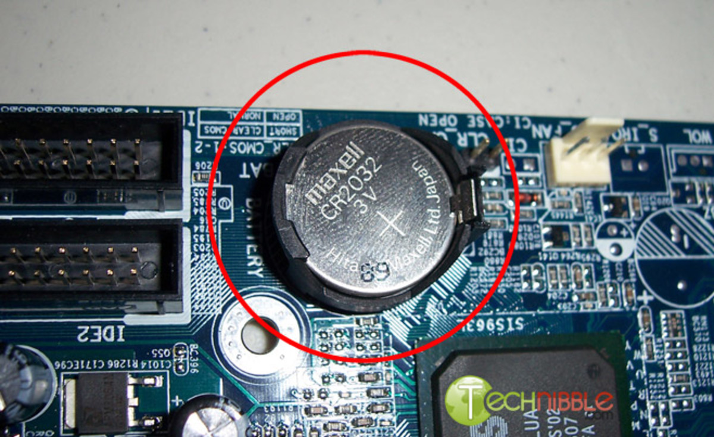

**The CMOS Battery:**

Motherboards also include a small separate block of memory made from CMOS RAM chips which are kept alive by a battery (known as a CMOS battery) even when the PC’s power is off. This prevents reconfiguration when the PC is powered on.

CMOS devices require very little power to operate.

**5.Cache Memory**

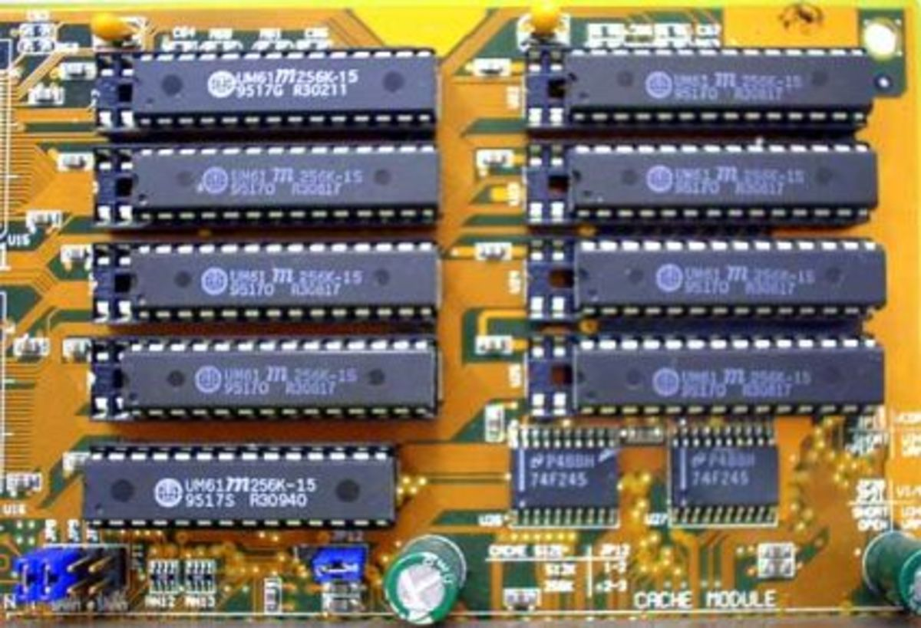

**The Computer Cache Memory:**

Cache memory is a small block of high-speed memory (RAM) that enhances PC performance by pre-loading information from the (relatively slow) main memory and passing it to the processor on demand.

Most CPUs have an internal cache memory (built into the processor) which is referred to as Level 1 or primary cache memory. This can be supplemented by external cache memory fitted on the motherboard. This is the Level 2 or secondary cache.

**6.The Expansion Buses :** PCI slots

**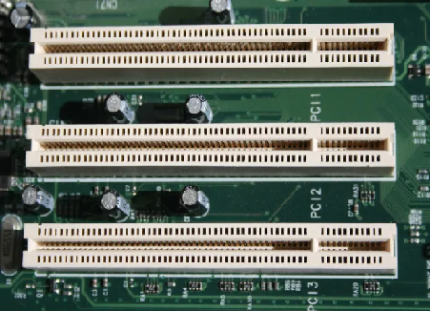**

An expansion bus is an input/output pathway from the CPU to peripheral devices and it is typically made up of a series of slots on the motherboard. Expansion boards (cards) plug into the bus.

PCI is the most common expansion bus in a PC and other hardware platforms.

**7. CPU-Fan Connection:**This is where the CPU fan will connect. Using this connection over one for the power supply will allow the motherboard to control the speed of the fan, based on the CPU temperature.

**8. Socket:** This is where the CPU will plug in. The orange bracket that is surrounding it is used for high end heat sinks. It helps to support the weight of the heat sink.

**9. ATX Power Connector:** This is the second of two power connections. This is the main power connection for the motherboard, and comes from the Power Supply.

**10. IDE connectors or PATA connectors:** IDE full form is Integrated Device Electronics. it supports IDE devices, such as Hard disks and CD and DVD drives. Most drives today come with SATA connections.

**11. Southbridge:**This is the controller for components such as the PCI slots, onboard audio, and USB connections.

**12. SATA Connections:**SATA full form is Serial Advanced Technology Attachment. These are connect with serial ATA devices, such as Hard disk drives and CD or DVD drives.

**13. Front Panel Connections:** this is where we will hook in the connections from the case. These are mostly the different lights on the case, such as power on, hard drive activity etc.

**14. FDD Connection:** The FDD is the Floppy Disk controller. Floppy Drive Connector is used to connect floppy drives. It supports two floppy drives.

**15. External USB Connections:** There are usually a couple of these ports located on each motherboard used for connecting pen drives and external hard drives, like Ipods or Mp3 players.