**ASSIGNMENT NO:1**

**AIM:** Design an entity relationship (ER)/ Extended entity relationship (EER) model.

**THEORY:**

[ER Diagram](https://www.geeksforgeeks.org/introduction-of-er-model/) is known as Entity-Relationship Diagram, it is used to analyze to the structure of the Database. It shows relationships between entities and their attributes. An ER Model provides a means of communication.

**SYMBOLS :**

| Entity Symbol | Name | Description |
| --- | --- | --- |
| Strong Entity Symbol | Strong entity | These shapes are independent from other entities, and are often called parent entities, since they will often have weak entities that depend on them. They will also have a primary key, distinguishing each occurrence of the entity. |
| Weak Entity Symbol | Weak entity | Weak entities depend on some other entity type. They don't have primary keys, and have no meaning in the diagram without their parent entity. |
| Associative entity symbol | Associative entity | Associative entities relate the instances of several entity types. They also contain attributes specific to the relationship between those entity instances. |

**ERD relationship symbols**

Within entity-relationship diagrams, relationships are used to document the interaction between two entities. Relationships are usually verbs such as assign, associate, or track and provide useful information that could not be discerned with just the entity types.

| Relationship Symbol | Name | Description |
| --- | --- | --- |
| Relationship Symbol | Relationship | Relationships are associations between or among entities. |
| Weak Relationship Symbol | Weak relationship | Weak Relationships are connections between a weak entity and its owner. |

**ERD attribute symbols**

ERD attributes are characteristics of the entity that help users to better understand the database. Attributes are included to include details of the various entities that are highlighted in a conceptual ER diagram.

| Attribute Symbol | Name | Description |
| --- | --- | --- |
| Attribute Symbol | Attribute | Attributes are characteristics of an entity, a many-to-many relationship, or a one-to-one relationship. |
| Multivalued Attribute Symbol | Multivalued attribute | Multivalued attributes are those that are can take on more than one value. |
| Derived Attribute Symbol | Derived attribute | Derived attributes are attributes whose value can be calculated from related attribute values. |
| Relationship Symbol | Relationship | Relationships are associations between or among entities. |

**PROBLEM STATEMEMT** :

The given problem statement ,first identify attribute entity ,relationships. we represent using ER diagram Using ER Diagram table structure created along with required constain.Thus to have data store efficiently, the ER diagram is to draw much detail and accurate as possible.

**ER DIGRAM : LIBRARY MANAGEMENT SYSTEM**

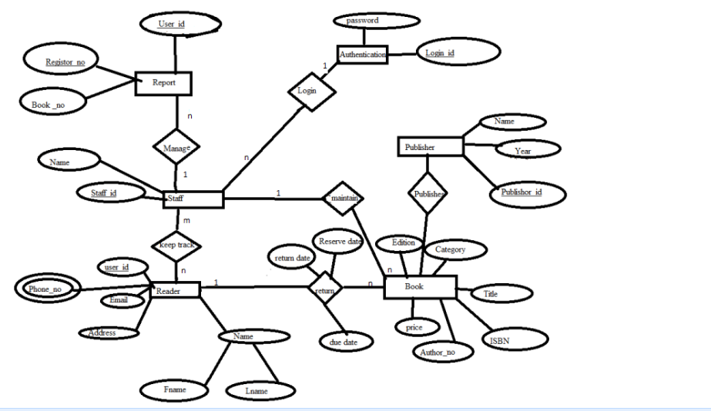

**CONCULSION :**

Hence, we successfully perform to design entity relationship model.