**SE_A_62_Janhvi Gujare**

**EXPERIMENT NO. 15**

**Aim:**

Write Java program to draw various shapes on Canvas.

**Theory:**

Canvas class is a part of JavaFX. Canvas class basically creates an image that can be drawn on using a set of graphics commands provided by a GraphicsContext. Canvas has a specified height and width and all the drawing operations are clipped to the bounds of the canvas.

**Constructors of the class:**

* **Canvas()**: Creates a new canvas object.
* **Canvas(double w, double h)**: Creates a new canvas object with specified width and height.

**Commonly Used Methods:**

|  |  |
| --- | --- |
| **Method** | **Explanation** |
| getGraphicsContext2D () | Returns the graphics context associated with the canvas. |
| getHeight() | Returns the height of the canvas. |
| getWidth() | Returns the width of the canvas. |
| setHeight(double v) | Sets the height of the canvas. |
| setWidth(double d) | Sets the width of the canvas. |

**Problem Definition:**

Write Java program to draw various shapes on Canvas using JavaFX.

**Program:**

package sample;

import javafx.application.Application; import javafx.scene.Scene; import javafx.scene.canvas.Canvas; import javafx.scene.canvas.GraphicsContext; import javafx.scene.layout.Pane; import javafx.scene.paint.Color; import javafx.scene.shape.ArcType; import javafx.stage.Stage; public class Shapes extends Application { public static void main(String[] args) {

Application.*launch*(args);

}

@Override

public void start(Stage stage) {

Canvas canvas = new Canvas(450, 400);

GraphicsContextgc = canvas.getGraphicsContext2D();

gc.strokeText("Chirag Canvas", 250, 350); Pane root = new Pane(); root.setStyle("-fx-padding: 10;" + "-fx-border-style: dashed inside;" + "-fxborder-width: 3;" + "-fx-borderinsets: 5;" + "-fx-border-radius: 5;" + "-fx-bordercolor: red;"); gc.setLineWidth(3.0); gc.setFill(Color.*RED*);

gc.strokeRoundRect(20, 20, 80, 80, 15, 15); gc.setFill(Color.*RED*); gc.strokeOval(20, 130, 100, 60);

gc.strokePolygon(new double[]{220, 270, 220}, new double[]{120, 170,

170}, 3);

gc.fillPolygon(new double[]{220, 270, 220}, new double[]{120, 170, 170},

3); gc.fillOval(250, 220, 150, 90); gc.strokeLine(180, 50, 300, 50); gc.strokeArc(320, 20, 60, 60, 70, 80, ArcType.*ROUND*); gc.fillArc(320, 70, 100, 100, 0, 120, ArcType.*OPEN*); gc.beginPath(); gc.moveTo(50, 350);

gc.quadraticCurveTo(30, 150, 200, 200); gc.setFill(Color.*LIME*); gc.fill(); gc.closePath(); root.getChildren().add(canvas); Scene scene = new Scene(root); stage.setScene(scene);

stage.setTitle("RUTAJ DAMODARE CANVAS");

stage.show();

} }

**OUTPUT:**

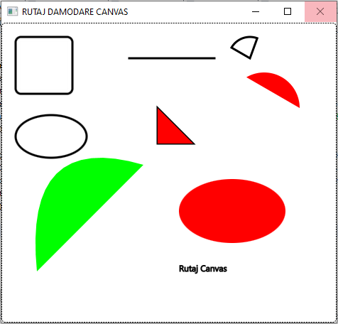

**Conclusion:**Java Program to draw various shapes on Canvas using JavaFX was successfully executed.