NAME: Shaik Jani Basha

Roll Number: 208X1A05H6

Email: [208x1a05h6@khitguntur.ac.in](mailto:208x1a05h6@khitguntur.ac.in)

Phone number: 9381225735

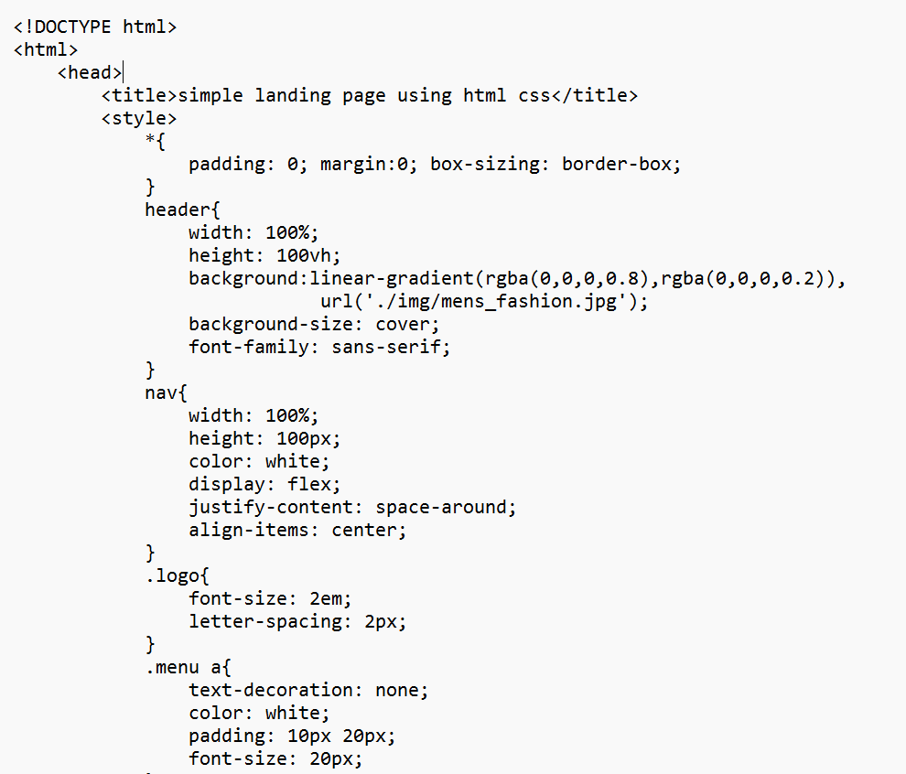

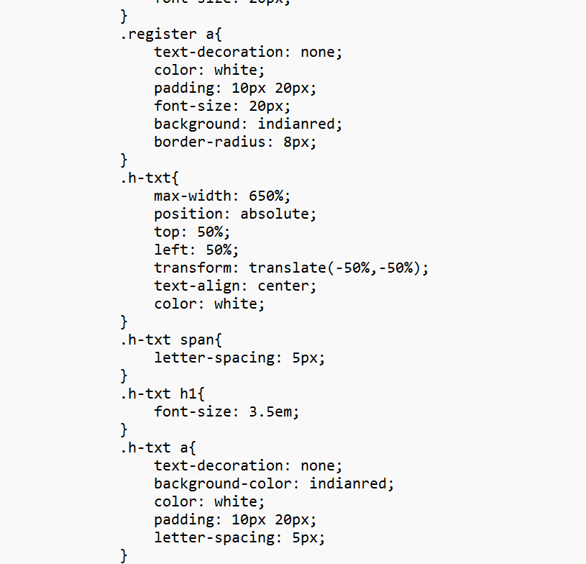

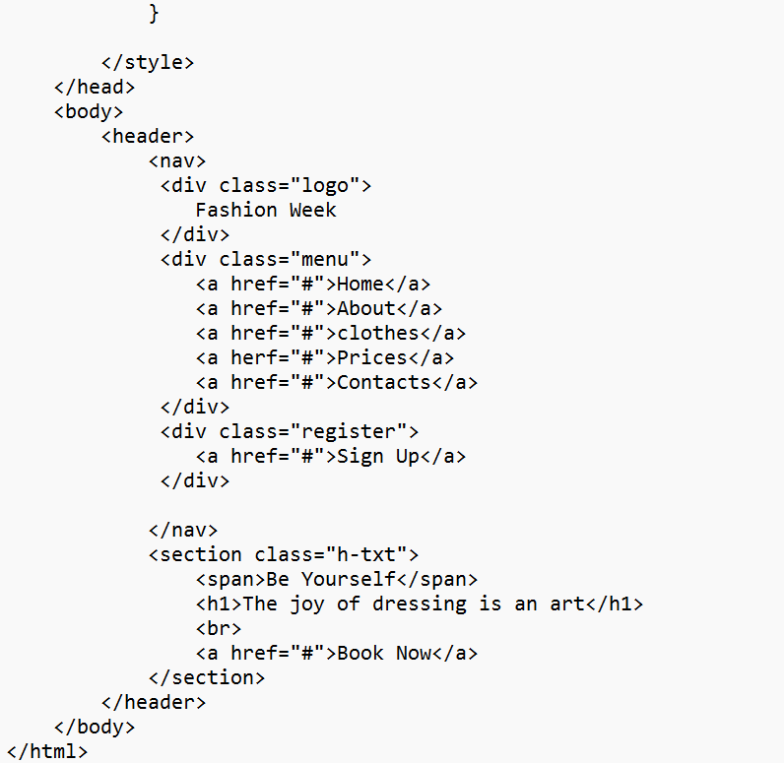

OUTPUT: