ASSIGNMENT 3

# Name: SHAIK JANI BASHA

# E-mail ID: 208x1a05h6@khitguntur.ac.in

# Phone: 9381225735

# Roll Number: 208x1a05h6

College: KALLAM HARANADHAREDDY INSTITUTE OF TECHNOLOGY.

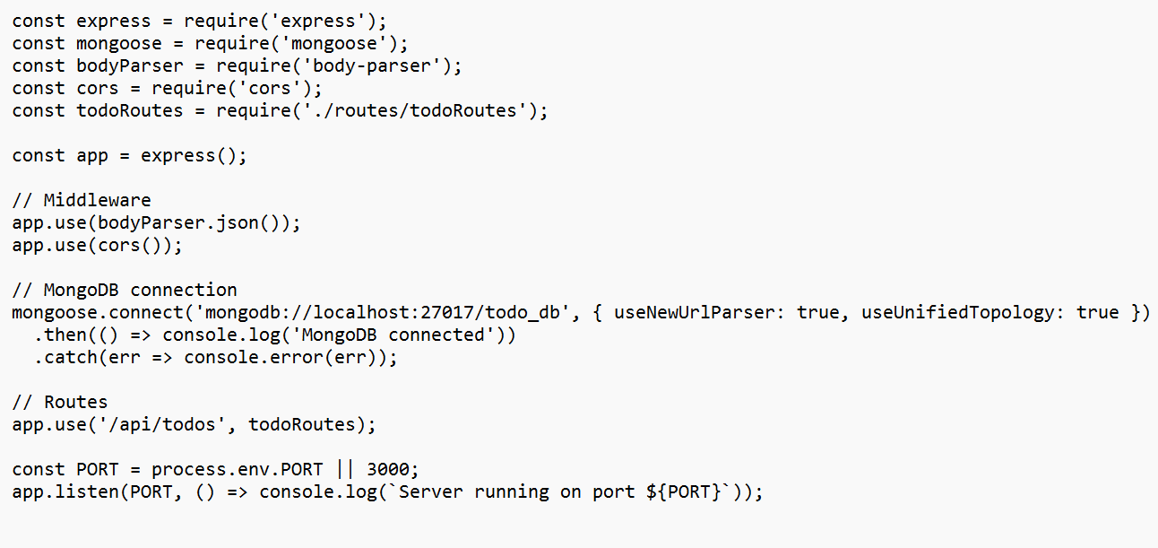**Create a RESTful API using express.js and create a database and index in MongoDB**

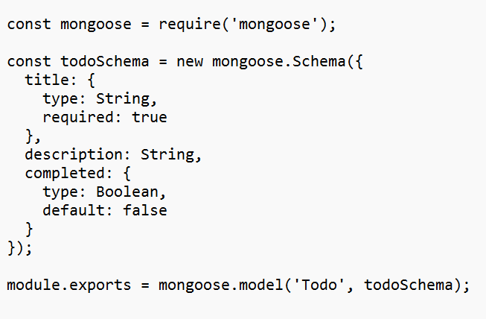

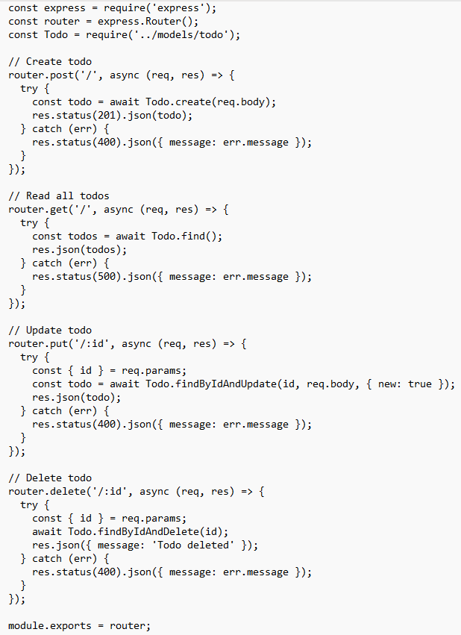

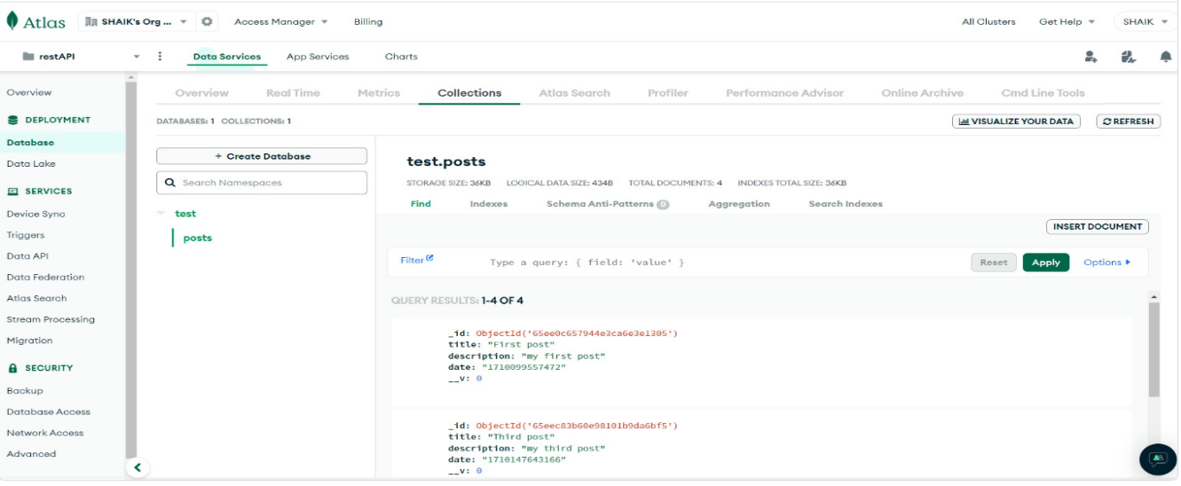OUTPUT: