**Assignment – 4**

1. **Database Setup: Create a new MongoDB database called myDatabase**
2. **Collection Creation**: **Create a collection named users within the myDatabase database.**

**Using mongosh:**

use myDatabase

switched to db myDatabase

db.createCollection('users')

**{ ok: 1 }**

**Output:** 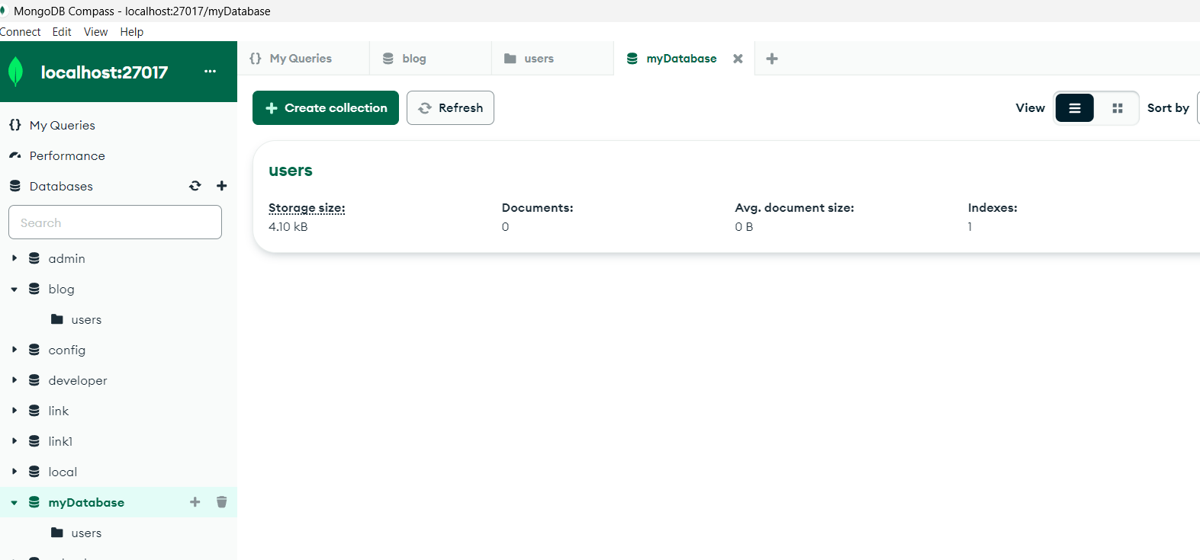

**3.Document Insertion: Insert at least three documents into the users collection, each representing a user with fields such as name, email, and age**.

Db.users.insertMany([{'name':'sreya','email':'sreya123@gmail.com','age':20},{'name':'rasi','email':'rasi@gmail.com','age':21},{'name':'pradeep','email':'pradeep@gmail.com','age':22}])

{

acknowledged: true,

insertedIds: {

'0': ObjectId('65fbcd518748e78646550acf'),

'1': ObjectId('65fbcd518748e78646550ad0'),

'2': ObjectId('65fbcd518748e78646550ad1')

}

}

**Output**:

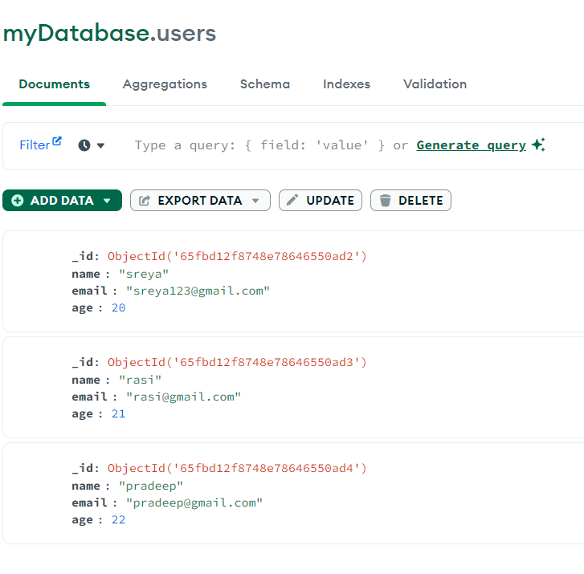

**4.Querying: Write queries to retrieve**:

***1.All users from the users collection***

db.myDatabase.find()

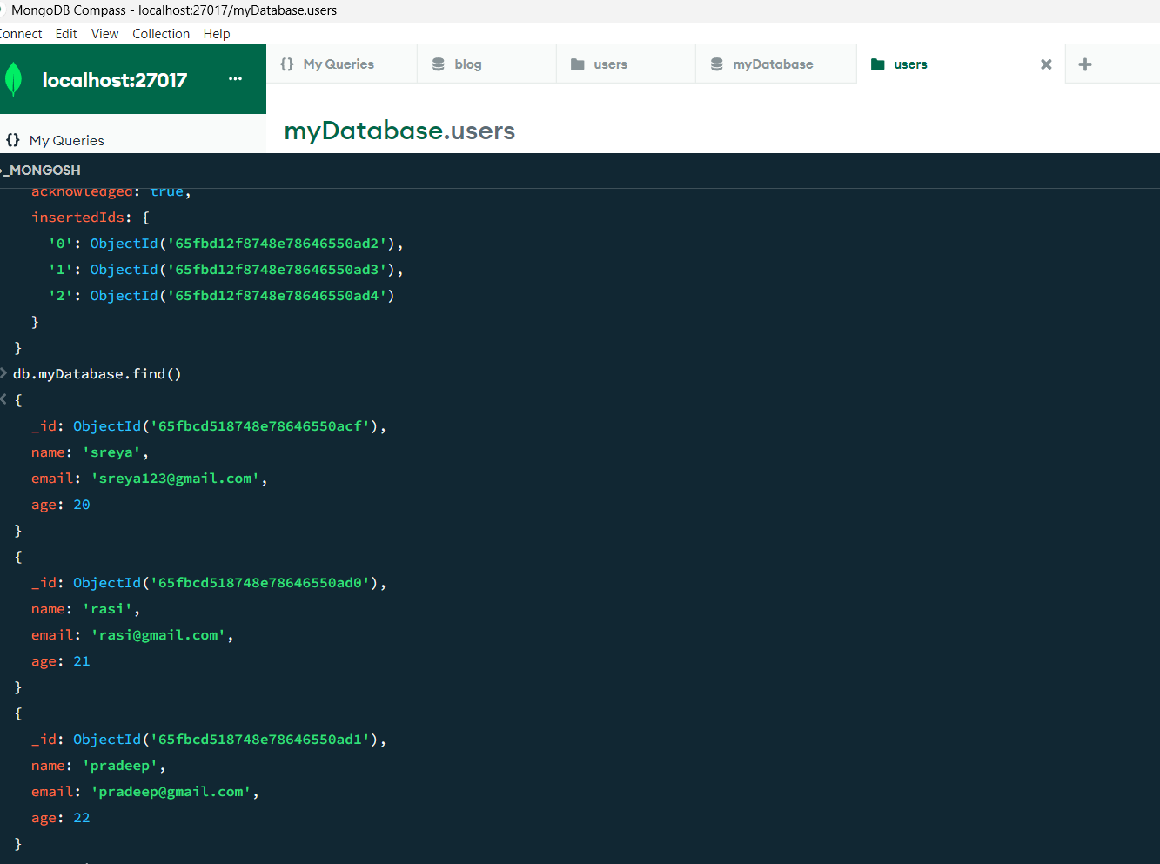

**2.*Users with an age greater than or equal to 20.***

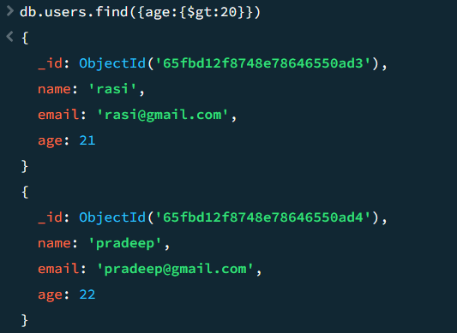

***3.Update Operation: Update the age of a user with a specific email address.***

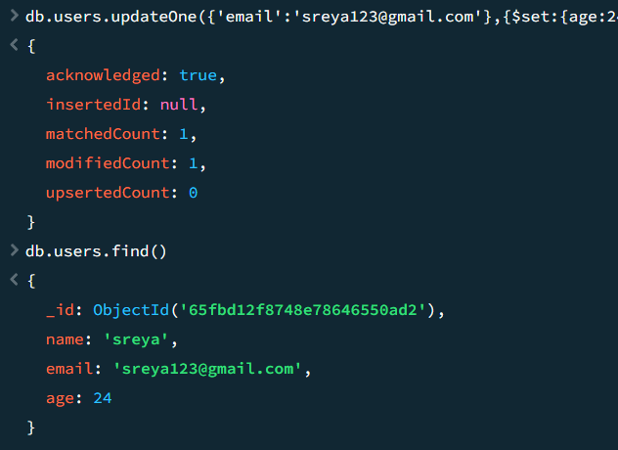

***4.Deletion Operation: Delete a user document based on a specific email address.***

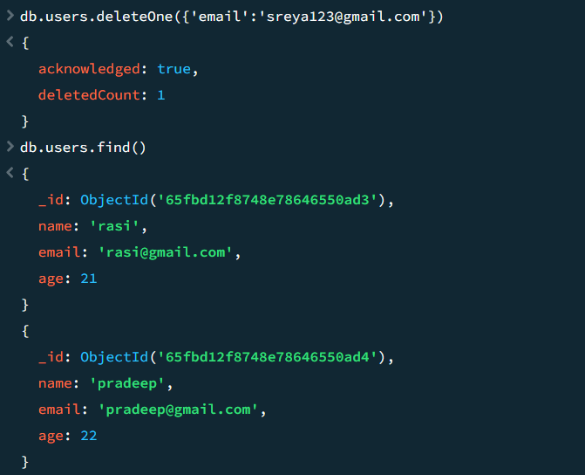

***5.Index Creation: Create an index on the email field of the users collection.***

db.users.createIndex({ "email": 1 })

email_1

db.users.getIndexes()

[

{ v: 2, key: { _id: 1 }, name: '_id_' },

{ v: 2, key: { email: 1 }, name: 'email_1' }

]

