1.1 Overview of Anatomy and Physiology

Learning Objectives
By the end of this section, you will be able to:
- Compare and contrast anatomy and physiology, including their specializations and methods of study
- Discuss the fundamental relationship between anatomy and physiology
Human anatomy is the scientific study of the body’s structures. Some of these structures are very small and can only be observed and analyzed with the assistance of a microscope. Other larger structures can readily be seen, manipulated, measured, and weighed. The word “anatomy” comes from a Greek root that means “to cut apart.” Human anatomy was first studied by observing the exterior of the body and observing the wounds of soldiers and other injuries. Later, physicians were allowed to dissect bodies of the dead to augment their knowledge. When a body is dissected, its structures are cut apart in order to observe their physical attributes and their relationships to one another. Dissection is still used in medical schools, anatomy courses, and in pathology labs. In order to observe structures in living people, however, a number of imaging techniques have been developed. These techniques allow clinicians to visualize structures inside the living body such as a cancerous tumor or a fractured bone.
Like most scientific disciplines, anatomy has areas of specialization. Gross anatomy is the study of the larger structures of the body, those visible without the aid of magnification (Figure 1.2 a). Macro- means “large,” thus, gross anatomy is also referred to as macroscopic anatomy. In contrast, micro- means “small,” and microscopic anatomy is the study of structures that can be observed only with the use of a microscope or other magnification devices (Figure 1.2 b). Microscopic anatomy includes cytology, the study of cells and histology, the study of tissues. As the technology of microscopes has advanced, anatomists have been able to observe smaller and smaller structures of the body, from slices of large structures like the heart, to the three-dimensional structures of large molecules in the body.
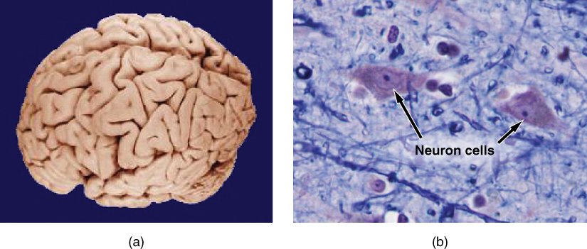
Figure 1.2 Gross and Microscopic Anatomy (a) Gross anatomy considers large structures such as the brain. (b) Microscopic anatomy can deal with the same structures, though at a different scale. This is a micrograph of nerve cells from the brain. LM × 1600. (credit a: University of Wisconsin and Michigan State Comparative Mammalian Brain Collections/BrainMuseum.org; credit b: Micrograph provided by the Regents of University of Michigan Medical School © 2012)
Anatomists take two general approaches to the study of the body’s structures: regional and systemic. Regional anatomy is the study of the interrelationships of all of the structures in a specific body region, such as the abdomen. Studying regional anatomy helps us appreciate the interrelationships of body structures, such as how muscles, nerves, blood vessels, and other structures work together to serve a particular body region. In contrast, systemic anatomy is the study of the structures that make up a discrete body system—that is, a group of structures that work together to perform a unique body function. For example, a systemic anatomical study of the muscular system would consider all of the skeletal muscles of the body.
Whereas anatomy is about structure, physiology is about function. Human physiology is the scientific study of the chemistry and physics of the structures of the body and the ways in which they work together to support the functions of life. Much of the study of physiology centers on the body’s tendency toward homeostasis. Homeostasis is the state of steady internal conditions maintained by living things. The study of physiology certainly includes observation, both with the naked eye and with microscopes, as well as manipulations and measurements. However, current advances in physiology usually depend on carefully designed laboratory experiments that reveal the functions of the many structures and chemical compounds that make up the human body.
Like anatomists, physiologists typically specialize in a particular branch of physiology. For example, neurophysiology is the study of the brain, spinal cord, and nerves and how these work together to perform functions as complex and diverse as vision, movement, and thinking. Physiologists may work from the organ level (exploring, for example, what different parts of the brain do) to the molecular level (such as exploring how an electrochemical signal travels along nerves).
Form is closely related to function in all living things. For example, the thin flap of your eyelid can snap down to clear away dust particles and almost instantaneously slide back up to allow you to see again. At the microscopic level, the arrangement and function of the nerves and muscles that serve the eyelid allow for its quick action and retreat. At a smaller level of analysis, the function of these nerves and muscles likewise relies on the interactions of specific molecules and ions. Even the three-dimensional structure of certain molecules is essential to their function.
Your study of anatomy and physiology will make more sense if you continually relate the form of the structures you are studying to their function. In fact, it can be somewhat frustrating to attempt to study anatomy without an understanding of the physiology that a body structure supports. Imagine, for example, trying to appreciate the unique arrangement of the bones of the human hand if you had no conception of the function of the hand. Fortunately, your understanding of how the human hand manipulates tools—from pens to cell phones—helps you appreciate the unique alignment of the thumb in opposition to the four fingers, making your hand a structure that allows you to pinch and grasp objects and type text messages.

