1.5 Homeostasis

Learning Objectives
By the end of this section, you will be able to:
- Discuss the role of homeostasis in healthy functioning
- Contrast negative and positive feedback, giving one physiologic example of each mechanism
Maintaining homeostasis requires that the body continuously monitor its internal conditions. From body temperature to blood pressure to levels of certain nutrients, each physiological condition has a particular set point. A set point is the physiological value around which the normal range fluctuates. A normal range is the restricted set of values that is optimally healthful and stable. For example, the set point for normal human body temperature is approximately 37°C (98.6°F) Physiological parameters, such as body temperature and blood pressure, tend to fluctuate within a normal range a few degrees above and below that point. Control centers in the brain and other parts of the body monitor and react to deviations from homeostasis using negative feedback. Negative feedback is a mechanism that reverses a deviation from the set point. Therefore, negative feedback maintains body parameters within their normal range. The maintenance of homeostasis by negative feedback goes on throughout the body at all times, and an understanding of negative feedback is thus fundamental to an understanding of human physiology.

Negative Feedback
A negative feedback system has three basic components (Figure 1.10a). A sensor, also referred to a receptor, is a component of a feedback system that monitors a physiological value. This value is reported to the control center. The control center is the component in a feedback system that compares the value to the normal range. If the value deviates too much from the set point, then the control center activates an effector. An effector is the component in a feedback system that causes a change to reverse the situation and return the value to the normal range.
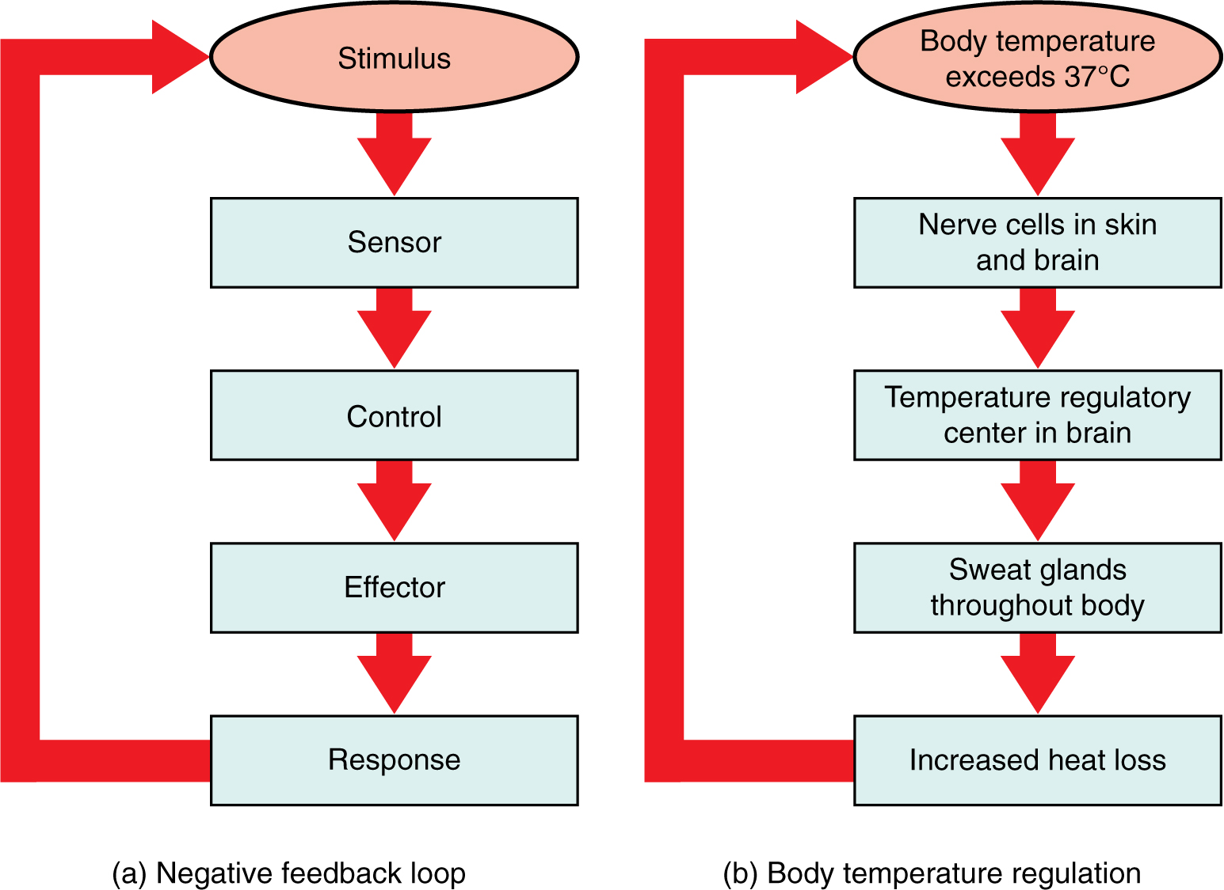
Figure 1.10 Negative Feedback System In a negative feedback system, a stimulus—a deviation from a set point—is resisted through a physiological process that returns the body to homeostasis. (a) A negative feedback system has five basic parts. (b) Body temperature is regulated by negative feedback.
In order to set the system in motion, a stimulus must drive a physiological parameter beyond its normal range (that is, beyond homeostasis). This stimulus is “heard” by a specific sensor. For example, in the control of blood glucose, specific endocrine cells in the pancreas detect excess glucose (the stimulus) in the bloodstream. These pancreatic beta cells respond to the increased level of blood glucose by releasing the hormone insulin into the bloodstream. The insulin signals skeletal muscle fibers, fat cells (adipocytes), and liver cells to take up the excess glucose, removing it from the bloodstream. As glucose concentration in the bloodstream drops, the decrease in concentration—the actual negative feedback—is detected by pancreatic alpha cells, and insulin release stops. This prevents blood sugar levels from continuing to drop below the normal range.
Humans have a similar temperature regulation feedback system that works by promoting either heat loss or heat gain (Figure 1.10b). When the brain’s temperature regulation center receives data from the sensors indicating that the body’s temperature exceeds its normal range, it stimulates a cluster of brain cells referred to as the “heat-loss center.” This stimulation has three major effects:
- Blood vessels in the skin begin to dilate allowing more blood from the body core to flow to the surface of the skin allowing the heat to radiate into the environment.
- As blood flow to the skin increases, sweat glands are activated to increase their output. As the sweat evaporates from the skin surface into the surrounding air, it takes heat with it.
- The depth of respiration increases, and a person may breathe through an open mouth instead of through the nasal passageways. This further increases heat loss from the lungs.
In contrast, activation of the brain’s heat-gain center by exposure to cold reduces blood flow to the skin, and blood returning from the limbs is diverted into a network of deep veins. This arrangement traps heat closer to the body core and restricts heat loss. If heat loss is severe, the brain triggers an increase in random signals to skeletal muscles, causing them to contract and producing shivering. The muscle contractions of shivering release heat while using up ATP. The brain triggers the thyroid gland in the endocrine system to release thyroid hormone, which increases metabolic activity and heat production in cells throughout the body. The brain also signals the adrenal glands to release epinephrine (adrenaline), a hormone that causes the breakdown of glycogen into glucose, which can be used as an energy source. The breakdown of glycogen into glucose also results in increased metabolism and heat production.

Interactive Link
Water concentration in the body is critical for proper functioning. A person’s body retains very tight control on water levels without conscious control by the person. Watch this video to learn more about water concentration in the body. Which organ has primary control over the amount of water in the body?

Positive Feedback
Positive feedback intensifies a change in the body’s physiological condition rather than reversing it. A deviation from the normal range results in more change, and the system moves farther away from the normal range. Positive feedback in the body is normal only when there is a definite end point. Childbirth and the body’s response to blood loss are two examples of positive feedback loops that are normal but are activated only when needed.
Childbirth at full term is an example of a situation in which the maintenance of the existing body state is not desired. Enormous changes in a person’s body are required to expel the baby at the end of pregnancy. And the events of childbirth, once begun, must progress rapidly to a conclusion or the life of a person giving birth and the baby are at risk. The extreme muscular work of labor and delivery are the result of a positive feedback system (Figure 1.11).
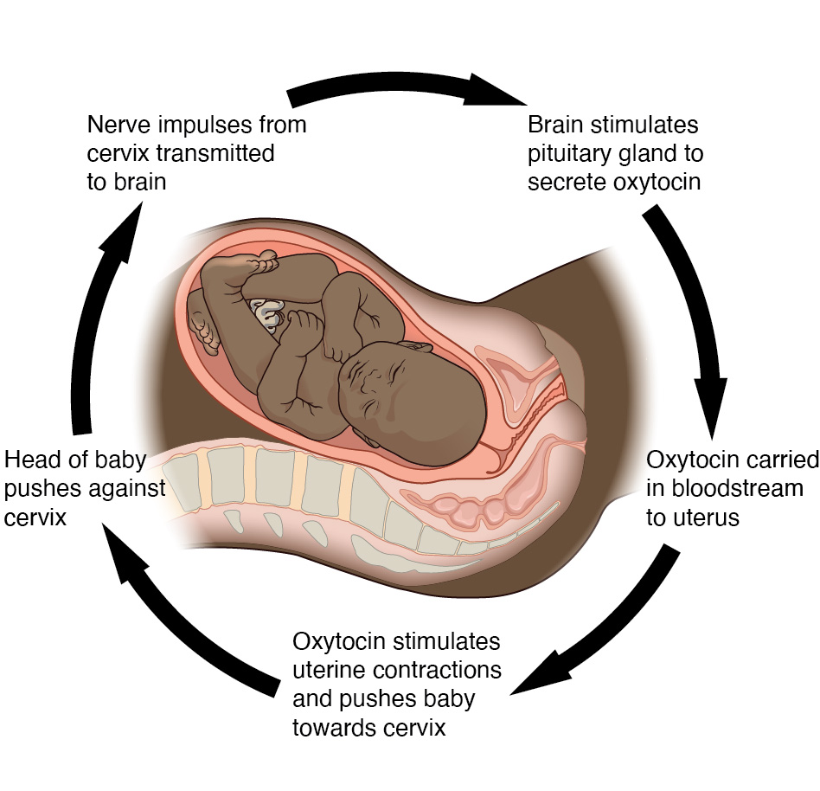
Figure 1.11 Positive Feedback Loop Normal childbirth is driven by a positive feedback loop. A positive feedback loop results in a change in the body’s status, rather than a return to homeostasis.
The first contractions of labor (the stimulus) push the baby toward the cervix (the lowest part of the uterus). The cervix contains stretch-sensitive nerve cells that monitor the degree of stretching (the sensors). These nerve cells send messages to the brain, which in turn causes the pituitary gland at the base of the brain to release the hormone oxytocin into the bloodstream. Oxytocin causes stronger contractions of the smooth muscles in of the uterus (the effectors), pushing the baby further down the birth canal. This causes even greater stretching of the cervix. The cycle of stretching, oxytocin release, and increasingly more forceful contractions stops only when the baby is born. At this point, the stretching of the cervix halts, stopping the release of oxytocin.
A second example of positive feedback centers on reversing extreme damage to the body. Following a penetrating wound, the most immediate threat is excessive blood loss. Less blood circulating means reduced blood pressure and reduced perfusion (penetration of blood) to the brain and other vital organs. If perfusion is severely reduced, vital organs will shut down and the person will die. The body responds to this potential catastrophe by releasing substances in the injured blood vessel wall that begin the process of blood clotting. As each step of clotting occurs, it stimulates the release of more clotting substances. This accelerates the processes of clotting and sealing off the damaged area. Clotting is contained in a local area based on the tightly controlled availability of clotting proteins. This is an adaptive, life-saving cascade of events.

