1.6 Anatomical Terminology

Learning Objectives
By the end of this section, you will be able to:
- Demonstrate the anatomical position
- Describe the human body using directional and regional terms
- Identify three planes most commonly used in the study of anatomy
- Distinguish between the posterior (dorsal) and the anterior (ventral) body cavities, identifying their subdivisions and representative organs found in each
- Describe serous membrane and explain its function
Anatomists and health care providers use terminology that can be bewildering to the uninitiated. However, the purpose of this language is not to confuse, but rather to increase precision and reduce medical errors. For example, is a scar “above the wrist” located on the forearm two or three inches away from the hand? Or is it at the base of the hand? Is it on the palm-side or back-side? By using precise anatomical terminology, we eliminate ambiguity. Anatomical terms derive from ancient Greek and Latin words. Because these languages are no longer used in everyday conversation, the meaning of their words does not change.
Anatomical terms are made up of roots, prefixes, and suffixes. The root of a term often refers to an organ, tissue, or condition, whereas the prefix or suffix often describes the root. For example, in the disorder hypertension, the prefix “hyper-” means “high” or “over,” and the root word “tension” refers to pressure, so the word “hypertension” refers to abnormally high blood pressure.

Anatomical Position
To further increase precision, anatomists standardize the way in which they view the body. Just as maps are normally oriented with north at the top, the standard body “map,” or anatomical position, is that of the body standing upright, with the feet at shoulder width and parallel, toes forward. The upper limbs are held out to each side, and the palms of the hands face forward as illustrated in Figure 1.12. Using this standard position reduces confusion. It does not matter how the body being described is oriented, the terms are used as if it is in anatomical position. For example, a scar in the “anterior (front) carpal (wrist) region” would be present on the palm side of the wrist. The term “anterior” would be used even if the hand were palm down on a table.
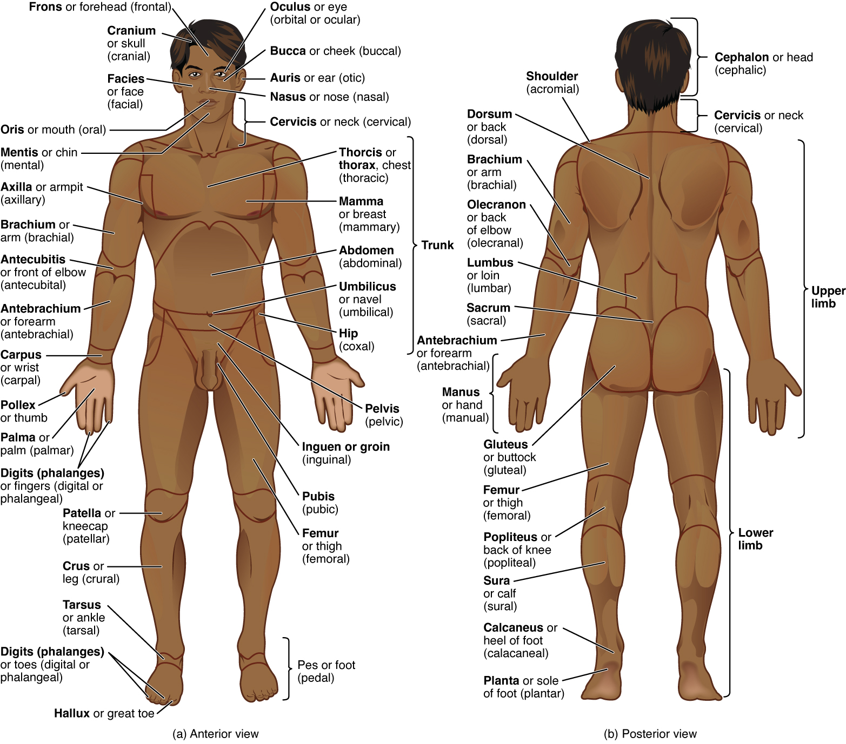
Figure 1.12 Regions of the Human Body The human body is shown in anatomical position in an (a) anterior view and a (b) posterior view. The regions of the body are labeled in boldface.
A body that is lying down is described as either prone or supine. Prone describes a face-down orientation, and supine describes a face up orientation. These terms are sometimes used in describing the position of the body during specific physical examinations or surgical procedures.

Regional Terms
The human body’s numerous regions have specific terms to help increase precision (see Figure 1.12). Notice that the term “brachium” or “arm” is reserved for the “upper arm” and “antebrachium” or “forearm” is used rather than “lower arm.” Similarly, “femur” or “thigh” is correct, and “leg” or “crus” is reserved for the portion of the lower limb between the knee and the ankle. You will be able to describe the body’s regions using the terms from the figure.

Directional Terms
Certain directional anatomical terms appear throughout this and any other anatomy textbook (Figure 1.13). These terms are essential for describing the relative locations of different body structures. For instance, an anatomist might describe one band of tissue as “inferior to” another or a physician might describe a tumor as “superficial to” a deeper body structure. Commit these terms to memory to avoid confusion when you are studying or describing the locations of particular body parts.
- Anterior (or ventral) Describes the front or direction toward the front of the body. The toes are anterior to the foot.
- Posterior (or dorsal) Describes the back or direction toward the back of the body. The popliteus is posterior to the patella.
- Superior (or cranial) describes a position above or higher than another part of the body proper. The orbits are superior to the oris.
- Inferior (or caudal) describes a position below or lower than another part of the body proper; near or toward the tail (in humans, the coccyx, or lowest part of the spinal column). The pelvis is inferior to the abdomen.
- Lateral describes the side or direction toward the side of the body. The thumb (pollex) is lateral to the digits.
- Medial describes the middle or direction toward the middle of the body. The hallux is the medial toe.
- Proximal describes a position in a limb that is nearer to the point of attachment or the trunk of the body. The brachium is proximal to the antebrachium.
- Distal describes a position in a limb that is farther from the point of attachment or the trunk of the body. The crus is distal to the femur.
- Superficial describes a position closer to the surface of the body. The skin is superficial to the bones.
- Deep describes a position farther from the surface of the body. The brain is deep to the skull.
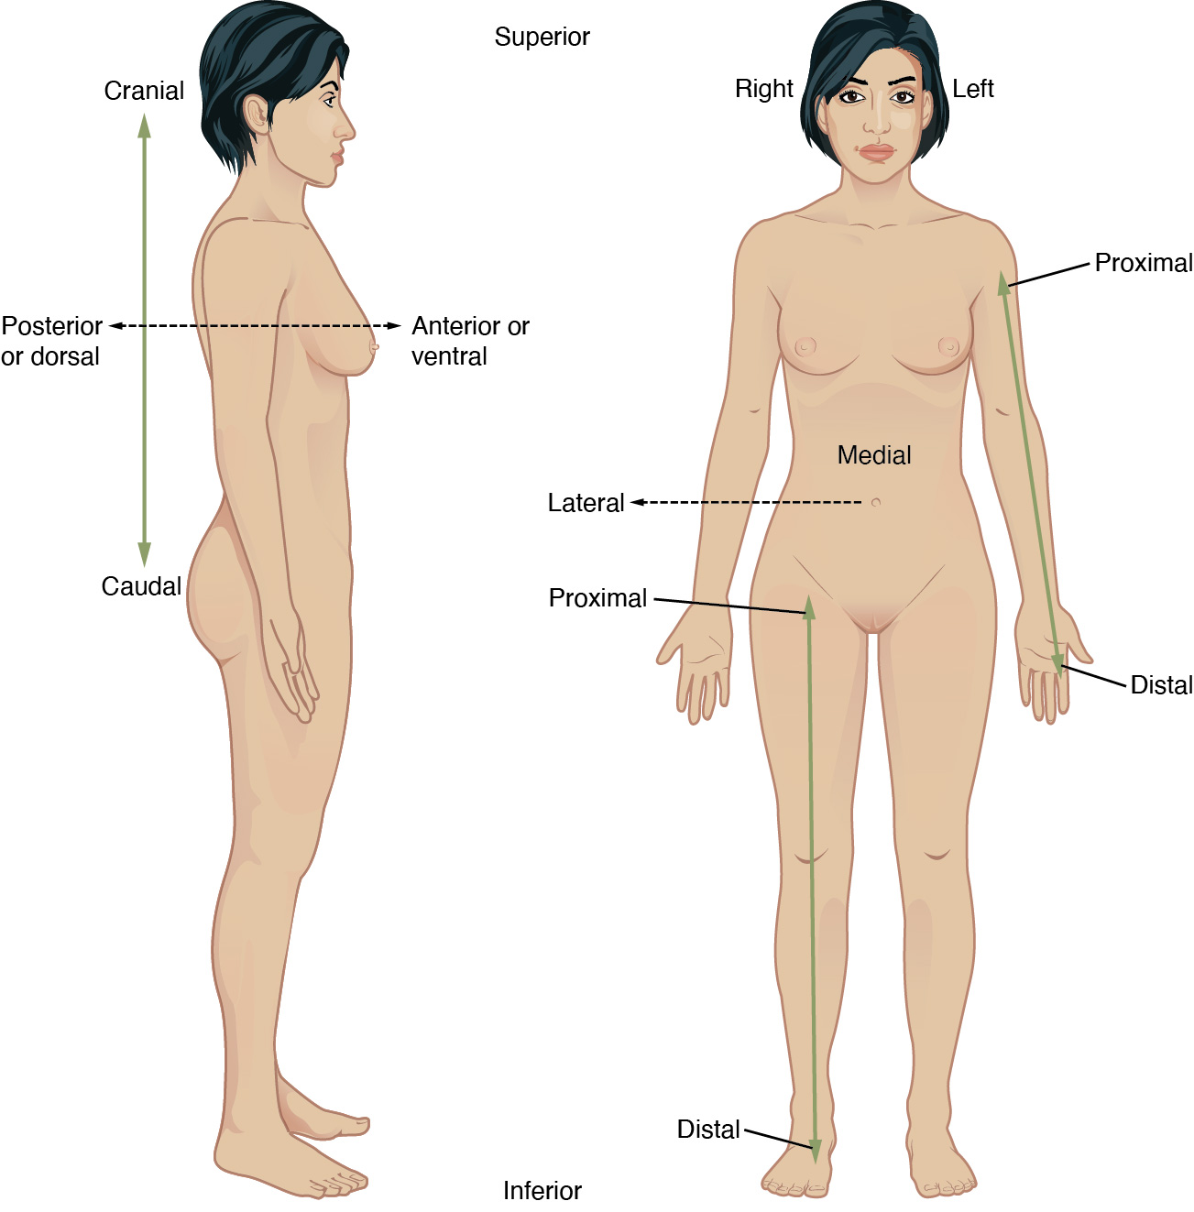
Figure 1.13 Directional Terms Applied to the Human Body Paired directional terms are shown as applied to the human body.

Body Planes
A section is a two-dimensional surface of a three-dimensional structure that has been cut. Modern medical imaging devices enable clinicians to obtain “virtual sections” of living bodies. We call these scans. Body sections and scans can be correctly interpreted, however, only if the viewer understands the plane along which the section was made. A plane is an imaginary two-dimensional surface that passes through the body. There are three planes commonly referred to in anatomy and medicine, as illustrated in Figure 1.14.
- The sagittal plane is the plane that divides the body or an organ vertically into right and left sides. If this vertical plane runs directly down the middle of the body, it is called the midsagittal or median plane. If it divides the body into unequal right and left sides, it is called a parasagittal plane or less commonly a longitudinal section.
- The frontal plane is the plane that divides the body or an organ into an anterior (front) portion and a posterior (rear) portion. The frontal plane is often referred to as a coronal plane. (“Corona” is Latin for “crown.”)
- The transverse plane is the plane that divides the body or organ horizontally into upper and lower portions. Transverse planes produce images referred to as cross sections.
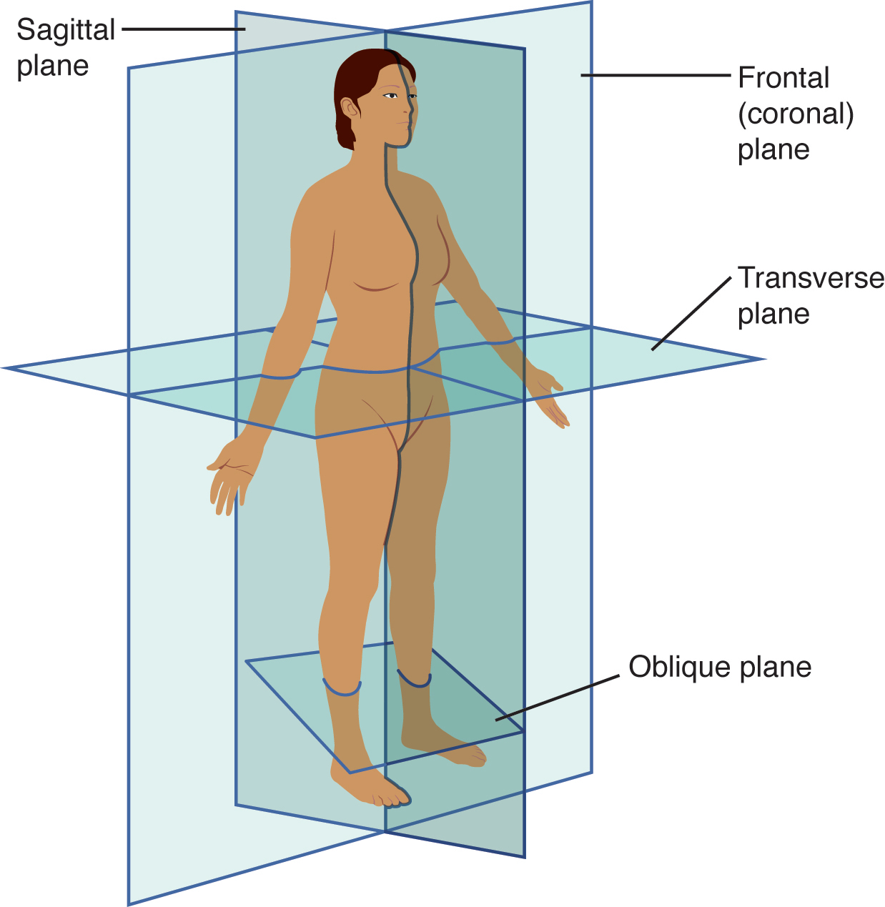
Figure 1.14 Planes of the Body The three planes most commonly used in anatomical and medical imaging are the sagittal, frontal (or coronal), and transverse plane.

Body Cavities and Serous Membranes
The body maintains its internal organization by means of membranes, sheaths, and other structures that separate compartments. The dorsal (posterior) cavity and the ventral (anterior) cavity are the largest body compartments (Figure 1.15). These cavities contain and protect delicate internal organs, and the ventral cavity allows for significant changes in the size and shape of the organs as they perform their functions. The lungs, heart, stomach, and intestines, for example, can expand and contract without distorting other tissues or disrupting the activity of nearby organs.
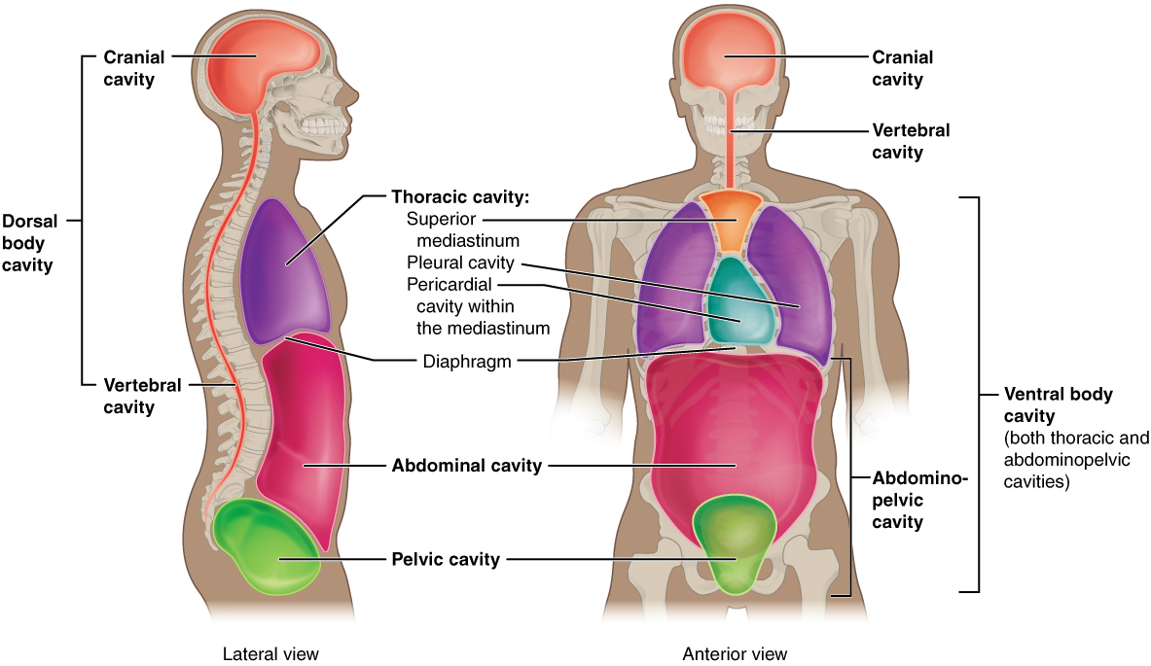
Figure 1.15 Dorsal and Ventral Body Cavities The ventral cavity includes the thoracic and abdominopelvic cavities and their subdivisions. The dorsal cavity includes the cranial and spinal cavities.

Subdivisions of the Posterior (Dorsal) and Anterior (Ventral) Cavities
The posterior (dorsal) and anterior (ventral) cavities are each subdivided into smaller cavities. In the posterior (dorsal) cavity, the cranial cavity houses the brain, and the spinal cavity (or vertebral cavity) encloses the spinal cord. Just as the brain and spinal cord make up a continuous, uninterrupted structure, the cranial and spinal cavities that house them are also continuous. The brain and spinal cord are protected by the bones of the skull and vertebral column and by cerebrospinal fluid, a colorless fluid produced by the brain, which cushions the brain and spinal cord within the posterior (dorsal) cavity.
The anterior (ventral) cavity has two main subdivisions: the thoracic cavity and the abdominopelvic cavity (see Figure 1.15). The thoracic cavity is the more superior subdivision of the anterior cavity, and it is enclosed by the rib cage. The thoracic cavity contains the lungs and the heart, which is located in the mediastinum. The diaphragm forms the floor of the thoracic cavity and separates it from the more inferior abdominopelvic cavity. The abdominopelvic cavity is the largest cavity in the body. Although no membrane physically divides the abdominopelvic cavity, it can be useful to distinguish between the abdominal cavity, the division that houses the digestive organs, and the pelvic cavity, the division that houses the organs of reproduction.

Abdominal Regions and Quadrants
To promote clear communication, for instance about the location of a patient’s abdominal pain or a suspicious mass, health care providers typically divide up the cavity into either nine regions or four quadrants (Figure 1.16).
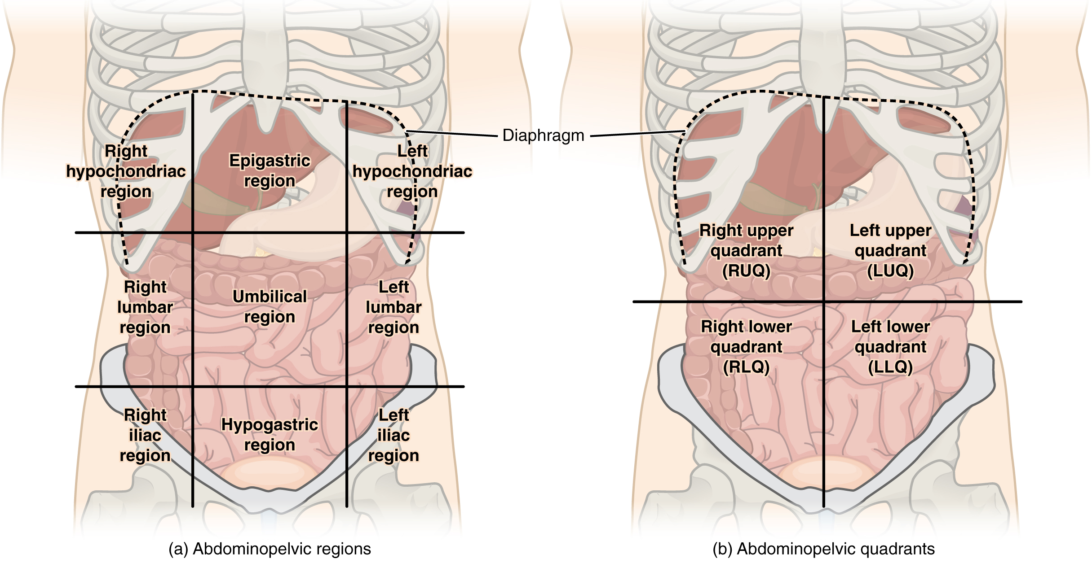
Figure 1.16 Regions and Quadrants of the Peritoneal Cavity There are (a) nine abdominal regions and (b) four abdominal quadrants in the peritoneal cavity.
The more detailed regional approach subdivides the cavity with one horizontal line immediately inferior to the ribs and one immediately superior to the pelvis, and two vertical lines drawn as if dropped from the midpoint of each clavicle (collarbone). There are nine resulting regions. The simpler quadrants approach, which is more commonly used in medicine, subdivides the cavity with one horizontal and one vertical line that intersect at the patient’s umbilicus (navel).

Membranes of the Anterior (Ventral) Body Cavity
A serous membrane (also referred to a serosa) is one of the thin membranes that cover the walls and organs in the thoracic and abdominopelvic cavities. The parietal layers of the membranes line the walls of the body cavity (pariet- refers to a cavity wall). The visceral layer of the membrane covers the organs (the viscera). Between the parietal and visceral layers is a very thin, fluid-filled serous space, or cavity (Figure 1.17).
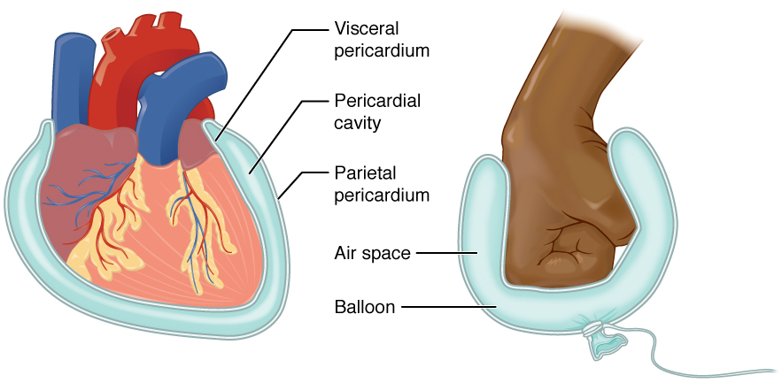
Figure 1.17 Serous Membrane Serous membrane lines the pericardial cavity and reflects back to cover the heart—much the same way that an underinflated balloon would form two layers surrounding a fist.
There are three serous cavities and their associated membranes. The pleura is the serous membrane that encloses the pleural cavity; the pleural cavity surrounds the lungs. The pericardium is the serous membrane that encloses the pericardial cavity; the pericardial cavity surrounds the heart. The peritoneum is the serous membrane that encloses the peritoneal cavity; the peritoneal cavity surrounds several organs in the abdominopelvic cavity. The serous membranes form fluid-filled sacs, or cavities, that are meant to cushion and reduce friction on internal organs when they move, such as when the lungs inflate or the heart beats. Both the parietal and visceral serosa secrete the thin, slippery serous fluid located within the serous cavities. The pleural cavity reduces friction between the lungs and the body wall. Likewise, the pericardial cavity reduces friction between the heart and the wall of the pericardium. The peritoneal cavity reduces friction between the abdominal and pelvic organs and the body wall. Therefore, serous membranes provide additional protection to the viscera they enclose by reducing friction that could lead to inflammation of the organs.

