10.1 Overview of Muscle Tissues

Learning Objectives
By the end of this section, you will be able to:
- Describe the different types of muscle
- Explain contractibility and extensibility
Muscle is one of the four primary tissue types of the body, and the body contains three types of muscle tissue: skeletal muscle, cardiac muscle, and smooth muscle (Figure 10.2). All three muscle tissues have some properties in common; they all exhibit a quality called excitability as their plasma membranes can change their electrical states (from polarized to depolarized) and send an electrical wave called an action potential along the entire length of the membrane. While the nervous system can influence the excitability of cardiac and smooth muscle to some degree, skeletal muscle completely depends on signaling from the nervous system to work properly. On the other hand, both cardiac muscle and smooth muscle can respond to other stimuli, such as hormones and local stimuli.
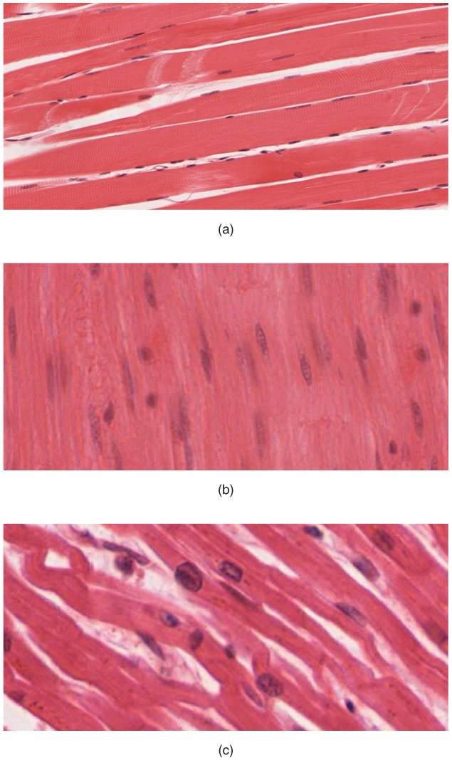
Figure 10.2 The Three Types of Muscle Tissue The body contains three types of muscle tissue: (a) skeletal muscle, (b) smooth muscle, and (c) cardiac muscle. (Micrographs provided by the Regents of University of Michigan Medical School © 2012)
The muscles all begin the actual process of contracting (shortening) when a protein called actin is pulled by a protein called myosin. This occurs in striated muscle (skeletal and cardiac) after specific binding sites on the actin have been exposed in response to the interaction between calcium ions (Ca⁺⁺) and proteins (troponin and tropomyosin) that “shield” the actin-binding sites. Ca⁺⁺ also is required for the contraction of smooth muscle, although its role is different: here Ca⁺⁺ activates enzymes, which in turn activate myosin heads. All muscles require adenosine triphosphate (ATP) to continue the process of contracting, and they all relax when the Ca⁺⁺ is removed and the actin-binding sites are re-shielded.
A muscle can return to its original length when relaxed due to a quality of muscle tissue called elasticity. It can recoil back to its original length due to elastic fibers. Muscle tissue also has the quality of extensibility; it can stretch or extend. Contractility allows muscle tissue to pull on its attachment points and shorten with force.
Differences among the three muscle types include the microscopic organization of their contractile proteins—actin and myosin. The actin and myosin proteins are arranged very regularly in the cytoplasm of individual muscle cells (referred to as fibers) in both skeletal muscle and cardiac muscle, which creates a pattern, or stripes, called striations. The striations are visible with a light microscope under high magnification (see Figure 10.2). Skeletal muscle fibers are multinucleated structures that compose the skeletal muscle. Cardiac muscle fibers each have one to two nuclei and are physically and electrically connected to each other so that the entire heart contracts as one unit (called a syncytium).
Because the actin and myosin are not arranged in such regular fashion in smooth muscle, the cytoplasm of a smooth muscle fiber (which has only a single nucleus) has a uniform, nonstriated appearance (resulting in the name smooth muscle). However, the less organized appearance of smooth muscle should not be interpreted as less efficient. Smooth muscle in the walls of arteries is a critical component that regulates blood pressure necessary to push blood through the circulatory system; and smooth muscle in the skin, visceral organs, and internal passageways is essential for moving all materials through the body.

