12.5 Communication Between Neurons

Learning Objectives
By the end of this section, you will be able to:
- Explain the differences between the types of graded potentials
- Categorize the major neurotransmitters by chemical type and effect
The electrical changes taking place within a neuron, as described in the previous section, are similar to a light switch being turned on. A stimulus starts the depolarization, but the action potential runs on its own once a threshold has been reached. The question is now, “What flips the light switch on?” Temporary changes to the cell membrane voltage can result from neurons receiving information from the environment, or from the action of one neuron on another. These special types of potentials influence a neuron and determine whether an action potential will occur or not. Many of these transient signals originate at the synapse.

Graded Potentials
Local changes in the membrane potential are called graded potentials and are usually associated with the dendrites of a neuron. The amount of change in the membrane potential is determined by the size of the stimulus that causes it. In the example of testing the temperature of the shower, slightly warm water would only initiate a small change in a thermoreceptor, whereas hot water would cause a large amount of change in the membrane potential.
Graded potentials can be of two sorts, either they are depolarizing or hyperpolarizing (Figure 12.25). For a membrane at the resting potential, a graded potential represents a change in that voltage either above -70 mV or below -70 mV. Depolarizing graded potentials are often the result of Na⁺ or Ca²⁺ entering the cell. Both of these ions have higher concentrations outside the cell than inside; because they have a positive charge, they will move into the cell causing it to become less negative relative to the outside. Hyperpolarizing graded potentials can be caused by K⁺ leaving the cell or Cl⁻ entering the cell. If a positive charge moves out of a cell, the cell becomes more negative; if a negative charge enters the cell, the same thing happens.
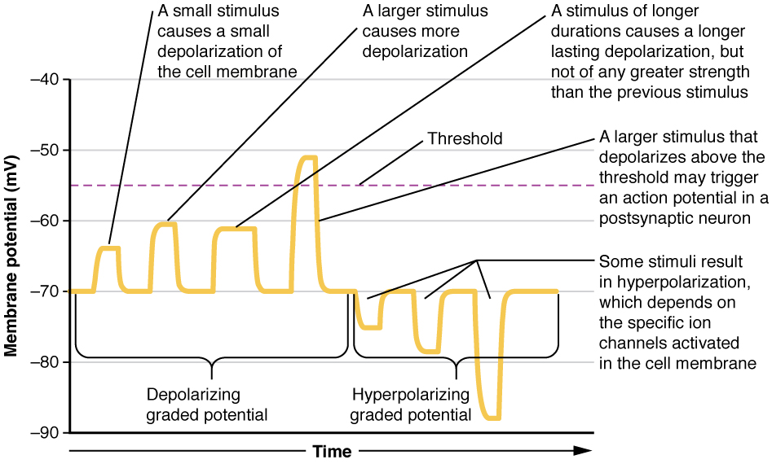
Figure 12.25 Graded Potentials Graded potentials are temporary changes in the membrane voltage, the characteristics of which depend on the size of the stimulus. Some types of stimuli cause depolarization of the membrane, whereas others cause hyperpolarization. It depends on the specific ion channels that are activated in the cell membrane.

Types of Graded Potentials
For the unipolar cells of sensory neurons—both those with free nerve endings and those within encapsulations—graded potentials develop in the dendrites that influence the generation of an action potential in the axon of the same cell. This is called a generator potential. For other sensory receptor cells, such as taste cells or photoreceptors of the retina, graded potentials in their membranes result in the release of neurotransmitters at synapses with sensory neurons. This is called a receptor potential.
A postsynaptic potential (PSP) is the graded potential in the dendrites of a neuron that is receiving synapses from other cells. Postsynaptic potentials can be depolarizing or hyperpolarizing. Depolarization in a postsynaptic potential is called an excitatory postsynaptic potential (EPSP) because it causes the membrane potential to move toward threshold. Hyperpolarization in a postsynaptic potential is an inhibitory postsynaptic potential (IPSP) because it causes the membrane potential to move away from threshold.

Summation
All types of graded potentials will result in small changes of either depolarization or hyperpolarization in the voltage of a membrane. These changes can lead to the neuron reaching threshold if the changes add together, or summate. The combined effects of different types of graded potentials are illustrated in Figure 12.26. If the total change in voltage in the membrane is a positive 15 mV, meaning that the membrane depolarizes from -70 mV to -55 mV, then the graded potentials will result in the membrane reaching threshold.
For receptor potentials, threshold is not a factor because the change in membrane potential for receptor cells directly causes neurotransmitter release. However, generator potentials can initiate action potentials in the sensory neuron axon, and postsynaptic potentials can initiate an action potential in the axon of other neurons. Graded potentials summate at a specific location at the beginning of the axon to initiate the action potential, namely the initial segment. For sensory neurons, which do not have a cell body between the dendrites and the axon, the initial segment is directly adjacent to the dendritic endings. For all other neurons, the axon hillock is essentially the initial segment of the axon, and it is where summation takes place. These locations have a high density of voltage-gated Na⁺ channels that initiate the depolarizing phase of the action potential.
Summation can be spatial or temporal, meaning it can be the result of multiple graded potentials at different locations on the neuron, or all at the same place but separated in time. Spatial summation is related to associating the activity of multiple inputs to a neuron with each other. Temporal summation is the relationship of multiple action potentials from a single cell resulting in a significant change in the membrane potential. Spatial and temporal summation can act together, as well.
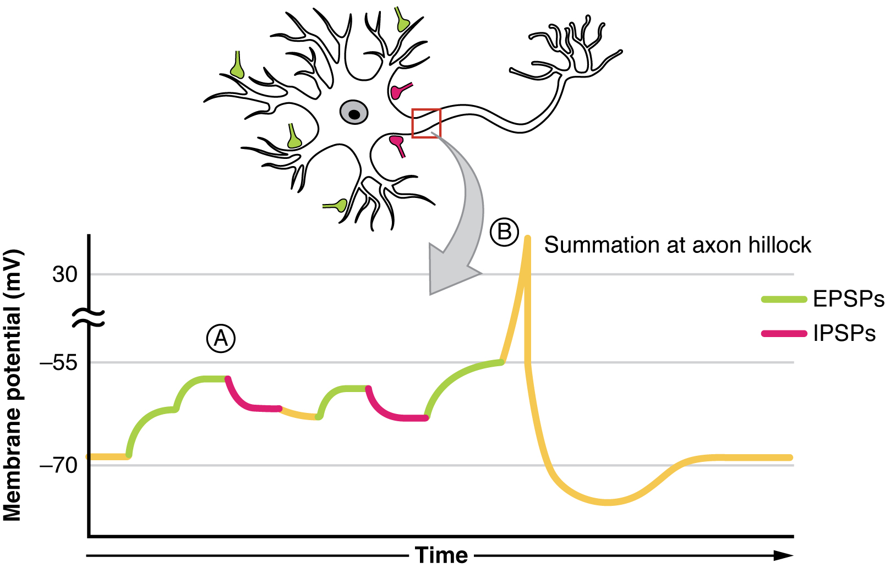
Figure 12.26 Postsynaptic Potential Summation The result of summation of postsynaptic potentials is the overall change in the membrane potential. At point A, several different excitatory postsynaptic potentials add up to a large depolarization. At point B, a mix of excitatory and inhibitory postsynaptic potentials result in a different end result for the membrane potential.

Interactive Link
Watch this video to learn about summation. The process of converting electrical signals to chemical signals and back requires subtle changes that can result in transient increases or decreases in membrane voltage. To cause a lasting change in the target cell, multiple signals are usually added together, or summated. Does spatial summation have to happen all at once, or can the separate signals arrive on the postsynaptic neuron at slightly different times? Explain your answer.

Synapses
There are two types of connections between electrically active cells, chemical synapses and electrical synapses. In a chemical synapse, a chemical signal—namely, a neurotransmitter—is released from one cell and it affects the other cell. In an electrical synapse, there is a direct connection between the two cells so that ions can pass directly from one cell to the next. If one cell is depolarized in an electrical synapse, the joined cell also depolarizes because the ions pass between the cells. Chemical synapses involve the transmission of chemical information from one cell to the next. This section will concentrate on the chemical type of synapse.
An example of a chemical synapse is the neuromuscular junction (NMJ) described in the chapter on muscle tissue. In the nervous system, there are many more synapses that are essentially the same as the NMJ. All synapses have common characteristics, which can be summarized in this list:
- presynaptic element
- neurotransmitter (packaged in vesicles)
- synaptic cleft
- receptor proteins
- postsynaptic element
- neurotransmitter elimination or re-uptake
For the NMJ, these characteristics are as follows: the presynaptic element is the motor neuron's axon terminals, the neurotransmitter is acetylcholine, the synaptic cleft is the space between the cells where the neurotransmitter diffuses, the receptor protein is the nicotinic acetylcholine receptor, the postsynaptic element is the sarcolemma of the muscle cell, and the neurotransmitter is eliminated by acetylcholinesterase. Other synapses are similar to this, and the specifics are different, but they all contain the same characteristics.

Neurotransmitter Release
When an action potential reaches the axon terminals, voltage-gated Ca²⁺ channels in the membrane of the synaptic end bulb open. The concentration of Ca²⁺ increases inside the end bulb, and the Ca²⁺ ion associates with proteins in the outer surface of neurotransmitter vesicles. The Ca²⁺ facilitates the merging of the vesicle with the presynaptic membrane so that the neurotransmitter is released through exocytosis into the small gap between the cells, known as the synaptic cleft.
Once in the synaptic cleft, the neurotransmitter diffuses the short distance to the postsynaptic membrane and can interact with neurotransmitter receptors. Receptors are specific for the neurotransmitter, and the two fit together like a key and lock. One neurotransmitter binds to its receptor and will not bind to receptors for other neurotransmitters, making the binding a specific chemical event (Figure 12.27).
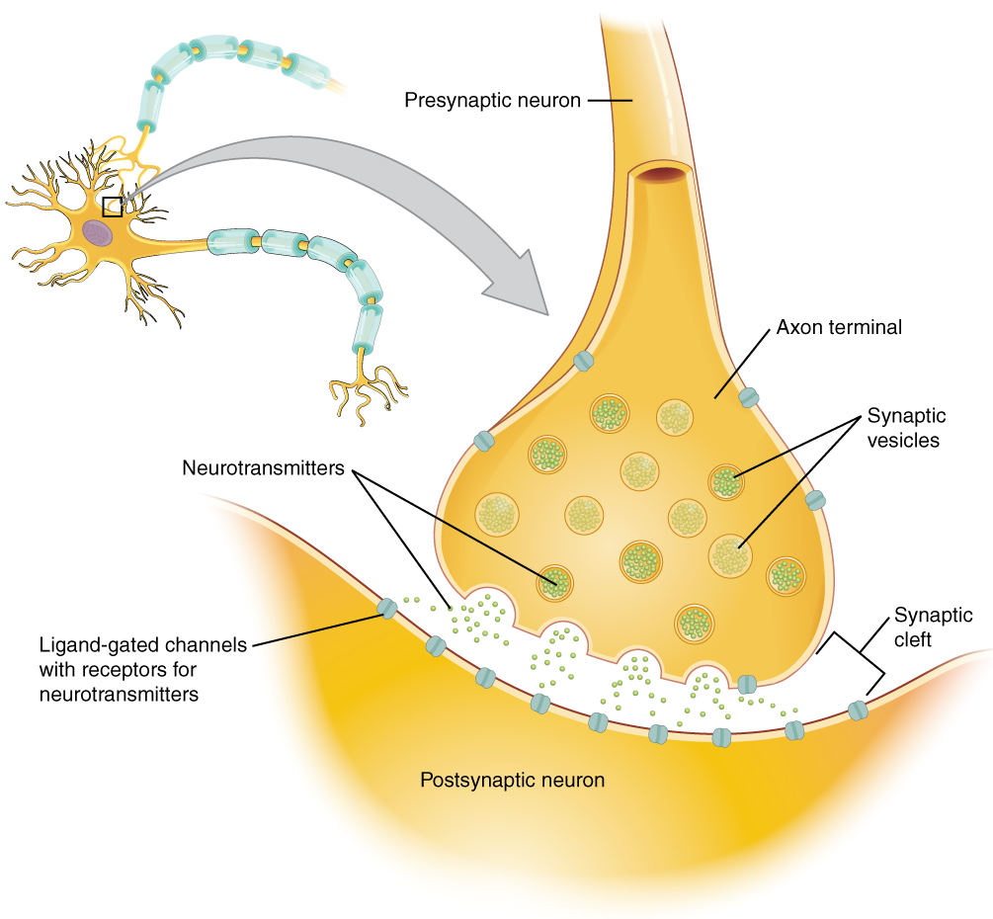
Figure 12.27 The Synapse The synapse is a connection between a neuron and its target cell (which is not necessarily a neuron). The presynaptic element is the synaptic end bulb of the axon where Ca²⁺ enters the bulb to cause vesicle fusion and neurotransmitter release. The neurotransmitter diffuses across the synaptic cleft to bind to its receptor. The neurotransmitter is cleared from the synapse either by enzymatic degradation, neuronal reuptake, or glial reuptake.

Neurotransmitter Systems
There are several systems of neurotransmitters that are found at various synapses in the nervous system. These groups refer to the chemicals that are the neurotransmitters, and within the groups are specific systems.
The first group, which is a neurotransmitter system of its own, is the cholinergic system. It is the system based on acetylcholine. This includes the NMJ as an example of a cholinergic synapse, but cholinergic synapses are found in other parts of the nervous system. They are in the autonomic nervous system, as well as distributed throughout the brain.
The cholinergic system has two types of receptors, the nicotinic receptor is found in the NMJ as well as other synapses. There is also an acetylcholine receptor known as the muscarinic receptor. Both of these receptors are named for drugs that interact with the receptor in addition to acetylcholine. Nicotine will bind to the nicotinic receptor and activate it similar to acetylcholine. Muscarine, a product of certain mushrooms, will bind to the muscarinic receptor. However, nicotine will not bind to the muscarinic receptor and muscarine will not bind to the nicotinic receptor.
Another group of neurotransmitters are amino acids. This includes glutamate (Glu), GABA (gamma-aminobutyric acid, a derivative of glutamate), and glycine (Gly). These amino acids have an amino group and a carboxyl group in their chemical structures. Glutamate is one of the 20 amino acids that are used to make proteins. Each amino acid neurotransmitter would be part of its own system, namely the glutamatergic, GABAergic, and glycinergic systems. They each have their own receptors and do not interact with each other. Amino acid neurotransmitters are eliminated from the synapse by reuptake. A pump in the cell membrane of the presynaptic element, or sometimes a neighboring glial cell, will clear the amino acid from the synaptic cleft so that it can be recycled, repackaged in vesicles, and released again.
Another class of neurotransmitter is the biogenic amine, a group of neurotransmitters that are enzymatically made from amino acids. They have amino groups in them, but no longer have carboxyl groups and are therefore no longer classified as amino acids. Serotonin is made from tryptophan. It is the basis of the serotonergic system, which has its own specific receptors. Serotonin is transported back into the presynaptic cell for repackaging.
Other biogenic amines are made from tyrosine, and include dopamine, norepinephrine, and epinephrine. Dopamine is part of its own system, the dopaminergic system, which has dopamine receptors. Dopamine is removed from the synapse by transport proteins in the presynaptic cell membrane. Norepinephrine and epinephrine belong to the adrenergic neurotransmitter system. The two molecules are very similar and bind to the same receptors, which are referred to as alpha and beta receptors. Norepinephrine and epinephrine are also transported back into the presynaptic cell. The chemical epinephrine (epi- = “on”; “-nephrine” = kidney) is also known as adrenaline (renal = “kidney”), and norepinephrine is sometimes referred to as noradrenaline. The adrenal gland produces epinephrine and norepinephrine to be released into the blood stream as hormones.
A neuropeptide is a neurotransmitter molecule made up of chains of amino acids connected by peptide bonds. This is what a protein is, but the term protein implies a certain length to the molecule. Some neuropeptides are quite short, such as met-enkephalin, which is five amino acids long. Others are long, such as beta-endorphin, which is 31 amino acids long. Neuropeptides are often released at synapses in combination with another neurotransmitter, and they often act as hormones in other systems of the body, such as vasoactive intestinal peptide (VIP) or substance P.
The effect of a neurotransmitter on the postsynaptic element is entirely dependent on the receptor protein. First, if there is no receptor protein in the membrane of the postsynaptic element, then the neurotransmitter has no effect. The depolarizing or hyperpolarizing effect is also dependent on the receptor. When acetylcholine binds to the nicotinic receptor, the postsynaptic cell is depolarized. This is because the receptor is a cation channel and positively charged Na⁺ will rush into the cell. However, when acetylcholine binds to the muscarinic receptor, of which there are several variants, it might cause depolarization or hyperpolarization of the target cell.
The amino acid neurotransmitters, glutamate, glycine, and GABA, are almost exclusively associated with just one effect. Glutamate is considered an excitatory amino acid, but only because Glu receptors in the adult cause depolarization of the postsynaptic cell. Glycine and GABA are considered inhibitory amino acids, again because their receptors cause hyperpolarization.
The biogenic amines have mixed effects. For example, the dopamine receptors that are classified as D1 receptors are excitatory whereas D2-type receptors are inhibitory. Biogenic amine receptors and neuropeptide receptors can have even more complex effects because some may not directly affect the membrane potential, but rather have an effect on gene transcription or other metabolic processes in the neuron. The characteristics of the various neurotransmitter systems presented in this section are organized in Table 12.3.
The important thing to remember about neurotransmitters, and signaling chemicals in general, is that the effect is entirely dependent on the receptor. Neurotransmitters bind to one of two classes of receptors at the cell surface, ionotropic or metabotropic (Figure 12.28). Ionotropic receptors are ligand-gated ion channels, such as the nicotinic receptor for acetylcholine or the glycine receptor. A metabotropic receptor involves a complex of proteins that result in metabolic changes within the cell. The receptor complex includes the transmembrane receptor protein, a G protein, and an effector protein. The neurotransmitter, referred to as the first messenger, binds to the receptor protein on the extracellular surface of the cell, and the intracellular side of the protein initiates activity of the G protein. The G protein is a guanosine triphosphate (GTP) hydrolase that physically moves from the receptor protein to the effector protein to activate the latter. An effector protein is an enzyme that catalyzes the generation of a new molecule, which acts as the intracellular mediator of the signal that binds to the receptor. This intracellular mediator is called the second messenger.
Different receptors use different second messengers. Two common examples of second messengers are cyclic adenosine monophosphate (cAMP) and inositol triphosphate (IP₃). The enzyme adenylate cyclase (an example of an effector protein) makes cAMP, and phospholipase C is the enzyme that makes IP₃. Second messengers, after they are produced by the effector protein, cause metabolic changes within the cell. These changes are most likely the activation of other enzymes in the cell. In neurons, they often modify ion channels, either opening or closing them. These enzymes can also cause changes in the cell, such as the activation of genes in the nucleus, and therefore the increased synthesis of proteins. In neurons, these kinds of changes are often the basis of stronger connections between cells at the synapse and may be the basis of learning and memory.
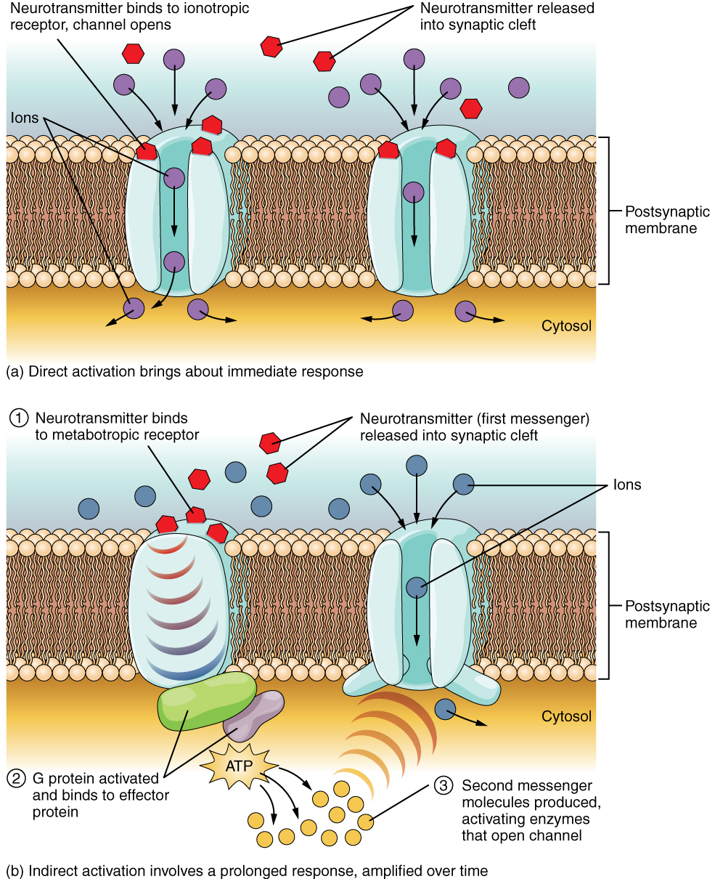
Figure 12.28 Receptor Types (a) An ionotropic receptor is a channel that opens when the neurotransmitter binds to it. (b) A metabotropic receptor is a complex that causes metabolic changes in the cell when the neurotransmitter binds to it (1). After binding, the G protein hydrolyzes ATP and moves to the effector protein (2). When the G protein contacts the effector protein, the latter is activated. In the case shown, the effector protein then acts on ATP to generate a second messenger, cAMP (3). The second messenger can then go on to cause changes in the neuron, such as opening or closing ion channels, metabolic changes, and changes in gene transcription.

Interactive Link
Watch this video to learn about the release of a neurotransmitter. The action potential reaches the end of the axon, called the axon terminal, and a chemical signal is released to tell the target cell to do something—either to initiate a new action potential, or to suppress that activity. In a very short space, the electrical signal of the action potential is changed into the chemical signal of a neurotransmitter and then back to electrical changes in the target cell membrane. What is the importance of voltage-gated calcium channels in the release of neurotransmitters?
Characteristics of Neurotransmitter Systems
System | Cholinergic | Amino acids | Biogenic amines | Neuropeptides
Neurotransmitters | Acetylcholine | Glutamate, glycine, GABA | Serotonin (5-HT), dopamine, norepinephrine, (epinephrine) | Met-enkephalin, beta-endorphin, VIP, Substance P, etc.
Receptors | Nicotinic and muscarinic receptors | Glu receptors, gly receptors, GABA receptors | 5-HT receptors, D1 and D2 receptors, α-adrenergic and β-adrenergic receptors | Receptors are too numerous to list, but are specific to the peptides.
Elimination | Degradation by acetylcholinesterase | Reuptake by neurons or glia | Reuptake by neurons | Degradation by enzymes called peptidases
Postsynaptic effect | Nicotinic receptor causes depolarization. Muscarinic receptors can cause both depolarization or hyperpolarization depending on the subtype. | Glu receptors cause depolarization. Gly and GABA receptors cause hyperpolarization. | Depolarization or hyperpolarization depends on the specific receptor. For example, D1 receptors cause depolarization and D2 receptors cause hyperpolarization. | Depolarization or hyperpolarization depends on the specific receptor.
Table 12.3

Disorders of the...

Nervous System
The underlying cause of some neurodegenerative diseases, such as Alzheimer’s and Parkinson’s, appears to be related to proteins—specifically, to proteins behaving badly. One of the strongest theories of what causes Alzheimer’s disease is based on the accumulation of beta-amyloid plaques, dense conglomerations of a protein that is not functioning correctly. Parkinson’s disease is linked to an increase in a protein known as alpha-synuclein that is toxic to the cells of the substantia nigra nucleus in the midbrain.
For proteins to function correctly, they are dependent on their three-dimensional shape. The linear sequence of amino acids folds into a three-dimensional shape that is based on the interactions between and among those amino acids. When the folding is disturbed, and proteins take on a different shape, they stop functioning correctly. But the disease is not necessarily the result of functional loss of these proteins; rather, these altered proteins start to accumulate and may become toxic. For example, in Alzheimer’s, the hallmark of the disease is the accumulation of these amyloid plaques in the cerebral cortex. The term coined to describe this sort of disease is “proteopathy” and it includes other diseases. Creutzfeld-Jacob disease, the human variant of the prion disease known as mad cow disease in the bovine, also involves the accumulation of amyloid plaques, similar to Alzheimer’s. Diseases of other organ systems can fall into this group as well, such as cystic fibrosis or type 2 diabetes. Recognizing the relationship between these diseases has suggested new therapeutic possibilities. Interfering with the accumulation of the proteins, and possibly as early as their original production within the cell, may unlock new ways to alleviate these devastating diseases.

