17.5 The Parathyroid Glands

Learning Objectives
By the end of this section, you will be able to:
- Describe the location and structure of the parathyroid glands
- Describe the hormonal control of blood calcium levels
- Discuss the physiological response of parathyroid dysfunction
The parathyroid glands are tiny, round structures usually found embedded in the posterior surface of the thyroid gland (Figure 17.15). A thick connective tissue capsule separates the glands from the thyroid tissue. Most people have four parathyroid glands, but occasionally there are more in tissues of the neck or chest. The function of one type of parathyroid cells, the oxyphil cells, is not clear. The primary functional cells of the parathyroid glands are the chief cells. These epithelial cells produce and secrete the parathyroid hormone (PTH), the major hormone involved in the regulation of blood calcium levels.
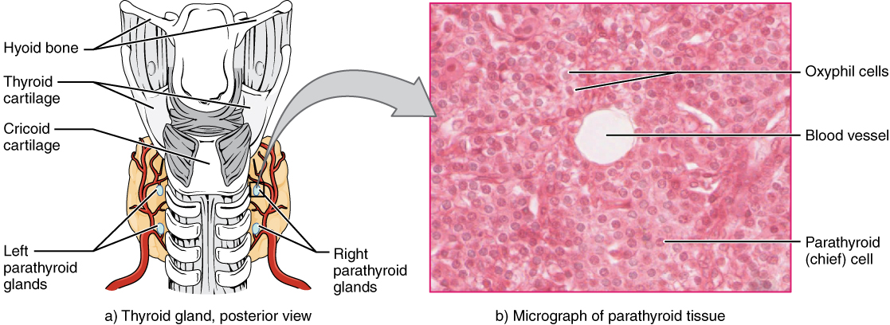
Figure 17.15 Parathyroid Glands The small parathyroid glands are embedded in the posterior surface of the thyroid gland. LM × 760. (Micrograph provided by the Regents of University of Michigan Medical School © 2012)

Interactive Link
View the University of Michigan WebScope to explore the tissue sample in greater detail.
The parathyroid glands produce and secrete PTH, a peptide hormone, in response to low blood calcium levels (Figure 17.16). PTH secretion causes the release of calcium from the bones by stimulating osteoclasts, which secrete enzymes that degrade bone and release calcium into the interstitial fluid. PTH also inhibits osteoblasts, the cells involved in bone deposition, thereby sparing blood calcium. PTH causes increased reabsorption of calcium (and magnesium) in the kidney tubules from the urine filtrate. In addition, PTH initiates the production of the steroid hormone calcitriol (also known as 1,25-dihydroxyvitamin D), which is the active form of vitamin D₃, in the kidneys. Calcitriol then stimulates increased absorption of dietary calcium by the intestines. A negative feedback loop regulates the levels of PTH, with rising blood calcium levels inhibiting further release of PTH.
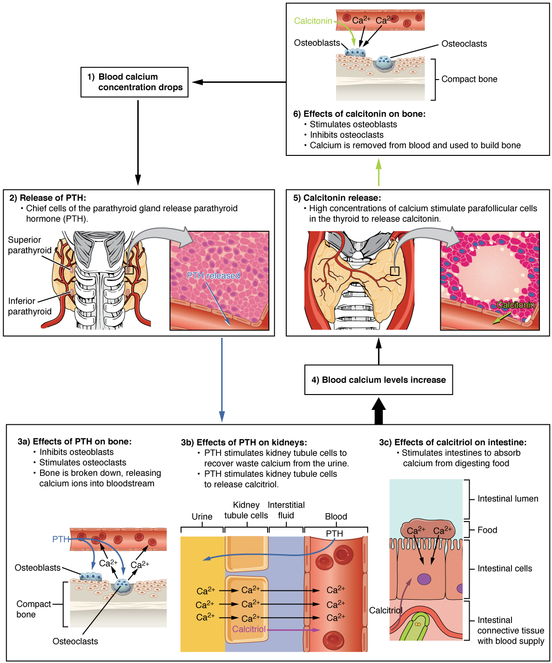
Figure 17.16 Parathyroid Hormone in Maintaining Blood Calcium Homeostasis Parathyroid hormone increases blood calcium levels when they drop too low. Conversely, calcitonin, which is released from the thyroid gland, decreases blood calcium levels when they become too high. These two mechanisms constantly maintain blood calcium concentration at homeostasis.
Abnormally high activity of the parathyroid gland can cause hyperparathyroidism, a disorder caused by an overproduction of PTH that results in excessive calcium reabsorption from bone. Hyperparathyroidism can significantly decrease bone density, leading to spontaneous fractures or deformities. As blood calcium levels rise, cell membrane permeability to sodium is decreased, and the responsiveness of the nervous system is reduced. At the same time, calcium deposits may collect in the body’s tissues and organs, impairing their functioning.
In contrast, abnormally low blood calcium levels may be caused by parathyroid hormone deficiency, called hypoparathyroidism, which may develop following injury or surgery involving the thyroid gland. Low blood calcium increases membrane permeability to sodium, resulting in muscle twitching, cramping, spasms, or convulsions. Severe deficits can paralyze muscles, including those involved in breathing, and can be fatal.
When blood calcium levels are high, calcitonin is produced and secreted by the parafollicular cells of the thyroid gland. As discussed earlier, calcitonin inhibits the activity of osteoclasts, reduces the absorption of dietary calcium in the intestine, and signals the kidneys to reabsorb less calcium, resulting in larger amounts of calcium excreted in the urine.

