22.3 The Process of Breathing

Learning Objectives
By the end of this section, you will be able to:
- Describe the mechanisms that drive breathing
- Discuss how pressure, volume, and resistance are related
- List the steps involved in pulmonary ventilation
- Discuss the physical factors related to breathing
- Discuss the meaning of respiratory volume and capacities
- Define respiratory rate
- Outline the mechanisms behind the control of breathing
- Describe the respiratory centers of the medulla oblongata
- Describe the respiratory centers of the pons
- Discuss factors that can influence the respiratory rate
Pulmonary ventilation is the act of breathing, which can be described as the movement of air into and out of the lungs. The major mechanisms that drive pulmonary ventilation are atmospheric pressure (P_{atm}); the air pressure within the alveoli, called intra-alveolar pressure (P_{alv}); and the pressure within the pleural cavity, called intrapleural pressure (P_{ip}).

Mechanisms of Breathing
The intra-alveolar and intrapleural pressures are dependent on certain physical features of the lung. However, the ability to breathe—to have air enter the lungs during inspiration and air leave the lungs during expiration—is dependent on the air pressure of the atmosphere and the air pressure within the lungs.

Pressure Relationships
Inspiration (or inhalation) and expiration (or exhalation) are dependent on the differences in pressure between the atmosphere and the lungs. In a gas, pressure is a force created by the movement of gas molecules that are confined. For example, a certain number of gas molecules in a two-liter container has more room than the same number of gas molecules in a one-liter container (Figure 22.15). In this case, the force exerted by the movement of the gas molecules against the walls of the two-liter container is lower than the force exerted by the gas molecules in the one-liter container. Therefore, the pressure is lower in the two-liter container and higher in the one-liter container. At a constant temperature, changing the volume occupied by the gas changes the pressure, as does changing the number of gas molecules. Boyle’s law describes the relationship between volume and pressure in a gas at a constant temperature. Boyle discovered that the pressure of a gas is inversely proportional to its volume: If volume increases, pressure decreases. Likewise, if volume decreases, pressure increases. Pressure and volume are inversely related (P = k/V). Therefore, the pressure in the one-liter container (one-half the volume of the two-liter container) would be twice the pressure in the two-liter container. Boyle’s law is expressed by the following formula:
$P_{1}V_{1}=P_{2}V_{2}$
22.1
In this formula, P₁ represents the initial pressure and V₁ represents the initial volume, whereas the final pressure and volume are represented by P₂ and V_{2,} respectively. If the two- and one-liter containers were connected by a tube and the volume of one of the containers were changed, then the gases would move from higher pressure (lower volume) to lower pressure (higher volume).
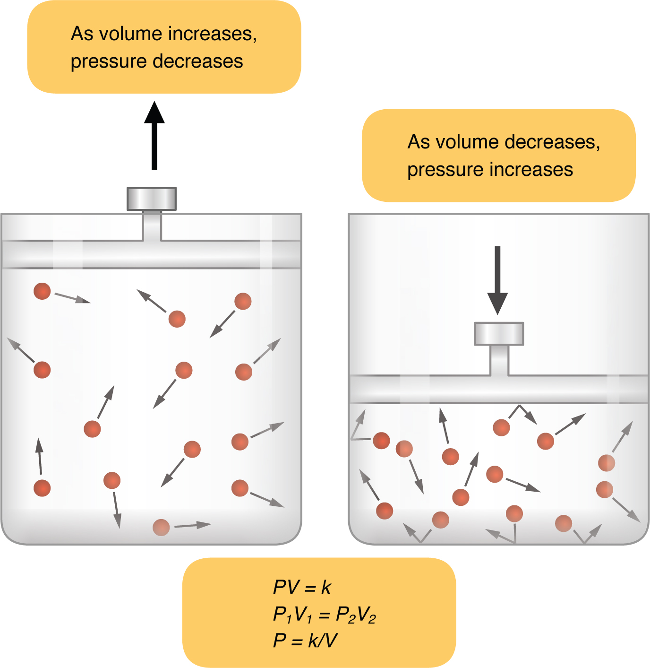
Figure 22.15 Boyle's Law In a gas, pressure increases as volume decreases.
Pulmonary ventilation is dependent on three types of pressure: atmospheric, intra-alveolar, and intrapleural. Atmospheric pressure is the amount of force that is exerted by gases in the air surrounding any given surface, such as the body. Atmospheric pressure can be expressed in terms of the unit atmosphere, abbreviated atm, or in millimeters of mercury (mm Hg). One atm is equal to 760 mm Hg, which is the atmospheric pressure at sea level. Typically, for respiration, other pressure values are discussed in relation to atmospheric pressure. Therefore, negative pressure is pressure lower than the atmospheric pressure, whereas positive pressure is pressure that it is greater than the atmospheric pressure. A pressure that is equal to the atmospheric pressure is expressed as zero.
Intra-alveolar pressure (intrapulmonary pressure) is the pressure of the air within the alveoli, which changes during the different phases of breathing (Figure 22.16). Because the alveoli are connected to the atmosphere via the tubing of the airways (similar to the two- and one-liter containers in the example above), the intrapulmonary pressure of the alveoli always equalizes with the atmospheric pressure.
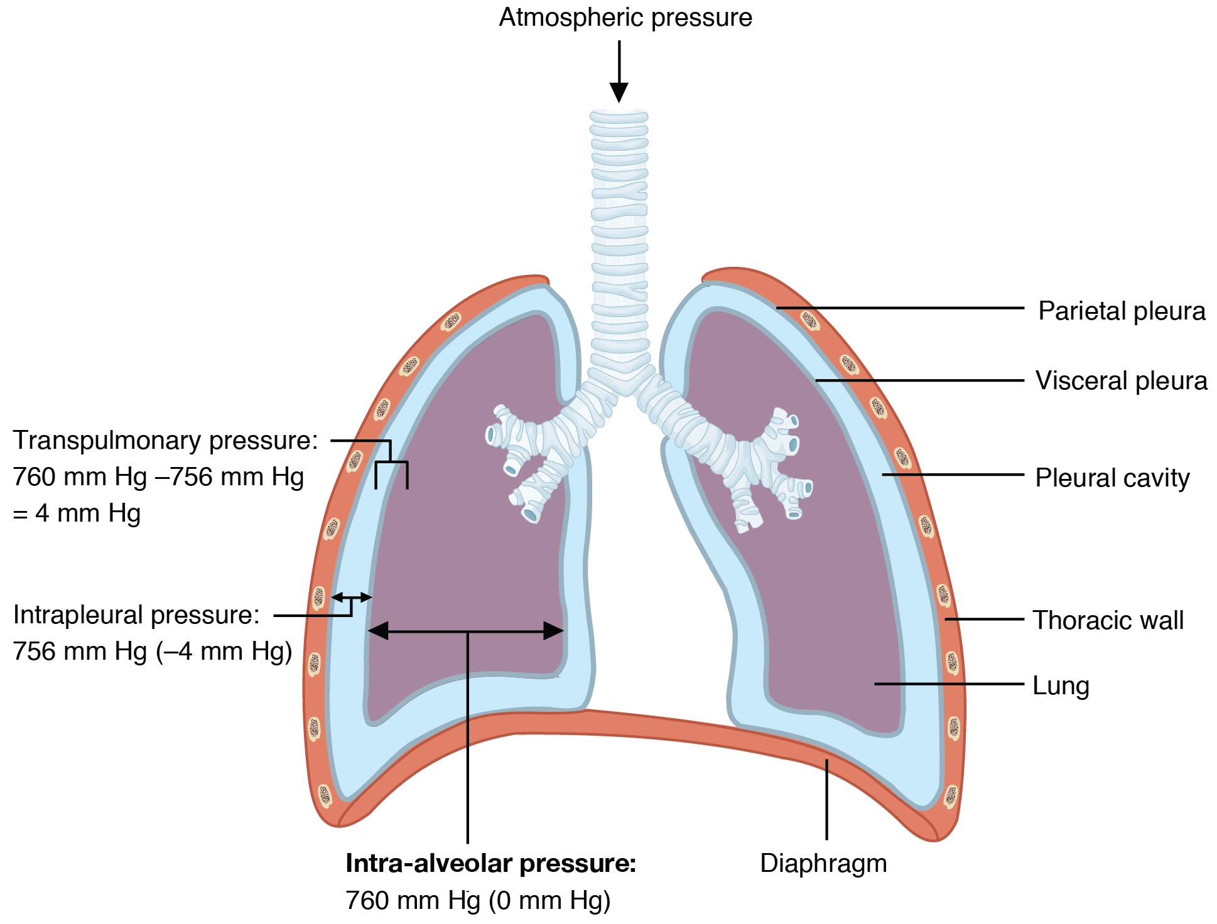
Figure 22.16 Intrapulmonary and Intrapleural Pressure Relationships Intra-alveolar pressure changes during the different phases of the cycle. It equalizes at 760 mm Hg but does not remain at 760 mm Hg.
Intrapleural pressure is the pressure of the air within the pleural cavity, between the visceral and parietal pleurae. Similar to intra-alveolar pressure, intrapleural pressure also changes during the different phases of breathing. However, due to certain characteristics of the lungs, the intrapleural pressure is always lower than, or negative to, the intra-alveolar pressure (and therefore also to atmospheric pressure). Although it fluctuates during inspiration and expiration, intrapleural pressure remains approximately –4 mm Hg throughout the breathing cycle.
Competing forces within the thorax cause the formation of the negative intrapleural pressure. One of these forces relates to the elasticity of the lungs themselves—elastic tissue pulls the lungs inward, away from the thoracic wall. Surface tension of alveolar fluid, which is mostly water, also creates an inward pull of the lung tissue. This inward tension from the lungs is countered by opposing forces from the pleural fluid and thoracic wall. Surface tension within the pleural cavity pulls the lungs outward. Too much or too little pleural fluid would hinder the creation of the negative intrapleural pressure; therefore, the level must be closely monitored by the mesothelial cells and drained by the lymphatic system. Since the parietal pleura is attached to the thoracic wall, the natural elasticity of the chest wall opposes the inward pull of the lungs. Ultimately, the outward pull is slightly greater than the inward pull, creating the –4 mm Hg intrapleural pressure relative to the intra-alveolar pressure. Transpulmonary pressure is the difference between the intrapleural and intra-alveolar pressures, and it determines the size of the lungs. A higher transpulmonary pressure corresponds to a larger lung.

Physical Factors Affecting Ventilation
In addition to the differences in pressures, breathing is also dependent upon the contraction and relaxation of muscle fibers of both the diaphragm and thorax. The lungs themselves are passive during breathing, meaning they are not involved in creating the movement that helps inspiration and expiration. This is because of the adhesive nature of the pleural fluid, which allows the lungs to be pulled outward when the thoracic wall moves during inspiration. The recoil of the thoracic wall during expiration causes compression of the lungs. Contraction and relaxation of the diaphragm and intercostals muscles (found between the ribs) cause most of the pressure changes that result in inspiration and expiration. These muscle movements and subsequent pressure changes cause air to either rush in or be forced out of the lungs.
Other characteristics of the lungs influence the effort that must be expended to ventilate. Resistance is a force that slows motion, in this case, the flow of gases. The size of the airway is the primary factor affecting resistance. A small tubular diameter forces air through a smaller space, causing more collisions of air molecules with the walls of the airways. The following formula helps to describe the relationship between airway resistance and pressure changes:
$F=ΔP/R$
22.2
As noted earlier, there is surface tension within the alveoli caused by water present in the lining of the alveoli. This surface tension tends to inhibit expansion of the alveoli. However, pulmonary surfactant secreted by type II alveolar cells mixes with that water and helps reduce this surface tension. Without pulmonary surfactant, the alveoli would collapse during expiration.
Thoracic wall compliance is the ability of the thoracic wall to stretch while under pressure. This can also affect the effort expended in the process of breathing. In order for inspiration to occur, the thoracic cavity must expand. The expansion of the thoracic cavity directly influences the capacity of the lungs to expand. If the tissues of the thoracic wall are not very compliant, it will be difficult to expand the thorax to increase the size of the lungs.

Pulmonary Ventilation
The difference in pressures drives pulmonary ventilation because air flows down a pressure gradient, that is, air flows from an area of higher pressure to an area of lower pressure. Air flows into the lungs largely due to a difference in pressure; atmospheric pressure is greater than intra-alveolar pressure, and intra-alveolar pressure is greater than intrapleural pressure. Air flows out of the lungs during expiration based on the same principle; pressure within the lungs becomes greater than the atmospheric pressure.
Pulmonary ventilation comprises two major steps: inspiration and expiration. Inspiration is the process that causes air to enter the lungs, and expiration is the process that causes air to leave the lungs (Figure 22.17). A respiratory cycle is one sequence of inspiration and expiration. In general, two muscle groups are used during normal inspiration: the diaphragm and the external intercostal muscles. Additional muscles can be used if a bigger breath is required. When the diaphragm contracts, it moves inferiorly toward the abdominal cavity, creating a larger thoracic cavity and more space for the lungs. Contraction of the external intercostal muscles moves the ribs upward and outward, causing the rib cage to expand, which increases the volume of the thoracic cavity. Due to the adhesive force of the pleural fluid, the expansion of the thoracic cavity forces the lungs to stretch and expand as well. This increase in volume leads to a decrease in intra-alveolar pressure, creating a pressure lower than atmospheric pressure. As a result, a pressure gradient is created that drives air into the lungs.
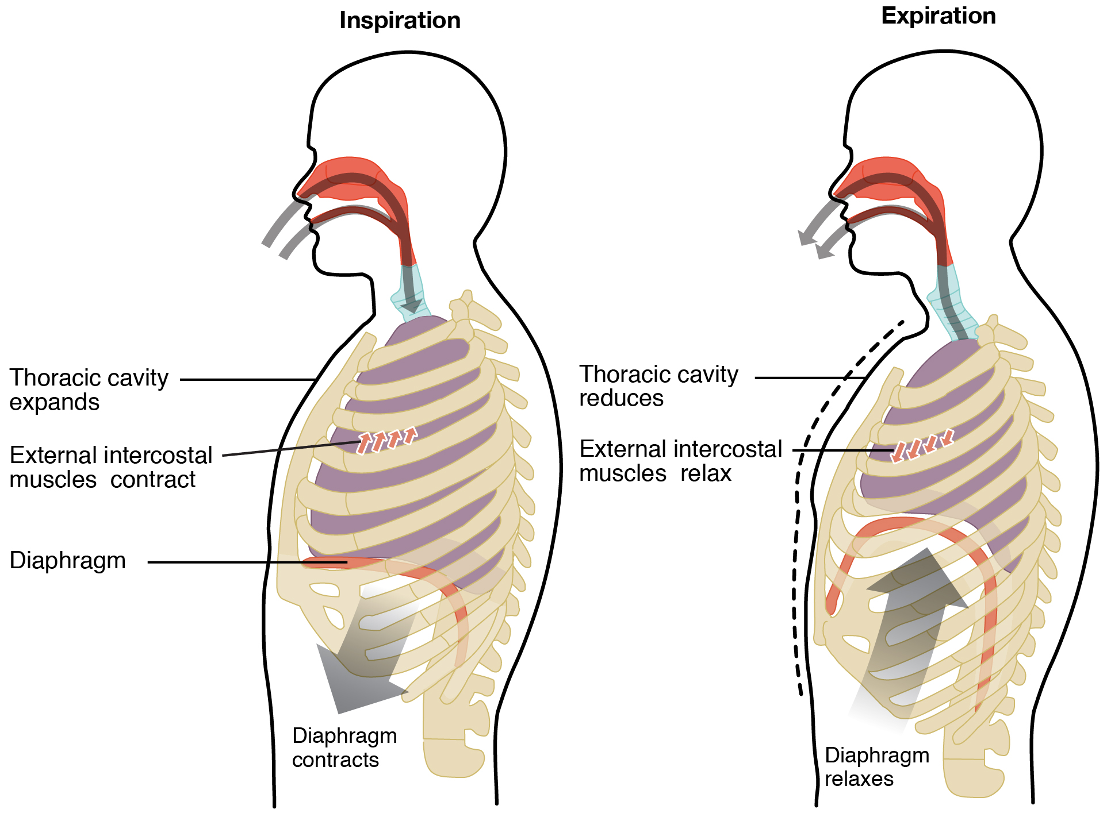
Figure 22.17 Normal Inspiration and Expiration Inspiration and expiration occur due to the expansion and contraction of the thoracic cavity, respectively.
The process of normal expiration is passive, meaning that energy is not required to push air out of the lungs. Instead, the elasticity of the lung tissue causes the lung to recoil, as the diaphragm and intercostal muscles relax following inspiration. In turn, the thoracic cavity and lungs decrease in volume, causing an increase in intrapulmonary pressure. The intrapulmonary pressure rises above atmospheric pressure, creating a pressure gradient that causes air to leave the lungs.
There are different types, or modes, of breathing that require a slightly different process to allow inspiration and expiration. Quiet breathing, also known as eupnea, is a mode of breathing that occurs at rest and does not require the cognitive thought of the individual. During quiet breathing, the diaphragm and external intercostals must contract.
A deep breath, called diaphragmatic breathing, requires the diaphragm to contract. As the diaphragm relaxes, air passively leaves the lungs. A shallow breath, called costal breathing, requires contraction of the intercostal muscles. As the intercostal muscles relax, air passively leaves the lungs.
In contrast, forced breathing, also known as hyperpnea, is a mode of breathing that can occur during exercise or actions that require the active manipulation of breathing, such as singing. During forced breathing, inspiration and expiration both occur due to muscle contractions. In addition to the contraction of the diaphragm and intercostal muscles, other accessory muscles must also contract. During forced inspiration, muscles of the neck, including the scalenes, contract and lift the thoracic wall, increasing lung volume. During forced expiration, accessory muscles of the abdomen, including the obliques, contract, forcing abdominal organs upward against the diaphragm. This helps to push the diaphragm further into the thorax, pushing more air out. In addition, accessory muscles (primarily the internal intercostals) help to compress the rib cage, which also reduces the volume of the thoracic cavity.

Respiratory Volumes and Capacities
Respiratory volume is the term used for various volumes of air moved by or associated with the lungs at a given point in the respiratory cycle. There are four major types of respiratory volumes: tidal, residual, inspiratory reserve, and expiratory reserve (Figure 22.18). Tidal volume (TV) is the amount of air that normally enters the lungs during quiet breathing, which is about 500 milliliters. Expiratory reserve volume (ERV) is the amount of air you can forcefully exhale past a normal tidal expiration, up to 1200 milliliters for males. Inspiratory reserve volume (IRV) is produced by a deep inhalation, past a tidal inspiration. This is the extra volume that can be brought into the lungs during a forced inspiration. Residual volume (RV) is the air left in the lungs if you exhale as much air as possible. The residual volume makes breathing easier by preventing the alveoli from collapsing. Respiratory volume is dependent on a variety of factors, and measuring the different types of respiratory volumes can provide important clues about a person’s respiratory health (Figure 22.19).
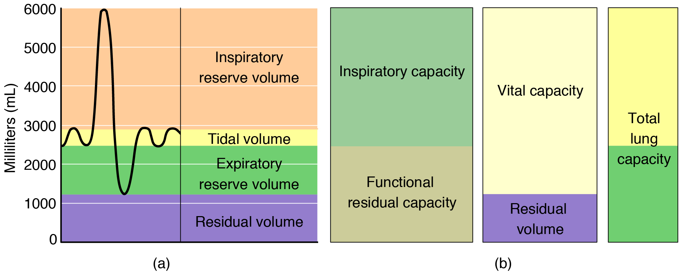
Figure 22.18 Respiratory Volumes and Capacities These two graphs show (a) respiratory volumes and (b) the combination of volumes that results in respiratory capacity.
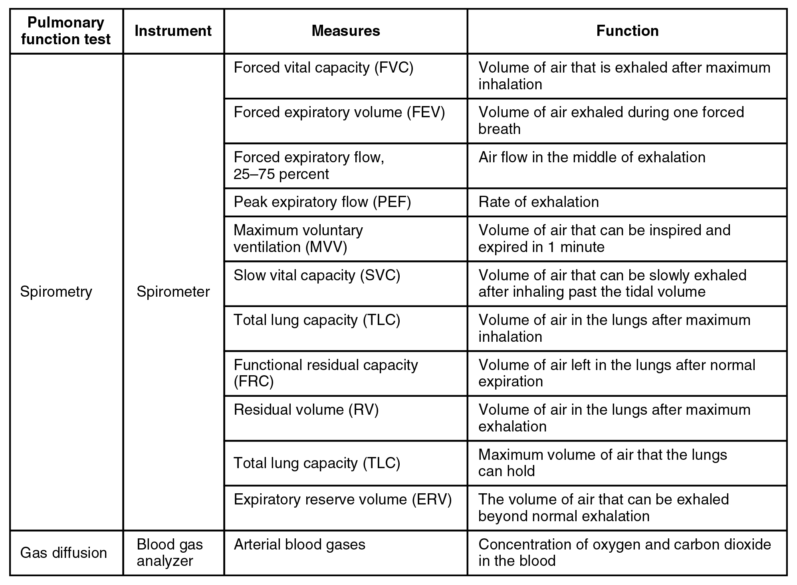
Figure 22.19 Pulmonary Function Testing
Respiratory capacity is the combination of two or more selected volumes, which further describes the amount of air in the lungs during a given time. For example, total lung capacity (TLC) is the sum of all of the lung volumes (TV, ERV, IRV, and RV), which represents the total amount of air a person can hold in the lungs after a forceful inhalation. TLC is about 6000 mL air for males, and about 4200 mL for females. Vital capacity (VC) is the amount of air a person can move into or out of their lungs, and is the sum of all of the volumes except residual volume (TV, ERV, and IRV), which is between 4000 and 5000 milliliters. Inspiratory capacity (IC) is the maximum amount of air that can be inhaled past a normal tidal expiration, is the sum of the tidal volume and inspiratory reserve volume. On the other hand, the functional residual capacity (FRC) is the amount of air that remains in the lung after a normal tidal expiration; it is the sum of expiratory reserve volume and residual volume (see Figure 22.18).

Interactive Link
Watch this video to learn more about lung volumes and spirometers. Explain how spirometry test results can be used to diagnose respiratory diseases or determine the effectiveness of disease treatment.
In addition to the air that creates respiratory volumes, the respiratory system also contains anatomical dead space, which is air that is present in the airway that never reaches the alveoli and therefore never participates in gas exchange. Alveolar dead space involves air found within alveoli that are unable to function, such as those affected by disease or abnormal blood flow. Total dead space is the anatomical dead space and alveolar dead space together, and represents all of the air in the respiratory system that is not being used in the gas exchange process.

Respiratory Rate and Control of Ventilation
Breathing usually occurs without thought, although at times you can consciously control it, such as when you swim under water, sing a song, or blow bubbles. The respiratory rate is the total number of breaths, or respiratory cycles, that occur each minute. Respiratory rate can be an important indicator of disease, as the rate may increase or decrease during an illness or in a disease condition. The respiratory rate is controlled by the respiratory center located within the medulla oblongata in the brain, which responds primarily to changes in carbon dioxide, oxygen, and pH levels in the blood.
The normal respiratory rate of a child decreases from birth to adolescence. A child under 1 year of age has a normal respiratory rate between 30 and 60 breaths per minute, but by the time a child is about 10 years old, the normal rate is closer to 18 to 30. By adolescence, the normal respiratory rate is similar to that of adults, 12 to 18 breaths per minute.

Ventilation Control Centers
The control of ventilation is a complex interplay of multiple regions in the brain that signal the muscles used in pulmonary ventilation to contract (Table 22.1). The result is typically a rhythmic, consistent ventilation rate that provides the body with sufficient amounts of oxygen, while adequately removing carbon dioxide.
Summary of Ventilation Regulation
System component | Function
Medullary respiratory center | Sets the basic rhythm of breathing
Ventral respiratory group (VRG) | Generates the breathing rhythm and integrates data coming into the medulla
Dorsal respiratory group (DRG) | Integrates input from the stretch receptors and the chemoreceptors in the periphery
Pontine respiratory group (PRG) | Influences and modifies the medulla oblongata’s functions
Aortic body | Monitors blood PCO₂, PO₂, and pH
Carotid body | Monitors blood PCO₂, PO₂, and pH
Hypothalamus | Monitors emotional state and body temperature
Cortical areas of the brain | Control voluntary breathing
Proprioceptors | Send impulses regarding joint and muscle movements
Pulmonary irritant reflexes | Protect the respiratory zones of the system from foreign material
Inflation reflex | Protects the lungs from over-inflating
Table 22.1
Neurons that innervate the muscles of the respiratory system are responsible for controlling and regulating pulmonary ventilation. The major brain centers involved in pulmonary ventilation are the medulla oblongata and the pontine respiratory group (Figure 22.20).
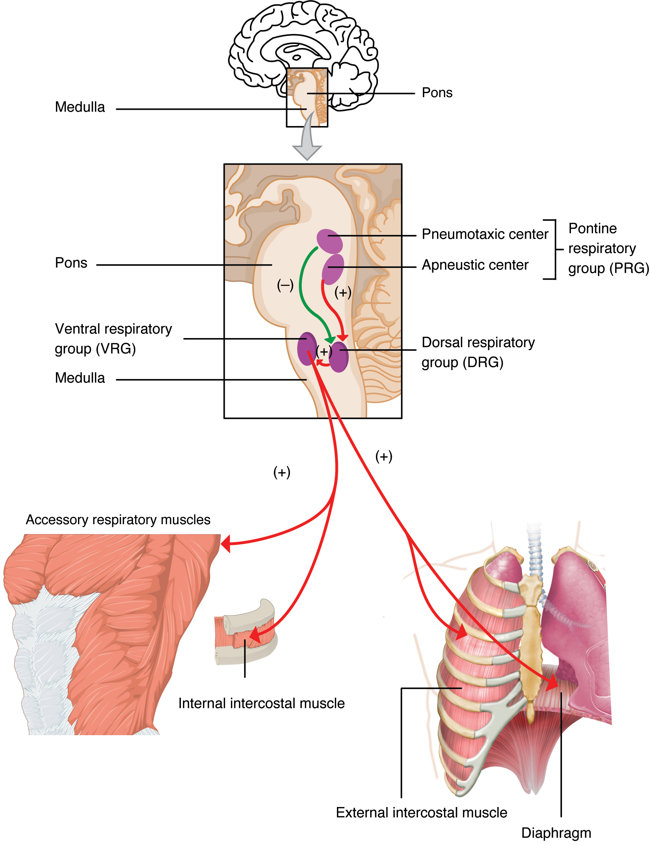
Figure 22.20 Respiratory Centers of the Brain
The medulla oblongata contains the dorsal respiratory group (DRG) and the ventral respiratory group (VRG). The VRG is involved in maintaining a constant breathing rhythm by stimulating the diaphragm and external intercostal muscles to contract, resulting in inspiration. When activity in the VRG ceases, it no longer stimulates the diaphragm and intercostals to contract, allowing them to relax, resulting in expiration. The DRG receives input from sensors such as lung stretch receptors and peripheral chemoreceptors. The DRG integrates this information, then communicates with the VRG to modify respiratory rhythm.
The second respiratory center of the brain is located within the pons, called the pontine respiratory group, and consists of the apneustic and pneumotaxic centers. The apneustic center is a double cluster of neuronal cell bodies that stimulate neurons in the DRG, controlling the depth of inspiration, particularly for deep breathing. The pneumotaxic center is a network of neurons that inhibits the activity of neurons in the DRG, allowing relaxation after inspiration, and thus controlling the overall rate.

Factors That Affect the Rate and Depth of Respiration
The respiratory rate and the depth of inspiration are regulated by the medulla oblongata and pons; however, these regions of the brain do so in response to systemic stimuli. It is a dose-response, positive-feedback relationship in which the greater the stimulus, the greater the response. Thus, increasing stimuli results in forced breathing. Multiple systemic factors are involved in stimulating the brain to produce pulmonary ventilation.
The major factor that stimulates the medulla oblongata and pons to produce respiration is surprisingly not oxygen concentration, but rather the concentration of carbon dioxide in the blood. As you recall, carbon dioxide is a waste product of cellular respiration and can be toxic. Concentrations of chemicals are sensed by chemoreceptors. A central chemoreceptor is one of the specialized receptors that are located in the brain and brainstem, whereas a peripheral chemoreceptor is one of the specialized receptors located in the carotid arteries and aortic arch. Concentration changes in certain substances, such as carbon dioxide or hydrogen ions, stimulate these receptors, which in turn signal the respiration centers of the brain. In the case of carbon dioxide, as the concentration of CO₂ in the blood increases, it readily diffuses across the blood-brain barrier, where it collects in the extracellular fluid. As will be explained in more detail later, increased carbon dioxide levels lead to increased levels of hydrogen ions, decreasing pH. The increase in hydrogen ions in the brain triggers the central chemoreceptors to stimulate the respiratory centers to initiate contraction of the diaphragm and intercostal muscles. As a result, the rate and depth of respiration increase, allowing more carbon dioxide to be expelled, which brings more air into and out of the lungs promoting a reduction in the blood levels of carbon dioxide, and therefore hydrogen ions, in the blood. In contrast, low levels of carbon dioxide in the blood cause low levels of hydrogen ions in the brain, leading to a decrease in the rate and depth of pulmonary ventilation, producing shallow, slow breathing.
Another factor involved in influencing the respiratory activity of the brain is systemic arterial concentrations of hydrogen ions. Increasing carbon dioxide levels can lead to increased H⁺ levels, as mentioned above, as well as other metabolic activities, such as lactic acid accumulation after strenuous exercise. Peripheral chemoreceptors of the aortic arch and carotid arteries sense arterial levels of hydrogen ions. When peripheral chemoreceptors sense decreasing, or more acidic, pH levels, they stimulate an increase in ventilation to remove carbon dioxide from the blood at a quicker rate. Removal of carbon dioxide from the blood helps to reduce hydrogen ions, thus increasing systemic pH.
Blood levels of oxygen are also important in influencing respiratory rate. The peripheral chemoreceptors are responsible for sensing large changes in blood oxygen levels. If blood oxygen levels become quite low—about 60 mm Hg or less—then peripheral chemoreceptors stimulate an increase in respiratory activity. The chemoreceptors are only able to sense dissolved oxygen molecules, not the oxygen that is bound to hemoglobin. As you recall, the majority of oxygen is bound by hemoglobin; when dissolved levels of oxygen drop, hemoglobin releases oxygen. Therefore, a large drop in oxygen levels is required to stimulate the chemoreceptors of the aortic arch and carotid arteries.
The hypothalamus and other brain regions associated with the limbic system also play roles in influencing the regulation of breathing by interacting with the respiratory centers. The hypothalamus and other regions associated with the limbic system are involved in regulating respiration in response to emotions, pain, and temperature. For example, an increase in body temperature causes an increase in respiratory rate. Feeling excited or the fight-or-flight response will also result in an increase in respiratory rate.

Disorders of the...

Respiratory System: Sleep Apnea
Sleep apnea is a chronic disorder that can occur in children or adults, and is characterized by the cessation of breathing during sleep. These episodes may last for several seconds or several minutes, and may differ in the frequency with which they are experienced. Sleep apnea leads to poor sleep, which is reflected in the symptoms of fatigue, evening napping, irritability, memory problems, and morning headaches. In addition, many individuals with sleep apnea experience a dry throat in the morning after waking from sleep, which may be due to excessive snoring.
There are two types of sleep apnea: obstructive sleep apnea and central sleep apnea. Obstructive sleep apnea is caused by an obstruction of the airway during sleep, which can occur at different points in the airway, depending on the underlying cause of the obstruction. For example, the tongue and throat muscles of some individuals with obstructive sleep apnea may relax excessively, causing the muscles to push into the airway. Another example is obesity, which is a known risk factor for sleep apnea, as excess adipose tissue in the neck region can push the soft tissues towards the lumen of the airway, causing the trachea to narrow.
In central sleep apnea, the respiratory centers of the brain do not respond properly to rising carbon dioxide levels and therefore do not stimulate the contraction of the diaphragm and intercostal muscles regularly. As a result, inspiration does not occur and breathing stops for a short period. In some cases, the cause of central sleep apnea is unknown. However, some medical conditions, such as stroke and congestive heart failure, may cause damage to the pons or medulla oblongata. In addition, some pharmacologic agents, such as morphine, can affect the respiratory centers, causing a decrease in the respiratory rate. The symptoms of central sleep apnea are similar to those of obstructive sleep apnea.
A diagnosis of sleep apnea is usually done during a sleep study, where the patient is monitored in a sleep laboratory for several nights. The patient’s blood oxygen levels, heart rate, respiratory rate, and blood pressure are monitored, as are brain activity and the volume of air that is inhaled and exhaled. Treatment of sleep apnea commonly includes the use of a device called a continuous positive airway pressure (CPAP) machine during sleep. The CPAP machine has a mask that covers the nose, or the nose and mouth, and forces air into the airway at regular intervals. This pressurized air can help to gently force the airway to remain open, allowing more normal ventilation to occur. Other treatments include lifestyle changes to decrease weight, eliminate alcohol and other sleep apnea–promoting drugs, and changes in sleep position. In addition to these treatments, patients with central sleep apnea may need supplemental oxygen during sleep.

