22.5 Transport of Gases

Learning Objectives
By the end of this section, you will be able to:
- Describe the principles of oxygen transport
- Describe the structure of hemoglobin
- Compare and contrast fetal and adult hemoglobin
- Describe the principles of carbon dioxide transport
The other major activity in the lungs is the process of respiration, the process of gas exchange. The function of respiration is to provide oxygen for use by body cells during cellular respiration and to eliminate carbon dioxide, a waste product of cellular respiration, from the body. In order for the exchange of oxygen and carbon dioxide to occur, both gases must be transported between the external and internal respiration sites. Although carbon dioxide is more soluble than oxygen in blood, both gases require a specialized transport system for the majority of the gas molecules to be moved between the lungs and other tissues.

Oxygen Transport in the Blood
Even though oxygen is transported via the blood, you may recall that oxygen is not very soluble in liquids. A small amount of oxygen does dissolve in the blood and is transported in the bloodstream, but it is only about 1.5% of the total amount. The majority of oxygen molecules are carried from the lungs to the body’s tissues by a specialized transport system, which relies on the erythrocyte—the red blood cell. Erythrocytes contain a metalloprotein, hemoglobin, which serves to bind oxygen molecules to the erythrocyte (Figure 22.25). Heme is the portion of hemoglobin that contains iron, and it is heme that binds oxygen. Each hemoglobin molecule contains four iron-containing heme molecules, and because of this, one hemoglobin molecule is capable of carrying up to four molecules of oxygen. As oxygen diffuses across the respiratory membrane from the alveolus to the capillary, it also diffuses into the red blood cell and is bound by hemoglobin. The following reversible chemical reaction describes the production of the final product, oxyhemoglobin (HbO₂), which is formed when oxygen binds to hemoglobin. Oxyhemoglobin is a bright red-colored molecule that contributes to the bright red color of oxygenated blood.
${\text{Hb + O}}_{\text{2}}↔\text{Hb}{\text{O}}_{\text{2}}$
22.3
In this formula, Hb represents reduced hemoglobin, that is, hemoglobin that does not have oxygen bound to it. There are multiple factors involved in how readily heme binds to and dissociates from oxygen, which will be discussed in the subsequent sections.
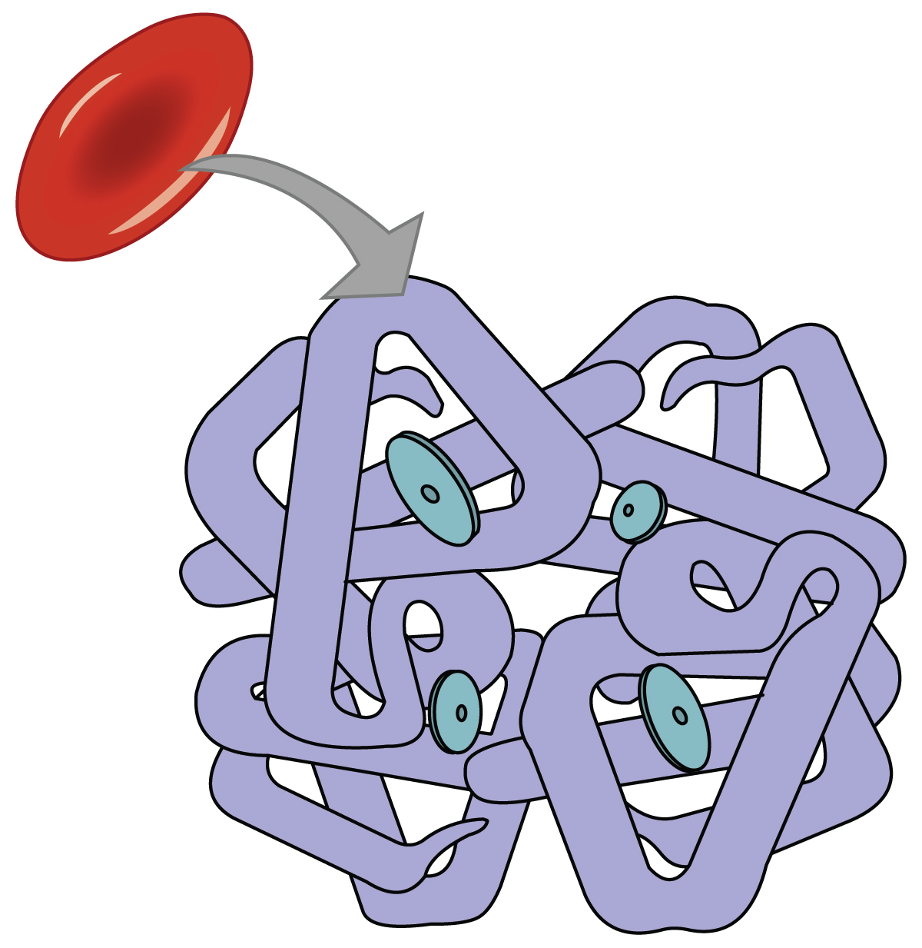
Figure 22.25 Erythrocyte and Hemoglobin Hemoglobin consists of four subunits, each of which contains one molecule of iron.

Function of Hemoglobin
Hemoglobin is composed of subunits, a protein structure that is referred to as a quaternary structure. Each of the four subunits that make up hemoglobin is arranged in a ring-like fashion, with an iron atom covalently bound to the heme in the center of each subunit. Binding of the first oxygen molecule causes a conformational change in hemoglobin that allows the second molecule of oxygen to bind more readily. As each molecule of oxygen is bound, it further facilitates the binding of the next molecule, until all four heme sites are occupied by oxygen. The opposite occurs as well: After the first oxygen molecule dissociates and is “dropped off” at the tissues, the next oxygen molecule dissociates more readily. When all four heme sites are occupied, the hemoglobin is said to be saturated. When one to three heme sites are occupied, the hemoglobin is said to be partially saturated. Therefore, when considering the blood as a whole, the percent of the available heme units that are bound to oxygen at a given time is called hemoglobin saturation. Hemoglobin saturation of 100 percent means that every heme unit in all of the erythrocytes of the body is bound to oxygen. In a healthy individual with normal hemoglobin levels, hemoglobin saturation generally ranges from 95 percent to 99 percent.

Oxygen Dissociation from Hemoglobin
Partial pressure is an important aspect of the binding of oxygen to and disassociation from heme. An oxygen–hemoglobin dissociation curve is a graph that describes the relationship of partial pressure to the binding of oxygen to heme and its subsequent dissociation from heme (Figure 22.26). Remember that gases travel from an area of higher partial pressure to an area of lower partial pressure. In addition, the affinity of an oxygen molecule for heme increases as more oxygen molecules are bound. Therefore, in the oxygen–hemoglobin saturation curve, as the partial pressure of oxygen increases, a proportionately greater number of oxygen molecules are bound by heme. Not surprisingly, the oxygen–hemoglobin saturation/dissociation curve also shows that the lower the partial pressure of oxygen, the fewer oxygen molecules are bound to heme. As a result, the partial pressure of oxygen plays a major role in determining the degree of binding of oxygen to heme at the site of the respiratory membrane, as well as the degree of dissociation of oxygen from heme at the site of body tissues.
  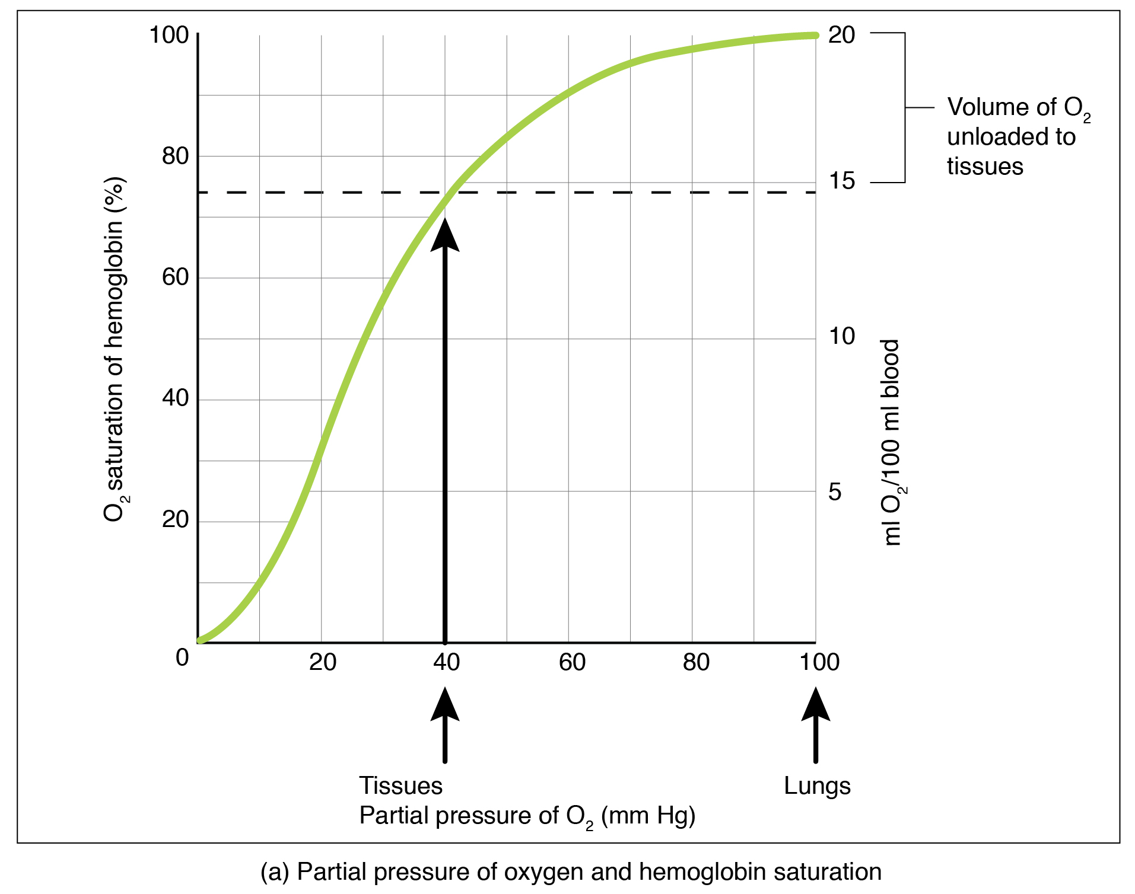
  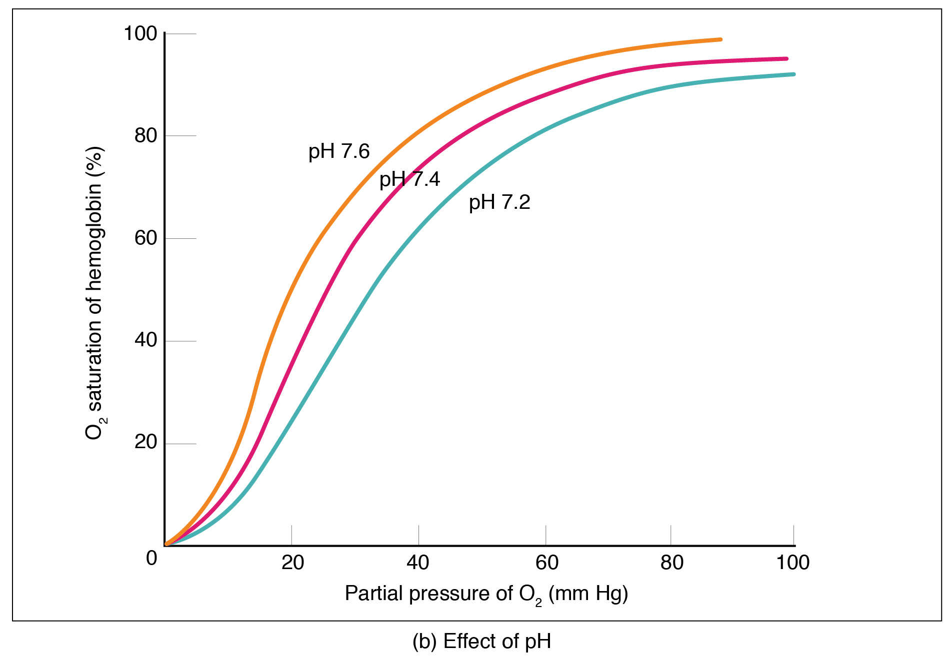
  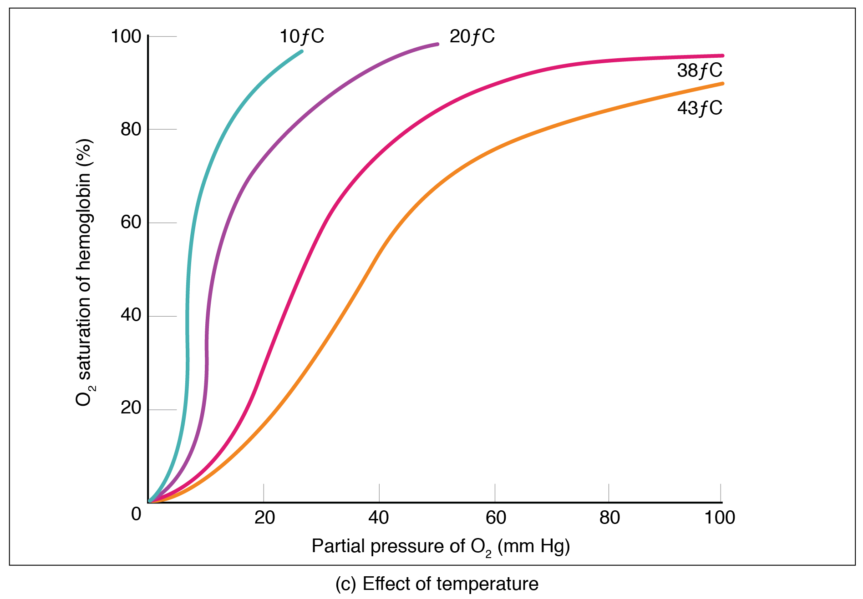
Figure 22.26 Oxygen-Hemoglobin Dissociation and Effects of pH and Temperature These three graphs show (a) the relationship between the partial pressure of oxygen and hemoglobin saturation, (b) the effect of pH on the oxygen–hemoglobin dissociation curve, and (c) the effect of temperature on the oxygen–hemoglobin dissociation curve.
The mechanisms behind the oxygen–hemoglobin saturation/dissociation curve also serve as automatic control mechanisms that regulate how much oxygen is delivered to different tissues throughout the body. This is important because some tissues have a higher metabolic rate than others. Highly active tissues, such as muscle, rapidly use oxygen to produce ATP, lowering the partial pressure of oxygen in the tissue to about 20 mm Hg. The partial pressure of oxygen inside capillaries is about 100 mm Hg, so the difference between the two becomes quite high, about 80 mm Hg. As a result, a greater number of oxygen molecules dissociate from hemoglobin and enter the tissues. The reverse is true of tissues, such as adipose (body fat), which have lower metabolic rates. Because less oxygen is used by these cells, the partial pressure of oxygen within such tissues remains relatively high, resulting in fewer oxygen molecules dissociating from hemoglobin and entering the tissue interstitial fluid. Although venous blood is said to be deoxygenated, some oxygen is still bound to hemoglobin in its red blood cells. This provides an oxygen reserve that can be used when tissues suddenly demand more oxygen.
Factors other than partial pressure also affect the oxygen–hemoglobin saturation/dissociation curve. For example, a higher temperature promotes hemoglobin and oxygen to dissociate faster, whereas a lower temperature inhibits dissociation (see Figure 22.26, middle). However, the human body tightly regulates temperature, so this factor may not affect gas exchange throughout the body. The exception to this is in highly active tissues, which may release a larger amount of energy than is given off as heat. As a result, oxygen readily dissociates from hemoglobin, which is a mechanism that helps to provide active tissues with more oxygen.
Certain hormones, such as androgens, epinephrine, thyroid hormones, and growth hormone, can affect the oxygen–hemoglobin saturation/disassociation curve by stimulating the production of a compound called 2,3-bisphosphoglycerate (BPG) by erythrocytes. BPG is a byproduct of glycolysis. Because erythrocytes do not contain mitochondria, glycolysis is the sole method by which these cells produce ATP. BPG promotes the disassociation of oxygen from hemoglobin. Therefore, the greater the concentration of BPG, the more readily oxygen dissociates from hemoglobin, despite its partial pressure.
The pH of the blood is another factor that influences the oxygen–hemoglobin saturation/dissociation curve (see Figure 22.26). The Bohr effect is a phenomenon that arises from the relationship between pH and oxygen’s affinity for hemoglobin: A lower, more acidic pH promotes oxygen dissociation from hemoglobin. In contrast, a higher, or more basic, pH inhibits oxygen dissociation from hemoglobin. The greater the amount of carbon dioxide in the blood, the more molecules that must be converted, which in turn generates hydrogen ions and thus lowers blood pH. Furthermore, blood pH may become more acidic when certain byproducts of cell metabolism, such as lactic acid, carbonic acid, and carbon dioxide, are released into the bloodstream.

Hemoglobin of the Fetus
The fetus has its own circulation with its own erythrocytes; however, it is dependent on the pregnant person for oxygen. Blood is supplied to the fetus by way of the umbilical cord, which is connected to the placenta and separated from maternal blood by the chorion. The mechanism of gas exchange at the chorion is similar to gas exchange at the respiratory membrane. However, the partial pressure of oxygen is lower in the maternal blood in the placenta, at about 35 to 50 mm Hg, than it is in maternal arterial blood. The difference in partial pressures between maternal and fetal blood is not large, as the partial pressure of oxygen in fetal blood at the placenta is about 20 mm Hg. Therefore, there is not as much diffusion of oxygen into the fetal blood supply. The fetus’ hemoglobin overcomes this problem by having a greater affinity for oxygen than maternal hemoglobin (Figure 22.27). Both fetal and adult hemoglobin have four subunits, but two of the subunits of fetal hemoglobin have a different structure that causes fetal hemoglobin to have a greater affinity for oxygen than does adult hemoglobin.
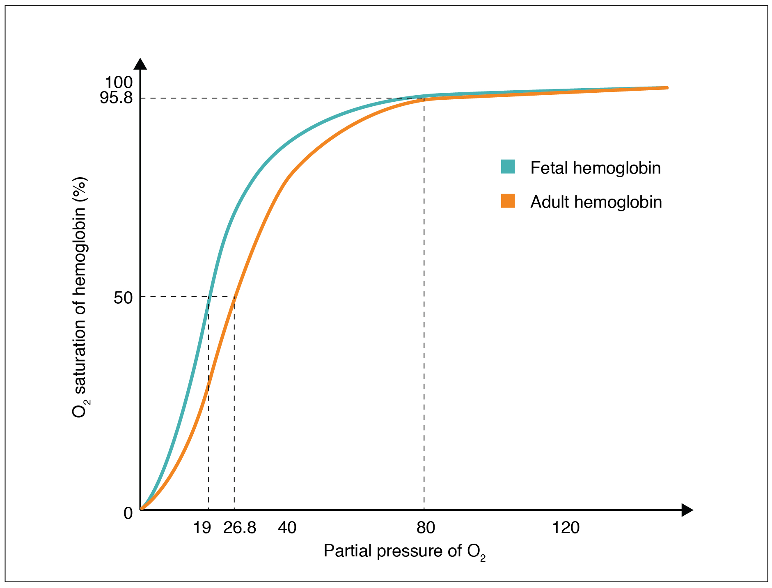
Figure 22.27 Oxygen-Hemoglobin Dissociation Curves in Fetus and Adult Fetal hemoglobin has a greater affinity for oxygen than does adult hemoglobin.

Carbon Dioxide Transport in the Blood
Carbon dioxide is transported by three major mechanisms. The first mechanism of carbon dioxide transport is by blood plasma, as some carbon dioxide molecules dissolve in the blood. The second mechanism is transport in the form of bicarbonate (HCO₃–), which also dissolves in plasma. The third mechanism of carbon dioxide transport is similar to the transport of oxygen by erythrocytes (Figure 22.28).
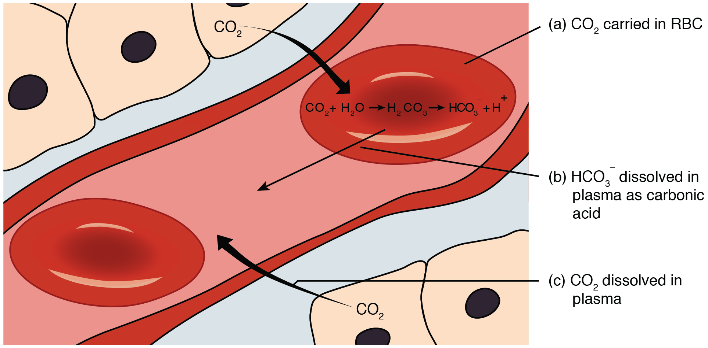
Figure 22.28 Carbon Dioxide Transport Carbon dioxide is transported by three different methods: (a) in erythrocytes; (b) after forming carbonic acid (H₂CO₃ ), which is dissolved in plasma; (c) and in plasma.

Dissolved Carbon Dioxide
Although carbon dioxide is not considered to be highly soluble in blood, a small fraction—about 7 to 10 percent—of the carbon dioxide that diffuses into the blood from the tissues dissolves in plasma. The dissolved carbon dioxide then travels in the bloodstream and when the blood reaches the pulmonary capillaries, the dissolved carbon dioxide diffuses across the respiratory membrane into the alveoli, where it is then exhaled during pulmonary ventilation.

Bicarbonate Buffer
A large fraction—about 70 percent—of the carbon dioxide molecules that diffuse into the blood is transported to the lungs as bicarbonate. Most bicarbonate is produced in erythrocytes after carbon dioxide diffuses into the capillaries, and subsequently into red blood cells. Carbonic anhydrase (CA) causes carbon dioxide and water to form carbonic acid (H₂CO₃), which dissociates into two ions: bicarbonate (HCO₃–) and hydrogen (H⁺). The following formula depicts this reaction:
${\text{CO}}_{\text{2}}{\text{ + H}}_{\text{2}}{\text{O }}^{\underset{↔}{\text{CA}}}{\text{ H}}_{\text{2}}{\text{CO}}_{\text{3}}↔{\text{H}}^{\text{+}}{\text{ + HCO}}_{3−}$
22.4
Bicarbonate tends to build up in the erythrocytes, so that there is a greater concentration of bicarbonate in the erythrocytes than in the surrounding blood plasma. As a result, some of the bicarbonate will leave the erythrocytes and move down its concentration gradient into the plasma in exchange for chloride (Cl–) ions. This phenomenon is referred to as the chloride shift and occurs because by exchanging one negative ion for another negative ion, neither the electrical charge of the erythrocytes nor that of the blood is altered.
At the pulmonary capillaries, the chemical reaction that produced bicarbonate (shown above) is reversed, and carbon dioxide and water are the products. Much of the bicarbonate in the plasma re-enters the erythrocytes in exchange for chloride ions. Hydrogen ions and bicarbonate ions join to form carbonic acid, which is converted into carbon dioxide and water by carbonic anhydrase. Carbon dioxide diffuses out of the erythrocytes and into the plasma, where it can further diffuse across the respiratory membrane into the alveoli to be exhaled during pulmonary ventilation.

Carbaminohemoglobin
About 20 percent of carbon dioxide is bound by hemoglobin and is transported to the lungs. Carbon dioxide does not bind to iron as oxygen does; instead, carbon dioxide binds amino acid moieties on the globin portions of hemoglobin to form carbaminohemoglobin, which forms when hemoglobin and carbon dioxide bind. When hemoglobin is not transporting oxygen, it tends to have a bluish-purple tone to it, creating the darker maroon color typical of deoxygenated blood. The following formula depicts this reversible reaction:
${\text{CO}}_{\text{2}}\text{ + Hb}↔{\text{HbCO}}_{\text{2}}$
22.5
Similar to the transport of oxygen by heme, the binding and dissociation of carbon dioxide to and from hemoglobin is dependent on the partial pressure of carbon dioxide. Because carbon dioxide is released from the lungs, blood that leaves the lungs and reaches body tissues has a lower partial pressure of carbon dioxide than is found in the tissues. As a result, carbon dioxide leaves the tissues because of its higher partial pressure, enters the blood, and then moves into red blood cells, binding to hemoglobin. In contrast, in the pulmonary capillaries, the partial pressure of carbon dioxide is high compared to within the alveoli. As a result, carbon dioxide dissociates readily from hemoglobin and diffuses across the respiratory membrane into the air.
In addition to the partial pressure of carbon dioxide, the oxygen saturation of hemoglobin and the partial pressure of oxygen in the blood also influence the affinity of hemoglobin for carbon dioxide. The Haldane effect is a phenomenon that arises from the relationship between the partial pressure of oxygen and the affinity of hemoglobin for carbon dioxide. Hemoglobin that is saturated with oxygen does not readily bind carbon dioxide. However, when oxygen is not bound to heme and the partial pressure of oxygen is low, hemoglobin readily binds to carbon dioxide.

Interactive Link
Watch this video to see the transport of oxygen from the lungs to the tissues. Why is oxygenated blood bright red, whereas deoxygenated blood tends to be more of a purple color?

