26.2 Water Balance

Learning Objectives
By the end of this section, you will be able to:
- Explain how water levels in the body influence the thirst cycle
- Identify the main route by which water leaves the body
- Describe the role of ADH and its effect on body water levels
- Define dehydration and identify common causes of dehydration
On a typical day, the average adult will take in about 2500 mL (almost 3 quarts) of aqueous fluids. Although most of the intake comes through the digestive tract, about 230 mL (8 ounces) per day is generated metabolically, in the last steps of aerobic respiration. Additionally, each day about the same volume (2500 mL) of water leaves the body by different routes; most of this lost water is removed as urine. The kidneys also can adjust blood volume though mechanisms that draw water out of the filtrate and urine. The kidneys can regulate water levels in the body; they conserve water if you are dehydrated, and they can make urine more dilute to expel excess water if necessary. Water is lost through the skin through evaporation from the skin surface without overt sweating and from air expelled from the lungs. This type of water loss is called insensible water loss because a person is usually unaware of it.

Regulation of Water Intake
Osmolality is the ratio of solutes in a solution to a volume of solvent in a solution. Plasma osmolality is thus the ratio of solutes to water in blood plasma. A person’s plasma osmolality value reflects the state of hydration. A healthy body maintains plasma osmolality within a narrow range, by employing several mechanisms that regulate both water intake and output.
Drinking water is considered voluntary. So how is water intake regulated by the body? Consider someone who is experiencing dehydration, a net loss of water that results in insufficient water in blood and other tissues. The water that leaves the body, as exhaled air, sweat, or urine, is ultimately extracted from blood plasma. As the blood becomes more concentrated, the thirst response—a sequence of physiological processes—is triggered (Figure 26.10). Osmoreceptors are sensory receptors in the thirst center in the hypothalamus that monitor the concentration of solutes (osmolality) of the blood. If blood osmolality increases above its ideal value, the hypothalamus transmits signals that result in a conscious awareness of thirst. The person should (and normally does) respond by drinking water. The hypothalamus of a dehydrated person also releases antidiuretic hormone (ADH) through the posterior pituitary gland. ADH signals the kidneys to recover water from urine, effectively diluting the blood plasma. To conserve water, the hypothalamus of a dehydrated person also sends signals via the sympathetic nervous system to the salivary glands in the mouth. The signals result in a decrease in watery, serous output (and an increase in stickier, thicker mucus output). These changes in secretions result in a “dry mouth” and the sensation of thirst.
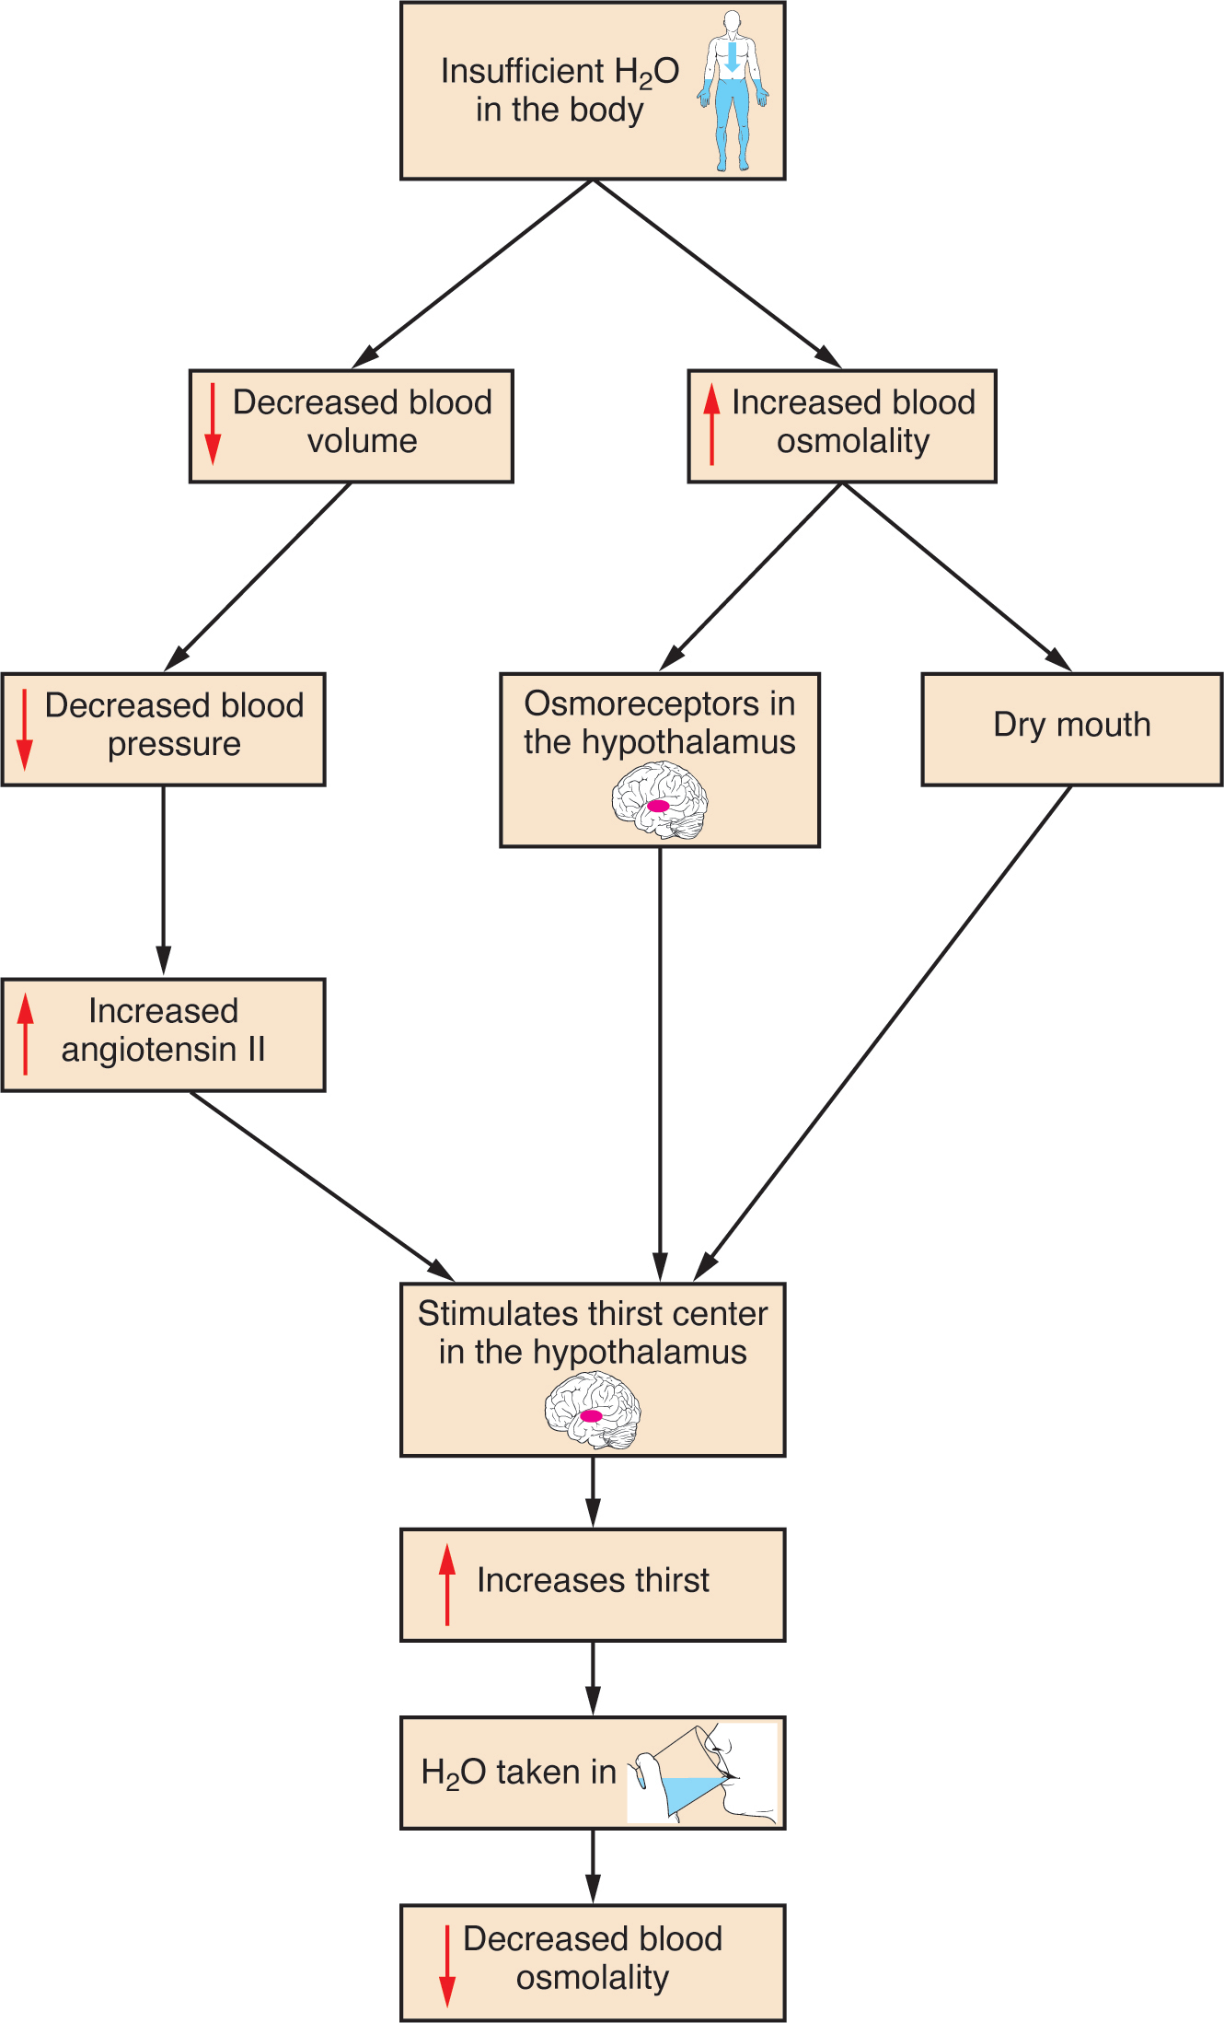
Figure 26.10 A Flowchart Showing the Thirst Response The thirst response begins when osmoreceptors detect a decrease in water levels in the blood.
Decreased blood volume resulting from water loss has two additional effects. First, baroreceptors, blood-pressure receptors in the arch of the aorta and the carotid arteries in the neck, detect a decrease in blood pressure that results from decreased blood volume. The heart is ultimately signaled to increase its rate and/or strength of contractions to compensate for the lowered blood pressure.
Second, the kidneys have a renin-angiotensin hormonal system that increases the production of the active form of the hormone angiotensin II, which helps stimulate thirst, but also stimulates the release of the hormone aldosterone from the adrenal glands. Aldosterone increases the reabsorption of sodium in the distal tubules of the nephrons in the kidneys, and water follows this reabsorbed sodium back into the blood.
If adequate fluids are not consumed, dehydration results and a person’s body contains too little water to function correctly. A person who repeatedly vomits or who has diarrhea may become dehydrated, and infants, because their body mass is so low, can become dangerously dehydrated very quickly. Endurance athletes such as distance runners often become dehydrated during long races. Dehydration can be a medical emergency, and a dehydrated person may lose consciousness, become comatose, or die, if their body is not rehydrated quickly.

Regulation of Water Output
Water loss from the body occurs predominantly through the renal system. A person produces an average of 1.5 liters (1.6 quarts) of urine per day. Although the volume of urine varies in response to hydration levels, there is a minimum volume of urine production required for proper bodily functions. The kidney excretes 100 to 1200 milliosmoles of solutes per day to rid the body of a variety of excess salts and other water-soluble chemical wastes, most notably creatinine, urea, and uric acid. Failure to produce the minimum volume of urine means that metabolic wastes cannot be effectively removed from the body, a situation that can impair organ function. The minimum level of urine production necessary to maintain normal function is about 0.47 liters (0.5 quarts) per day.
The kidneys also must make adjustments in the event of ingestion of too much fluid. Diuresis, which is the production of urine in excess of normal levels, begins about 30 minutes after drinking a large quantity of fluid. Diuresis reaches a peak after about 1 hour, and normal urine production is reestablished after about 3 hours.

Role of ADH
Antidiuretic hormone (ADH), also known as vasopressin, controls the amount of water reabsorbed from the collecting ducts and tubules in the kidney. This hormone is produced in the hypothalamus and is delivered to the posterior pituitary for storage and release (Figure 26.11). When the osmoreceptors in the hypothalamus detect an increase in the concentration of blood plasma, the hypothalamus signals the release of ADH from the posterior pituitary into the blood.
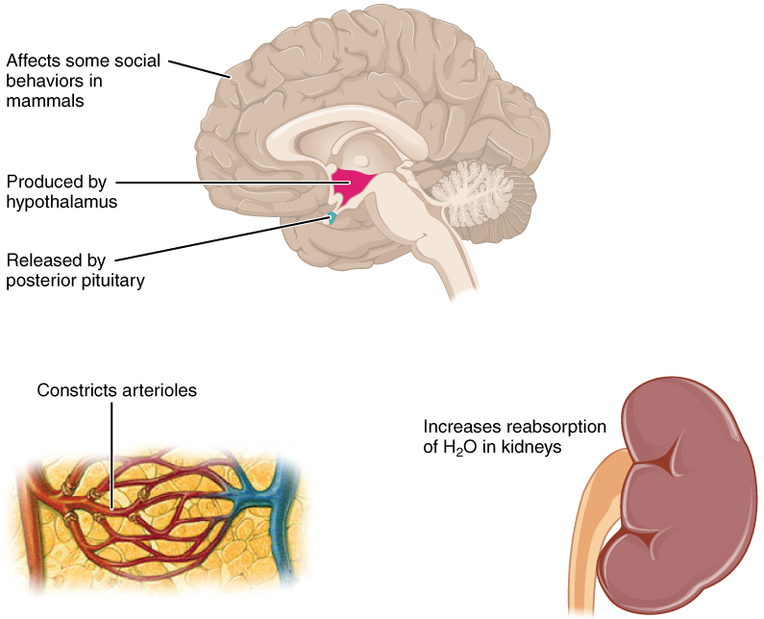
Figure 26.11 Antidiuretic Hormone (ADH) ADH is produced in the hypothalamus and released by the posterior pituitary gland. It causes the kidneys to retain water, constricts arterioles in the peripheral circulation, and affects some social behaviors in mammals.
ADH has two major effects. It constricts the arterioles in the peripheral circulation, which reduces the flow of blood to the extremities and thereby increases the blood supply to the core of the body. ADH also causes the epithelial cells that line the renal collecting tubules to move water channel proteins, called aquaporins, from the interior of the cells to the apical surface, where these proteins are inserted into the cell membrane (Figure 26.12). The result is an increase in the water permeability of these cells and, thus, a large increase in water passage from the urine through the walls of the collecting tubules, leading to more reabsorption of water into the bloodstream. When the blood plasma becomes less concentrated and the level of ADH decreases, aquaporins are removed from collecting tubule cell membranes, and the passage of water out of urine and into the blood decreases.
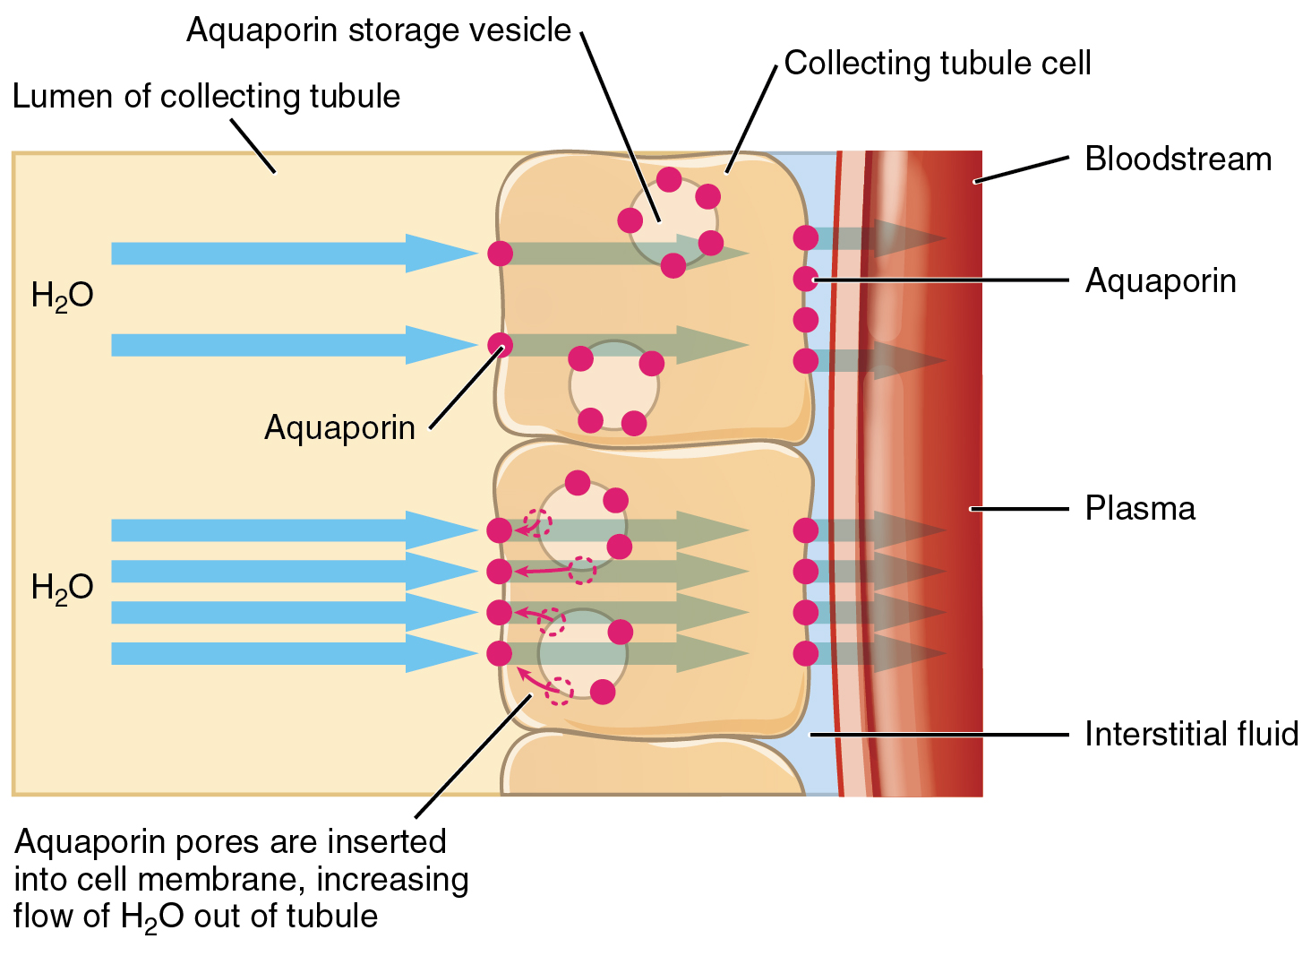
Figure 26.12 Aquaporins The binding of ADH to receptors on the cells of the collecting tubule results in aquaporins being inserted into the plasma membrane, shown in the lower cell. This dramatically increases the flow of water out of the tubule and into the bloodstream.
A diuretic is a compound that increases urine output and therefore decreases water conservation by the body. Diuretics are used to treat hypertension, congestive heart failure, and fluid retention associated with menstruation. Alcohol acts as a diuretic by inhibiting the release of ADH. Additionally, caffeine, when consumed in high concentrations, acts as a diuretic.

