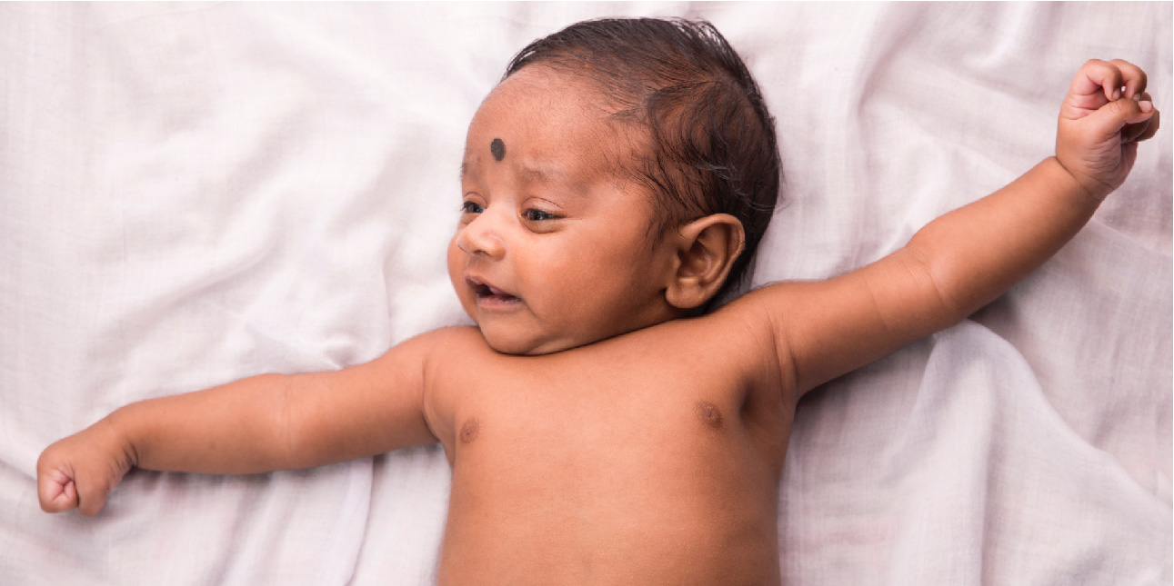
Figure 28.1 Newborn A single fertilized egg develops over the span of nine months into an infant consisting of trillions of cells and capable of surviving outside the womb. (credit: “Seattleye”/flickr.com)

Chapter Objectives
After studying this chapter, you will be able to:
- List and explain the steps involved in fertilization
- Describe the major events in embryonic development
- Describe the major events in fetal development
- Discuss the adaptations of the body to pregnancy
- Describe the physiologic adjustments that the newborn must make in the first hours of extrauterine life
- Summarize the physiology of lactation
- Classify and describe the different patterns of inheritance

Introduction
In approximately nine months, a single cell—a fertilized egg—develops into a fully formed infant consisting of trillions of cells with myriad specialized functions. The dramatic changes of fertilization, embryonic development, and fetal development are followed by remarkable adaptations of the newborn to life outside the womb. An offspring’s normal development depends upon the appropriate synthesis of structural and functional proteins. This, in turn, is governed by the genetic material inherited from the egg and sperm, as well as environmental factors.

