4.1 Types of Tissues

Learning Objectives
By the end of this section, you will be able to:
- Identify the four main tissue types
- Discuss the functions of each tissue type
- Relate the structure of each tissue type to their function
- Discuss the embryonic origin of tissue
- Identify the three major germ layers
- Identify the main types of tissue membranes
The term tissue is used to describe a group of cells found together in the body. The cells within a tissue share a common embryonic origin. Microscopic observation reveals that the cells in a tissue share morphological features and are arranged in an orderly pattern that achieves the tissue’s functions. From the evolutionary perspective, tissues appear in more complex organisms. For example, multicellular protists, ancient eukaryotes, do not have cells organized into tissues.
Although there are many types of cells in the human body, they are organized into four broad categories of tissues: epithelial, connective, muscle, and nervous. Each of these categories is characterized by specific functions that contribute to the overall health and maintenance of the body. A disruption of the structure is a sign of injury or disease. Such changes can be detected through histology, the microscopic study of tissue appearance, organization, and function.

The Four Types of Tissues
Epithelial tissue, also referred to as epithelium, refers to the sheets of cells that cover exterior surfaces of the body, line internal cavities and passageways, and form certain glands. Connective tissue, as its name implies, binds the cells and organs of the body together and functions in the protection, support, and integration of all parts of the body. Muscle tissue is excitable, responding to stimulation and contracting to provide movement, and occurs as three major types: skeletal (voluntary) muscle, smooth muscle, and cardiac muscle in the heart. Nervous tissue is also excitable, allowing the propagation of electrochemical signals in the form of nerve impulses that communicate between different regions of the body (Figure 4.2).
The next level of organization is the organ, where several types of tissues come together to form a working unit. Just as knowing the structure and function of cells helps you in your study of tissues, knowledge of tissues will help you understand how organs function. The epithelial and connective tissues are discussed in detail in this chapter. Muscle and nervous tissues will be discussed only briefly in this chapter.
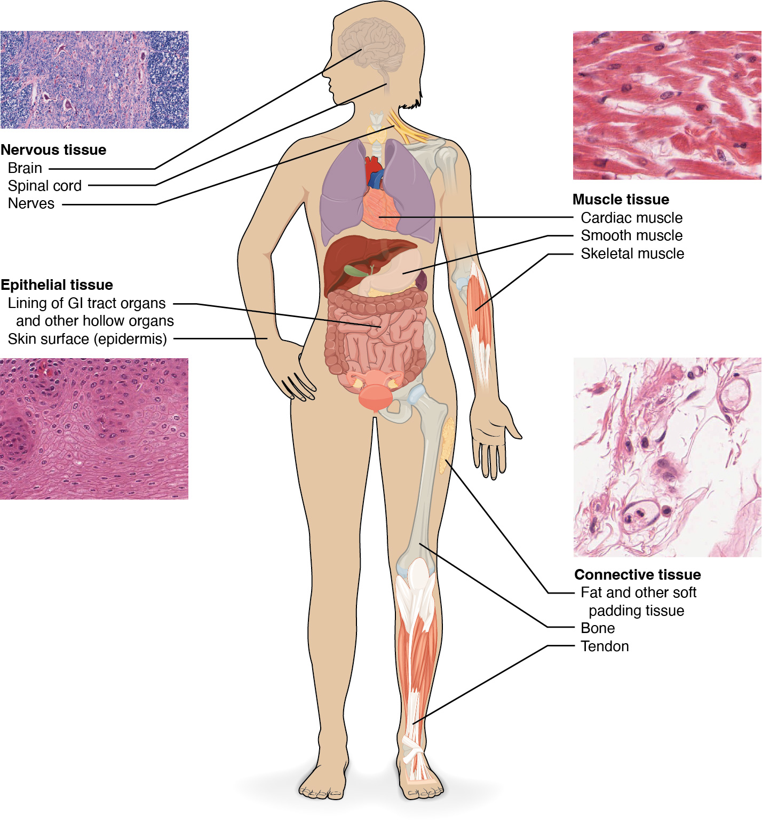
Figure 4.2 Four Types of Tissue: Body The four types of tissues are exemplified in nervous tissue, stratified squamous epithelial tissue, cardiac muscle tissue, and connective tissue. (Micrographs provided by the Regents of University of Michigan Medical School © 2012)

Embryonic Origin of Tissues
The zygote, or fertilized egg, is a single cell formed by the fusion of an egg and sperm. After fertilization the zygote gives rise to rapid mitotic cycles, generating many cells to form the embryo. The first embryonic cells generated have the ability to differentiate into any type of cell in the body and, as such, are called totipotent, meaning each has the capacity to divide, differentiate, and develop into a new organism. As cell proliferation progresses, three major cell lineages are established within the embryo. As explained in a later chapter, each of these lineages of embryonic cells forms the distinct germ layers from which all the tissues and organs of the human body eventually form. Each germ layer is identified by its relative position: ectoderm (ecto- = “outer”), mesoderm (meso- = “middle”), and endoderm (endo- = “inner”). Figure 4.3 shows the types of tissues and organs associated with the each of the three germ layers. Note that epithelial tissue originates in all three layers, whereas nervous tissue derives primarily from the ectoderm and muscle tissue from mesoderm.
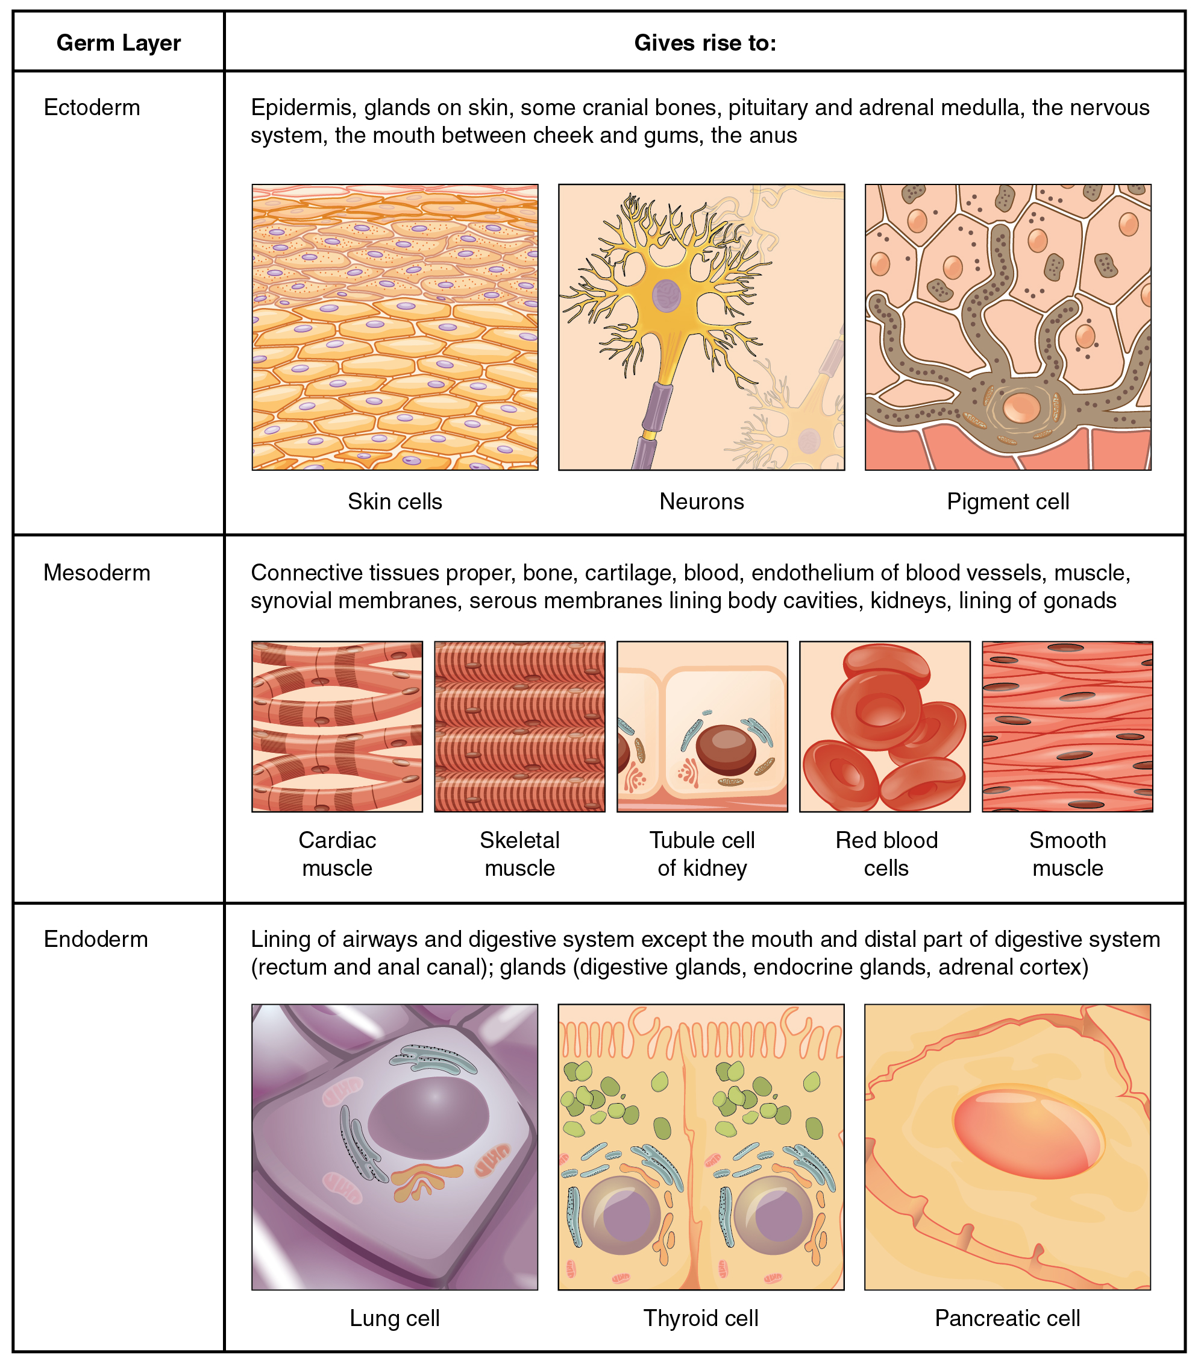
Figure 4.3 Embryonic Origin of Tissues and Major Organs

Interactive Link
View this slideshow to learn more about stem cells. How do somatic stem cells differ from embryonic stem cells?

Tissue Membranes
A tissue membrane is a thin layer or sheet of cells that covers the outside of the body (for example, skin), the organs (for example, pericardium), internal passageways that lead to the exterior of the body (for example, mucosa of stomach), and the lining of the moveable joint cavities. There are two basic types of tissue membranes: connective tissue and epithelial membranes (Figure 4.4).
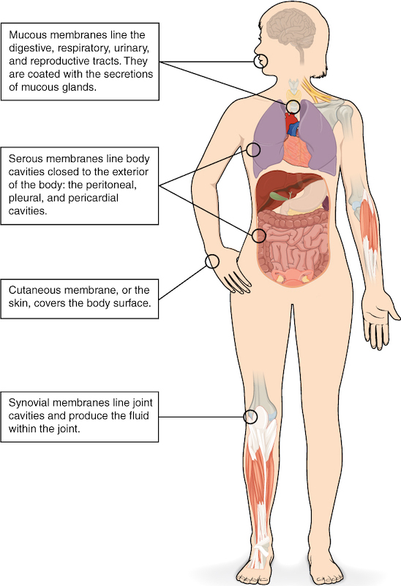
Figure 4.4 Tissue Membranes The two broad categories of tissue membranes in the body are (1) connective tissue membranes, which include synovial membranes, and (2) epithelial membranes, which include mucous membranes, serous membranes, and the cutaneous membrane, in other words, the skin.

Connective Tissue Membranes
The connective tissue membrane is formed solely from connective tissue. These membranes encapsulate organs, such as the kidneys, and line our movable joints. A synovial membrane is a type of connective tissue membrane that lines the cavity of a freely movable joint. For example, synovial membranes surround the joints of the shoulder, elbow, and knee. Fibroblasts in the inner layer of the synovial membrane release hyaluronan into the joint cavity. The hyaluronan effectively traps available water to form the synovial fluid, a natural lubricant that enables the bones of a joint to move freely against one another without much friction. This synovial fluid readily exchanges water and nutrients with blood, as do all body fluids.

Epithelial Membranes
The epithelial membrane is composed of epithelium attached to a layer of connective tissue, for example, your skin. The mucous membrane is also a composite of connective and epithelial tissues. Sometimes called mucosae, these epithelial membranes line the body cavities and hollow passageways that open to the external environment, and include the digestive, respiratory, excretory, and reproductive tracts. Mucus, produced by the epithelial exocrine glands, covers the epithelial layer. The underlying connective tissue, called the lamina propria (literally “own layer”), help support the fragile epithelial layer.
A serous membrane is an epithelial membrane composed of mesodermally derived epithelium called the mesothelium that is supported by connective tissue. These membranes line the coelomic cavities of the body, that is, those cavities that do not open to the outside, and they cover the organs located within those cavities. They are essentially membranous bags, with mesothelium lining the inside and connective tissue on the outside. Serous fluid secreted by the cells of the thin squamous mesothelium lubricates the membrane and reduces abrasion and friction between organs. Serous membranes are identified according locations. Three serous membranes line the thoracic cavity; the two pleura that cover the lungs and the pericardium that covers the heart. A fourth, the peritoneum, is the serous membrane in the abdominal cavity that covers abdominal organs and forms double sheets of mesenteries that suspend many of the digestive organs.
The skin is an epithelial membrane also called the cutaneous membrane. It is a stratified squamous epithelial membrane resting on top of connective tissue. The apical surface of this membrane is exposed to the external environment and is covered with dead, keratinized cells that help protect the body from desiccation and pathogens.

