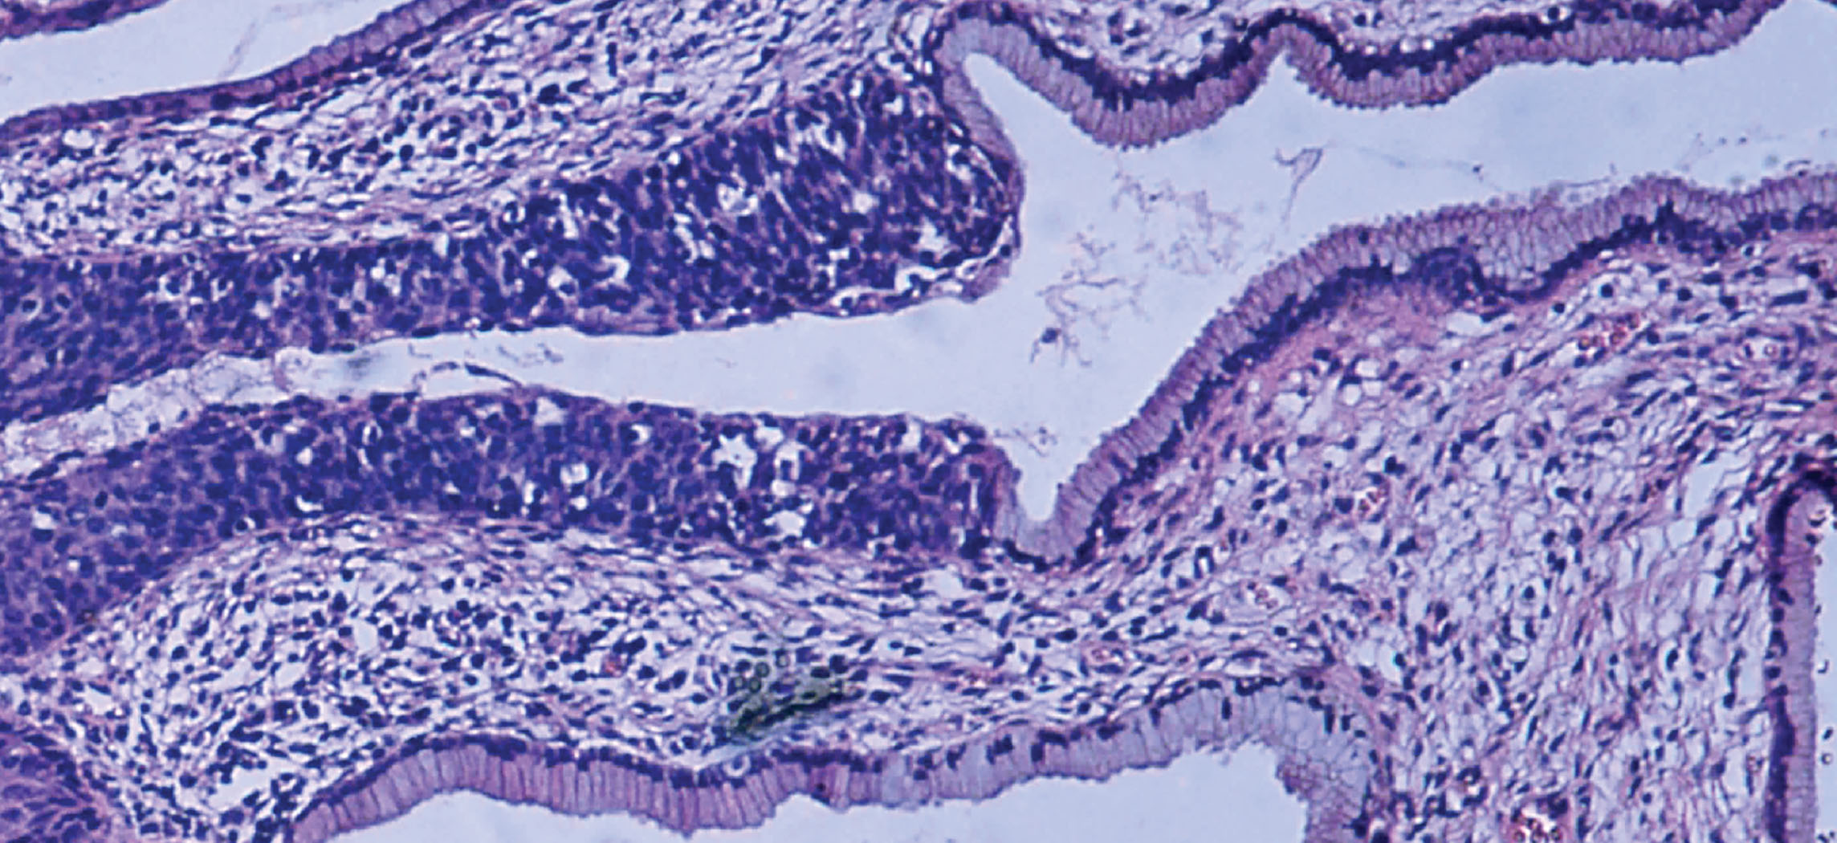
Figure 4.1 Micrograph of Cervical Tissue This figure is a view of the regular architecture of normal tissue contrasted with the irregular arrangement of cancerous cells. (credit: “Haymanj”/Wikimedia Commons)

Chapter Objectives
After studying this chapter, you will be able to:
- Identify the main tissue types and discuss their roles in the human body
- Identify the four types of tissue membranes and the characteristics of each that make them functional
- Explain the functions of various epithelial tissues and how their forms enable their functions
- Explain the functions of various connective tissues and how their forms enable their functions
- Describe the characteristics of muscle tissue and how these enable function
- Discuss the characteristics of nervous tissue and how these enable information processing and control of muscular and glandular activities

Introduction
The body contains at least 200 distinct cell types. These cells contain essentially the same internal structures yet they vary enormously in shape and function. The different types of cells are not randomly distributed throughout the body; rather they occur in organized layers, a level of organization referred to as tissue. The micrograph that opens this chapter shows the high degree of organization among different types of cells in the tissue of the cervix. You can also see how that organization breaks down when cancer takes over the regular mitotic functioning of a cell.
The variety in shape reflects the many different roles that cells fulfill in your body. The human body starts as a single cell at fertilization. As this fertilized egg divides, it gives rise to trillions of cells, each built from the same blueprint, but organizing into tissues and becoming irreversibly committed to a developmental pathway.

