6.2 Bone Classification

Learning Objectives
By the end of this section, you will be able to:
- Classify bones according to their shapes
- Describe the function of each category of bones
A baby's body has 270–300 bones at birth, some of which are made entirely of a special material called cartilage. These bones eventually fuse (grow together) to form the 206 bones that adults have. Bones stop growing in length between the ages of 16 and 18. But the total amount of bone tissue you have—your bone density—continues to increase slowly, until your late 20s. The 206 bones that compose the adult skeleton are divided into five categories based on their shapes (Figure 6.6). Their shapes and their functions are related such that each categorical shape of bone has a distinct function.
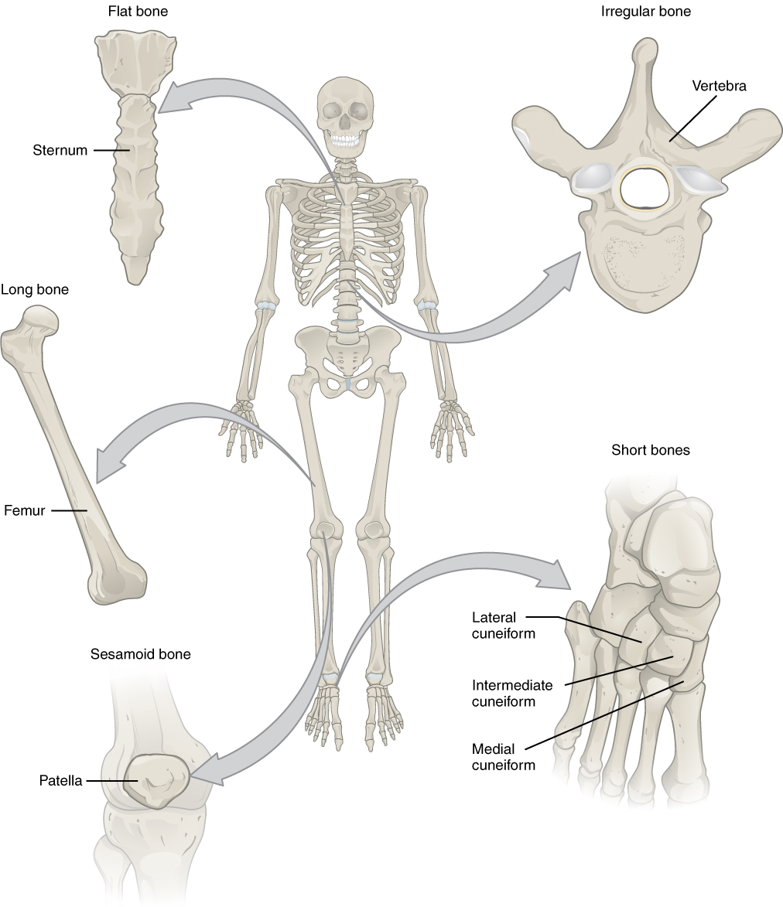
Figure 6.6 Classifications of Bones Bones are classified according to their shape.

Long Bones
A long bone is one that is cylindrical in shape, being longer than it is wide. Keep in mind, however, that the term describes the shape of a bone, not its size. Long bones are found in the arms (humerus, ulna, radius) and legs (femur, tibia, fibula), as well as in the fingers (metacarpals, phalanges) and toes (metatarsals, phalanges). Long bones function as levers; they move when muscles contract.

Short Bones
A short bone is one that is cube-like in shape, being approximately equal in length, width, and thickness. The only short bones in the human skeleton are in the carpals of the wrists and the tarsals of the ankles. Short bones provide stability and support as well as some limited motion.

Flat Bones
The term “flat bone” is somewhat of a misnomer because, although a flat bone is typically thin, it is also often curved. Examples include the cranial (skull) bones, the scapulae (shoulder blades), the sternum (breastbone), and the ribs. Flat bones serve as points of attachment for muscles and often protect internal organs.

Irregular Bones
An irregular bone is one that does not have any easily characterized shape and therefore does not fit any other classification. These bones tend to have more complex shapes, like the vertebrae that support the spinal cord and protect it from compressive forces. Many facial bones, particularly the ones containing sinuses, are classified as irregular bones.

Sesamoid Bones
A sesamoid bone is a small, round bone that, as the name suggests, is shaped like a sesame seed. These bones form in tendons (the sheaths of tissue that connect bones to muscles) where a great deal of pressure is generated in a joint. The sesamoid bones protect tendons by helping them overcome compressive forces. Sesamoid bones vary in number and placement from person to person but are typically found in tendons associated with the feet, hands, and knees. The patellae (singular = patella) are the only sesamoid bones found in common with every person. Table 6.1 reviews bone classifications with their associated features, functions, and examples.
Bone Classifications
Bone classification | Features | Function(s) | Examples
Long | Cylinder-like shape, longer than it is wide | Leverage | Femur, tibia, fibula, metatarsals, humerus, ulna, radius, metacarpals, phalanges
Short | Cube-like shape, approximately equal in length, width, and thickness | Provide stability, support, while allowing for some motion | Carpals, tarsals
Flat | Thin and curved | Points of attachment for muscles; protectors of internal organs | Sternum, ribs, scapulae, cranial bones
Irregular | Complex shape | Protect internal organs | Vertebrae, facial bones
Sesamoid | Small and round; embedded in tendons | Protect tendons from compressive forces | Patellae
Table 6.1

