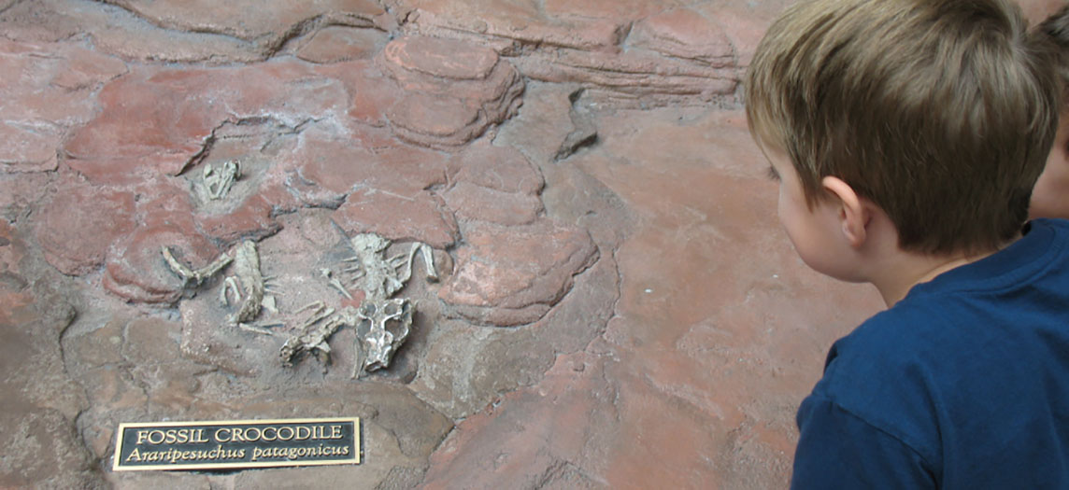
Figure 6.1 Child Looking at Bones Bone is a living tissue. Unlike the bones of a fossil made inert by a process of mineralization, a child’s bones will continue to grow and develop while contributing to the support and function of other body systems. (credit: James Emery)

Chapter Objectives
After studying this chapter, you will be able to:
- List and describe the functions of bones
- Describe the classes of bones
- Discuss the process of bone formation and development
- Explain how bone repairs itself after a fracture
- Discuss the effect of exercise, nutrition, and hormones on bone tissue
- Describe how an imbalance of calcium can affect bone tissue

Introduction
Bones make good fossils. While the soft tissue of a once living organism will decay and fall away over time, bone tissue will, under the right conditions, undergo a process of mineralization, effectively turning the bone to stone. A well-preserved fossil skeleton can give us a good sense of the size and shape of an organism, just as your skeleton helps to define your size and shape. Unlike a fossil skeleton, however, your skeleton is a structure of living tissue that grows, repairs, and renews itself. The bones within it are dynamic and complex organs that serve a number of important functions, including some necessary to maintain homeostasis.

