9.1 Classification of Joints

Learning Objectives
By the end of this section, you will be able to:
- Distinguish between the functional and structural classifications for joints
- Describe the three functional types of joints and give an example of each
- List the three types of diarthrodial joints
A joint, also called an articulation, is any place where adjacent bones or bone and cartilage come together (articulate with each other) to form a connection. Joints are classified both structurally and functionally. Structural classifications of joints take into account whether the adjacent bones are strongly anchored to each other by fibrous connective tissue or cartilage, or whether the adjacent bones articulate with each other within a fluid-filled space called a joint cavity. Functional classifications describe the degree of movement available between the bones, ranging from immobile, to slightly mobile, to freely moveable joints. The amount of movement available at a particular joint of the body is related to the functional requirements for that joint. Thus immobile or slightly moveable joints serve to protect internal organs, give stability to the body, and allow for limited body movement. In contrast, freely moveable joints allow for much more extensive movements of the body and limbs.

Structural Classification of Joints
The structural classification of joints is based on whether the articulating surfaces of the adjacent bones are directly connected by fibrous connective tissue or cartilage, or whether the articulating surfaces contact each other within a fluid-filled joint cavity. These differences serve to divide the joints of the body into three structural classifications. A fibrous joint is where the adjacent bones are united by fibrous connective tissue. At a cartilaginous joint, the bones are joined by hyaline cartilage or fibrocartilage. At a synovial joint, the articulating surfaces of the bones are not directly connected, but instead come into contact with each other within a joint cavity that is filled with a lubricating fluid. Synovial joints allow for free movement between the bones and are the most common joints of the body.

Functional Classification of Joints
The functional classification of joints is determined by the amount of mobility found between the adjacent bones. Joints are thus functionally classified as a synarthrosis or immobile joint, an amphiarthrosis or slightly moveable joint, or as a diarthrosis, which is a freely moveable joint (arthroun = “to fasten by a joint”). Depending on their location, fibrous joints may be functionally classified as a synarthrosis (immobile joint) or an amphiarthrosis (slightly mobile joint). Cartilaginous joints are also functionally classified as either a synarthrosis or an amphiarthrosis joint. All synovial joints are functionally classified as a diarthrosis joint.

Synarthrosis
An immobile or nearly immobile joint is called a synarthrosis. The immobile nature of these joints provide for a strong union between the articulating bones. This is important at locations where the bones provide protection for internal organs. Examples include sutures, the fibrous joints between the bones of the skull that surround and protect the brain (Figure 9.2), and the manubriosternal joint, the cartilaginous joint that unites the manubrium and body of the sternum for protection of the heart.
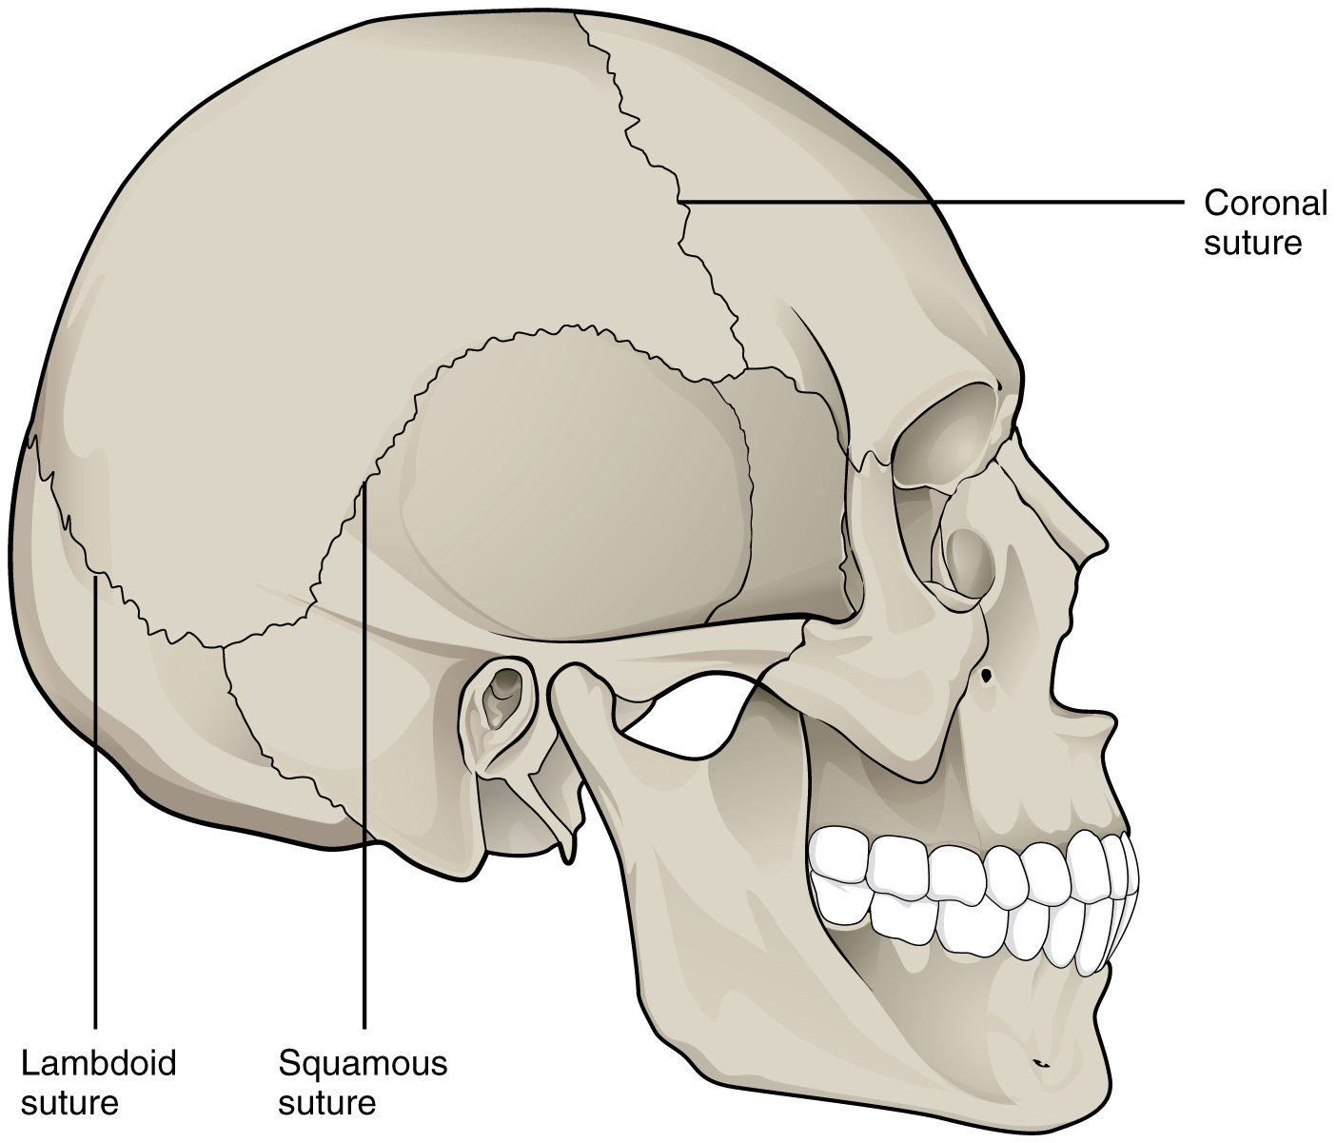
Figure 9.2 Suture Joints of Skull The suture joints of the skull are an example of a synarthrosis, an immobile or essentially immobile joint.

Amphiarthrosis
An amphiarthrosis is a joint that has limited mobility. An example of this type of joint is the cartilaginous joint that unites the bodies of adjacent vertebrae. Filling the gap between the vertebrae is a thick pad of fibrocartilage called an intervertebral disc (Figure 9.3). Each intervertebral disc strongly unites the vertebrae but still allows for a limited amount of movement between them. However, the small movements available between adjacent vertebrae can sum together along the length of the vertebral column to provide for large ranges of body movements.
Another example of an amphiarthrosis is the pubic symphysis of the pelvis. This is a cartilaginous joint in which the pubic regions of the right and left hip bones are strongly anchored to each other by fibrocartilage. This joint normally has very little mobility. The strength of the pubic symphysis is important in conferring weight-bearing stability to the pelvis.
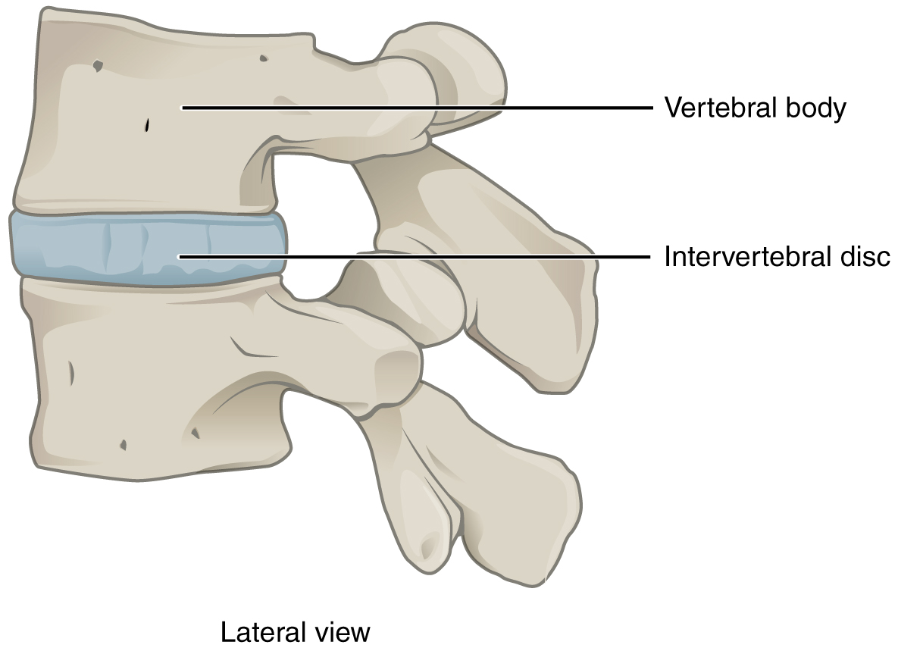
Figure 9.3 Intervertebral Disc An intervertebral disc unites the bodies of adjacent vertebrae within the vertebral column. Each disc allows for limited movement between the vertebrae and thus functionally forms an amphiarthrosis type of joint. Intervertebral discs are made of fibrocartilage and thereby structurally form a symphysis type of cartilaginous joint.

Diarthrosis
A freely mobile joint is classified as a diarthrosis. These types of joints include all synovial joints of the body, which provide the majority of body movements. Most diarthrotic joints are found in the appendicular skeleton and thus give the limbs a wide range of motion. These joints are divided into three categories, based on the number of axes of motion provided by each. An axis in anatomy is described as the movements in reference to the three anatomical planes: transverse, frontal, and sagittal. Thus, diarthroses are classified as uniaxial (for movement in one plane), biaxial (for movement in two planes), or multiaxial joints (for movement in all three anatomical planes).
A uniaxial joint only allows for a motion in a single plane (around a single axis). The elbow joint, which only allows for bending or straightening, is an example of a uniaxial joint. A biaxial joint allows for motions within two planes. An example of a biaxial joint is a metacarpophalangeal joint (knuckle joint) of the hand. The joint allows for movement along one axis to produce bending or straightening of the finger, and movement along a second axis, which allows for spreading of the fingers away from each other and bringing them together. A joint that allows for the several directions of movement is called a multiaxial joint (polyaxial or triaxial joint). This type of diarthrotic joint allows for movement along three axes (Figure 9.4). The shoulder and hip joints are multiaxial joints. They allow the upper or lower limb to move in an anterior-posterior direction and a medial-lateral direction. In addition, the limb can also be rotated around its long axis. This third movement results in rotation of the limb so that its anterior surface is moved either toward or away from the midline of the body.
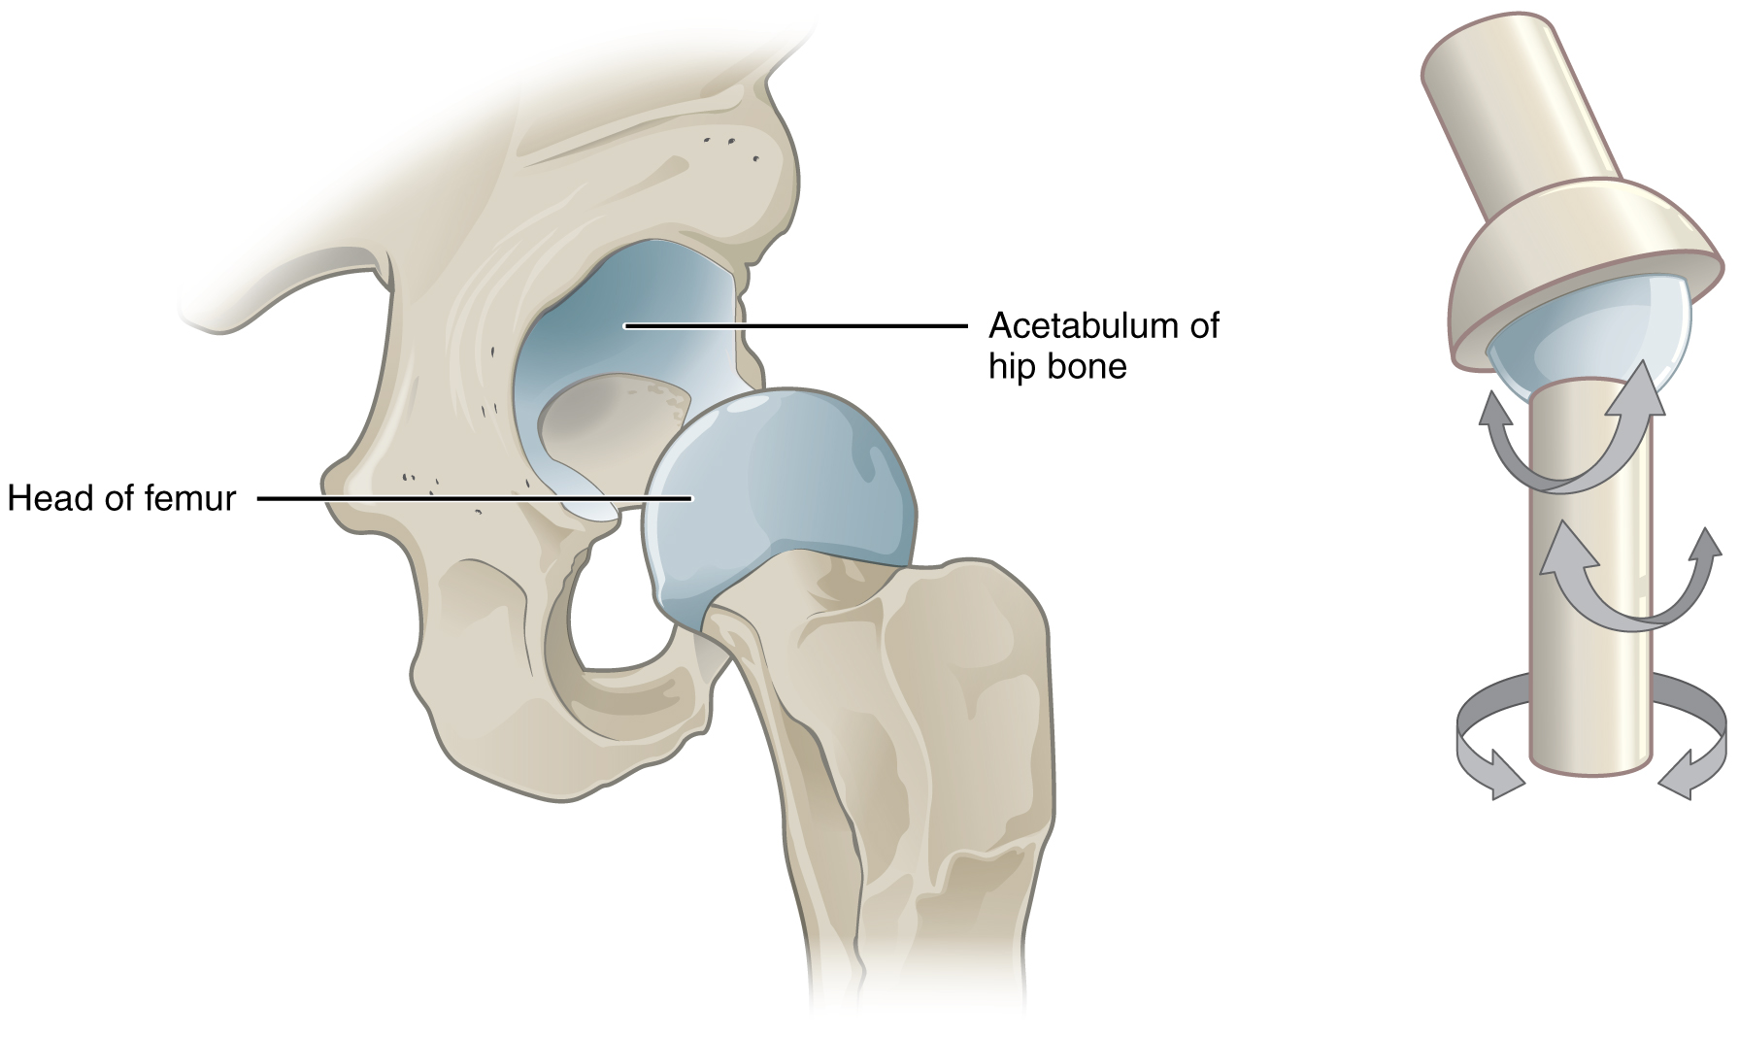
Figure 9.4 Multiaxial Joint A multiaxial joint, such as the hip joint, allows for three types of movement: anterior-posterior, medial-lateral, and rotational.

