9.5 Types of Body Movements

Learning Objectives
By the end of this section, you will be able to:
- Define the different types of body movements
- Identify the joints that allow for these motions
Synovial joints allow the body a tremendous range of movements. Each movement at a synovial joint results from the contraction or relaxation of the muscles that are attached to the bones on either side of the articulation. The type of movement that can be produced at a synovial joint is determined by its structural type. While the ball-and-socket joint gives the greatest range of movement at an individual joint, in other regions of the body, several joints may work together to produce a particular movement. Overall, each type of synovial joint is necessary to provide the body with its great flexibility and mobility. There are many types of movement that can occur at synovial joints (Table 9.1). Movement types are generally paired, with one being the opposite of the other. Body movements are always described in relation to the anatomical position of the body: upright stance, with upper limbs to the side of body and palms facing forward. Refer to Figure 9.12 as you go through this section.

Interactive Link
Watch this video to learn about anatomical motions. What motions involve increasing or decreasing the angle of the foot at the ankle?
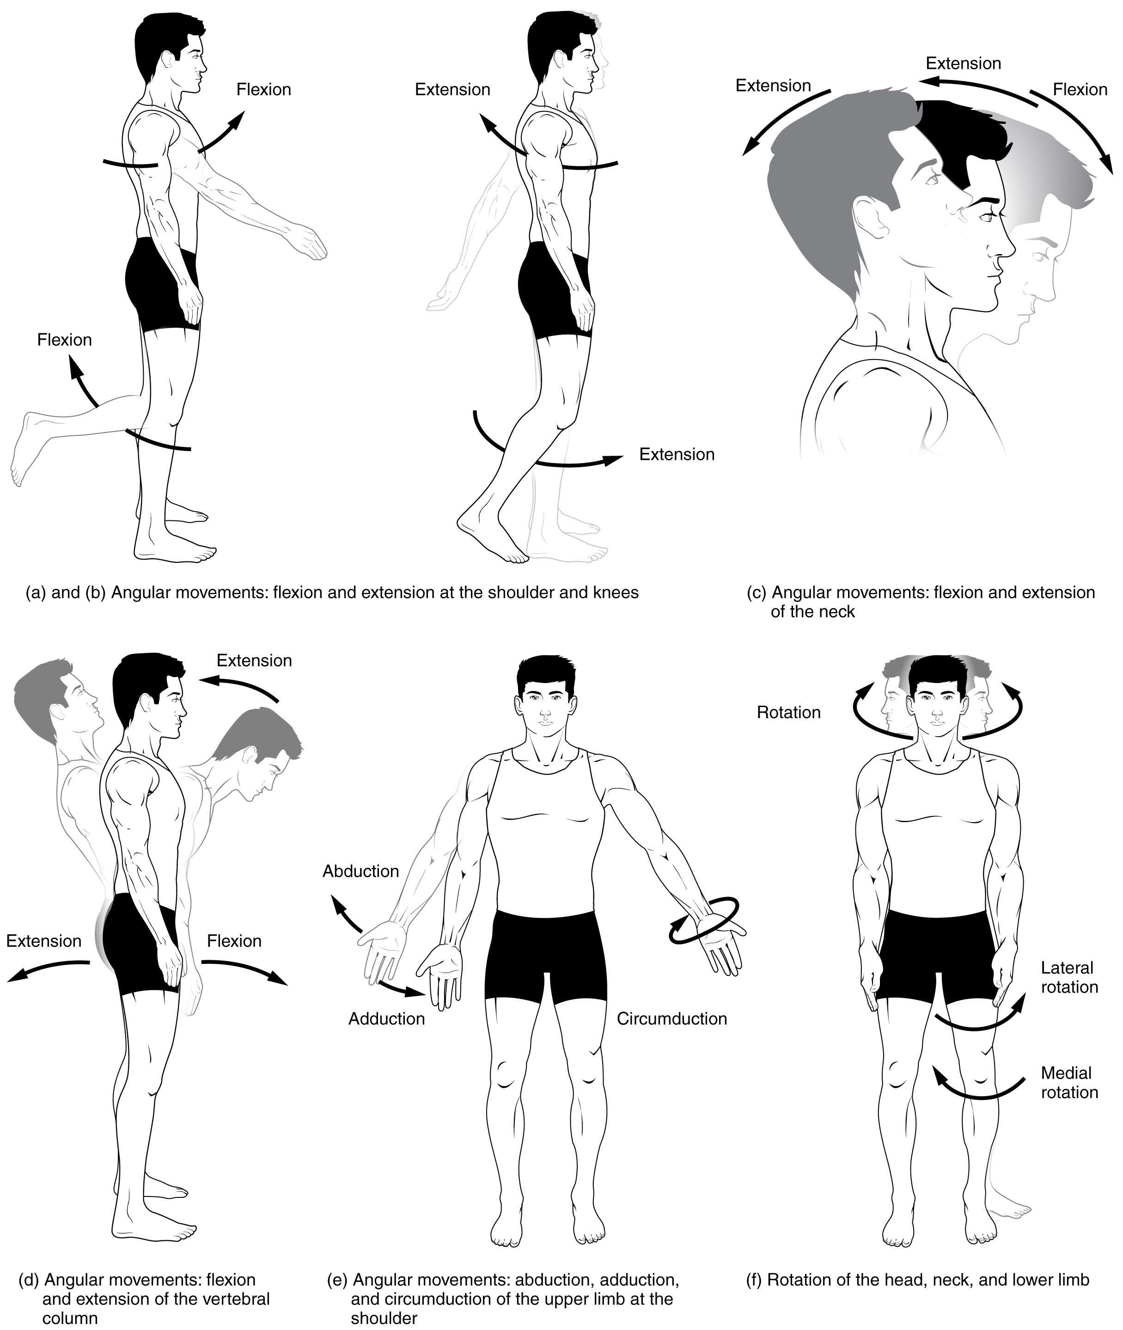
Figure 9.12 Movements of the Body, Part 1 Synovial joints give the body many ways in which to move. (a)–(b) Flexion and extension motions are in the sagittal (anterior–posterior) plane of motion. These movements take place at the shoulder, hip, elbow, knee, wrist, metacarpophalangeal, metatarsophalangeal, and interphalangeal joints. (c)–(d) Anterior bending of the head or vertebral column is flexion, while any posterior-going movement is extension. (e) Abduction and adduction are motions of the limbs, hand, fingers, or toes in the coronal (medial–lateral) plane of movement. Moving the limb or hand laterally away from the body, or spreading the fingers or toes, is abduction. Adduction brings the limb or hand toward or across the midline of the body, or brings the fingers or toes together. Circumduction is the movement of the limb, hand, or fingers in a circular pattern, using the sequential combination of flexion, adduction, extension, and abduction motions. Adduction/abduction and circumduction take place at the shoulder, hip, wrist, metacarpophalangeal, and metatarsophalangeal joints. (f) Turning of the head side to side or twisting of the body is rotation. Medial and lateral rotation of the upper limb at the shoulder or lower limb at the hip involves turning the anterior surface of the limb toward the midline of the body (medial or internal rotation) or away from the midline (lateral or external rotation).
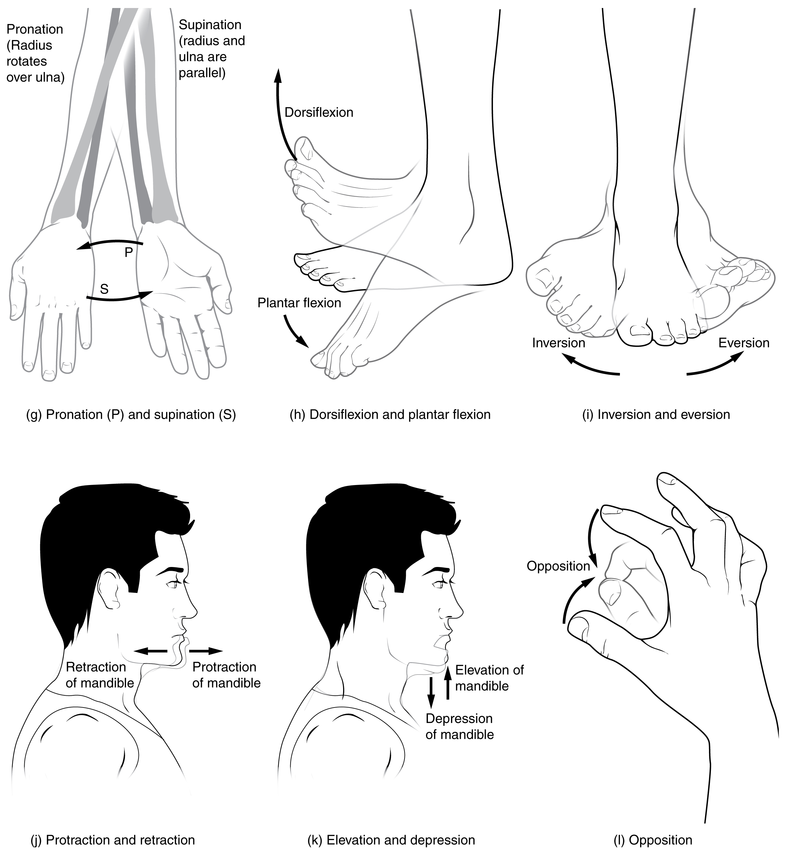
Figure 9.13 Movements of the Body, Part 2 (g) Supination of the forearm turns the hand to the palm forward position in which the radius and ulna are parallel, while forearm pronation turns the hand to the palm backward position in which the radius crosses over the ulna to form an "X." (h) Dorsiflexion of the foot at the ankle joint moves the top of the foot toward the leg, while plantar flexion lifts the heel and points the toes. (i) Eversion of the foot moves the bottom (sole) of the foot away from the midline of the body, while foot inversion faces the sole toward the midline. (j) Protraction of the mandible pushes the chin forward, and retraction pulls the chin back. (k) Depression of the mandible opens the mouth, while elevation closes it. (l) Opposition of the thumb brings the tip of the thumb into contact with the tip of the fingers of the same hand and reposition brings the thumb back next to the index finger.

Flexion and Extension
Flexion and extension are typically movements that take place within the sagittal plane and involve anterior or posterior movements of the neck, trunk, or limbs. For the vertebral column, flexion (anterior flexion) is an anterior (forward) bending of the neck or trunk, while extension involves a posterior-directed motion, such as straightening from a flexed position or bending backward. Lateral flexion of the vertebral column occurs in the coronal plane and is defined as the bending of the neck or trunk toward the right or left side. These movements of the vertebral column involve both the symphysis joint formed by each intervertebral disc, as well as the plane type of synovial joint formed between the inferior articular processes of one vertebra and the superior articular processes of the next lower vertebra.
In the limbs, flexion decreases the angle between the bones (bending of the joint), while extension increases the angle and straightens the joint. For the upper limb, all anterior-going motions are flexion and all posterior-going motions are extension. These include anterior-posterior movements of the arm at the shoulder, the forearm at the elbow, the hand at the wrist, and the fingers at the metacarpophalangeal and interphalangeal joints. For the thumb, extension moves the thumb away from the palm of the hand, within the same plane as the palm, while flexion brings the thumb back against the index finger or into the palm. These motions take place at the first carpometacarpal joint. In the lower limb, bringing the thigh forward and upward is flexion at the hip joint, while any posterior-going motion of the thigh is extension. Note that extension of the thigh beyond the anatomical (standing) position is greatly limited by the ligaments that support the hip joint. Knee flexion is the bending of the knee to bring the foot toward the posterior thigh, and extension is the straightening of the knee. Flexion and extension movements are seen at the hinge, condyloid, saddle, and ball-and-socket joints of the limbs (see Figure 9.12a-d).
Hyperextension is the abnormal or excessive extension of a joint beyond its normal range of motion, thus resulting in injury. Similarly, hyperflexion is excessive flexion at a joint. Hyperextension injuries are common at hinge joints such as the knee or elbow. In cases of “whiplash” in which the head is suddenly moved backward and then forward, a patient may experience both hyperextension and hyperflexion of the cervical region.

Abduction and Adduction
Abduction and adduction motions occur within the coronal plane and involve medial-lateral motions of the limbs, fingers, toes, or thumb. Abduction moves the limb laterally away from the midline of the body, while adduction is the opposing movement that brings the limb toward the body or across the midline. For example, abduction is raising the arm at the shoulder joint, moving it laterally away from the body, while adduction brings the arm down to the side of the body. Similarly, abduction and adduction at the wrist moves the hand away from or toward the midline of the body. Spreading the fingers or toes apart is also abduction, while bringing the fingers or toes together is adduction. For the thumb, abduction is the anterior movement that brings the thumb to a 90° perpendicular position, pointing straight out from the palm. Adduction moves the thumb back to the anatomical position, next to the index finger. Abduction and adduction movements are seen at condyloid, saddle, and ball-and-socket joints (see Figure 9.12e).

Circumduction
Circumduction is the movement of a body region in a circular manner, in which one end of the body region being moved stays relatively stationary while the other end describes a circle. It involves the sequential combination of flexion, abduction, extension, and adduction at a joint. This type of motion is found at biaxial condyloid and saddle joints, and at multiaxial ball-and-sockets joints (see Figure 9.12e).

Rotation
Rotation can occur within the vertebral column, at a pivot joint, or at a ball-and-socket joint. Rotation of the neck or body is the twisting movement produced by the summation of the small rotational movements available between adjacent vertebrae. At a pivot joint, one bone rotates in relation to another bone. This is a uniaxial joint, and thus rotation is the only motion allowed at a pivot joint. For example, at the atlantoaxial joint, the first cervical (C1) vertebra (atlas) rotates around the dens, the upward projection from the second cervical (C2) vertebra (axis). This allows the head to rotate from side to side as when shaking the head “no.” The proximal radioulnar joint is a pivot joint formed by the head of the radius and its articulation with the ulna. This joint allows for the radius to rotate along its length during pronation and supination movements of the forearm.
Rotation can also occur at the ball-and-socket joints of the shoulder and hip. Here, the humerus and femur rotate around their long axis, which moves the anterior surface of the arm or thigh either toward or away from the midline of the body. Movement that brings the anterior surface of the limb toward the midline of the body is called medial (internal) rotation. Conversely, rotation of the limb so that the anterior surface moves away from the midline is lateral (external) rotation (see Figure 9.12f). Be sure to distinguish medial and lateral rotation, which can only occur at the multiaxial shoulder and hip joints, from circumduction, which can occur at either biaxial or multiaxial joints.

Supination and Pronation
Supination and pronation are movements of the forearm. In the anatomical position, the upper limb is held next to the body with the palm facing forward. This is the supinated position of the forearm. In this position, the radius and ulna are parallel to each other. When the palm of the hand faces backward, the forearm is in the pronated position, and the radius and ulna form an X-shape.
Supination and pronation are the movements of the forearm that go between these two positions. Pronation is the motion that moves the forearm from the supinated (anatomical) position to the pronated (palm backward) position. This motion is produced by rotation of the radius at the proximal radioulnar joint, accompanied by movement of the radius at the distal radioulnar joint. The proximal radioulnar joint is a pivot joint that allows for rotation of the head of the radius. Because of the slight curvature of the shaft of the radius, this rotation causes the distal end of the radius to cross over the distal ulna at the distal radioulnar joint. This crossing over brings the radius and ulna into an X-shape position. Supination is the opposite motion, in which rotation of the radius returns the bones to their parallel positions and moves the palm to the anterior facing (supinated) position. It helps to remember that supination is the motion you use when scooping up soup with a spoon (see Figure 9.13g).

Dorsiflexion and Plantar Flexion
Dorsiflexion and plantar flexion are movements at the ankle joint, which is a hinge joint. Lifting the front of the foot, so that the top of the foot moves toward the anterior leg is dorsiflexion, while lifting the heel of the foot from the ground or pointing the toes downward is plantar flexion. These are the only movements available at the ankle joint (see Figure 9.13h).

Inversion and Eversion
Inversion and eversion are complex movements that involve the multiple plane joints among the tarsal bones of the posterior foot (intertarsal joints) and thus are not motions that take place at the ankle joint. Inversion is the turning of the foot to angle the bottom of the foot toward the midline, while eversion turns the bottom of the foot away from the midline. The foot has a greater range of inversion than eversion motion. These are important motions that help to stabilize the foot when walking or running on an uneven surface and aid in the quick side-to-side changes in direction used during active sports such as basketball, racquetball, or soccer (see Figure 9.13i).

Protraction and Retraction
Protraction and retraction are anterior-posterior movements of the scapula or mandible. Protraction of the scapula occurs when the shoulder is moved forward, as when pushing against something or throwing a ball. Retraction is the opposite motion, with the scapula being pulled posteriorly and medially, toward the vertebral column. For the mandible, protraction occurs when the lower jaw is pushed forward, to stick out the chin, while retraction pulls the lower jaw backward. (See Figure 9.13j.)

Depression and Elevation
Depression and elevation are downward and upward movements of the scapula or mandible. The upward movement of the scapula and shoulder is elevation, while a downward movement is depression. These movements are used to shrug your shoulders. Similarly, elevation of the mandible is the upward movement of the lower jaw used to close the mouth or bite on something, and depression is the downward movement that produces opening of the mouth (see Figure 9.13k).

Excursion
Excursion is the side to side movement of the mandible. Lateral excursion moves the mandible away from the midline, toward either the right or left side. Medial excursion returns the mandible to its resting position at the midline.

Superior Rotation and Inferior Rotation
Superior and inferior rotation are movements of the scapula and are defined by the direction of movement of the glenoid cavity. These motions involve rotation of the scapula around a point inferior to the scapular spine and are produced by combinations of muscles acting on the scapula. During superior rotation, the glenoid cavity moves upward as the medial end of the scapular spine moves downward. This is a very important motion that contributes to upper limb abduction. Without superior rotation of the scapula, the greater tubercle of the humerus would hit the acromion of the scapula, thus preventing any abduction of the arm above shoulder height. Superior rotation of the scapula is thus required for full abduction of the upper limb. Superior rotation is also used without arm abduction when carrying a heavy load with your hand or on your shoulder. You can feel this rotation when you pick up a load, such as a heavy book bag and carry it on only one shoulder. To increase its weight-bearing support for the bag, the shoulder lifts as the scapula superiorly rotates. Inferior rotation occurs during limb adduction and involves the downward motion of the glenoid cavity with upward movement of the medial end of the scapular spine.

Opposition and Reposition
Opposition is the thumb movement that brings the tip of the thumb in contact with the tip of a finger. This movement is produced at the first carpometacarpal joint, which is a saddle joint formed between the trapezium carpal bone and the first metacarpal bone. Thumb opposition is produced by a combination of flexion and abduction of the thumb at this joint. Returning the thumb to its anatomical position next to the index finger is called reposition (see Figure 9.13l).
Movements of the Joints
Type of Joint | Movement | Example
Pivot | Uniaxial joint; allows rotational movement | Atlantoaxial joint (C1–C2 vertebrae articulation); proximal radioulnar joint
Hinge | Uniaxial joint; allows flexion/extension movements | Knee; elbow; ankle; interphalangeal joints of fingers and toes
Condyloid | Biaxial joint; allows flexion/extension, abduction/adduction, and circumduction movements | Metacarpophalangeal (knuckle) joints of fingers; radiocarpal joint of wrist; metatarsophalangeal joints for toes
Saddle | Biaxial joint; allows flexion/extension, abduction/adduction, and circumduction movements | First carpometacarpal joint of the thumb; sternoclavicular joint
Plane | Multiaxial joint; allows inversion and eversion of foot, or flexion, extension, and lateral flexion of the vertebral column | Intertarsal joints of foot; superior-inferior articular process articulations between vertebrae
Ball-and-socket | Multiaxial joint; allows flexion/extension, abduction/adduction, circumduction, and medial/lateral rotation movements | Shoulder and hip joints
Table 9.1

