Department of Computer Engineering

**Academic Year: 2022-2023 Semester: VIII**

**Subject:-ADSL(CSL8023) Class / Branch / Division:**

**Name :- Roll Number:**

**Date :- Seat-no:-**

**Experiment no. 6**

**Aim** : Use SMOTE technique to generate synthetic data using Borderline-SMOTE

**THEORY**

SMOTE

In imbalanced classification, the minority class is underrepresented compared to the majority class, leading to poor performance of most machine learning algorithms on the minority class. SMOTE solves this problem by generating synthetic samples of the minority class, instead of simply duplicating existing samples.

**Borderline-SMOTE**

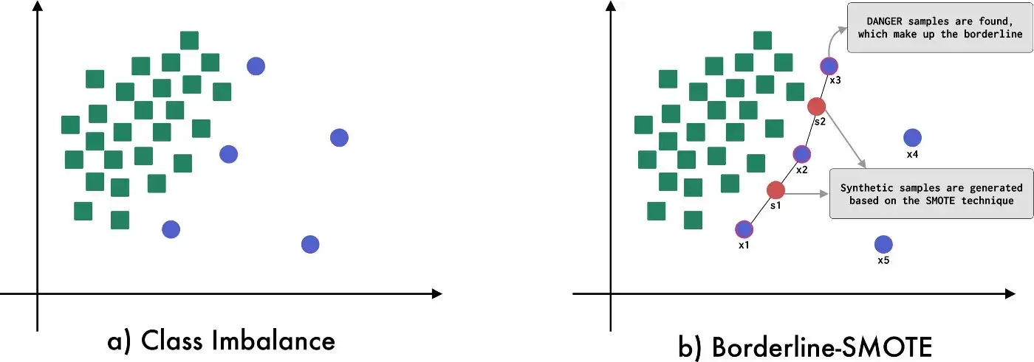

**Figure 1 :- Borderline-SMOTE visual description**

Borderline-SMOTE is a variation of SMOTE introduced by Hui Han in 2005. Unlike the original SMOTE technique, Borderline-SMOTE focuses on generating synthetic data by considering only samples that make up the border that divides one class from another. That is, Borderline-SMOTE detects which samples are on the border of the class space and applies the SMOTE technique to these samples. In Figure 2 you can see a visual description of Borderline-SMOTE.

**CODE**

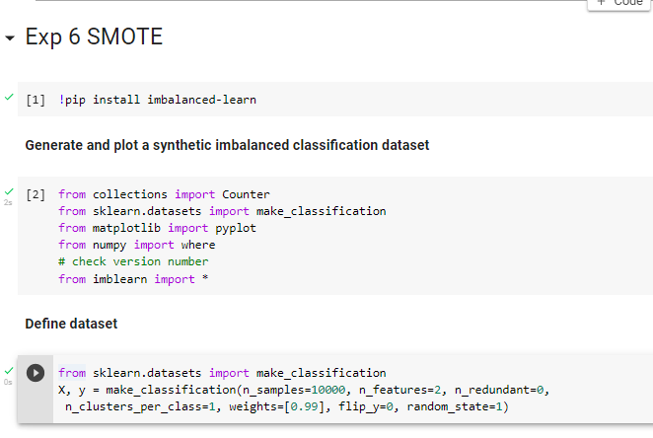

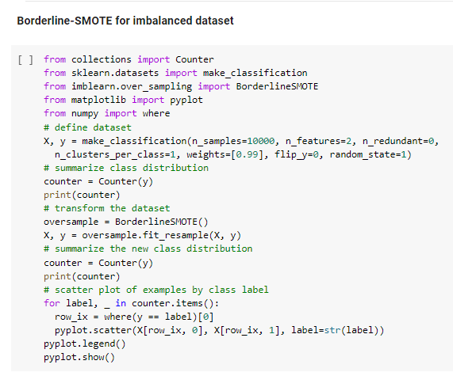

**OUTPUT**

