Department of Computer Engineering

**Academic Year: 2022-2023 Semester: VIII**

**Subject:-ADSL(CSL8023) Class / Branch / Division:**

**Name :- Roll Number:**

**Date :- Seat-no:-**

**Experiment no. 6**

**Aim** : Use SMOTE technique to generate synthetic data using Borderline-SMOTE

**THEORY**

SMOTE

In imbalanced classification, the minority class is underrepresented compared to the majority class, leading to poor performance of most machine learning algorithms on the minority class. SMOTE solves this problem by generating synthetic samples of the minority class, instead of simply duplicating existing samples.

**Borderline-SMOTE SVM**

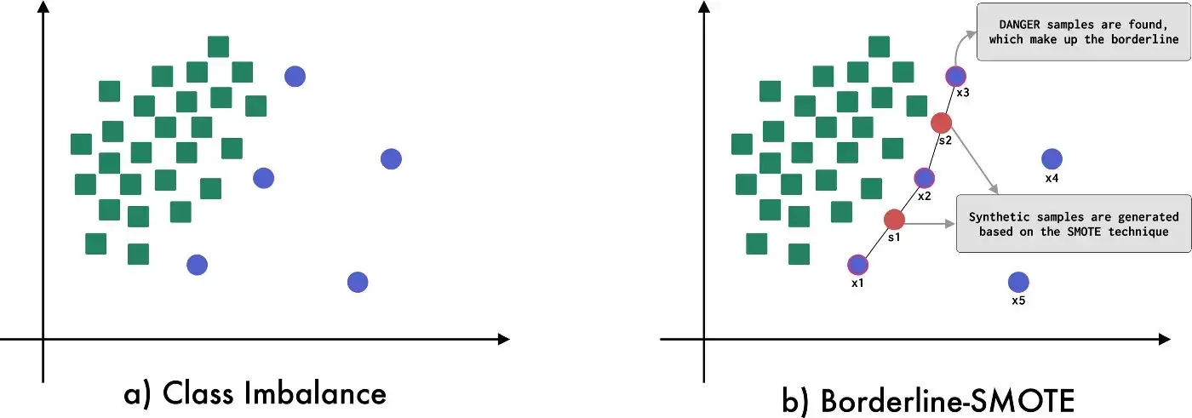

**Figure 1 :- Borderline-SMOTE SVM visual description**

It is an alternative to Borderline-SMOTE where an SVM algorithm is used instead of a KNN to identify misclassified examples on the decision boundary. Their approach is summarized in the 2009 paper titled “Borderline Over-sampling For Imbalanced Data Classification.” An SVM is used to locate the decision boundary defined by the support vectors and examples in the minority class that close to the support vectors become the focus for generating synthetic examples.

**CODE**

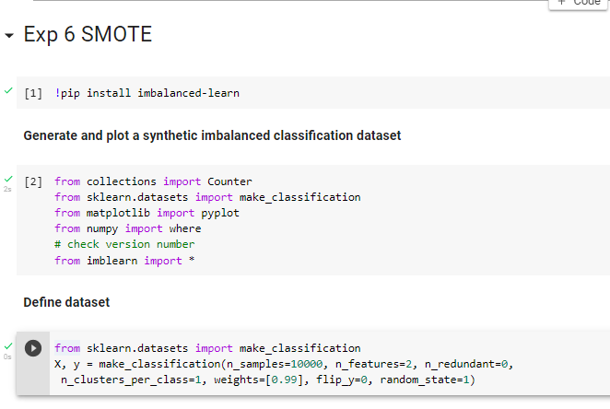

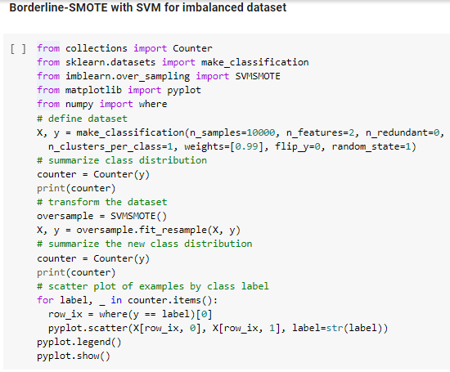

**OUTPUT**

