Department of Computer Engineering

**Academic Year: 2022-2023 Semester: VIII**

**Subject:-ADSL(CSL8023) Class / Branch / Division:**

**Name :- Roll Number:**

**Date :- Seat-no:-**

**Experiment no. 6**

**Aim** : Use SMOTE technique to generate synthetic data using ADASYN

**THEORY**

SMOTE

In imbalanced classification, the minority class is underrepresented compared to the majority class, leading to poor performance of most machine learning algorithms on the minority class. SMOTE solves this problem by generating synthetic samples of the minority class, instead of simply duplicating existing samples.

**ADASYN**

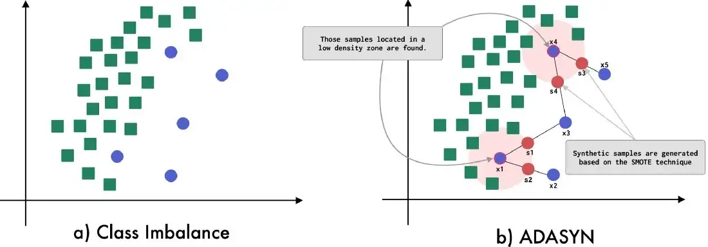

**Figure 1:- ADASYN visual description**

ADASYN is based on the idea of adaptively generating minority data samples according to their distributions: more synthetic data is generated for minority class samples that are harder to learn compared to those minority samples that are easier to learn.

**CODE**

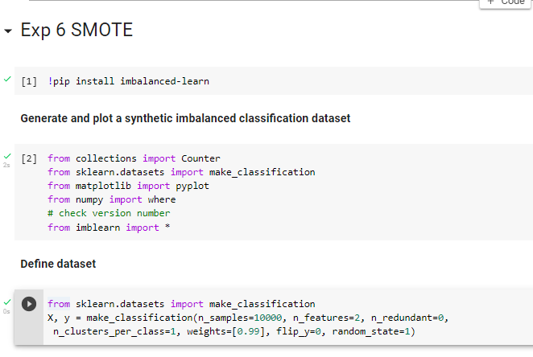

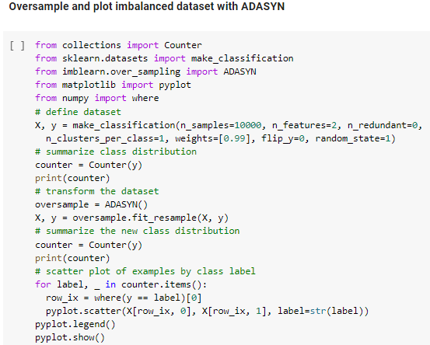

**OUTPUT**

