Department of Computer Engineering

**Academic Year: 2022-2023 Semester: VIII**

**Subject:-ADSL(CSL8023) Class / Branch / Division:**

**Name :- Roll Number:**

**Date :- Seat-no:-**

**Experiment no. 8**

**Aim** :Implement time series forecasting using AR model

**THEORY**

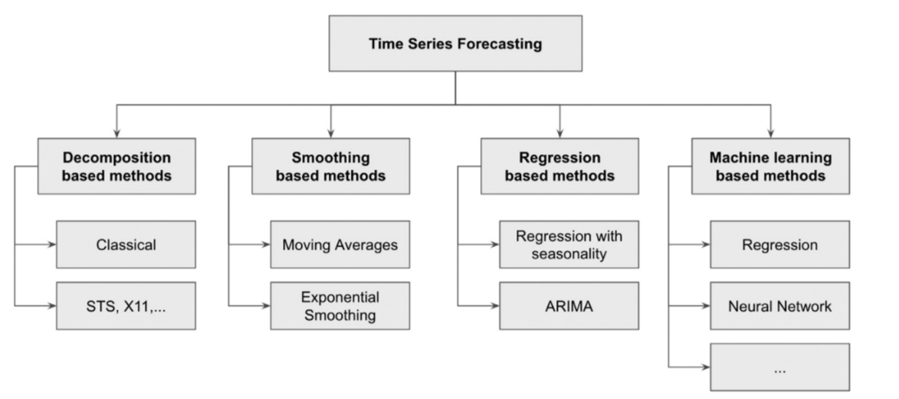

**Fig 1. Taxonomy of time series forecasting techniques.**

The investigation of time series can also be broadly divided into descriptive modeling, called time series analysis, and predictive modeling, called time series forecasting.

Time series forecasting is a method used to predict future values based on previously observed values. It is commonly used in areas such as economics, finance, and demand forecasting for products.

**Autoregressive Model**

A statistical model is autoregressive if it predicts future values based on past values. For example, an autoregressive model might seek to predict a stock's future prices based on its past performance.

* Autoregressive models predict future values based on past values.
* They are widely used in technical analysis to forecast future security prices.
* Autoregressive models implicitly assume that the future will resemble the past.

**CODE**

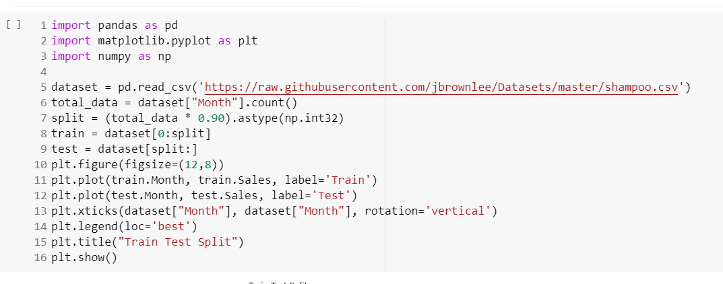

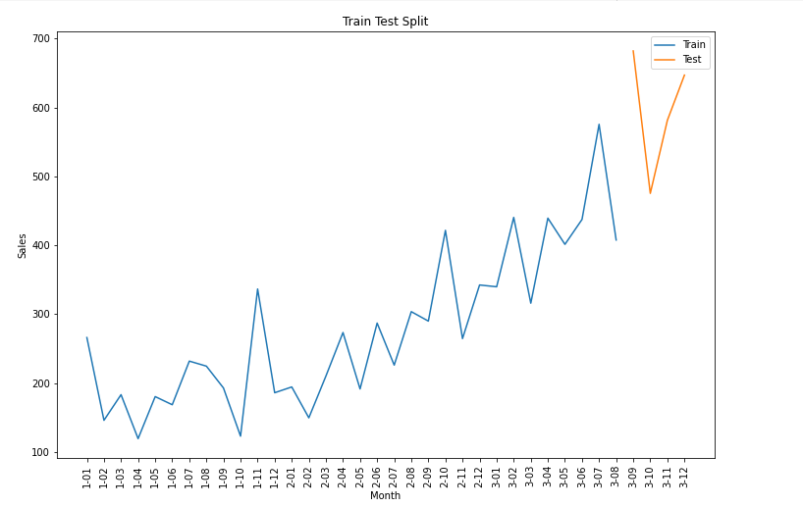

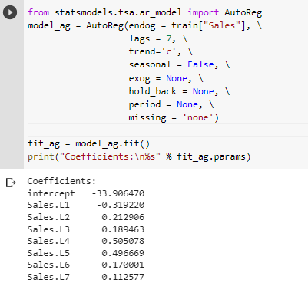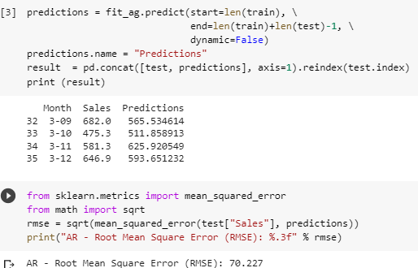

**OUTPUT**

