Department of Computer Engineering

**Academic Year: 2022-2023 Semester: VIII**

**Subject:-ADSL(CSL8023) Class / Branch / Division:**

**Name :- Roll Number:**

**Date :- Seat-no:-**

**Experiment no. 8**

**Aim** :Implement time series forecasting using ARIMA model

**THEORY**

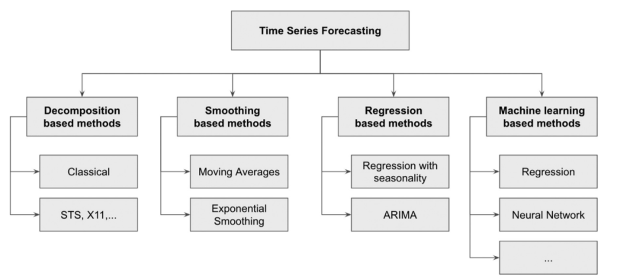

**Fig 1. Taxonomy of time series forecasting techniques.**

The investigation of time series can also be broadly divided into descriptive modeling, called time series analysis, and predictive modeling, called time series forecasting.

Time series forecasting is a method used to predict future values based on previously observed values. It is commonly used in areas such as economics, finance, and demand forecasting for products.

**ARIMA Model**

An autoregressive integrated moving average, or ARIMA, is a statistical analysis model that uses time series data to either better understand the data set or to predict future trends. A statistical model is autoregressive if it predicts future values based on past values.

An ARIMA model can be understood by outlining each of its components as follows:

Autoregression (AR): refers to a model that shows a changing variable that regresses on its own lagged, or prior, values.

Integrated (I): represents the differencing of raw observations to allow the time series to become stationary (i.e., data values are replaced by the difference between the data values and the previous values).

Moving average (MA): incorporates the dependency between an observation and a residual error from a moving average model applied to lagged observations.

**CODE**

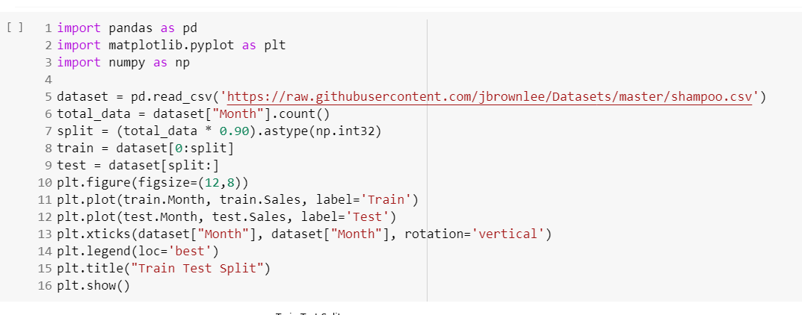

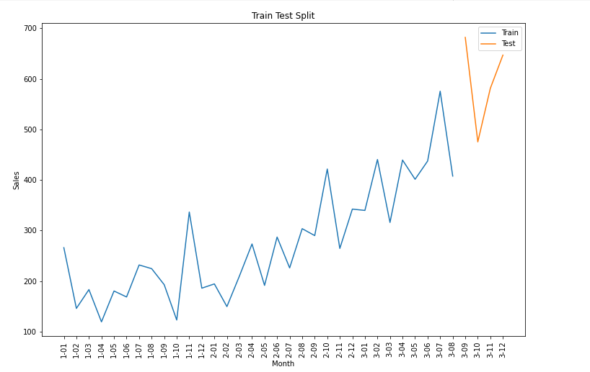

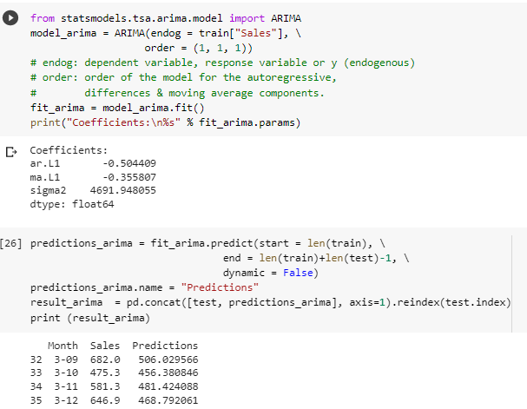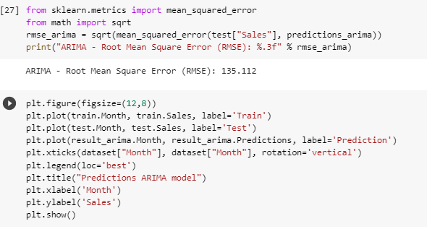

**OUTPUT**

