Department of Computer Engineering

**Academic Year: 2022-2023 Semester: VIII**

**Subject:-ADSL(CSL8023) Class / Branch / Division:**

**Name :- Roll Number:**

**Date :- Seat-no:-**

**Experiment no. 8**

**Aim** :Implement time series forecasting using MA model

**THEORY**

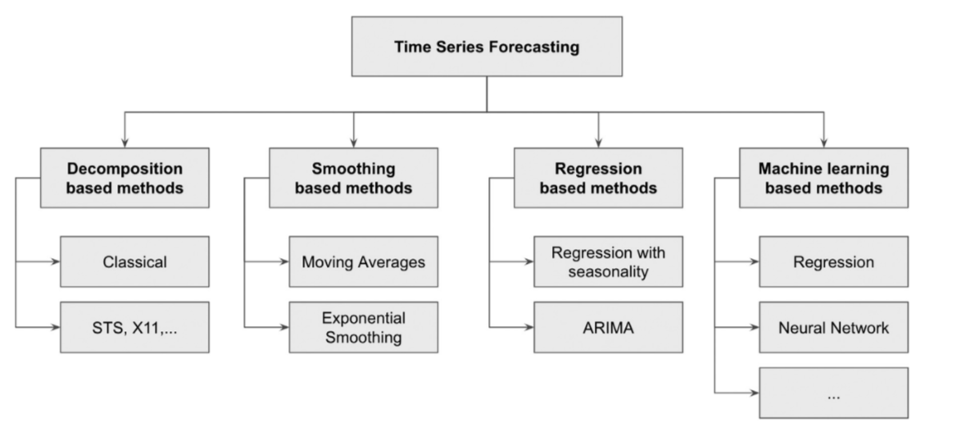

**Fig 1. Taxonomy of time series forecasting techniques.**

The investigation of time series can also be broadly divided into descriptive modeling, called time series analysis, and predictive modeling, called time series forecasting.

Time series forecasting is a method used to predict future values based on previously observed values. It is commonly used in areas such as economics, finance, and demand forecasting for products.

**MA Model**

In time series analysis, the moving-average model (MA model), also known as moving-average process, is a common approach for modeling univariate time series. The moving-average model specifies that the output variable is cross-correlated with a non-identical to itself random-variable.

**CODE**

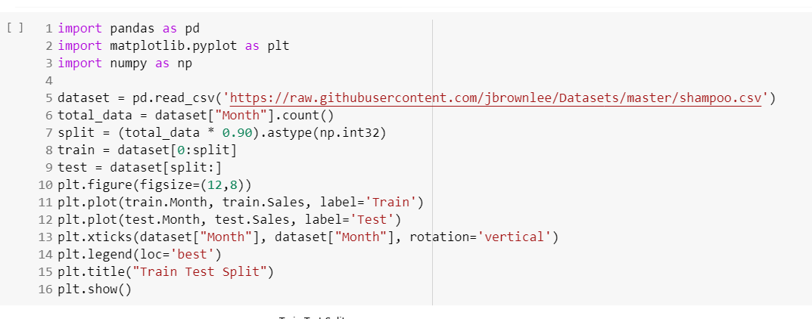

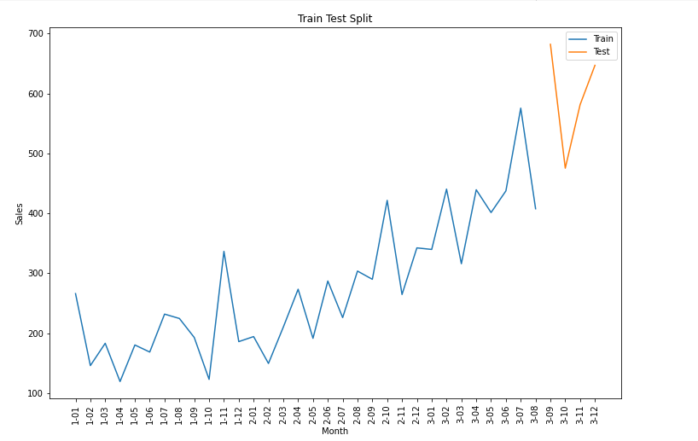

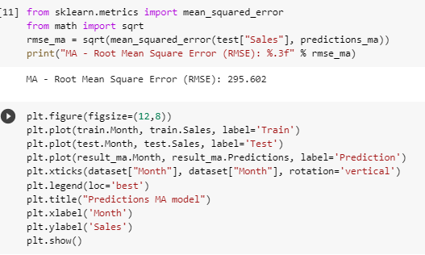

**OUTPUT**

