Department of Computer Engineering

**Academic Year: 2022-2023 Semester: VIII**

**Subject:-ADSL(CSL8023) Class / Branch / Division:**

**Name :- Roll Number:**

**Date :- Seat-no:-**

**Experiment no.**

**Aim** :Implement Karl Pearson’s coefficient of correlation

**THEORY**

Karl Pearson’s correlation coefficient is a measure of the linear correlation between two variables, X and Y. It ranges between -1 and 1, with -1 indicating a perfect negative correlation, 0 indicating no correlation, and 1 indicating a perfect positive correlation.

The coefficient takes on values between -1 and +1, where -1 indicates a perfect negative correlation (i.e., as one variable increases, the other decreases), +1 indicates a perfect positive correlation (i.e., as one variable increases, the other also increases), and 0 indicates no correlation. The closer the coefficient is to -1 or +1, the stronger the correlation, while coefficients closer to 0 indicate weaker correlations.

It is calculated as follows:

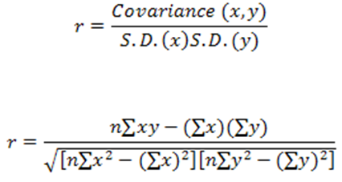

Use of Karl Pearson’s coefficient of correlation

The coefficient is useful for understanding the relationship between two variables and for making predictions based on that relationship. For example, if we are interested in predicting a person's height based on their weight, we can calculate the correlation coefficient between height and weight to see how closely related the two variables are. We can then use that information to make more accurate predictions about a person's height based on their weight.

The coefficient is also useful for identifying outliers and influential points in the data. If there are points that are far away from the main cluster of data, they can have a large impact on the correlation coefficient, and removing them may lead to a more accurate representation of the relationship between the variables.

**CODE**

