Department of Computer Engineering

**Academic Year: 2022-2023 Semester: VIII**

**Subject:-ADSL(CSL8023) Class / Branch / Division:**

**Name :- Roll Number:**

**Date :- Seat-no:-**

**Experiment no.**

**Aim** :Implement Skewness and kurtosis

**THEORY**

Skewness and kurtosis are two common measures of the shape of a probability distribution. Skewness measures the asymmetry of the distribution, while kurtosis measures the degree of peakedness or flatness of the distribution.

## Skewness

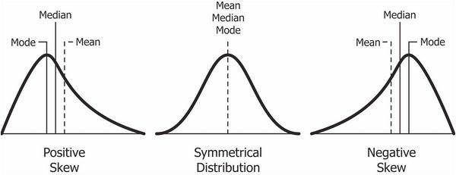

**Figure 1:- Types of Skew**

Skewness is a way of estimating and measuring the shape of a distribution. It is a vital statistical method for estimating asymmetrical behavior rather than computing the frequency distribution. Its value can be either positive or negative

The distribution of skewness values is as below:

* Skewness = 0 when the distribution is normal.
* Skewness > 0 or positive when more weight is on the left side of the distribution.
* Skewness < 0 or negative when more weight is on the right side of the distribution.

## Kurtosis

Kurtosis is a statistical term that characterizes frequency distribution. Aside from determining if a distribution is heavy-tailed, it also provides insight into the shape of the frequency distribution.

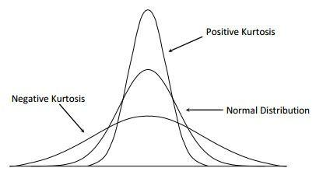

**Figure 1:- Types of Skew**

Kurtosis of a normal distribution is equal to 3. When the kurtosis is less than 3, it is known as platykurtic, and when it is greater than 3, it is leptokurtic. If it is leptokurtic, it will signify that it produces outliers rather than a normal distribution.

Formula for Skewness and Kurtosis

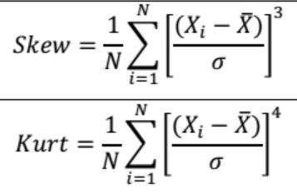

**CODE**

