Department of Computer Engineering

**Academic Year: 2022-2023 Semester: VIII**

**Subject:-ADSL(CSL8023) Class / Branch / Division:**

**Name :- Roll Number:**

**Date :- Seat-no:-**

**Experiment no.**

**Aim** :Implement Spearman correlation coefficient

**THEORY**

The Spearman correlation coefficient is a statistical measure of the strength and direction of the monotonic relationship between two variables. It is named after Charles Spearman and is often used as an alternative to the Pearson correlation coefficient when the data are not normally distributed or when the relationship between the variables is not linear.

Spearman correlation coefficient is a non-parametric measure of the rank correlation between two variables, X and Y. It ranges between -1 and 1, with -1 indicating a perfect negative correlation, 0 indicating no correlation, and 1 indicating a perfect positive correlation.

It is calculated as follows:

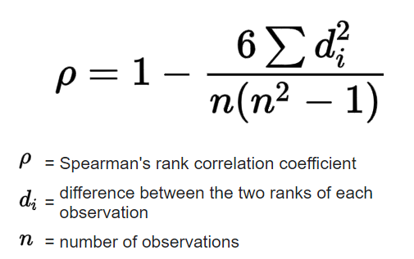

**CODE**

