Elderly Fall Detection System

Hiu Ching Ma1*, Tsz Yi Theodora Kwok2, and Zahabiyah Boty3

*1,2 International Christian school, Hong Kong*

*3 German Swiss International School, Hong Kong*

*\*Contact:*[***janicema0702@gmail.com***](mailto:janicema0702@gmail.com)

***Abstract*— To create a system that can detect when an elderly person has become off-balance. Using accelerometers and a machine learning model, the system monitors the elderly persons accelerations and tilt to determine if an elderly person has fallen and if so notifies the elderly’s family and or hospital.**

1. Introduction

Living in an aging country - Hong Kong - the elderly population is a vital and significant part of it [4]. However, Hong Kong’s notably small homes are often not catered for this age group as there can be many hazards from living in cramped homes that can result in an elderly person falling. Over 3 million elderly people are treated in the emergency section yearly due to fall accidents [1]. To ensure that our elderly population can maintain a safe and healthy lifestyle we wanted to create a system that monitors an elderly person's movement to detect if they have fallen. By measuring their acceleration when a sudden spike is detected a machine learning model will determine whether or not the elderly person has fallen or not. If they have it, the system will notify the elderly person’s family and the hospital.

The system will be in two main forms: wearable watches and jewellery. With wearable watches currently burgeoning and becoming a key player in health-tech, by implementing this system in the form of a watch an elderly person can conveniently put on and remove it and easily access it. To make the device more aesthetic it will also be available in the form of a necklace.

While performing a market analysis of our product we found two main competitors: wearable watches and camera systems. However, after further assessment of our competitors we were able to determine certain shortcomings that we were eager to overcome in our own product. Firstly, one of the most popular wearable watches was the Apple watch. However, these were highly costly and had numerous other functions that can be irrelevant to the elderly. To create a more customized product we wanted to create a wearable watch that would serve the niche market of just the elderly population. By discarding numerous unnecessary features, we will also be able to make the product at a significantly cheaper price. Secondly, camera systems were often inconvenient to install and were an invasion of privacy. One of the key places where elderly people are easily prone to falling is the bathroom, however, it would be invasive to install cameras there. Additionally, installing cameras around the rest of the house can also feel like an invasion of privacy as it monitors the elderly person throughout the day.

1. Methodology

To build our system we first developed the hardware and software code separately and then linked them together.

1. *Software*

To build the software side of our system we created a machine learning model using TensorFlow 2.0 that could determine whether an elderly person has fallen or not based on the hardware input. By finding over 2,000,000 data points of fall data, we were able to train our machine learning model [2].

We integrated other tools and libraries in the data science ecosystem, such as NumPy, Pandas, and Matplotlib to improve data processing and visualization. To effectively train the model, we had to change the categorical values of “Fall” and “Not Fall” into numerical values of 1 and 0 where 1 indicates a fall. This better helps improve the model through allowing the data to be more efficient and effectively read. We further split each input and output dataset into two groups - training data and testing data - in a 85:15 ratio. Regarding the DNN model, we utilized one-hot encoding to better determine the probability of the fall. We further imported keras and integrated the Adam optimizer as well as regularizers to limit the overfitting or underfitting of the model. Our final loss and accuracy values resulted as 0.4747 and 0.7711 respectively. Figures 1 and 2 below illustrate our DNN model’s loss and accuracy functions.

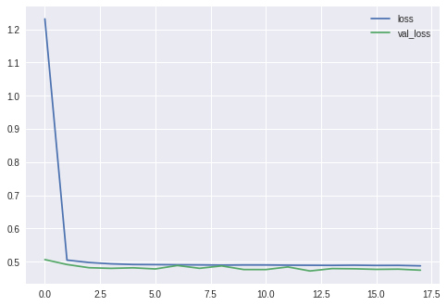 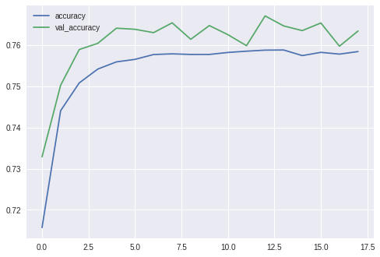

Fig. 1 The loss function of the data Fig. 2 The accuracy of the machine learning model

i.e. the distance between the expected and current output

1. *Hardware*

We used Grove - IMU 10DOF accelerometer and gyroscope and Arduino Uno to build the fall detection sensor. The Grove sensor has 10 degrees of freedom, and we collected six of them – accelerations and gyro data for x, y, z directions, in the units of “g” and “degrees/second” respectively. The sensor was connected to an I2C pin on the base shield, which was then connected to the Arduino board. We dropped the sensor from various heights and recorded the data at a rate of 10 data points per second. We tested the sensor and observed a pattern for fall vs not fall [3]. For example, the gyro of all three directions were significantly greater during a fall, and the acceleration in the y direction was larger as well.

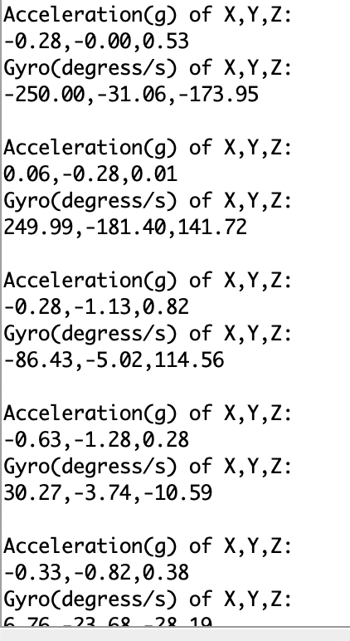 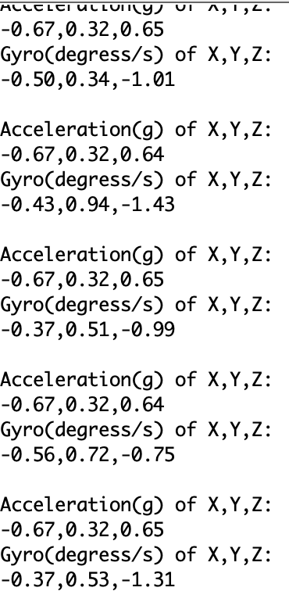

Fig. 4 The recorded data of a fall Fig. 5 The recorded data when the sensor is at rest

1. Results

Through integrating and hardware output values from Grove - IMU 10DOF and Arduino Uno and the trained DNN model, we attempted to predict a fall. In figure 3 below, it can be seen that our predictions and the actual output test set values correspond to each other. Each list in the array output represents the probability of not falling (list[0]) and the probability of falling (list[1]).

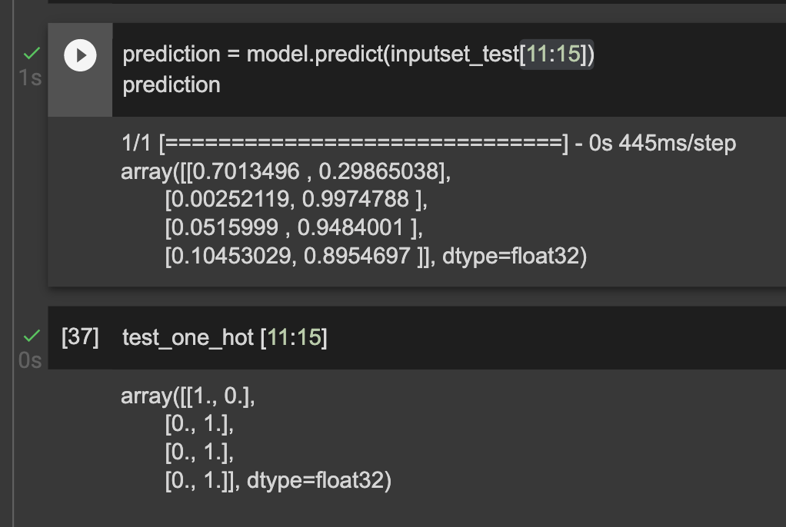

Fig. 3 Prediction vs actual output values of the machine learning model

1. Future improvements

To further improve our current product, in the future we want to implement additional sensors to improve the accuracy of our system. We also hope to develop new features that can also enhance our products ability. The table below depicts a few ways in which we hope to improve our product.

TABLE I  
future improvements

| **Sensor** | **Information** |
| --- | --- |
| Heart Rate sensor | By integrating a heart sensor we want to allow the system to absorb additional biomechanics data points to improve its accuracy. For example, when a sudden spike in heart rate is detected it could indicate the person has faced some stress or a potential fall giving the system an additional data point. |
| Other motional sensors | By providing additional tilt and motional sensors it can help the system differentiate between an elderly person falling and performing other movements, which increase acceleration. For example, when a person is chopping vegetables it may falsely detect that a person has fallen; however, by integrating motional sensors it can provide the machine learning model with additional data points to indicate that the person is still standing. |
| Position sensors | By implementing position sensors, it can provide the system with more information on the elderly person’s location allowing it to understand whether a person is easily prone to falling. For example, if the person is outside, on a particularly wet day, the system can use this information to know that the elderly person is more prone to falling. |

Aside from these additional sensors to increase the accuracy of the system, we also hope to integrate new features that can make the device more catered towards the elderly's needs. For example, by implementing features like reminders to take medicines and go for walks, this device can help elderly people with more tasks. Furthermore, password logs and other information at hand can also help them in times of emergencies. By making this product more customised for the elderly we hope to create a dynamic product that can help them in numerous aspects of their lives.

1. Conclusions

In conclusion, while building our elderly fall detection system we have gained numerous skills. Throughout these past few months while participating in this programme and building our projects we have gained numerous skills. Firstly, we have been introduced to the fundamentals of machine learning. By applying these concepts and experimenting with different algorithms and the split ratio between testing and training data to optimize our machine learning model we have gained a deeper understanding of machine learning. Furthermore, we have also learned how to utilise information from the internet and use the vast resources available to help us work more efficiently and learn on the spot. On the hardware end, we also were exposed to numerous electrical components. While assembling our project we studied gyrometers and accelerometers and used an arduino uno board to assemble it. Through our exposure to these components we have gained numerous technical skills. Aside from the technical side of hardware and software, we have also gained skills on the entrepreneurship side. From creating business plans, to performing evaluations of our product and studying market competitors, we have learned to appreciate the process that startups undertake when launching a business.

References

1. “Facts About Falls | Fall Prevention | Injury Center.” CDC, https://www.cdc.gov/falls/facts.html. Accessed 13 February 2023.
2. Sucerquia, A., López, J. D., &amp; Vargas-Bonilla, J. F. (2016). SisFall_Dataset_With_Lable (ADL or Fall). Retrieved February 13, 2023, from https://www.kaggle.com/datasets/moonesmobaraki/sisfall-dataset-with-lableadl-or-fall.
3. Sucerquia, A., López, J. D., &amp; Vargas-Bonilla, J. F. (2017, January 20). Sisfall: A fall and movement dataset. Sensors (Basel, Switzerland). Retrieved February 13, 2023, from https://www.ncbi.nlm.nih.gov/pmc/articles/PMC5298771/
4. “Summary results of 2021 Population Census and Year-end Population Estimate for 2021.” Government Information Centre, 28 February 2022, https://www.info.gov.hk/gia/general/202202/28/P2022022800462.htm. Accessed 13 February 2023.