WEEK 3 DATA SCIENCE PROJECT FROM JANICE CYRIL VAZ
MEALCYCLE AI
Python-Based Machine Learning Model Development and Evaluation Plan

University Submission Details | Information
Student Name | ____________________________
Course / Programme | ____________________________
Subject | Data Science / Python
Assignment | Week 3 – Machine Learning Model Development & Evaluation Plan
Faculty / Guide | ____________________________
Date of Submission | ____________________________

Project focus: Forecasting cafeteria food surplus before it becomes waste.

Table of Contents
1. Introduction & Problem Definition
2. Project Objectives
3. Data Preprocessing Strategy
4. Feature Engineering & Selection
5. Model Selection & Training
6. Validation & Evaluation
7. Hyperparameter Tuning
8. Model Interpretation & Error Analysis
9. Model Deployment & Maintenance
10. Machine Learning Workflow
11. Tools & Libraries
12. 33-Hour Work Plan
13. Risks and Mitigation
14. Expected Outcomes
15. Conclusion

1. Introduction & Problem Definition

1.1 Problem Statement
MealCycle AI is a hypothetical machine learning system designed to forecast cafeteria food surplus before a meal service takes place. Cafeterias must decide how much food to prepare without knowing the exact demand in advance. Overestimation can produce unnecessary surplus, while underestimation can create shortages. The Week 3 task focuses on designing the machine learning process that will eventually turn the Week 1 planning framework and Week 2 EDA plan into a predictive model.

1.2 Machine Learning Formulation
The proposed problem is a supervised regression task. The target variable is the expected number of surplus meals. Historical records provide examples from which the model can learn relationships between demand, attendance, menu characteristics, calendar conditions, events and weather.
Target: Surplus Meals = Meals Prepared − Meals Sold

1.3 Why Machine Learning is Appropriate
A simple historical average can provide a useful benchmark, but cafeteria demand may depend on several interacting factors. Machine learning can model nonlinear relationships and combine multiple signals. The project will therefore compare simple and more flexible approaches rather than assuming that the most complex model is automatically the best.

2. Project Objectives
ID | Objective
O1 | Prepare a clean, model-ready dataset from the proposed cafeteria data sources.
O2 | Create features that represent historical demand, calendar effects, attendance, menu and external conditions.
O3 | Establish a transparent baseline before training machine learning models.
O4 | Train and compare multiple regression algorithms.
O5 | Use time-aware validation to obtain a realistic estimate of future performance.
O6 | Tune the selected model while controlling overfitting.
O7 | Evaluate accuracy using MAE, RMSE and R² and compare results with the baseline.
O8 | Design a deployment and maintenance concept for future implementation.

3. Data Preprocessing Strategy

3.1 Data Preparation Pipeline
- Inspect dataset dimensions, column names, data types and unique values.
- Validate date fields and order observations chronologically.
- Identify duplicate records and preserve an audit count before removal.
- Check missingness by variable and investigate whether missingness follows a pattern.
- Validate numerical ranges and investigate impossible values.
- Separate the target variable from predictors before model preparation.
- Apply preprocessing operations only using information available from the training data.

3.2 Missing Data Strategy
Situation | Proposed Treatment
Small amount of numerical missingness | Training-set median imputation where appropriate.
Categorical missingness | Explicit 'Unknown' category or training-set mode.
Systematic missingness | Investigate source process before imputation.
Missing target value | Exclude from supervised training; do not invent target values.

3.3 Outlier Strategy
Outliers will not be removed automatically. An unusually high surplus could represent a genuine event, a holiday, a special menu or a recording error. Observations will first be investigated. Where an extreme value is confirmed as a valid operational event, it may be retained and represented through appropriate features.

3.4 Scaling and Encoding
Numerical variables may be standardized when required by the selected algorithm. Tree-based models generally do not require feature scaling. Categorical variables such as menu category or weather class can be encoded using an appropriate training-fitted encoding approach. A scikit-learn Pipeline will be preferred so that preprocessing is reproducible and does not leak information from validation or test data.

4. Feature Engineering & Selection
Feature Group | Examples | Purpose
Historical demand | sales_lag_1, sales_lag_7 | Capture recent and weekly demand.
Rolling statistics | rolling_sales_7d | Smooth short-term variation.
Calendar | weekday, month, holiday_flag | Capture recurring patterns.
Attendance | aggregated_attendance | Represent potential customer volume.
Menu | category, cuisine, vegetarian_ratio | Represent meal composition.
Events | event_flag, expected_event_attendance | Explain abnormal demand.
Weather | rain_flag, temperature_band | Capture external conditions.

4.1 Leakage Prevention
Only information that would realistically be known before the prediction time will be used. For example, actual sales from the future meal service cannot be used to predict its surplus. Rolling and lagged variables will be calculated using past records only. This is a critical design requirement for a credible forecasting model.

4.2 Feature Selection
- Remove identifiers that have no predictive meaning.
- Check highly redundant variables and unnecessary duplicates.
- Use domain reasoning before automated selection.
- Compare feature importance from tree-based models as a diagnostic.
- Retain features that improve validation performance without creating leakage or unnecessary complexity.

5. Model Selection & Training

5.1 Candidate Models
Model | Role | Reason for Inclusion
Historical average / previous-week rule | Baseline | Shows whether ML adds value.
Linear Regression | Benchmark | Simple and interpretable relationship.
Decision Tree Regressor | Nonlinear benchmark | Captures threshold-style relationships.
Random Forest Regressor | Primary candidate | Handles nonlinear interactions and mixed feature effects.
Gradient Boosting Regressor | Advanced candidate | Can provide strong predictive performance on structured data.

5.2 Training Process
- Split observations chronologically into development and final future hold-out periods.
- Fit preprocessing only on the training portion.
- Train the baseline first.
- Train candidate regression models using the same evaluation framework.
- Compare validation metrics and error patterns.
- Select a model for tuning based on performance, stability and interpretability.
- Retrain the selected configuration on the full development period before final testing.

6. Validation & Evaluation

6.1 Why Time-Aware Validation?
MealCycle AI is intended to predict future cafeteria surplus. Randomly mixing observations from different dates can make the task unrealistically easy because future patterns may influence the training set. Time-aware validation preserves the direction of time and better simulates actual deployment.
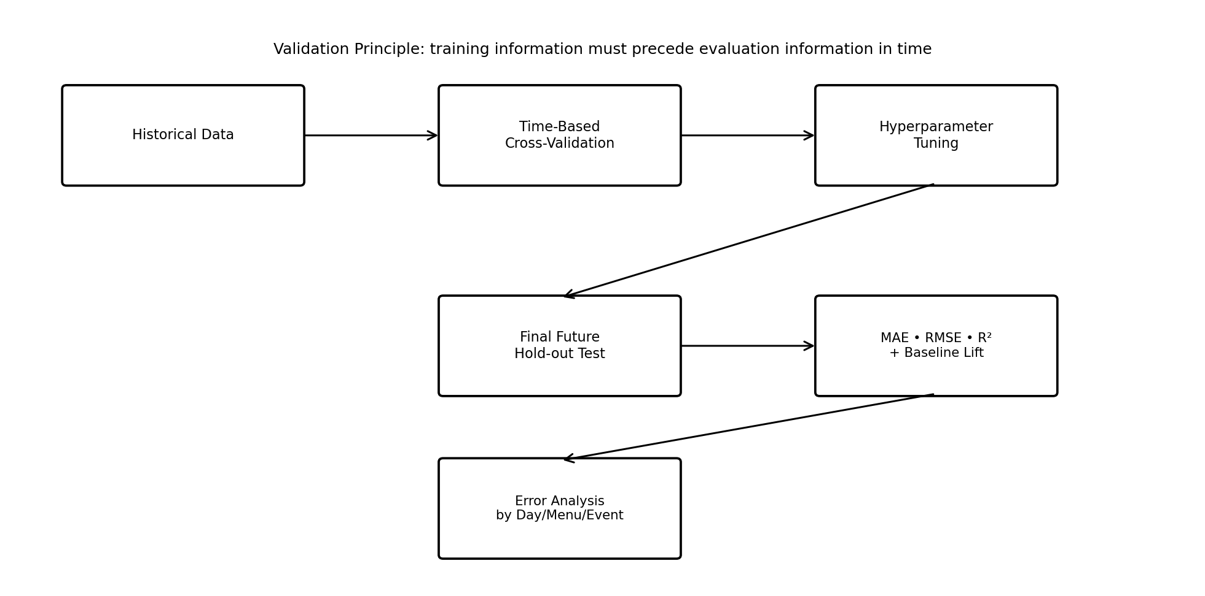
Figure 1. Proposed time-aware validation and evaluation strategy.

6.2 Evaluation Metrics
Metric | Interpretation | Why It Matters
MAE | Average absolute error in predicted meals. | Easy to interpret operationally.
RMSE | Root mean squared error; emphasizes large misses. | Important when large forecast errors are costly.
R² | Proportion of target variance explained. | Useful secondary measure of explanatory performance.
Baseline lift | Improvement relative to simple baseline. | Demonstrates whether ML provides additional value.

6.3 Model Selection Principle
The selected model will not be chosen using a single metric in isolation. MAE will be the primary operational metric, while RMSE will be examined for large errors and R² will provide additional context. Stability across time-based folds and the model's ability to explain major error patterns will also influence the final choice.

7. Hyperparameter Tuning
After identifying the strongest candidate, hyperparameters will be tuned using validation data. The purpose of tuning is to improve generalization rather than to maximize performance on a single sample.
Model | Example Hyperparameters
Decision Tree | max_depth, min_samples_split, min_samples_leaf
Random Forest | n_estimators, max_depth, min_samples_leaf, max_features
Gradient Boosting | n_estimators, learning_rate, max_depth, min_samples_leaf
GridSearchCV or RandomizedSearchCV can be considered with a time-aware cross-validation splitter. The final test set will remain untouched until the selected configuration is finalized.

8. Model Interpretation & Error Analysis

8.1 Interpretation
- Review feature importance for tree-based models.
- Use permutation importance as a model-agnostic diagnostic where appropriate.
- Compare predicted and actual surplus values.
- Examine whether the model behaves differently on high-attendance or special-event days.

8.2 Error Analysis
Error Segment | Question
Weekday | Does the model perform worse on specific days?
Meal service | Are breakfast, lunch or dinner forecasts different in quality?
Menu category | Are some cuisines systematically harder to predict?
Events | Do unusual events create larger errors?
High-surplus days | Does the model underestimate costly surplus events?
Error analysis is important because a model with a good average score can still fail in a particular operational scenario. The project therefore treats error patterns as a source of improvement rather than relying only on one overall metric.

9. Model Deployment & Maintenance

9.1 Conceptual Deployment
In a future implementation, the trained model could receive the next meal-service information and produce an estimated surplus together with an action category. A simple dashboard or Streamlit interface could display the prediction to a cafeteria manager.

9.2 Human-in-the-Loop Decision
The model would remain a decision-support tool. Staff would review the prediction, consider operational circumstances not captured by the data and then decide whether production should be adjusted or food-rescue planning should be initiated.

9.3 Monitoring & Retraining
- Monitor MAE and RMSE after deployment.
- Track prediction errors over time.
- Watch for changes in menu patterns, attendance and operating schedules.
- Investigate data drift and performance deterioration.
- Retrain periodically or when a defined performance threshold is reached.
- Maintain versioned models and documented training data.

10. Machine Learning Workflow
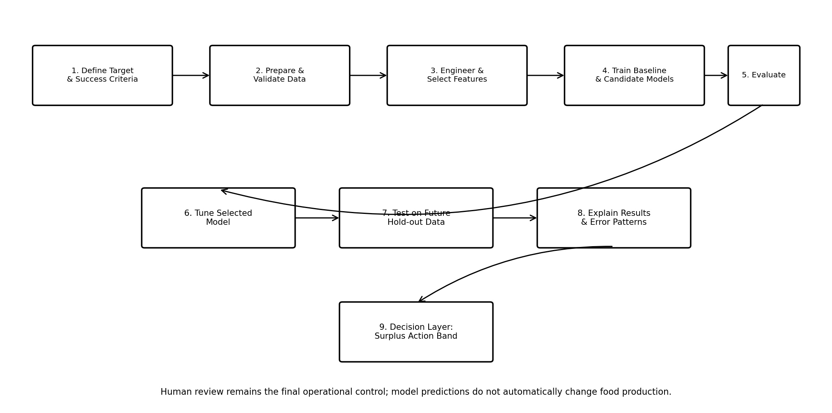
Figure 2. End-to-end MealCycle AI machine learning workflow.
The workflow begins with a clearly defined target and success criteria. Data are then prepared and converted into predictive features. Baseline and candidate models are trained, evaluated through time-aware validation and tuned only after a suitable candidate has been identified. The final future hold-out test provides the most realistic estimate of generalization. Results are interpreted and translated into a decision-support layer.

11. Python Libraries & Tools
Tool / Library | Planned Use
Python | Core implementation language.
pandas | Data manipulation and preprocessing.
NumPy | Numerical operations.
Matplotlib / Seaborn | EDA and model evaluation plots.
scikit-learn | Preprocessing, models, pipelines and validation.
Jupyter Notebook | Reproducible experimentation.
Git / GitHub | Version control and documentation.
Optional: Streamlit | Future lightweight prediction interface.
Optional: Power BI | Future business reporting layer.

12. 33-Hour Work Plan
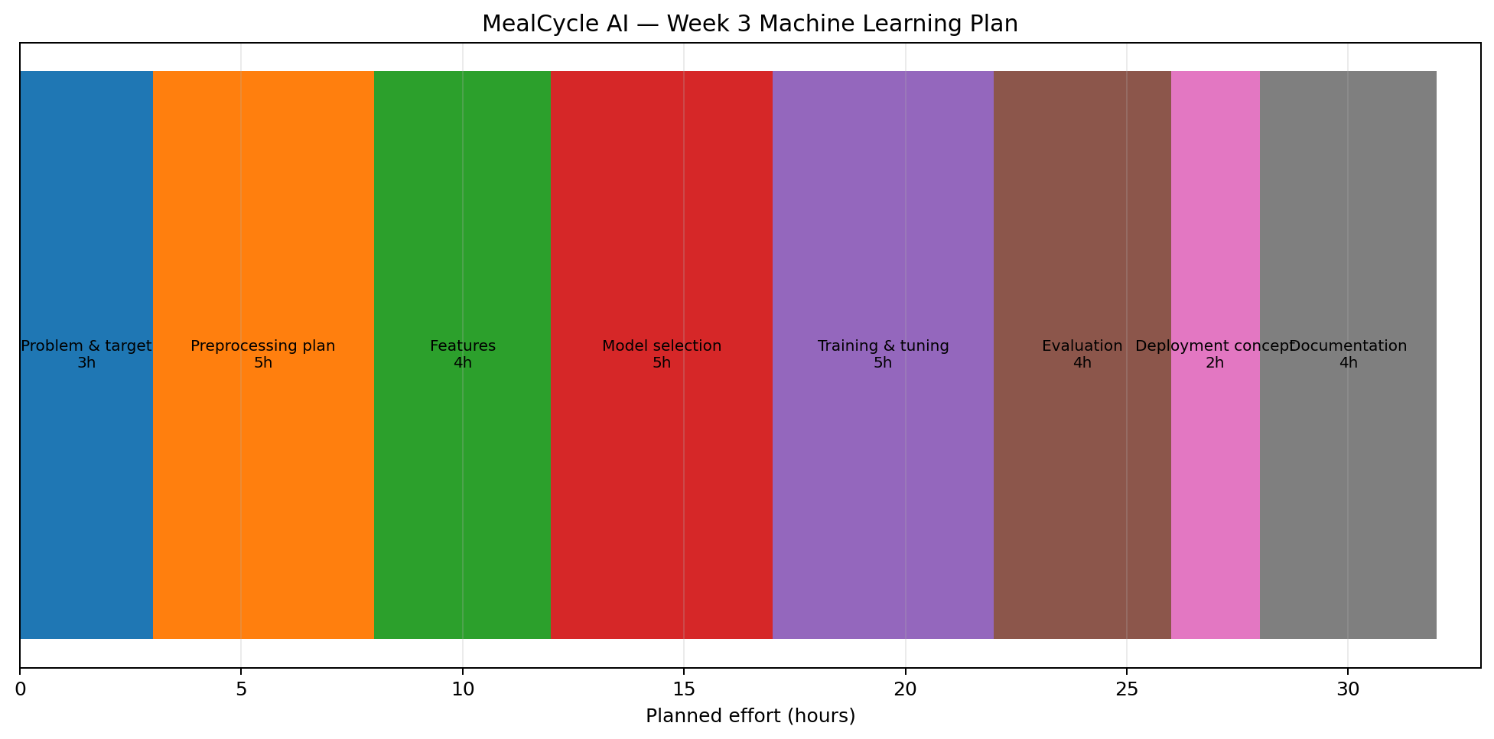
Figure 3. Proposed 33-hour Week 3 work allocation.
Phase | Hours | Deliverable
Problem definition & target design | 3 | ML problem statement and success criteria.
Preprocessing strategy | 5 | Cleaning, missing values, outliers and leakage controls.
Feature engineering | 4 | Feature specification and selection plan.
Model selection | 5 | Baseline and candidate algorithms.
Training & tuning | 5 | Training process and hyperparameter plan.
Evaluation & validation | 4 | Metrics, time-based validation and error analysis.
Deployment concept | 2 | Maintenance and monitoring plan.
Documentation & presentation | 5 | DOCX, diagrams and final review.
TOTAL | 33 | Complete Week 3 ML development plan.

13. Risks and Mitigation
Risk | Potential Effect | Mitigation
Data leakage | Artificially high accuracy. | Strict temporal feature construction and validation.
Overfitting | Poor future performance. | Cross-validation, simpler models and untouched hold-out test.
Concept drift | Accuracy decreases after deployment. | Monitoring and scheduled/triggered retraining.
Class/category imbalance | Some menu/event types poorly represented. | Review coverage and use appropriate sampling/weighting only where justified.
Outliers | Unstable regression results. | Investigate operational causes before treatment.
Shortage risk | Waste reduction could harm availability. | Monitor stockouts as a separate guardrail KPI.
Uninterpretable recommendation | Low user trust. | Provide feature diagnostics and human review.

14. Expected Outcomes
- A documented and reproducible machine-learning development framework.
- A justified choice of regression algorithms for the proposed problem.
- A clear preprocessing and feature-engineering strategy.
- A realistic validation approach that avoids temporal leakage.
- A set of evaluation metrics aligned with the operational objective.
- A future deployment concept including monitoring and retraining.
- A decision-support layer connecting predictions with cafeteria operations.

15. Conclusion
Week 3 develops the machine-learning blueprint for MealCycle AI. The proposed system treats cafeteria surplus forecasting as a supervised regression problem and follows a structured process covering preprocessing, feature engineering, model selection, training, validation, tuning, evaluation and deployment planning. A baseline is deliberately included so that machine-learning performance can be judged against a simple alternative rather than assumed to be useful by default.
The use of chronological validation is a central design choice because the intended task is future prediction. The project also recognizes that model quality cannot be judged solely by numerical accuracy. Error analysis, interpretability, operational guardrails and human review are necessary for responsible use. The resulting plan provides a practical foundation for the next implementation stage while remaining within the Week 3 requirement of conceptual planning rather than actual code execution.

