WEEK 4 DATA SCIENCE PROJECT
MEALCYCLE AI
Comprehensive Data Science Report & Insights Presentation Plan

University Submission Details | Information
Student Name | ____________________________
Course / Programme | ____________________________
Subject | Data Science / Python
Assignment | Week 4 – Comprehensive Data Science Report & Insights Presentation Plan
Faculty / Guide | ____________________________
Date of Submission | ____________________________

Project focus: Turning cafeteria data into understandable, actionable decisions.

Table of Contents
1. Executive Summary
2. Project Context and Purpose
3. Methodology Overview
4. Hypothetical Findings & Analysis
5. Visualization and Insight Framework
6. Actionable Insights
7. Presentation Strategy for a Non-Technical Audience
8. Recommendations for Future Work
9. Reporting and Documentation Plan
10. Evaluation Criteria and Success Measures
11. 30–35 Hour Work Plan
12. Conclusion

1. Executive Summary
MealCycle AI is a proposed data science solution for improving cafeteria meal planning by forecasting food surplus before it becomes waste. The project combines structured operational data with exploratory analysis, visualization and predictive modeling to support practical decisions. The final reporting stage is designed to translate technical analysis into a concise narrative that can be understood by cafeteria managers and other non-technical stakeholders.
For this comprehensive report, the analysis is treated as hypothetical because no real dataset is supplied. The expected analytical story is therefore expressed as a set of illustrative findings rather than claims about actual cafeteria performance. The framework considers patterns in meal preparation, sales, attendance, menu categories, calendar effects, events and weather. Visualizations are selected according to the question they answer: line charts for change over time, bar charts for category comparisons, scatter plots for relationships, KPI cards for executive summary information and heatmaps for identifying broader patterns.
The report emphasizes actionable insight rather than simply presenting charts. For example, if certain menu categories repeatedly show higher surplus, managers could investigate portion planning or production quantities. If higher attendance is associated with lower surplus, attendance forecasts could become an important input to preparation decisions. Model outputs can then be combined with these analytical findings to create a practical decision-support view.
The communication strategy follows a simple sequence: problem, evidence, insight, implication and recommendation. This structure helps a non-technical audience understand why the analysis matters and what action should follow. The ultimate goal is to demonstrate how data science can move from technical analysis to responsible business decision-making.

2. Project Context and Purpose

2.1 Business Question
The central question is: How can a cafeteria use historical and contextual information to anticipate food surplus and make better preparation decisions without increasing the risk of shortages?

2.2 Intended Audience
Audience | Information Need
Cafeteria Manager | Which services or menu types require attention?
Operations Team | What preparation changes could reduce avoidable surplus?
Institutional Management | What is the overall trend and potential business value?
Food-Rescue Partner | When might surplus volumes justify coordination?
Data/IT Team | How reliable and maintainable is the analytical process?

2.3 Report Principle
Technical detail will be available for auditability, but the main presentation will emphasize decisions and evidence. The report will avoid presenting hypothetical numbers as real observations; all mock findings in this planning document are explicitly illustrative.

3. Methodology Overview
The analytical framework begins with data validation and proceeds through exploratory analysis, feature construction, predictive modeling and interpretation. The final reporting layer combines descriptive findings with model-based evidence.
Stage | Approach | Expected Output
Data preparation | Quality checks, missing values, duplicates, valid ranges | Reliable analytical table
EDA | Univariate, bivariate and multivariate exploration | Patterns, anomalies and relationships
Feature engineering | Lag demand, rolling averages, calendar, attendance, menu and event variables | Model-ready predictors
Modeling | Baseline plus regression candidates | Surplus forecast
Evaluation | MAE, RMSE, R² and time-aware validation | Performance evidence
Insight synthesis | Combine statistical, visual and model findings | Actionable conclusions
Presentation | Narrative + charts + recommendations | Executive-ready communication

3.1 Analytical Questions
- How does surplus change across days and meal services?
- Which menu categories are associated with higher average surplus?
- How is attendance related to surplus?
- Are there unusual periods that require separate interpretation?
- Which factors appear most useful for forecasting?
- Does the machine-learning approach improve on a simple baseline?

4. Hypothetical Findings & Analysis
Because the assignment does not provide a dataset, this section defines the type of findings that the completed analysis would report. The following examples are illustrative and should be replaced by measured values if a real dataset is introduced later.

4.1 Trend Insight
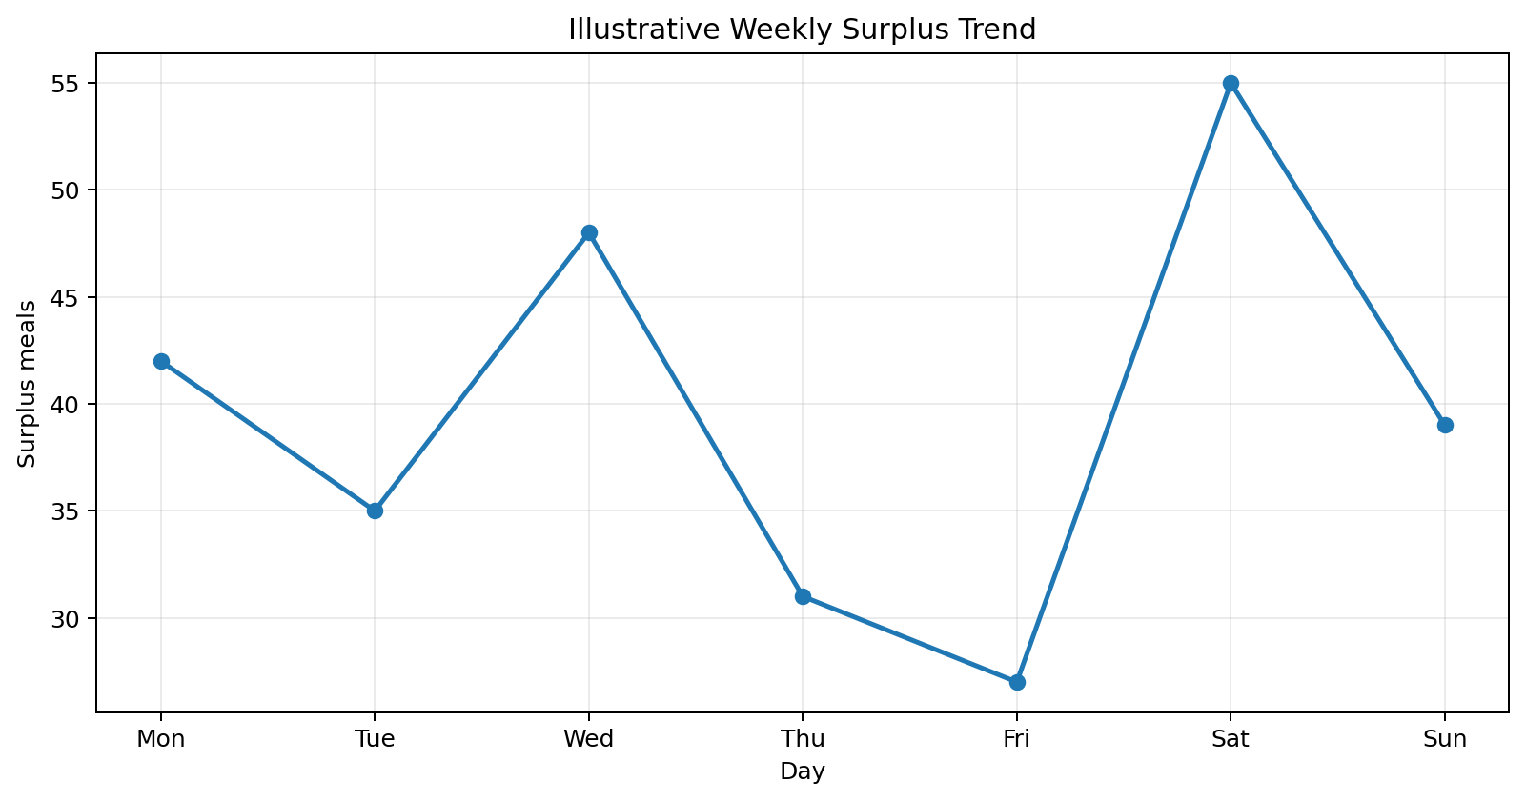
Figure 1. Illustrative weekly surplus trend — hypothetical values only.
An illustrative trend view suggests that surplus may vary considerably by day. A real analysis would determine whether such variation is driven by attendance, menu composition, recurring weekly behavior or unusual events. The purpose of the line chart is to reveal changes that could be hidden in a single average.

4.2 Category Comparison
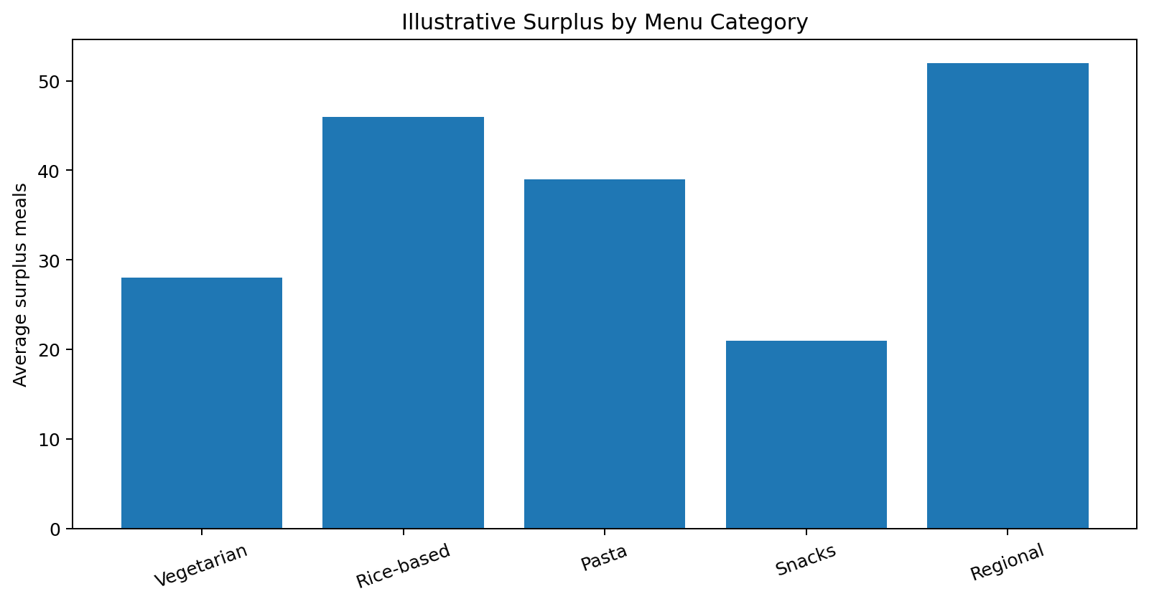
Figure 2. Illustrative surplus by menu category — hypothetical values only.
A category comparison can identify menu groups that consistently produce more surplus than others. If a pattern were confirmed, the next step would not be to remove the category automatically. Instead, the team could investigate portion sizes, popularity, preparation quantities and serving practices before recommending a change.

4.3 Relationship Analysis
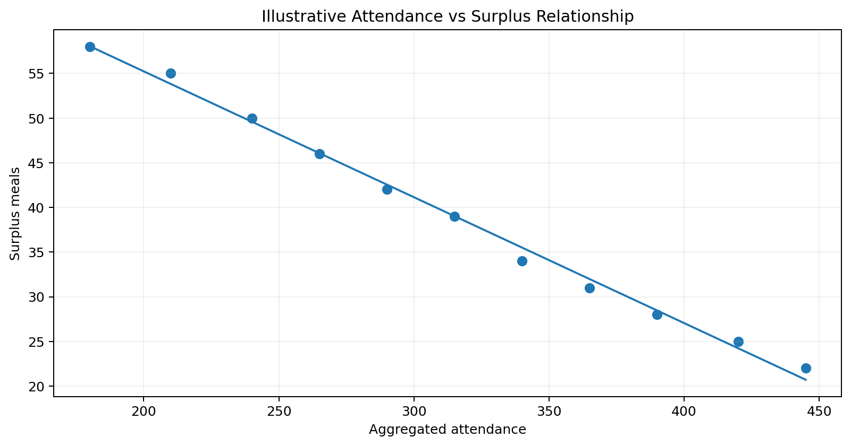
Figure 3. Illustrative attendance-versus-surplus relationship — hypothetical values only.
A scatter plot is useful for determining whether attendance is associated with surplus. A visible relationship could justify including attendance as a predictive feature. However, correlation alone would not establish causation, so other variables such as menu type and day of week would also be considered.

5. Visualization and Insight Framework
Question | Recommended Visualization | Reason
What is the overall current status? | KPI cards | Fast executive overview.
How is surplus changing over time? | Line chart | Shows trends and turning points.
Which categories differ? | Bar chart | Easy comparison across groups.
How are two numerical variables related? | Scatter plot | Shows direction, spread and possible outliers.
What is the distribution? | Histogram / box plot | Reveals skewness and unusual values.
Which variables move together? | Correlation heatmap | Provides a compact multivariate overview.
Where are patterns concentrated? | Heatmap by day/category | Highlights recurring combinations.
Which forecasts are inaccurate? | Actual vs predicted plot | Supports model error interpretation.

5.1 Executive KPI Panel
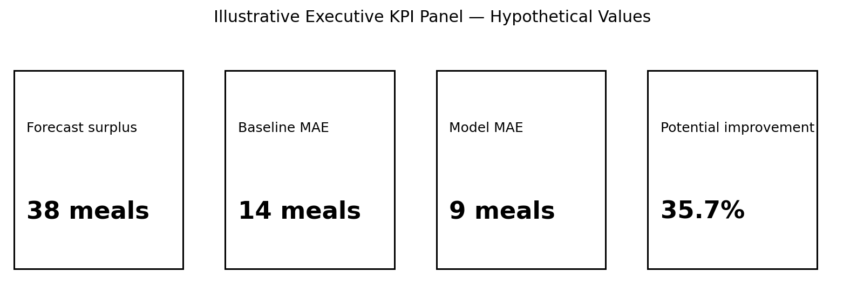
Figure 4. Illustrative executive KPI panel — all values are hypothetical.
The KPI panel is designed for quick scanning. In a real implementation, values would be calculated from validated data and accompanied by a clear reporting date and data-freshness indicator.

6. Actionable Insights
The reporting stage should distinguish between an observation, an insight and an action. An observation describes what the data shows; an insight explains why it matters; an action identifies what could be done next.
Observation Type | Potential Insight | Possible Action
Repeated high surplus in a menu category | Production may exceed demand for that category. | Review preparation quantities and serving history.
Higher attendance linked with lower surplus | Demand forecasting may improve when attendance is known. | Include attendance in future preparation planning.
Large errors on event days | Special events may behave differently from normal days. | Create event-specific indicators or planning rules.
Surplus spikes on specific weekdays | Weekly operational patterns may exist. | Adjust planning by day rather than using one fixed quantity.
Model underestimates high-surplus days | Large misses may create operational cost. | Investigate high-surplus cases and tune the model.

7. Presentation Strategy for a Non-Technical Audience
The final presentation will use storytelling rather than beginning with algorithms. The audience should first understand the operational problem, then see evidence, then understand the proposed action.

7.1 Recommended Storyline
- Opening: Explain the cafeteria surplus problem in one clear sentence.
- Evidence: Show the most important trend or comparison.
- Insight: Explain what the pattern means in operational terms.
- Prediction: Introduce the forecast as decision support, not as an unquestionable answer.
- Recommendation: State the practical next step.
- Impact: Explain how success would be measured.
- Closing: Summarize the decision the stakeholder can take.

7.2 Communication Rules
- Use plain language instead of unexplained technical terminology.
- Limit each visual to one primary message.
- Use titles that state the takeaway, not just the chart type.
- Show units, dates and definitions clearly.
- Separate measured findings from hypothetical examples.
- Explain uncertainty and limitations when they affect a decision.

8. Recommendations for Future Work
- Collect several months of reliable cafeteria records before drawing operational conclusions.
- Add attendance and event information at an aggregated level.
- Compare model performance with a simple operational baseline.
- Create a dashboard that combines historical trends and future surplus forecasts.
- Monitor model error and data drift after deployment.
- Test recommendations in a controlled pilot before changing production policy.
- Track both waste reduction and shortage/stockout rates so that one objective does not create a new problem.
- Evaluate whether surplus food can be safely and responsibly redirected through approved food-rescue processes.

8.1 Recommended Success Measures
Measure | Purpose
Surplus meals | Primary operational outcome.
Stockout frequency | Guardrail against excessive production reduction.
MAE / RMSE | Forecast reliability.
Baseline improvement | Evidence that modeling adds value.
Data freshness | Trustworthiness of current reporting.
User adoption / decision usage | Practical usefulness of the system.

9. Reporting and Documentation Plan
The final report will follow a repeatable structure:
- Executive Summary
- Business Context and Objective
- Data and Methodology
- Key Findings
- Visual Evidence
- Predictive Model Summary
- Actionable Insights
- Recommendations
- Limitations
- Future Work
- Appendix: Definitions and Technical Notes

9.1 Documentation Standards
- Record the data period and source for every reported finding.
- Maintain a data dictionary for important fields.
- Document assumptions and transformations.
- Keep code, charts and model versions reproducible.
- Label hypothetical or mock values clearly.
- Record limitations so readers do not interpret planning assumptions as measured facts.

10. Evaluation Criteria and Success Measures
University Criterion | How the Report Addresses It
Clarity and comprehensiveness | Provides an end-to-end narrative from problem to recommendation.
Actionable insights | Connects observations to possible operational decisions.
Quality of visual aids | Uses purpose-driven charts and clearly labels hypothetical examples.
Strategic communication | Separates technical detail from executive-level messaging.
Logical analysis | Uses a sequence of question → evidence → insight → action.
Professional reporting | Includes documentation, limitations and future-work sections.

11. 33-Hour Work Plan
Work Package | Hours | Output
Executive framing and objectives | 3 | Business question and success criteria.
Methodology synthesis | 4 | Concise analytical workflow.
Insight framework | 6 | Questions, findings structure and interpretation rules.
Visualization design | 6 | Mock charts, KPI panel and chart rationale.
Actionable recommendations | 4 | Insight-to-action framework.
Presentation storytelling | 4 | Non-technical communication plan.
Documentation and quality review | 6 | Final DOCX and consistency check.
TOTAL | 33 | Completed Week 4 report and presentation plan.

12. Conclusion
MealCycle AI demonstrates how a data science project can progress beyond model development into insight communication and decision support. The final reporting framework is designed to transform analytical results into a narrative that stakeholders can understand and act upon. Rather than presenting a collection of charts, the proposed report gives each visual a specific analytical purpose and connects findings to operational implications.
Because this Week 4 assignment is based on a hypothetical project without a supplied dataset, the mock visualizations and example findings in this document are intentionally illustrative. Their purpose is to demonstrate the proposed reporting style, not to claim real-world measurements. Once actual data are available, the same framework can be populated with validated statistics and model outputs.
The recommended communication approach follows a simple sequence: define the problem, present credible evidence, explain the insight, acknowledge uncertainty and recommend a practical next step. This combination of analysis, visualization and strategic communication provides a professional foundation for an executive-level data science presentation.

