WEEK 2 DATA SCIENCE PROJECT
MEALCYCLE AI
Exploratory Data Analysis (EDA) & Visualization Framework Design by
Janice Cyril Vaz
“Finding the story hidden inside the cafeteria data.”

Table of Contents
1. Introduction to EDA
2. EDA Objectives for MealCycle AI
3. Proposed Data Types & Structure
4. Data Profiling & Quality Audit
5. Univariate Analysis
6. Bivariate Analysis
7. Multivariate Analysis
8. Missing Data & Outlier Strategy
9. Visualization Framework
10. Python Libraries & Tools
11. Insight Validation & Interpretation
12. Reporting & Documentation Plan
13. 35-Hour Work Plan
14. Expected Outcomes
15. Evaluation Criteria Mapping
16. Conclusion

1. Introduction to Exploratory Data Analysis
Exploratory Data Analysis (EDA) is the stage where a dataset is examined before formal statistical modeling or machine learning is attempted. The purpose is not simply to generate charts; it is to understand what the data contains, whether it is trustworthy, which variables appear useful, and what unusual patterns need further investigation.
For MealCycle AI, EDA will be treated as a structured investigation. The analysis will begin with the shape and structure of the data, continue through data-quality checks and individual-variable analysis, and then move toward relationships among demand, preparation, attendance, menu and contextual factors. Every visualization will be linked to a question and accompanied by a short interpretation.

Why EDA matters to MealCycle AI
- Identify whether the proposed target variable, surplus meals, is correctly constructed.
- Understand typical and unusual cafeteria demand behavior.
- Detect missing, duplicated, inconsistent or implausible records before modeling.
- Discover candidate predictors for future feature engineering.
- Choose visual forms that make operational patterns understandable to a non-technical audience.
- Reduce the risk of building a machine-learning model on misleading or poorly understood data.

2. EDA Objectives for MealCycle AI
EDA Objective | Question to Answer | Potential Decision
Understand distributions | What does normal surplus look like? | Select transformations/model strategy.
Understand time patterns | Which days/services behave differently? | Create calendar features.
Compare categories | Which menu groups show larger surplus? | Investigate menu effects.
Study relationships | Does attendance relate to surplus? | Assess predictive usefulness.
Find anomalies | Which observations look unusual? | Investigate events/data errors.
Assess missingness | Where and why is information absent? | Choose appropriate treatment.
Assess associations | Which numeric variables move together? | Guide feature selection.

3. Proposed Data Types & Structure
The Week 2 exercise does not require a real dataset. The following is the proposed structure that EDA would examine once data becomes available.
Variable | Expected Type | Role | Example
date | datetime | Time index | 2026-08-10
service | categorical | Meal period | Lunch
meals_prepared | integer | Input | 500
meals_sold | integer | Input / demand | 425
surplus_meals | integer | Target | 75
attendance | integer | Predictor | 2350
menu_category | categorical | Predictor | Indian
price | float | Predictor | 85.00
temperature | float | Predictor | 28.5
rain_flag | binary | Predictor | 1
holiday_flag | binary | Predictor | 0
exam_period | binary | Predictor | 1
event_attendance | integer | Predictor | 500

Data-type checks
- Datetime fields will be parsed explicitly rather than treated as plain text.
- Counts will be stored as numeric values and checked for negative values.
- Categories will be inspected for spelling variations and inconsistent labels.
- Binary flags will be checked to ensure they use a consistent representation.
- Continuous variables will be examined for unreasonable ranges.

4. Data Profiling & Quality Audit
The first EDA notebook will produce a compact data profile before any business interpretation is made.
- Dataset dimensions: number of rows and columns.
- Column names, data types and unique-value counts.
- Missing-value count and percentage by column.
- Duplicate-row count.
- Minimum, maximum, mean, median and standard deviation for numeric variables.
- Frequency tables for categorical variables.
- Date range and gaps in the observation period.

Quality questions
Check | Example Warning | Action
Negative quantity | meals_sold = -4 | Flag for investigation.
Impossible relationship | sold > prepared | Verify source definition.
Duplicate service | Same date/service repeated | Audit and deduplicate if confirmed.
Missing target | surplus_meals missing | Do not silently impute the target.
Category drift | 'Veg', 'Vegetarian', 'Veg.' | Standardize after reviewing meaning.
Date gap | Several days absent | Check whether cafeteria was closed or data failed.

5. Univariate Analysis
Univariate analysis studies one variable at a time. It will be used to understand distributions, frequency, central tendency and unusual values.
Variable Type | Planned Technique | Visualization
Continuous | mean, median, spread, skewness | Histogram + box plot
Count | range, quartiles | Histogram / box plot
Categorical | frequency and proportion | Bar chart / dot plot
Binary | class balance | Count plot
Datetime | coverage and gaps | Timeline / line chart
Key questions include: Is surplus heavily skewed? Are there extreme service days? Are some menu categories rare? Is the target dominated by a small number of high-surplus observations?

6. Bivariate Analysis
Bivariate analysis examines two variables together to determine whether meaningful relationships or group differences appear.
Relationship | Plot | Question
Attendance vs surplus | Scatter plot | Does higher attendance generally correspond to lower or higher surplus?
Prepared vs sold | Scatter plot | How closely does preparation track demand?
Weekday vs surplus | Box plot | Which weekdays show different surplus distributions?
Menu category vs surplus | Box/bar plot | Are some categories associated with higher surplus?
Rain vs surplus | Box plot | Does rainy weather correspond to different demand?
Event vs surplus | Grouped bar/box plot | Do event days behave differently?
Important principle: an observed relationship will be treated as an association, not automatically as proof of causation.

7. Multivariate Analysis
Multivariate EDA considers several variables simultaneously. This is important because cafeteria surplus is unlikely to have a single cause.
- Correlation matrix for selected numerical variables.
- Pairwise plots for a small set of important continuous variables.
- Grouped analysis such as weekday × meal service × menu category.
- Heatmaps showing average surplus by weekday and service.
- Comparisons of event days versus normal days while controlling descriptively for attendance bands.
- Segmented analysis for high-attendance and low-attendance periods.
The purpose is to discover interactions and conditional patterns that may be hidden when variables are inspected separately.

8. Missing Data & Outlier Strategy

8.1 Missing data
Missing values will not automatically be replaced with zero. First, the reason for missingness will be considered.
Situation | Planned Treatment
Non-critical numeric predictor missing | Compare median/robust imputation options and document the choice.
Categorical predictor missing | Use an explicit 'Unknown' category when appropriate.
Weather value missing | Use a documented external-source or statistical treatment if permitted.
Target variable missing | Exclude from supervised training rather than inventing a target.
Large block of missing dates | Investigate system/closure causes before modeling.

8.2 Outliers
- Use IQR-based checks and visual inspection to flag unusual observations.
- Do not remove an outlier merely because it is statistically unusual.
- Cross-check extreme values against events, holidays, closures or operational incidents.
- Keep genuine rare events if they represent real future conditions.
- Document every exclusion or transformation.

9. Visualization Framework
MealCycle AI will follow a 'question → chart → observation → implication' framework. A chart will be included only when it helps answer a defined analytical question.
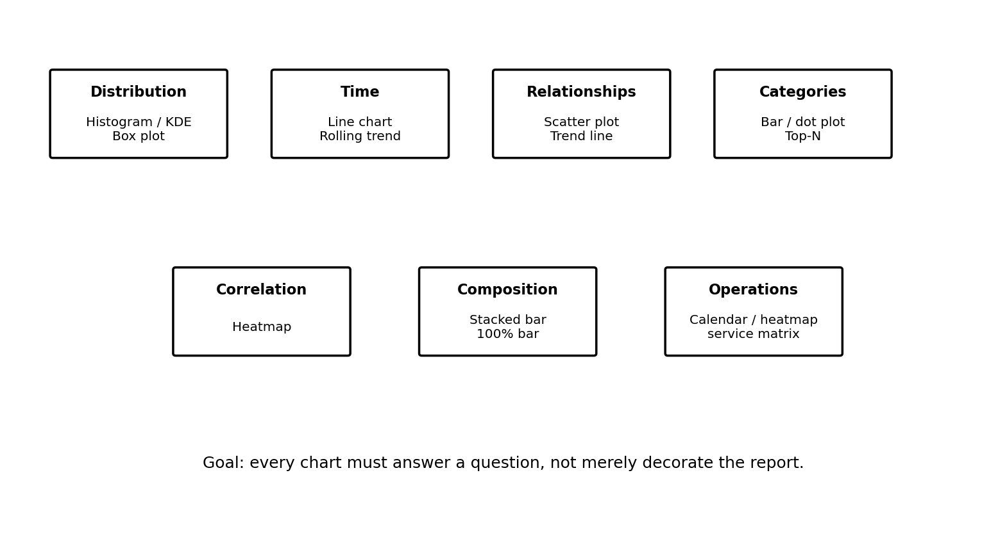
Figure 1. Proposed visualization map for the MealCycle AI EDA stage.
Analytical Purpose | Preferred Visual | Why It Fits
Distribution | Histogram / box plot | Shows shape, spread and unusual values.
Trend | Line chart | Makes changes over time visible.
Comparison | Bar / dot / box plot | Compares groups clearly.
Relationship | Scatter plot | Shows direction, strength and unusual points.
Correlation | Heatmap | Summarizes many pairwise associations.
Composition | Stacked / 100% bar | Shows category contribution.
Operational pattern | Heatmap / calendar view | Highlights recurring service-day patterns.

Visualization design rules
- Use a descriptive title that communicates the analytical question.
- Label axes with meaningful units.
- Use consistent terminology across charts.
- Avoid unnecessary 3-D effects and decorative elements.
- Show units such as meals, percentage or currency where relevant.
- Add a short interpretation beneath important charts.
- Do not imply causality when the analysis only demonstrates association.

10. Python Libraries & Tools
Library / Tool | Role in EDA
pandas | Loading, filtering, grouping, summarizing and reshaping data.
NumPy | Numerical calculations and array operations.
Matplotlib | Flexible construction of publication-style charts.
Seaborn | Statistical plots such as box plots, heatmaps and pair plots.
Plotly | Optional interactive exploration when a richer view is useful.
Jupyter Notebook | Step-by-step EDA, commentary and reproducibility.
SciPy (optional) | Statistical tests where justified.
Git / GitHub | Versioning notebooks and documentation.

Planned notebook structure
01_data_profile.ipynb
02_data_quality.ipynb
03_univariate_eda.ipynb
04_bivariate_eda.ipynb
05_multivariate_eda.ipynb
06_visualization_summary.ipynb

11. Insight Validation & Interpretation
EDA findings will be validated before being described as meaningful business insights.
- Check whether the pattern remains visible across multiple time periods.
- Compare means with medians when distributions are skewed.
- Check sample sizes before interpreting category differences.
- Investigate whether an apparent relationship could be caused by a third variable.
- Cross-check unusual observations with operational context.
- Record uncertainty and limitations instead of overstating conclusions.

Example insight format
Observation → Evidence → Possible explanation → Business implication → Limitation
Example: “Friday lunch services show a higher median surplus than Tuesday lunch services in the exploratory sample. This pattern should be checked against attendance, menu composition and event schedules before concluding that Friday itself causes higher surplus.”

12. Reporting & Documentation Plan
The final EDA report will be structured so that a technical reader and a non-technical decision-maker can both understand the findings.
Report Section | Content
Executive Summary | Three to five major findings and their practical meaning.
Dataset Overview | Sources, dimensions, variables and time coverage.
Data Quality | Missingness, duplicates, outliers and decisions taken.
Univariate Findings | Important distributions and category patterns.
Relationship Findings | Key bivariate and multivariate observations.
Visualization Gallery | Selected charts with captions and interpretations.
Business Implications | What the findings could mean for cafeteria planning.
Limitations | Data gaps, sampling issues and uncertainty.
Next Steps | Feature engineering and modeling recommendations.

Documentation standard
- Every major chart will have a title, axis labels and interpretation.
- Important cleaning decisions will be recorded in the notebook.
- Figures will use consistent naming and numbering.
- Unexpected results will be discussed rather than hidden.
- Final conclusions will distinguish observed patterns from assumptions.

13. 35-Hour Work Plan
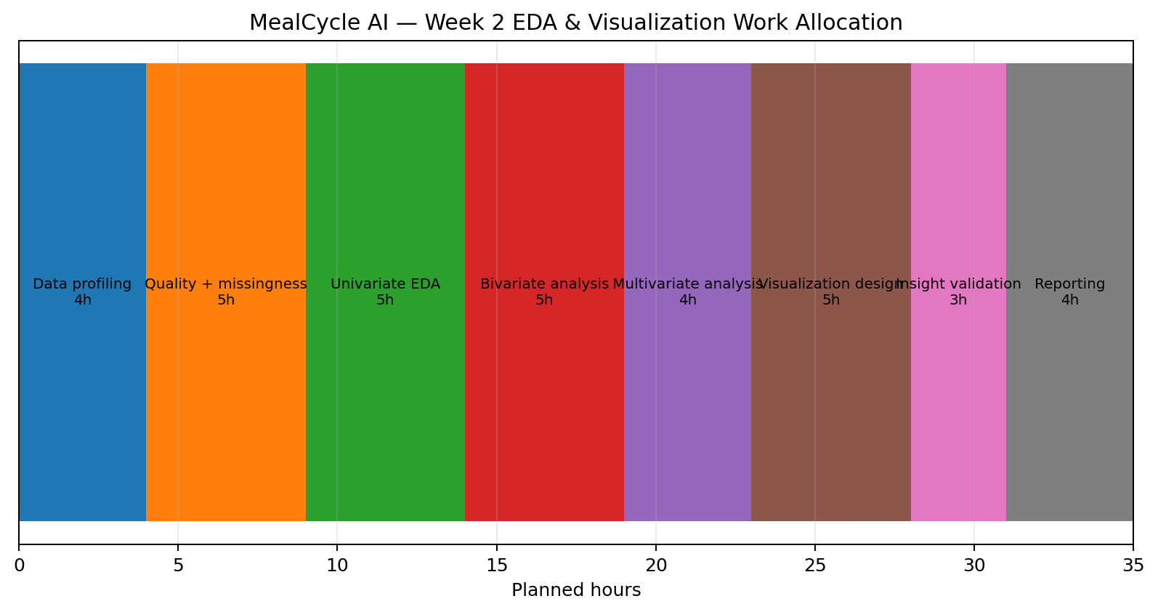
Proposed 35-hour Week 2 EDA work allocation.
Task | Hours | Output
Data profiling | 4 | Initial data dictionary and profile.
Quality + missingness analysis | 5 | Quality report and treatment plan.
Univariate EDA | 5 | Distribution and category analysis.
Bivariate EDA | 5 | Relationship and group comparisons.
Multivariate EDA | 4 | Correlation and segmented analysis.
Visualization design | 5 | Final chart framework.
Insight validation | 3 | Verified observations and limitations.
Reporting | 4 | Final DOCX and presentation-ready summary.
TOTAL | 35 | Complete Week 2 framework.

14. Expected Outcomes
- A structured EDA workflow that can be reused for the future MealCycle dataset.
- A documented understanding of variable types, distributions and data quality.
- A set of visualization choices tied to specific analytical questions.
- A list of candidate features for the Week 3/4 modeling stages.
- Early identification of data leakage, outliers and potential biases.
- A concise set of business-oriented insights suitable for later presentation.
The intended outcome of Week 2 is therefore not a final machine-learning result. It is a defensible analytical foundation that makes later modeling more reliable.

15. Evaluation Criteria Mapping
University Criterion | How This Framework Meets It
Depth and clarity of EDA | Covers profiling, quality checks, univariate, bivariate and multivariate analysis.
Visualization methodology | Defines chart choices by analytical purpose and includes visualization rules.
HTML/DOC structure | Uses clear headings, tables, figures, captions and logical sections.
Logical adaptable process | Framework can be applied to other datasets by changing the data dictionary and questions.
Planning & documentation | Includes insight validation, reporting structure and a 35-hour schedule.

16. Conclusion
MealCycle AI Week 2 establishes a structured framework for understanding cafeteria data before predictive modeling begins. The proposed EDA process deliberately moves from basic data inspection to increasingly detailed analysis: first understanding individual variables, then examining relationships, and finally investigating combinations of factors that may influence food surplus. Missing data and outliers will be investigated rather than automatically removed, while visualization choices will be tied to clear analytical questions.
The framework also emphasizes responsible interpretation. A visible pattern will not automatically be treated as a causal relationship, and unusual observations will be checked against operational context. This approach helps ensure that future machine-learning models are based on a trustworthy understanding of the data. By the end of Week 2, MealCycle AI will have a clear EDA workflow, visualization strategy, documentation format and list of potential analytical features, providing a strong bridge between project planning and the later technical implementation.

