WEEK 1 DATA SCIENCE PROJECT
MEALCYCLE
Predicting Cafeteria Food Surplus Before It Becomes Waste

A Comprehensive Python-Based Data Science Project Plan By Janice Cyril Vaz
“From yesterday’s leftovers to tomorrow’s smarter decisions.”

Table of Contents
1. Introduction & Background
2. Project Objectives & Scope
3. Proposed Data Strategy
4. Methodology & Strategy
5. Project Architecture
6. Python Libraries & Tools
7. Timeline & Work Allocation
8. Expected Outcomes & Business Value
9. Challenges & Mitigation Strategies
10. Ethical, Privacy & Responsible AI Considerations
11. Evaluation Criteria & Success Measures
12. Future Implementation Plan
13. Conclusion

1. Introduction & Background

1.1 Problem Statement
Cafeterias in universities, corporate campuses and other large institutions must prepare food before knowing the exact number of customers who will purchase it. If demand is overestimated, prepared food may remain unused, increasing waste and operating costs. If demand is underestimated, shortages and customer dissatisfaction can occur.
MealCycle AI is a hypothetical Python-based data science project designed to predict the quantity of food likely to remain unused after a meal service. The proposed system will learn from historical cafeteria operations and contextual information such as attendance, menu type, weekdays, holidays, events and weather.

1.2 Project Motivation
The motivation is to shift cafeteria planning from intuition-driven preparation to evidence-based decision support. Instead of waiting until food becomes surplus, managers could use a forecast to adjust preparation levels before service begins.

1.3 What Makes the Project Unique
Unlike many beginner data science projects that stop after producing a prediction, MealCycle AI includes a decision layer. A predicted surplus is converted into an operational category such as Normal, Caution or High Surplus. The project also considers time-aware validation, human review, privacy-conscious aggregated data and stockout monitoring as a guardrail.

2. Project Objectives & Scope

2.1 Main Objective
To design a Python-based data science system that forecasts cafeteria food surplus and converts the forecast into practical recommendations for production planning and responsible food-rescue decisions.

2.2 Specific Objectives
ID | Objective
O1 | Identify the major factors associated with cafeteria food surplus.
O2 | Design a reliable data collection and data-quality strategy.
O3 | Explore demand and surplus patterns using exploratory data analysis.
O4 | Engineer predictive features from historical and contextual variables.
O5 | Develop a simple baseline and machine-learning regression candidates.
O6 | Evaluate models using MAE, RMSE and R² with time-aware validation.
O7 | Translate forecasts into operational decision categories.
O8 | Document a future-ready architecture for implementation.

2.3 In Scope
- Historical cafeteria sales and production records.
- Aggregated attendance information.
- Menu, calendar, holiday, event and weather variables.
- Data cleaning, validation and exploratory analysis.
- Feature engineering and regression modeling.
- Time-aware model evaluation and error analysis.
- Surplus forecasting and decision-support recommendations.
- Documentation and visualization of the proposed system.

2.4 Out of Scope
- Facial recognition or individual student tracking.
- Personally identifiable student information.
- Automatic food disposal or autonomous operational decisions.
- Full procurement and financial-accounting automation.
- Medical, dietary or health profiling of individuals.
- Live production deployment during this planning phase.

3. Proposed Data Strategy
The Week 1 assignment is a planning exercise and therefore does not require a real dataset. The following data design specifies what information would be required during the implementation phase.
Data Source | Example Fields | Purpose
Point of Sale | date, item, quantity_sold, service | Measure actual demand.
Kitchen Production | date, item, meals_prepared | Measure preparation quantity.
Attendance | date, aggregated_attendance | Estimate potential customer volume.
Menu | item, category, cuisine, price | Represent menu characteristics.
Calendar | weekday, holiday, exam_period | Capture recurring demand patterns.
Events | event_type, expected_attendance | Explain unusual demand.
Weather | temperature, rainfall, category | Capture external demand effects.

3.1 Target Variable
The proposed target variable is Surplus Meals, calculated as:
Surplus Meals = Meals Prepared − Meals Sold
For example, if 500 meals are prepared and 425 are sold, the observed surplus is 75 meals. The future model would attempt to forecast this surplus before the meal service occurs.

3.2 Data Quality Rules
- Validate dates, data types and column names.
- Identify duplicate service or transaction records.
- Check for impossible negative quantities.
- Investigate cases where recorded sales exceed meals prepared.
- Flag missing values before selecting an appropriate treatment.
- Investigate extreme values as possible operational incidents instead of automatically deleting them.

4. Methodology & Strategy
The proposed methodology follows a complete data science lifecycle. Each stage produces an output that becomes the input for the next stage.
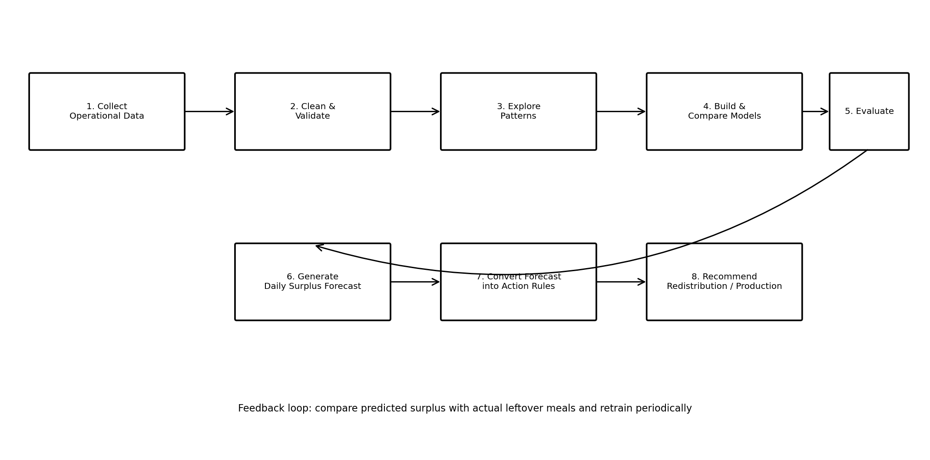
Figure 1. MealCycle AI end-to-end data science workflow.

4.1 Phase A — Data Collection
Historical operational records would be collected from point-of-sale systems, kitchen records and other approved aggregated sources. Python would be used to ingest CSV/Excel files or connect to a structured database.

4.2 Phase B — Data Cleaning & Preparation
- Standardize column names and data types.
- Convert dates to a consistent format.
- Remove or investigate duplicate records.
- Handle missing values using documented, variable-specific rules.
- Aggregate transactions to the prediction level: cafeteria × date × meal service.
- Validate the definition and calculation of the target variable.

4.3 Phase C — Exploratory Data Analysis
EDA will focus on business questions rather than producing graphs without a purpose.
- Which weekdays generate the highest surplus?
- Does attendance explain variation in surplus?
- Which menu categories tend to produce higher surplus?
- Does weather affect cafeteria demand?
- Do holidays, exams or events create unusual demand patterns?
- How does surplus change over time?

4.4 Phase D — Feature Engineering
Feature | Example | Reason
day_of_week | Monday | Capture weekly patterns.
is_holiday | 0 / 1 | Represent holiday effects.
exam_period | 0 / 1 | Capture changes in campus activity.
attendance | 2,350 | Estimate potential demand.
sales_lag_1 | Yesterday's sales | Use recent demand history.
sales_lag_7 | Same weekday last week | Capture weekly seasonality.
rolling_sales_7d | 7-day average | Smooth short-term fluctuations.
event_attendance | 500 | Explain unusual demand.
rain_flag | 0 / 1 | Represent weather effects.
menu_category | Indian | Capture menu composition.

4.5 Phase E — Modeling Strategy
The project will establish a baseline before applying machine learning. This prevents the common mistake of assuming that a complex model is automatically useful.
Model | Purpose
Historical Average / Previous Week | Simple baseline for comparison.
Linear Regression | Transparent and interpretable benchmark.
Random Forest Regressor | Capture nonlinear relationships.
Gradient Boosting Regressor | Candidate model for complex patterns.

4.6 Phase F — Validation Strategy
Because the project predicts future cafeteria surplus, purely random train-test splitting may create an unrealistic evaluation. A chronological split or TimeSeriesSplit approach will be preferred so that training information comes from the past and evaluation simulates future prediction.

4.7 Phase G — Evaluation
Metric | Meaning | Use
MAE | Average absolute prediction error. | Primary metric; lower is better.
RMSE | Penalizes large errors more strongly. | Detect costly large misses.
R² | Proportion of target variation explained. | Secondary diagnostic.
Baseline Lift | Improvement over simple baseline. | Confirm ML provides practical value.

5. Project Architecture
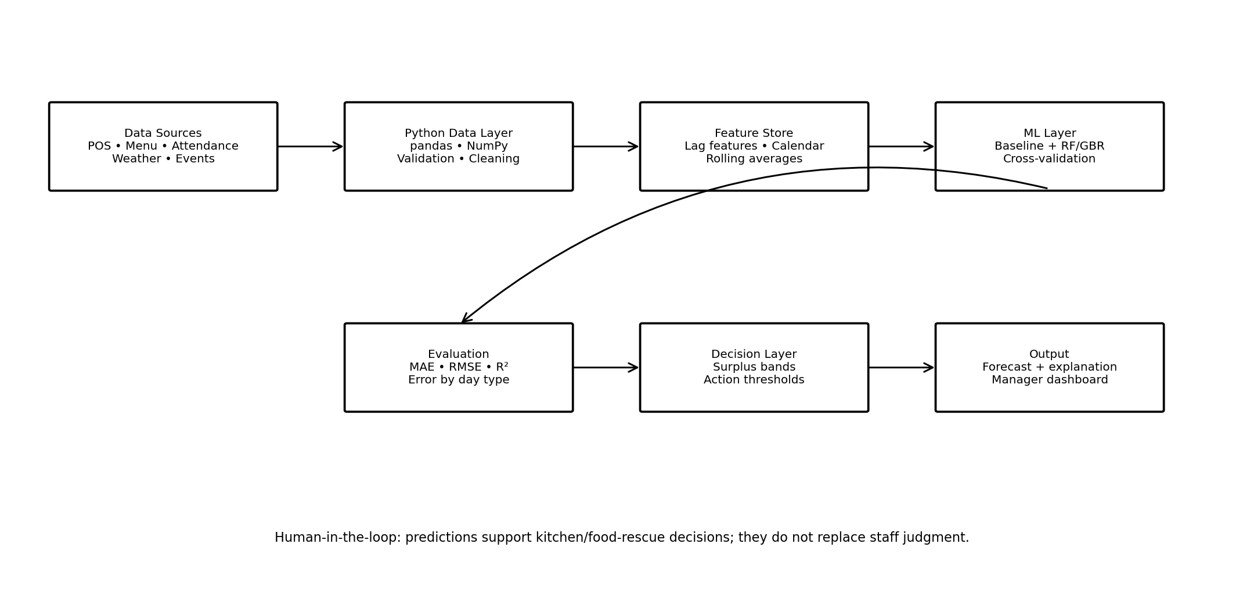
Figure 2. Proposed technical architecture for MealCycle
The architecture separates data ingestion, data preparation, feature engineering, modeling, evaluation and decision support. This modular design makes the future implementation easier to test, maintain and improve.

6. Python Libraries & Tools
Tool / Library | Planned Use
Python | Primary programming language.
pandas | Data ingestion, cleaning, grouping and feature creation.
NumPy | Numerical operations.
Matplotlib | Charts and visual analysis.
Seaborn | Statistical visualization.
scikit-learn | Regression models, preprocessing and validation.
Jupyter Notebook | Experimentation and reproducible analysis.
SQL | Optional structured-data querying.
Git / GitHub | Version control and project documentation.
Power BI | Optional future business dashboard.
Streamlit | Optional future interactive prediction interface.

7. Timeline & Work Allocation
The assignment requires approximately 30–35 hours. The proposed plan allocates 33 hours across the complete planning lifecycle.
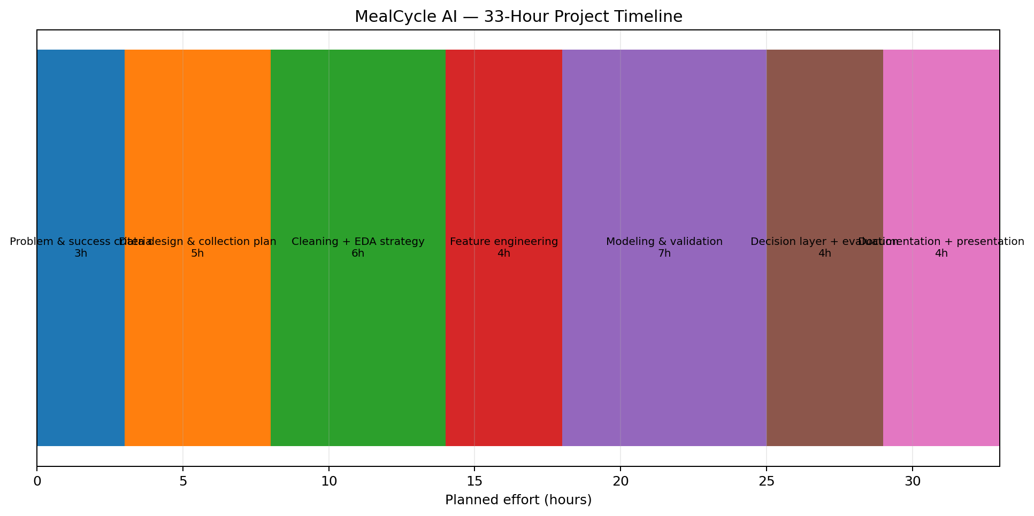
Figure 3. 33-hour MealCycle AI project timeline.
Phase | Hours | Expected Output
Problem definition & success criteria | 3 | Problem statement, target and KPIs.
Data strategy | 5 | Data sources, fields and data dictionary.
Cleaning & quality planning | 4 | Validation and cleaning rules.
EDA strategy | 4 | Business questions and visualization plan.
Feature engineering | 4 | Predictive feature specification.
Modeling strategy | 5 | Baseline and ML candidates.
Evaluation strategy | 3 | Metrics and time-aware validation.
Architecture & diagrams | 2 | System architecture and workflow.
Documentation & presentation | 3 | Final university submission.
TOTAL | 33 | Complete project plan.

8. Expected Outcomes & Business Value

8.1 Technical Outcomes
- A documented Python data pipeline design.
- A structured exploratory analysis framework.
- A feature engineering strategy.
- A baseline and machine-learning modeling strategy.
- A time-aware evaluation framework.
- A future-ready system architecture.

8.2 Business Outcomes
- Better food preparation decisions.
- Potential reduction in avoidable food surplus.
- Improved use of food and operational resources.
- Evidence-based cafeteria planning.
- A reusable analytics framework for future implementation.

8.3 Decision-Support Layer
Forecasted Surplus | Category | Possible Recommendation
Low | Normal | Maintain normal preparation.
Moderate | Caution | Consider reducing the next preparation batch.
High | High Surplus | Adjust production and consider appropriate food-rescue planning.
The final thresholds would be determined from historical performance and operational requirements rather than being treated as universal fixed values.

9. Challenges & Mitigation Strategies
Challenge | Potential Impact | Mitigation
Missing data | Biased analysis. | Quality checks and documented imputation.
Duplicate records | Inflated demand. | Duplicate detection and audit counts.
Rare events | Large prediction errors. | Event indicators and separate error analysis.
Data leakage | Unrealistically high accuracy. | Chronological validation.
Overfitting | Poor future performance. | Baseline comparison and cross-validation.
Seasonal change | Model drift. | Monitor performance and retrain periodically.
Menu changes | Distribution shift. | Include menu features and monitor drift.
Shortage risk | Customer dissatisfaction. | Track stockouts as a guardrail metric.
Privacy | Unnecessary exposure of users. | Use aggregated data and exclude personal identifiers.

10. Ethical, Privacy & Responsible AI Considerations
MealCycle AI is designed as a responsible decision-support system. The project does not require individual student identities. Attendance should be used only in aggregated form, such as the number of people present on a given day.
- No facial recognition or individual tracking.
- No personally identifiable information is required.
- Human staff retain responsibility for operational decisions.
- Food-waste reduction must not be optimized at the expense of creating shortages.
- Model performance should be monitored after deployment because demand patterns can change.

11. Evaluation Criteria & Success Measures
The following criteria directly address the university assignment requirements.
Evaluation Area | How MealCycle AI Addresses It
Completeness | Covers background, objectives, scope, methodology, timeline, tools, outcomes and challenges.
Data Science Understanding | Follows collection → cleaning → EDA → features → modeling → evaluation.
Logical Organization | Each stage has a clear purpose and output.
Visual Clarity | Workflow, architecture and timeline diagrams are embedded.
Strategic Thinking | Includes baseline comparison, time-aware validation and decision support.
Practical Relevance | Forecast connects directly to cafeteria production decisions.

11.1 Proposed Success Criteria
- The final model should outperform the chosen baseline on MAE.
- Model errors should remain stable across different time periods.
- Major drivers of surplus should be interpretable.
- The forecast should map to a clear operational action.
- Stockout risk should be monitored alongside surplus reduction.
- The implementation should be reproducible through documented code and assumptions.

12. Future Implementation Plan
Although Week 1 focuses only on planning, the proposed project can be implemented in subsequent stages.
Future Stage | Planned Work
Stage 1 | Acquire or construct an appropriate historical dataset.
Stage 2 | Implement Python ingestion and data-quality checks.
Stage 3 | Perform EDA and generate business insights.
Stage 4 | Engineer time, attendance, menu and event features.
Stage 5 | Train baseline and machine-learning regression models.
Stage 6 | Evaluate using chronological validation.
Stage 7 | Create surplus decision bands and visualizations.
Stage 8 | Build an optional Power BI or Streamlit presentation layer.

12.1 Proposed Project Folder Structure
MealCycle-AI/
│
├── data/
│ ├── raw/
│ ├── processed/
│ └── README.md
├── notebooks/
│ ├── 01_data_quality.ipynb
│ ├── 02_eda.ipynb
│ └── 03_modeling.ipynb
├── src/
│ ├── data_cleaning.py
│ ├── features.py
│ ├── train.py
│ └── evaluate.py
├── reports/
│ └── figures/
├── requirements.txt
└── README.md

13. Conclusion
MealCycle AI presents a structured and practical approach to a hypothetical data science problem: forecasting cafeteria food surplus before it becomes waste. The proposed project demonstrates the complete planning lifecycle of a Python data science solution, from defining the problem and designing the data strategy to exploratory analysis, feature engineering, model selection, time-aware evaluation and decision support.
The project is intentionally designed to balance predictive performance with real-world usefulness. Its strongest feature is the decision layer, which translates forecasts into actionable recommendations while retaining human oversight and monitoring shortage risk. This makes the project suitable not only as a Week 1 university submission but also as a foundation for a future portfolio-quality data science implementation.

