WEEK 5 TASK
Data Quality Assurance and Compliance Analysis
Healthcare Analytics – UCI Heart Disease Dataset
A practical, auditable plan for data integrity, quality assurance, security and compliance readiness.
Assignment requirement | Coverage in this report
Regulatory overview | HIPAA, India DPDP, WHO ethics and Good Machine Learning Practice principles.
Quality assurance | Completeness, validity, accuracy, consistency, uniqueness, integrity and reproducibility.
Data governance | Provenance, access control, versioning, change control, retention and audit evidence.
Risk management | Risk register, mitigation controls and CAPA template.
Documentation | Workflow, numerical examples, Python QA template and audit checklist.

1. Executive Summary
This report establishes a structured Data Quality Assurance (DQA) and compliance framework for the healthcare analytics project using the UCI Heart Disease dataset. The UCI repository describes the dataset as a health-and-medicine classification dataset with 303 instances and 13 commonly used features, containing categorical, integer and real-valued data. The repository also states that missing values are present. The broader source database contains 76 attributes, while published experiments commonly use a 14-attribute subset including the diagnosis field. UCI notes that patient names and social-security numbers were removed or replaced with dummy values. Source: UCI Machine Learning Repository, Heart Disease, DOI 10.24432/C52P4X.
The purpose of Week 5 is to demonstrate how a healthcare dataset can be audited before analytical or predictive use. The proposed controls cover completeness, uniqueness, validity, consistency, accuracy, integrity, provenance, security and reproducibility. Each quality dimension is converted into a measurable test, an acceptance criterion and a corrective action so that 'data quality' is not treated as a subjective judgement.
Regulatory compliance is presented as a governance reference, not as a claim that this academic dataset is automatically subject to every healthcare regulation. HIPAA applies to covered entities and business associates handling protected health information; India's DPDP framework establishes requirements for lawful processing, accuracy, security safeguards and accountability; and WHO guidance provides ethical principles for responsible health AI. Applicability depends on the organisation, jurisdiction, data and intended use.

2. Dataset and Data-Quality Context
Documented fact | Value | QA implication
Dataset | UCI Heart Disease | Record exact source, DOI and licence.
Instances | 303 | Reconcile row count at every pipeline stage.
Common analytical features | 13 | Validate schema and data types.
Source databases | 4 | Record whether the project uses Cleveland or another subset.
Feature types | Categorical, integer, real | Use type-specific validation rules.
Missing values | Yes | Profile before imputation/deletion.
Target | Diagnosis; commonly binary 0 vs 1–4 | Document target mapping and validate it.
Licence | CC BY 4.0 | Preserve attribution and licence conditions.
The UCI documentation lists variables including age, sex, chest-pain type, resting blood pressure, cholesterol, fasting blood sugar, resting ECG, maximum heart rate, exercise-induced angina, ST depression, slope, number of major vessels and thalassemia-related information. These definitions form the basis for the validation dictionary.

3. Data Quality Dimensions and Acceptance Criteria
Dimension | Metric/test | Proposed acceptance criterion | If failed
Completeness | Missing cells / total cells × 100 | Target complete; critical variables ≤5% missing unless justified. | Investigate pattern; document imputation/exclusion.
Uniqueness | Duplicate rows / total rows × 100 | 0% unintended duplicates. | Confirm whether repeats are legitimate.
Validity | Values satisfy documented domain rules | 100% of retained values valid. | Quarantine and investigate.
Consistency | Allowed categories + standard units | 100% valid codes and consistent units. | Correct only with documented mapping.
Accuracy | Reconciliation with trusted source | 100% agreement in defined spot checks. | Trace to source and correct/escalate.
Integrity | Keys/relationships remain valid | No unexplained broken relationships. | Repair or exclude affected records.
Reproducibility | Same input/version gives same QA result | Repeatable run with versioned environment. | Freeze versions and investigate.
Security | Access/log review | Only authorised users/tools. | Revoke access and investigate.

4. Detailed QA Workflow
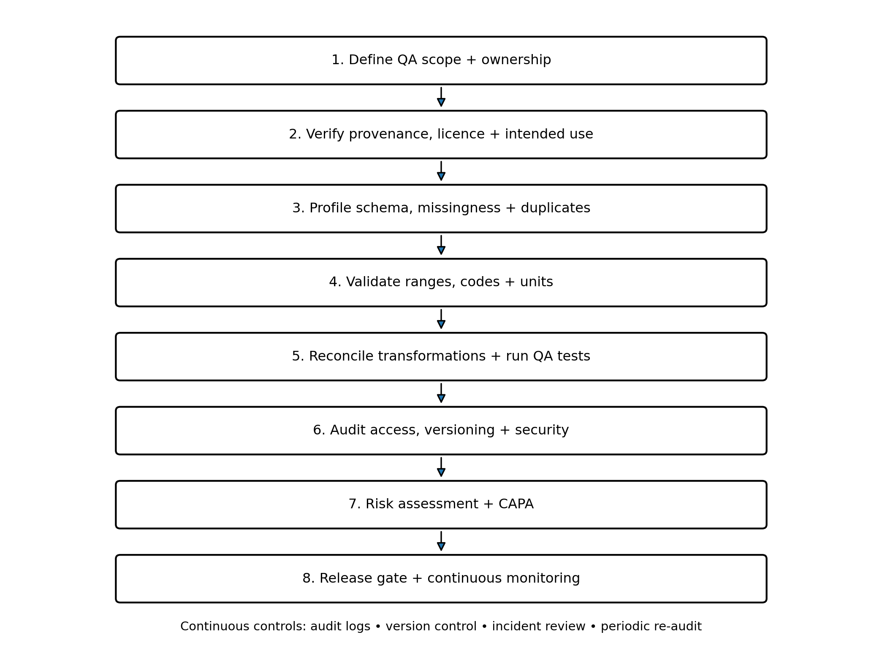
Figure 1. End-to-end data quality assurance and compliance workflow.

4.1 Scope and ownership
Define analytical purpose, target, dataset version, owner, reviewer, intended audience and quality gates.

4.2 Provenance and licence
Record UCI URL/DOI, download date, file name/version, checksum where practical, licence and analytical subset.

4.3 Structural profiling
Measure rows, columns, types, unique values, missingness, duplicates and target distribution; save the output.

4.4 Clinical/domain validation
Check documented codes, units and plausible ranges. Do not silently invent clinical thresholds.

4.5 Transformation audit
Keep raw data immutable. Record every transformation, record-count change and reason.

4.6 Release gate
Only release a dataset after required tests pass or exceptions are formally documented and reviewed.

4.7 Monitoring
For operational use, monitor data drift, missingness, pipeline failures, access events and model performance.

5. Concrete Numerical QA Examples
These are worked examples to show the calculations. They are illustrative unless explicitly stated as UCI metadata; they must not be copied into the final analysis as observed findings without rerunning the checks on the exact project file.
Test | Formula | Worked example | Decision
Missingness | missing / records × 100 | 18 missing values in 303 records = 18/303×100 = 5.94% | Investigate mechanism; apply pre-specified handling.
Duplicate rate | duplicates / records × 100 | 3 unintended duplicates in 303 = 0.99% | Confirm true duplicates before removal.
Invalid-value rate | invalid / non-missing × 100 | 2 invalid values among 301 = 0.66% | Quarantine and investigate.
Category validity | invalid codes / all codes × 100 | 1 invalid code in 303 = 0.33% | Trace to source dictionary; do not silently recode.
Post-clean completeness | valid critical cells / expected × 100 | 300 valid target values out of 303 = 99.01% | Three records need a documented decision.
A key reconciliation rule is that a row-count change must be explainable. For example, if a 303-row raw file becomes 300 rows, the QA evidence must identify the three removed records and the reason for each removal.

6. Reproducible QA Implementation
import pandas as pd
df = pd.read_csv("heart_disease.csv")
qa = {
"rows": len(df),
"columns": df.shape[1],
"duplicates": int(df.duplicated().sum()),
"missing_cells": int(df.isna().sum().sum())
}
missing_pct = (df.isna().sum() / len(df) * 100).sort_values(ascending=False)
# Domain checks: thresholds must be justified by documentation
age_invalid = ((df["age"] < 0) | (df["age"] > 120)).sum()
bp_invalid = ((df["trestbps"] < 50) | (df["trestbps"] > 300)).sum()
allowed_cp = {1, 2, 3, 4}
cp_invalid = (~df["cp"].isin(allowed_cp)).sum()
qa_report = pd.DataFrame({
"metric": ["rows","columns","duplicates","missing_cells",
"invalid_age","invalid_bp","invalid_cp"],
"value": [qa["rows"], qa["columns"], qa["duplicates"],
qa["missing_cells"], age_invalid, bp_invalid, cp_invalid]
})
qa_report.to_csv("qa_summary.csv", index=False)
This is an implementation template. The example bounds are programming validation examples, not clinical reference ranges. Before operational use, each domain rule must be supported by authoritative documentation and the intended population.

7. Data Governance and Security Controls
Control | Required practice | Evidence
Ownership | Name data steward/project lead and technical custodian. | RACI/ownership register.
Raw-data protection | Keep raw source read-only; transform copies. | Raw file + checksum + permissions.
Least privilege | Separate read/edit/approve roles. | Access list + review log.
Version control | Version data, scripts and reports. | Git history/tags.
Change control | Review schema and cleaning-rule changes. | Change request + approval.
Audit logging | Record material access, QA runs and corrections. | Timestamped audit log.
Backup/recovery | Protect backups where operational data are involved. | Recovery test record.
Retention/deletion | Retain only as justified and delete securely when required. | Retention/deletion evidence.
Sharing controls | Do not place restricted health data in unapproved tools. | Approved-tool register.
HHS states that the HIPAA Security Rule establishes national standards to protect electronic protected health information and requires appropriate administrative, physical and technical safeguards. The HIPAA Privacy Rule establishes standards concerning protected health information and its uses/disclosures. Applicability depends on the organisation and activity.
India's Digital Personal Data Protection Act places responsibilities on Data Fiduciaries, including appropriate technical and organisational measures and reasonable security safeguards. The final DPDP Rules, 2025 were notified in November 2025 and have staged commencement dates, so the current enforcement timeline must be checked for the relevant provision.

8. Regulatory and Ethical Compliance Matrix
Framework | Relevant principle | Project control | Important limitation
HIPAA | Privacy, permitted use/disclosure, confidentiality, integrity, availability. | Access control, audit logs, secure storage, incident response. | Only applies where HIPAA-covered entities/business associates and PHI are in scope.
India DPDP Act/Rules | Lawful processing, transparency, accuracy, security and accountability. | Purpose register, minimisation, access control, breach process, retention review. | Applicability depends on processing context and current commencement dates.
WHO AI ethics | Autonomy, safety, transparency, accountability, equity and sustainability. | Human oversight, limitations, subgroup review, transparent reporting. | Ethical guidance; not a single statutory compliance regime.
IMDRF/FDA GMLP | Representative data, independent train/test sets, clinically relevant testing, human-AI performance and monitoring. | Leakage prevention, validation design, monitoring plan. | Most directly relevant to regulated medical-device AI; this academic project is not being claimed as a medical device.

9. Risk Management Register
Risk | Likelihood | Impact | Detection | Mitigation
Missing/incomplete values | Medium | High | Missingness exceeds threshold | Profile pattern; justified imputation/exclusion.
Incorrect clinical/category coding | Medium | High | Unexpected codes/ranges | Validate against data dictionary; quarantine anomalies.
Duplicates | Medium | Medium | Duplicate test fails | Confirm unit of analysis before removal.
Data leakage | Medium | High | Test data influences preprocessing | Use training-only fitting and pipeline audit.
Representation bias | High | High | Small/uneven subgroup counts | Report subgroup sizes; avoid unsupported generalisation.
Unauthorised access | Low/Medium | High | Unexpected access event | Revoke access, rotate credentials, investigate.
Version mismatch | Medium | Medium | Row/column counts differ | Record source version, download date and checksum.
Misleading interpretation | Medium | High | Report implies diagnosis/causation | Use limitations and human-oversight language.

10. Audit Checklist and Evidence Pack
ID | Audit question | Pass evidence
QA-01 | Is source, DOI, licence and version recorded? | Completed provenance record.
QA-02 | Is the analytical subset identified? | Cleveland-focused scope documented.
QA-03 | Are row/column counts reconciled? | Before/after table.
QA-04 | Are missing values quantified? | Counts + percentages.
QA-05 | Are duplicates tested and explained? | Duplicate report + decision log.
QA-06 | Are categories validated? | Allowed-value dictionary + result.
QA-07 | Are numerical values checked? | Range-test output + review.
QA-08 | Are transformations reproducible? | Versioned script/notebook.
QA-09 | Is leakage prevention documented? | Pipeline/split evidence.
QA-10 | Are access and sharing controls documented? | Access/approved-tool record.
QA-11 | Are ethical limitations stated? | Ethics section.
QA-12 | Has release been reviewed? | Recorded QA approval.

11. Corrective and Preventive Action (CAPA) Template
Field | Example
Issue ID | DQ-2026-001
Issue | Unexpected category code
Evidence | Automated validation test reports 1 invalid code
Containment | Quarantine affected record
Root-cause analysis | Compare raw value, source documentation and transformation history
Corrective action | Apply documented mapping only if meaning is confirmed; otherwise retain as unresolved
Preventive action | Add automated category assertion to every QA run
Verification | Re-run QA and confirm invalid count is resolved
Approval | Reviewer, date and evidence reference

12. Ethical Standards for Healthcare Data
- Purpose limitation: use the dataset only for the documented analytical purpose.
- Data minimisation: avoid unnecessary collection or exposure of identifiers.
- Human oversight: analytical or predictive outputs should support, not independently replace, appropriate human judgement.
- Transparency: document source, preprocessing, assumptions, evaluation design and limitations.
- Equity: inspect subgroup representation and avoid unsupported generalisation.
- Security: protect non-public health information with appropriate technical and organisational controls.
- No clinical overclaim: a historical public dataset is not sufficient evidence to present a model as a diagnosis or clinical recommendation.

13. Methodological Decision Rules
Scenario | Decision rule | Reason
Missing target | Do not invent/impute the outcome solely to increase sample size. | Avoid artificial labels.
Missing predictor | Use a pre-specified training-only imputation strategy when justified. | Prevents leakage and improves reproducibility.
Outlier | Investigate before deleting; distinguish error from legitimate extreme. | Clinical data can contain genuine extremes.
Duplicate | Remove only after confirming unintended duplication. | Repeated encounters may be legitimate.
Unknown category | Flag/investigate rather than silently mapping. | Preserves semantic integrity.
Schema change | Block release until reviewed. | Prevents silent pipeline breakage.
Compliance uncertainty | Escalate to privacy/compliance/ethics function. | Applicability depends on context.

14. Implementation Timeline and Resources
Phase | Hours | Output
Scope/provenance/compliance review | 3 | Data register + framework notes
Automated profiling/QA | 5 | QA summary
Clinical/code validation | 4 | Validation dictionary + anomaly log
Governance/security | 4 | Access/version/change controls
Risk + CAPA | 4 | Risk register + CAPA
Documentation/audit pack | 5 | Checklist + evidence index
Review/release gate | 4 | Approved Week 5 report
Contingency | 2 | Unexpected findings
Total | 31 | Complete QA/compliance package
Recommended tools: Python, Pandas, NumPy, scikit-learn where modelling is required, Jupyter/VS Code, Git/GitHub and Excel for audit registers. Keep raw data immutable and derived data separate.

15. Expected Outcomes and Deliverables
- Dataset provenance, DOI/licence and version record.
- Reproducible QA script/notebook covering structure, missingness, duplicates, ranges and categories.
- Before/after quality table with reasons for all material row/column changes.
- Data dictionary and validation-rule register.
- Compliance matrix and security-control checklist.
- Risk register and CAPA template.
- Formal QA release gate showing passed tests and documented exceptions.
- GitHub repository containing documentation/code without credentials or restricted health information.

16. Limitations
- The commonly used Cleveland presentation has 303 records, so quality assurance does not establish generalisability to modern clinical populations.
- The UCI metadata says missing values exist, but exact missingness counts must be calculated from the exact file used in the project.
- Public availability does not mean unrestricted clinical deployment.
- The compliance matrix is an academic governance aid, not legal advice or proof of regulatory compliance.
- Clinical plausibility rules must be validated against authoritative clinical sources before operational use.

17. Conclusion
A high-quality healthcare analytics project requires more than code that executes. It requires a controlled data lifecycle in which provenance, completeness, validity, consistency, security, ethics and reproducibility are measurable and auditable. This Week 5 framework provides explicit QA dimensions, numerical calculations, governance controls, compliance references, risk management, CAPA and a release gate. The central principle is traceability: every material change from raw source to analytical dataset should be explainable, measurable and reproducible.

18. References
- UCI Machine Learning Repository. Heart Disease. DOI 10.24432/C52P4X. https://www.archive.ics.uci.edu/dataset/45/heart%2Bdisease
- U.S. Department of Health and Human Services. HIPAA Security Rule. https://www.hhs.gov/hipaa/for-professionals/security/index.html
- U.S. Department of Health and Human Services. HIPAA Privacy Rule. https://www.hhs.gov/hipaa/for-professionals/privacy/laws-regulations/index.html
- World Health Organization. Ethics and governance of artificial intelligence for health. https://www.who.int/publications/i/item/9789240029200
- World Health Organization. Artificial intelligence-related health research: ethics review and oversight. https://www.who.int/publications/i/item/9789240124073
- FDA / IMDRF. Good Machine Learning Practice for Medical Device Development. https://www.fda.gov/medical-devices/software-medical-device-samd/good-machine-learning-practice-medical-device-development-guiding-principles
- Government of India, MeitY. Digital Personal Data Protection Act, 2023. https://www.meity.gov.in/static/uploads/2024/02/Digital-Personal-Data-Protection-Act-2023.pdf
- Government of India, MeitY. Digital Personal Data Protection Rules, 2025. https://www.meity.gov.in/documents/act-and-policies/digital-personal-data-protection-rules-2025

19. Academic Integrity Note
The report is written specifically for this assignment. Numerical worked examples are clearly identified as illustrative unless they are direct dataset metadata. Regulatory and dataset facts are attributed to the relevant official sources. No fabricated model-performance result is presented as an observed finding.

