WEEK 1: DATA ANALYSIS PLANNING AND STRATEGY
Strategic Healthcare Data Analysis Plan:
Heart Disease Risk Analysis
A structured, measurable and responsible analytics framework using the UCI Heart Disease dataset

Submission purpose
This report directly addresses the Week 1 requirements: research/background, key metrics and variables, analytical and business objectives, measurable targets, project framework, hypotheses, data collection methods, timeline/resources, risk management, expected outcomes and responsible healthcare analytics.

Planning document: no model performance is presented as an achieved Week 1 result.

1. Executive Summary
This strategic plan proposes a healthcare data analysis project focused on understanding and predicting the presence of heart disease from routinely recorded patient characteristics. The proposed source is the UCI Machine Learning Repository Heart Disease dataset, documented as a health-and-medicine classification dataset with 303 patient instances and 13 commonly used predictor features. The UCI documentation explains that the goal field represents the presence of heart disease and that published experiments commonly distinguish absence from presence.
The strategic question is: Can routinely recorded clinical characteristics provide useful information for identifying patterns associated with heart disease and support earlier risk assessment? The plan covers the complete analytical lifecycle: healthcare background research, dataset understanding, data-quality assessment, preprocessing, exploratory analysis, statistical testing, baseline modelling, predictive modelling, evaluation, interpretation, risk management and responsible-use review.
The project is framed as an analytical and decision-support exercise, not an autonomous diagnostic system. A model trained on a small historical dataset would require external validation, clinical assessment, subgroup evaluation and governance before real-world use. WHO guidance emphasises human autonomy, safety, transparency, accountability, inclusiveness and equity for AI in health.
Key Week 1 outcome
A reproducible roadmap linking each healthcare question to variables, analytical methods, measurable success criteria, risk controls and expected decision-support outputs.

2. Healthcare Background and Strategic Context
Cardiovascular diseases are a major global health challenge. WHO reports that CVDs remain the leading cause of death globally and estimates that 19.8 million people died from CVDs in 2022, approximately 32% of all global deaths. WHO also emphasises the importance of detecting cardiovascular disease as early as possible so that appropriate management can begin. This provides a strong strategic rationale for analysing routinely collected cardiovascular indicators.
From a data-science perspective, structured patient information can be used to investigate patterns, identify potentially informative variables and evaluate whether predictive models add value beyond simple baselines. However, the UCI dataset is small and historical, so it is treated as a learning and planning resource rather than a representative clinical population.
Strategic challenge | Why it matters | Planned analytical response
Early identification | Potentially useful patterns may exist before definitive clinical assessment. | Explore associations and predictive performance of recorded clinical variables.
Multiple risk indicators | Heart-disease status may relate to several variables simultaneously. | Use multivariable analysis and classification models.
Target definition | The UCI goal field has multiple integer values. | Document and validate the binary target transformation before modelling.
Small historical dataset | 303 records limit generalisability and statistical power. | Use careful validation and clearly report limitations.
Responsible AI | Incorrect predictions can affect health decisions. | Require human oversight, transparency, fairness checks and external validation before deployment.

3. Dataset Selection and Data Strategy
The proposed source is the UCI Machine Learning Repository Heart Disease dataset. UCI identifies the subject area as Health and Medicine, the associated task as Classification, feature types as categorical/integer/real, and the commonly used representation as 303 instances with 13 features. The repository also notes that the original database contains more attributes while published machine-learning experiments commonly use a subset.
Dataset characteristic | Planning detail
Source | UCI Machine Learning Repository — Heart Disease
Commonly used records | 303 patient instances
Predictor features | 13 commonly used features
Task | Classification
Feature types | Categorical, integer and real
Target concept | Presence/absence of heart disease
Planned use | Exploratory analysis and predictive-modelling strategy
Important limitation | Small historical dataset; results should not be generalised without external validation.

3.1 Candidate Variables
Variable | Description | Type | Planned role
age | Age of patient | Numeric | Distribution and association
sex | Patient sex | Categorical/binary | Group comparison and fairness review
cp | Chest-pain type | Categorical | Association/predictive feature
trestbps | Resting blood pressure | Numeric | Clinical risk-pattern analysis
chol | Serum cholesterol | Numeric | Distribution/association
fbs | Fasting blood sugar indicator | Binary | Potential predictor
restecg | Resting ECG result | Categorical | Potential predictor
thalach | Maximum heart rate achieved | Numeric | Group comparison/predictor
exang | Exercise-induced angina | Binary | Association/predictor
oldpeak | ST depression induced by exercise | Numeric | Potential predictor
slope | Peak-exercise ST slope | Categorical | Potential predictor
ca | Number of major vessels | Numeric/ordinal | Potential predictor
thal | Thalassemia-related result | Categorical | Potential predictor
target/goal | Heart-disease presence after documented target definition | Target | Outcome

4. Analytical and Business Objectives

4.1 Analytical Objectives
- Profile the dataset structure, variable types, target definition and data-quality characteristics before modelling.
- Quantify missing values, duplicate records and implausible or unexpected values for every analytical field.
- Describe distributions of important clinical variables using summary statistics and appropriate visualisations.
- Compare clinical-variable patterns between the heart-disease target groups.
- Test selected associations using appropriate statistical methods, with assumptions and limitations documented.
- Build a transparent baseline classifier and compare it with at least two supervised classification approaches.
- Evaluate predictive performance using precision, recall, F1-score, ROC-AUC and confusion matrices rather than relying on accuracy alone.
- Investigate whether model performance differs across relevant patient subgroups where sample size permits.

4.2 Healthcare/Business Objectives
- Translate analytical findings into an evidence summary that a healthcare stakeholder can understand.
- Identify which available variables appear most informative for further investigation without claiming causal effects.
- Develop a framework for prioritising future validation work, including external testing on a larger and more recent population.
- Define safeguards so any future model is used as decision support for trained healthcare professionals rather than an autonomous diagnostic tool.

4.3 Measurable Success Criteria
Objective | Measure | Acceptance criterion
Data understanding | Dataset profile | 100% of planned variables documented with type, meaning and role.
Data quality | Missingness, duplicates, range checks | Quality audit for every analytical field before modelling.
EDA | Charts + numerical summaries | At least one distribution summary and one target-group comparison for each major variable family.
Statistical analysis | Effect/association estimates | Appropriate test selected with assumptions and interpretation documented.
Modelling | Baseline + ≥2 models | Reproducible comparison framework defined before fitting.
Evaluation | Precision, recall, F1, ROC-AUC | No final model selected using accuracy alone.
Responsible AI | Governance checklist | Privacy, fairness, explainability, human oversight and validation requirements documented.
Documentation | Reproducibility | Code, decisions, assumptions and limitations recorded.

5. Research Questions and Hypotheses
Research question | Planned evidence
Which clinical variables show the strongest differences between target groups? | Group summaries, plots and effect/association measures.
Are age, resting blood pressure, cholesterol and maximum heart rate distributed differently across target groups? | Descriptive statistics and appropriate two-group tests.
Do chest-pain type and exercise-induced angina show association with the target? | Contingency tables and categorical association tests.
Can a supervised classifier outperform a majority-class baseline? | Held-out test metrics and confusion matrix.
Are predictive errors concentrated in any subgroup? | Subgroup performance where sample sizes are adequate.

5.1 Hypotheses
- H1: Exercise-induced angina (exang) will show a measurable association with the heart-disease target.
- H2: Maximum heart rate achieved (thalach) will have different distributions across target groups.
- H3: Chest-pain type (cp) will contain predictive information about the target.
- H4: A supervised classification model will provide better discrimination than a majority-class baseline.
- H5: Predictive performance will vary across at least some patient subgroups, demonstrating the need for fairness and generalisability checks.
Interpretation rule
These are proposed questions, not findings. They must be tested against the dataset; statistical association must not be interpreted as proof of causation.

6. Detailed Analytical Framework
Stage | Activities | Output / evidence
1. Problem definition | Define healthcare question, target and decision-support context. | Approved analytical question and target specification.
2. Research | Review cardiovascular-health context and responsible AI guidance. | Background summary and cited sources.
3. Data acquisition | Download dataset and record source/version information. | Raw-data provenance record.
4. Data audit | Inspect shape, types, missingness, duplicates and ranges. | Data-quality table.
5. Preprocessing | Define target, encode categorical fields, scale where needed and avoid leakage. | Modelling-ready pipeline.
6. EDA | Histograms, boxplots, bar charts and target-group comparisons. | Charts + numerical summaries.
7. Statistical analysis | Test selected numerical/categorical associations. | Test statistics/effect estimates.
8. Baseline | Majority-class and/or simple logistic baseline. | Baseline metrics.
9. Modelling | Evaluate logistic regression and tree-based models. | Model comparison table.
10. Evaluation | Confusion matrix, precision, recall, F1 and ROC-AUC. | Performance evidence.
11. Interpretation | Review feature importance/coefficient direction and limitations. | Explainability summary.
12. Governance | Assess bias, privacy, safety and human oversight. | Responsible-use checklist.
13. Recommendation | Summarise evidence and future validation needs. | Stakeholder-ready conclusion.

7. Professional Project Workflow
The workflow below is included as a separate PNG for the GitHub repository.
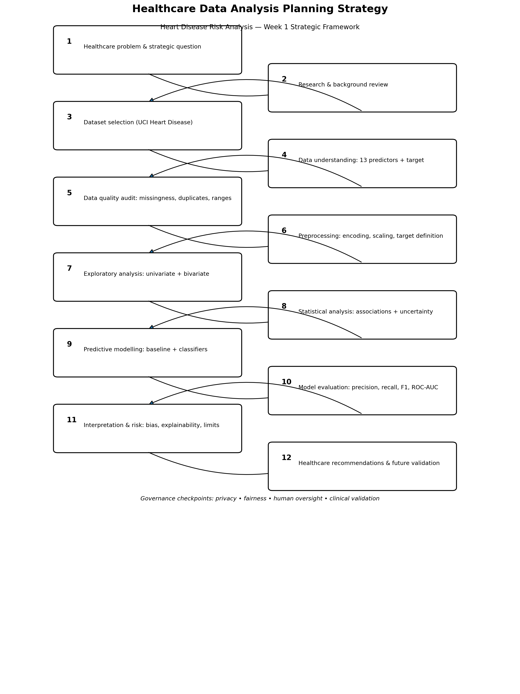

8. Data Collection and Preprocessing Strategy
Data collection will use the official UCI repository. Source metadata and target transformation decisions will be recorded. The raw dataset will be treated as read-only; cleaned data will be generated through reproducible code rather than manual editing.
Check | Example procedure | Decision rule
Schema | Inspect columns and data types. | Unexpected types investigated before analysis.
Missingness | Count null/placeholder values by variable. | Report count and percentage; choose treatment based on variable and purpose.
Duplicates | Check complete-row duplicates. | Investigate before removal.
Range validation | Check age, blood pressure, cholesterol and other numeric ranges. | Flag implausible values for review; never silently delete.
Categorical validation | List unique categories for categorical fields. | Map documented categories consistently.
Target definition | Inspect raw goal values and document binary mapping. | Freeze definition before train/test modelling.
Leakage control | Fit imputation/encoding/scaling on training data only. | No test-set information used during preprocessing.
Reproducibility | Record random seed, package versions and transformations. | Another analyst should reproduce the pipeline.

8.1 Concrete Missingness Calculation Example
Illustrative example only: if 6 observations were missing a variable in a dataset of 303 observations:
Missing percentage = (6 / 303) × 100 = 1.98%
The actual project will calculate missingness from the downloaded file rather than assuming that 6 values are missing.

9. Exploratory Data Analysis Plan
Analysis | Variables/examples | Planned evidence
Univariate numeric | age, trestbps, chol, thalach, oldpeak | Histogram, boxplot, median, mean, IQR, min/max.
Univariate categorical | sex, cp, fbs, restecg, exang, slope, ca, thal | Frequency/percentage tables; bar charts.
Target distribution | target/goal | Count and percentage of each class.
Bivariate numeric vs target | age, chol, trestbps, thalach, oldpeak | Boxplots and group summaries.
Bivariate categorical vs target | cp, exang, sex, restecg | Grouped/stacked bars and contingency tables.
Multivariable relationships | selected numeric variables | Correlation matrix/heatmap with appropriate method.
Outlier review | trestbps, chol, thalach, oldpeak | Boxplots plus data-quality review before treatment.

9.1 Example Python EDA Pattern
import pandas as pd
import matplotlib.pyplot as plt
import seaborn as sns
df = pd.read_csv("heart_disease.csv")
print(df.shape)
print(df.dtypes)
print(df.isna().sum())
numeric_cols = ["age", "trestbps", "chol", "thalach", "oldpeak"]
print(df[numeric_cols].describe().T)
sns.boxplot(data=df, x="target", y="age")
plt.title("Age Distribution by Heart-Disease Target")
plt.show()
sns.countplot(data=df, x="cp", hue="target")
plt.title("Chest-Pain Type by Target Group")
plt.show()

10. Statistical Analysis Strategy
Tests will be selected according to variable type, distribution and assumptions. The goal is to answer defined research questions with interpretable evidence rather than generate a large number of unplanned p-values.
Relationship | Possible method | Interpretation
Numeric vs binary target | Mann–Whitney U or t-test depending on assumptions | Whether distributions/means differ between groups.
Categorical vs target | Chi-square or Fisher's exact test where appropriate | Whether category membership is associated with target.
Numeric vs numeric | Pearson or Spearman correlation | Strength/direction of association.
Model coefficients | Logistic-regression coefficients and confidence intervals where implemented | Direction and estimated strength within the fitted model.

11. Predictive Modelling Strategy
The modelling phase will begin with a simple baseline and then evaluate increasingly flexible classifiers. The target definition must be fixed before the train/test split. Preprocessing will be placed inside a reproducible pipeline to reduce leakage risk.
Model | Reason for inclusion | Main consideration
Majority-class baseline | Shows performance from always predicting the most common class. | May have high accuracy while offering no useful minority-class detection.
Logistic Regression | Interpretable baseline for binary classification. | Linear log-odds relationship unless extended.
Decision Tree | Captures non-linear decision rules and is easy to visualise. | Can overfit without control.
Random Forest | Captures non-linear relationships and interactions. | Less directly interpretable; requires validation.

11.1 Planned Modelling Pseudocode
LOAD dataset
DEFINE and validate binary target
SEPARATE X predictors and y target
SPLIT data into training and testing sets
BUILD preprocessing pipeline:
handle missing values
encode categorical variables
scale numerical variables when required
FIT majority-class baseline
FIT Logistic Regression
FIT Decision Tree
FIT Random Forest
FOR each model:
predict test observations
calculate accuracy, precision, recall, F1-score, ROC-AUC
generate confusion matrix
COMPARE models
CHECK subgroup performance where sample sizes permit
DOCUMENT limitations and responsible-use requirements

12. Evaluation Metrics and Concrete Example
Metric | Formula | Why it matters
Accuracy | (TP + TN) / Total | Overall correctness; can mislead with imbalance.
Precision | TP / (TP + FP) | Of predicted positives, how many were actually positive.
Recall | TP / (TP + FN) | Of actual positives, how many were identified.
F1-score | 2 × Precision × Recall / (Precision + Recall) | Balances precision and recall.
ROC-AUC | Area under ROC curve | Measures ranking/discrimination across thresholds.

12.1 Illustrative Confusion-Matrix Calculation
Hypothetical example only; these are not results from the UCI dataset.
 | Actual positive | Actual negative
Predicted positive | TP = 45 | FP = 10
Predicted negative | FN = 8 | TN = 38

Accuracy = (45 + 38) / (45 + 10 + 8 + 38) = 82.18%
Precision = 45 / (45 + 10) = 81.82%
Recall = 45 / (45 + 8) = 84.91%
F1 ≈ 83.32%
For a healthcare use case, the consequences of false negatives and false positives must be discussed with domain experts before selecting an operating threshold.

13. Risk Management
Risk | Potential impact | Mitigation / control
Small sample size (303 records) | Unstable estimates and weak generalisability. | Cross-validation, uncertainty reporting and future external validation.
Historical dataset | Current clinical practice may differ. | State temporal limitations and avoid deployment claims.
Missing/placeholder values | Biased summaries or model inputs. | Audit missingness and document treatment.
Data leakage | Artificially high performance. | Split before fitting transformations; use pipelines.
Class imbalance | Accuracy may hide poor positive detection. | Report precision, recall, F1 and ROC-AUC.
Overfitting | Poor unseen performance. | Cross-validation and regularisation.
Demographic bias | Unequal performance across groups. | Subgroup evaluation where sample size permits.
Clinical overinterpretation | Association mistaken for diagnosis/causation. | Use cautious language and clinician review.
Privacy/misuse | Potential harm if data are exposed or repurposed. | Use de-identified public data and governance controls.
Reproducibility failure | Results cannot be independently checked. | Version code and document assumptions.

14. Resources, Technology and Team Requirements
Resource | Planned use
Python | Data cleaning, EDA, statistics and modelling.
Pandas / NumPy | Data manipulation and numerical processing.
Matplotlib / Seaborn | Charts and exploratory visualisation.
Scikit-learn | Preprocessing, classification and evaluation.
Jupyter Notebook / Google Colab | Reproducible analysis environment.
Git / GitHub | Version control and portfolio presentation.
Word / DOCX | Formal strategic report.
UCI Repository | Public dataset source and metadata.
WHO guidance | Healthcare AI ethics and governance reference.

15. Project Timeline — 35 Hours
Phase | Activities | Hours
1 | Background research, healthcare problem and research questions | 3
2 | Dataset selection, provenance and variable dictionary | 2
3 | Data understanding and quality audit | 4
4 | Preprocessing strategy and reproducible pipeline design | 4
5 | EDA and visualisation | 6
6 | Statistical/association analysis | 3
7 | Baseline and predictive modelling | 5
8 | Model evaluation and interpretation | 3
9 | Responsible AI, risk and limitations review | 2
10 | Report, GitHub documentation and final quality check | 3
Total |  | 35

16. Expected Outcomes
- A complete data-analysis roadmap that can be implemented reproducibly.
- A documented understanding of the dataset, variables and target definition.
- Evidence-based exploratory findings describing relationships worth investigating.
- A baseline and model-comparison framework with healthcare-relevant metrics.
- A transparent explanation of risks, limitations and responsible-use requirements.
- A stakeholder-oriented summary of what the analysis could support and what requires additional evidence.
- A GitHub-ready project structure containing the strategic report and workflow diagram.

17. Limitations and Future Validation
The principal limitation is that the UCI Heart Disease dataset is small and historical. It should not be treated as representative of all patients, hospitals, regions or current clinical practice. Any observed association may be affected by sampling, measurement and confounding. A model that performs well on this dataset would not automatically be safe or clinically useful in another population.
- Validate on a larger, contemporary and independent dataset.
- Assess calibration as well as discrimination.
- Evaluate clinically meaningful thresholds with domain experts.
- Conduct subgroup performance and fairness analysis.
- Perform external or prospective validation before operational use.
- Establish governance, monitoring and human-override procedures.

18. Responsible Healthcare Analytics and Ethics
WHO guidance states that ethical and human-rights considerations should be central to the design, deployment and use of AI in health. Relevant principles include human autonomy, safety and public interest, transparency and explainability, accountability, inclusiveness and equity, and responsible sustainability.
Principle | Project application
Human autonomy | Future predictions should support, not replace, qualified clinical decision-making.
Safety | Do not claim clinical readiness from a small public dataset.
Transparency | Document target definition, preprocessing, metrics and limitations.
Accountability | Identify who would review outputs and handle errors in future deployment.
Equity | Check performance across relevant demographic groups where sample size allows.
Privacy | Use public de-identified data only for the defined analytical purpose.
Explainability | Use interpretable summaries and feature-level explanations where feasible.

19. Conclusion
This strategic plan provides a practical framework for a healthcare data-analysis project focused on heart disease risk patterns. It converts the assignment requirements into measurable objectives, a documented dataset strategy, explicit hypotheses, a reproducible workflow, evaluation criteria, a realistic 35-hour schedule and a detailed risk-management framework. The plan deliberately separates proposed analyses from actual findings and recognises that a small historical dataset cannot establish clinical effectiveness. The next phases can therefore proceed from a clear baseline while preserving methodological transparency and responsible healthcare use.

20. References and Data Sources
- UCI Machine Learning Repository. Heart Disease dataset. https://archive.ics.uci.edu/dataset/45/heart+disease
- World Health Organization. Cardiovascular diseases (CVDs), 31 July 2025. https://www.who.int/news-room/fact-sheets/detail/cardiovascular-diseases-%28cvds%29
- World Health Organization. Ethics and governance of artificial intelligence for health: WHO guidance, 2021. https://www.who.int/publications/i/item/9789240029200
- World Health Organization. Ethics and governance of artificial intelligence for health: Executive summary, 2021. https://www.who.int/publications/i/item/9789240037403
Submission note
Upload this Word document to the assignment portal. If the task is treated as technical/software-related, include the GitHub repository URL as requested. Store the separate flowchart PNG in the repository alongside the DOCX.

