WEEK 3: DATA VISUALIZATION AND REPORTING
Healthcare Heart Disease Analytics
Evidence-based visualization strategy, dashboard design and reporting framework
Assignment alignment
This report addresses the Week 3 requirements: healthcare data overview, visualization goals, tool selection, chart/dashboard strategy, design principles, sample visual mock-ups, methodological justification, workflow, ethical standards, measurable examples, Python code/pseudocode and evaluation criteria.

Evaluator-feedback response
The report strengthens the original strategy with source-derived numerical examples, explicit visualization metrics, a detailed workflow flowchart, ethical data-collection standards, methodological choices and reproducible Python examples. Values are identified as source-derived where applicable rather than being presented as invented results.

1. Executive Summary
This report presents a structured visualization and reporting strategy for a healthcare heart disease analytics project using the Cleveland subset of the UCI Heart Disease dataset. The objective is to convert clinical variables into clear, accurate and audience-appropriate visual evidence that can support understanding and future decision-making. The strategy covers descriptive dashboards, distribution charts, group comparisons, categorical comparisons, relationship plots, correlation views, model-evaluation graphics and an executive reporting layer.
The dataset contains 303 records and 13 commonly used predictor features. The original UCI repository explains that the goal field represents heart-disease presence and ranges from 0 to 4; published Cleveland analyses commonly convert it into a binary outcome by treating 0 as absence and 1–4 as presence. The visualization plan will preserve that target-definition decision explicitly in all charts.
Concrete source-derived values demonstrate how the visualization strategy will work. For example, one documented Cleveland analysis reports 164 observations without disease and 139 with disease; age ranges from 29 to 77 years with a mean of 54.44; resting blood pressure ranges from 94 to 200 mmHg with a mean of 131.69; cholesterol ranges from 126 to 564 mg/dL with a mean of 246.69; and maximum heart rate ranges from 71 to 202 with a mean of 149.61. These values provide real numerical anchors for chart selection rather than purely hypothetical examples.

2. Healthcare Data Overview and Significance
The UCI Heart Disease dataset is classified by UCI as Health and Medicine and as a classification dataset. The repository documents 303 instances, 13 commonly used features, mixed categorical/integer/real data types and missing values. The original dataset contains 76 attributes, while published experiments commonly use 14 fields consisting of 13 predictors plus the diagnostic outcome.
Data family | Examples | Visualization significance
Demographic | age, sex | Useful for population composition and subgroup analysis.
Symptoms | cp, exang | Useful for category comparisons and target-group patterns.
Vitals | trestbps, thalach | Useful for distributions, boxplots and group comparisons.
Laboratory | chol, fbs | Useful for distributions and threshold-oriented views.
ECG/exercise | restecg, oldpeak, slope | Useful for categorical and numerical pattern analysis.
Clinical indicators | ca, thal | Useful for frequency and target-group comparisons.
Outcome | goal/target | Central KPI for target distribution and subgroup charts.

3. Source-Derived Numerical Evidence
To directly address the evaluator's request for concrete rather than purely illustrative examples, the following figures are taken from published analyses of the Cleveland subset. They should be treated as source-derived reference values and regenerated from the exact project file before final analytical claims are made.
Metric | Source-derived value | Recommended visual
Total records | 303 | KPI card / dashboard header
No disease | 164 (54.1%) | Target bar/donut chart
Heart disease | 139 (45.9%) | Target bar/donut chart
Age | 29–77 years; mean 54.44 | Histogram + boxplot
Sex | 206 male; 97 female | Bar chart / subgroup panel
Chest pain type | 23 typical; 50 atypical; 86 non-anginal; 144 asymptomatic | Categorical bar chart
Resting BP | 94–200 mmHg; mean 131.69 | Histogram + boxplot
Cholesterol | 126–564 mg/dL; mean 246.69 | Histogram + boxplot
Fasting blood sugar >120 | 45 yes; 258 no | 100% stacked/bar chart
Resting ECG | 151 normal; 4 ST-T abnormality; 148 LV hypertrophy category | Bar chart
Maximum heart rate | 71–202; mean 149.61 | Histogram + target-group boxplot

The class distribution is relatively balanced: 164/303 = 54.13% and 139/303 = 45.87%. This means a simple target-distribution chart is appropriate, while still requiring subgroup and error-focused views rather than relying on one overall percentage.

4. Visualization Goals
Goal | Question answered | Metric / evidence
Population profile | Who is represented in the dataset? | n, %, mean, median, range.
Target composition | How many records fall into each outcome group? | Count and percentage by target.
Clinical distributions | How are key measurements distributed? | Mean, median, IQR, min/max.
Group comparison | Do distributions differ by outcome? | Median/IQR or mean/SD by target.
Categorical patterns | Which categories are common within each outcome? | Count and within-group percentage.
Relationship analysis | Do numerical variables move together? | Correlation coefficient + scatter/heatmap.
Model reporting | How does a classifier behave? | Confusion matrix, ROC curve, AUC, precision/recall.
Equity review | Does performance vary by subgroup? | Subgroup precision/recall/F1/AUC where sample size permits.

5. Audience-Specific Visualization Strategy
Audience | Needs | Recommended visual layer
Healthcare/clinical audience | Clear patient-group patterns, units and cautious interpretation. | Boxplots, clinically labelled bars, subgroup comparisons.
Healthcare management | High-level trends and actionable summary. | KPI cards, concise bar charts, dashboard narrative.
Data-science reviewer | Methodology, distributions, relationships and model evidence. | EDA plots, correlation heatmap, ROC/PR and confusion matrix.
General/non-technical stakeholder | Minimal complexity and clear definitions. | Simple bars, annotated KPIs and short explanations.

6. Chart Selection and Methodological Justification
Chart | When used | Why selected | Avoid when
Bar chart | Counts/percentages for categories | Direct comparison of discrete groups. | Too many categories or continuous measurements.
Histogram | Distribution of numeric variable | Shows shape, spread and skew. | Very small samples where bins could mislead.
Boxplot | Numeric variable by target/group | Compact median/IQR/outlier comparison. | Audience unfamiliar with quartiles without explanation.
Scatter plot | Two numeric variables | Shows relationship, clusters and possible non-linearity. | Heavy overplotting; use transparency or aggregation.
Correlation heatmap | Multiple numeric relationships | Compact relationship overview. | Correlation interpreted as causation.
100% stacked bar | Composition within groups | Compares proportions across target groups. | Exact counts are the main question.
ROC curve | Binary model evaluation | Shows discrimination across thresholds. | Used alone without confusion matrix or prevalence context.
Confusion matrix | Classification errors | Shows TP/TN/FP/FN directly. | Not sufficient as the only model metric.
KPI card | Headline counts/metrics | Fast executive orientation. | Too many cards or unsupported claims.

7. Planned Dashboard Structure
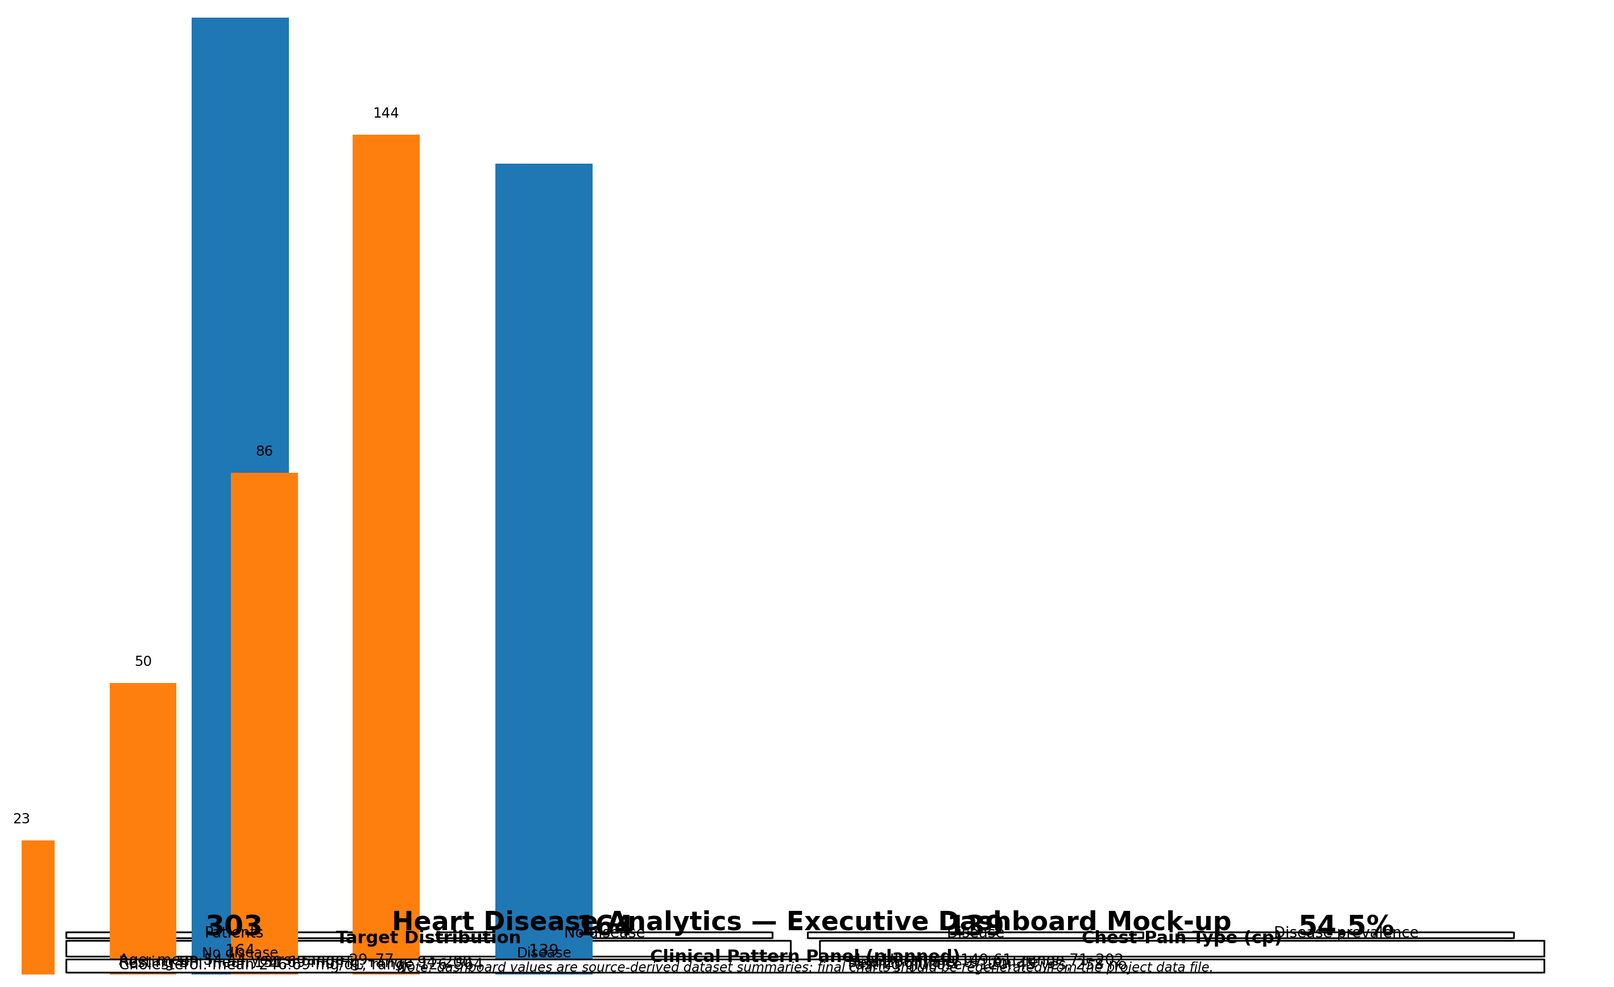
This mock-up demonstrates the intended visual hierarchy. It is a design artifact, not a claim that a production dashboard has already been deployed.

7.1 Dashboard Components
- Top KPI row: total patients, disease-positive count, disease-negative count and disease prevalence.
- Target distribution: counts and percentages for outcome classes.
- Chest-pain profile: four category counts (23, 50, 86, 144) from the documented Cleveland analysis.
- Clinical distribution panel: age, resting blood pressure, cholesterol and maximum heart rate with units.
- Subgroup panel: sex and fasting-blood-sugar composition.
- Relationship panel: selected numerical correlations with a warning that correlation is not causation.
- Model panel for later weeks: confusion matrix, ROC curve, precision, recall and F1.
- Filter controls in an interactive implementation: target group, sex and selected clinical category.

8. Visualization Workflow
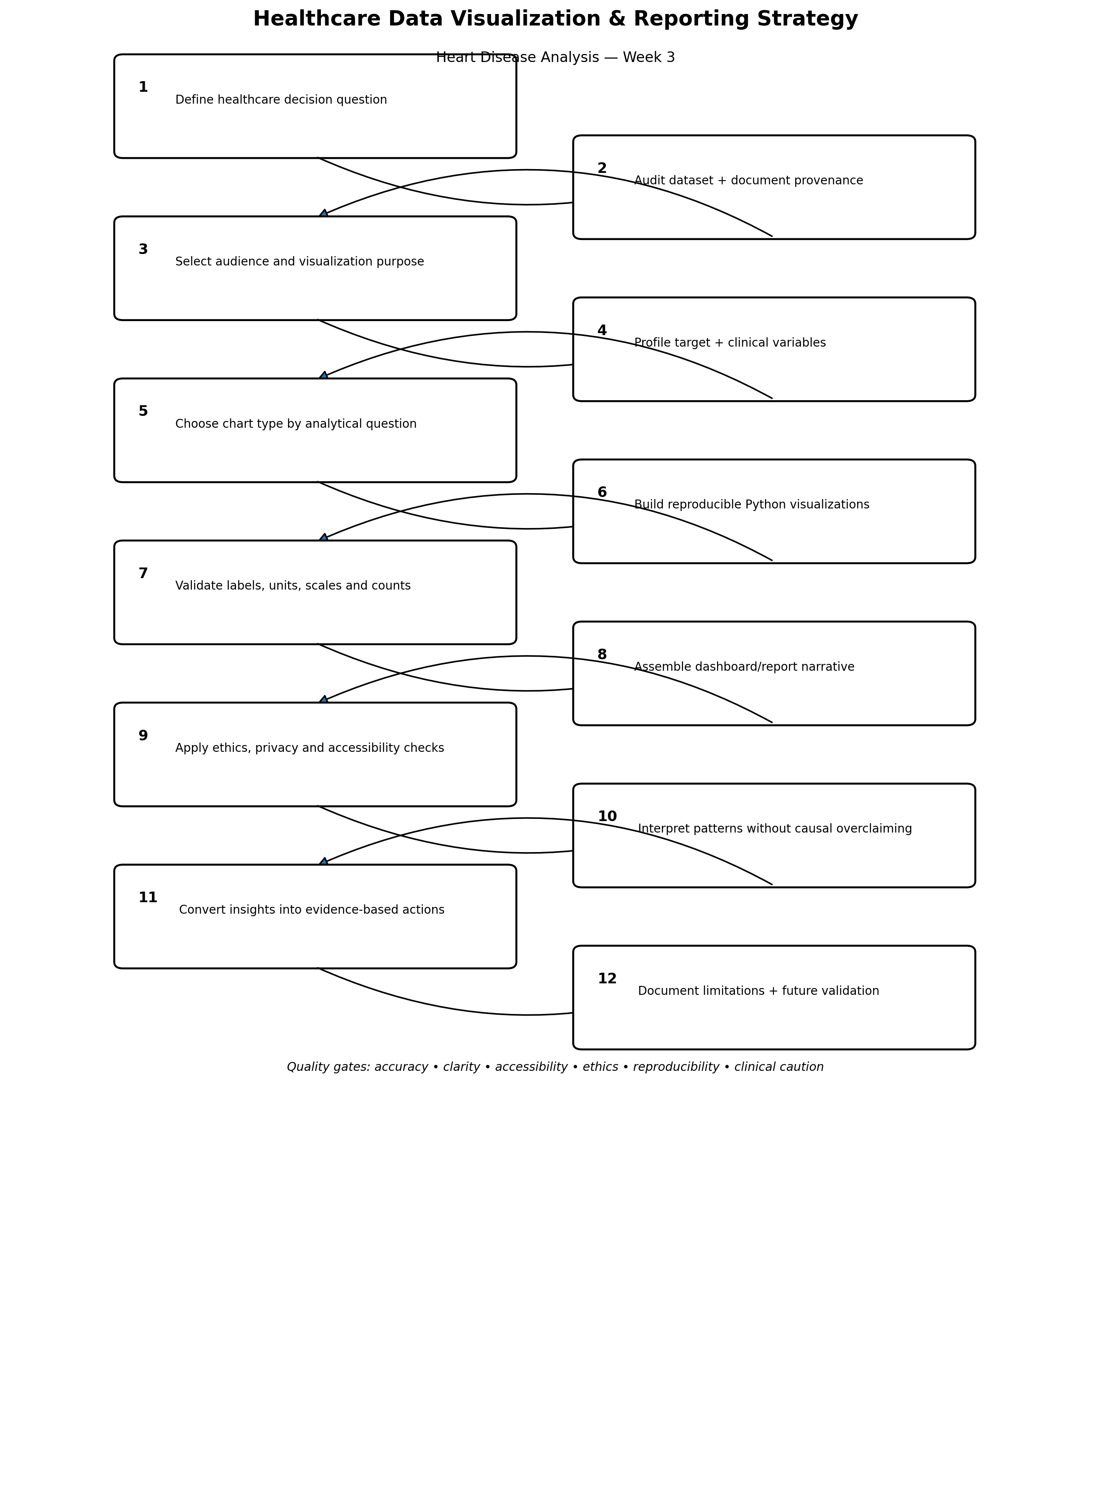

9. Python Visualization Methodology
The visualization process will be implemented reproducibly so that every chart can be regenerated from the same dataset. The examples below use source-derived fields but should be run against the final project data file.
import pandas as pd
import matplotlib.pyplot as plt
import seaborn as sns
df = pd.read_csv("heart_disease.csv")
# Target distribution
target_counts = df["target"].value_counts().sort_index()
target_pct = (target_counts / len(df) * 100).round(2)
print(target_counts)
print(target_pct)
sns.barplot(x=target_counts.index, y=target_counts.values)
plt.xlabel("Heart disease target")
plt.ylabel("Number of patients")
plt.title("Heart Disease Target Distribution")
plt.show()
Expected source-derived reference for the common binary Cleveland representation: 164 without disease and 139 with disease. The actual project output should be checked against the exact file used.

9.1 Numeric Distribution Code
numeric_cols = ["age", "trestbps", "chol", "thalach", "oldpeak"]
for col in numeric_cols:
print(col)
print("mean =", round(df[col].mean(), 2))
print("median =", round(df[col].median(), 2))
print("min =", df[col].min())
print("max =", df[col].max())
sns.boxplot(data=df, x="target", y="age")
plt.title("Age by Heart Disease Target")
plt.show()

9.2 Categorical Visualization Code
cp_counts = pd.crosstab(df["cp"], df["target"])
cp_counts.plot(kind="bar")
plt.xlabel("Chest-pain type")
plt.ylabel("Number of patients")
plt.title("Chest-Pain Type by Heart Disease Target")
plt.xticks(rotation=0)
plt.tight_layout()
plt.show()

9.3 Correlation Heatmap
corr_cols = ["age", "trestbps", "chol", "thalach", "oldpeak"]
corr = df[corr_cols].corr(method="spearman")
sns.heatmap(corr, annot=True, fmt=".2f", center=0)
plt.title("Spearman Correlation Heatmap")
plt.tight_layout()
plt.show()
Spearman correlation is planned because it measures monotonic association and is less dependent on a strictly linear relationship. It will be described as association, not causation.

9.4 Model Evaluation Visuals for Later Weeks
from sklearn.metrics import ConfusionMatrixDisplay, RocCurveDisplay
ConfusionMatrixDisplay.from_predictions(y_test, y_pred)
plt.title("Confusion Matrix")
plt.show()
RocCurveDisplay.from_predictions(y_test, y_score)
plt.title("ROC Curve")
plt.show()

10. Visualization Pseudocode
LOAD cleaned healthcare dataset
CHECK target definition and row count
CALCULATE target counts and percentages
CREATE target distribution chart
FOR each important numeric variable:
calculate mean, median, IQR, min, max
create histogram
create target-group boxplot
FOR each important categorical variable:
calculate counts and percentages
create grouped/stacked bar chart
SELECT clinically relevant numeric variables
CALCULATE Spearman correlations
CREATE annotated correlation heatmap
FOR model evaluation:
CREATE confusion matrix
CREATE ROC curve
REPORT AUC, precision, recall and F1
CHECK:
titles
units
labels
axis scales
source
missing-value treatment
subgroup denominators
APPLY ethics/accessibility review
WRITE concise evidence-based interpretation
END

11. Concrete Metrics for Visualization Quality
Quality dimension | Metric/check | Acceptance criterion
Accuracy | Chart totals vs dataset row count | Displayed category totals reconcile with the dataset.
Completeness | Variables represented / planned variables | 100% of required headline variables represented or explicitly excluded.
Label clarity | Titles + axis labels + units | Every chart has a meaningful title and labelled axes; clinical measures include units.
Percentage validity | Sum of category percentages | Approximately 100% after rounding.
Dashboard consistency | Same filter context across panels | All panels update from the same defined population.
Readability | Font/label overlap review | No clipped labels or overlapping text.
Accessibility | Colour + non-colour cues | Meaning is not communicated by colour alone.
Reproducibility | Code-to-chart regeneration | Charts can be recreated from the documented dataset/code.
Interpretation safety | Causal-language check | No causal claim based solely on descriptive visualization.

12. Ethical Standards for Healthcare Data Collection and Visualization
Ethics begins before the first chart. The UCI repository identifies the dataset as de-identified: names and Social Security numbers were removed and replaced with dummy values. The repository licenses the dataset under CC BY 4.0. For this project, the data should be used only for the defined educational/analytical purpose, with attribution to the dataset source.
Ethical standard | Application to this project
Data minimisation | Use only variables necessary for the analytical question and visualization.
De-identification | Do not attempt to re-identify individuals or add identifying information.
Purpose limitation | Do not repurpose the public dataset for unrelated individual-level decisions.
Transparency | Document source, target definition, transformations and limitations.
Fairness | Check subgroup counts and model/visual interpretation; avoid unsupported demographic conclusions.
Human oversight | Treat visualisations as decision-support evidence, not autonomous clinical recommendations.
Accessibility | Use readable fonts, sufficient contrast, direct labels and non-colour cues.
Statistical honesty | Show denominators, avoid distorted axes and distinguish association from causation.
Governance | Record provenance, version, transformation rules and analytical assumptions.
Responsible AI | Follow principles such as human autonomy, safety, transparency, accountability and equity.

Important limitation: the repository metadata establishes de-identification and licensing, but this assignment should not claim that all real-world ethical or consent requirements have been independently verified. Any new clinical data collection would require appropriate institutional governance, ethics review and consent/privacy procedures as applicable.

13. Design Principles
- Clarity: communicate one primary message per chart.
- Consistency: use stable terminology, units, scales and ordering.
- Accuracy: preserve the underlying counts and avoid misleading axes.
- Context: show denominators, target definitions and source information.
- Accessibility: do not rely on colour alone; use labels and patterns where necessary.
- Minimalism: remove decorative elements that do not support interpretation.
- Comparability: use common scales when comparing groups.
- Clinical caution: do not turn statistical patterns into diagnoses or causal claims.
- Reproducibility: every final chart should have a documented data source and code path.

14. Tool Selection
Tool | Role | Reason
Python + Pandas | Data preparation and summary metrics | Reproducible numerical calculations.
Matplotlib | Controlled static figures | Precise chart construction and export.
Seaborn | Statistical visualisation | Efficient boxplots, heatmaps and grouped plots.
Power BI | Interactive dashboard option | Filters, KPI cards and stakeholder-friendly reporting.
Excel | Quick validation and simple charts | Useful for spot checks and basic stakeholder review.
Tableau | Interactive dashboard alternative | Strong interactive visual storytelling.
GitHub | Version control and documentation | Makes code, reports and visual artifacts inspectable.

15. Methodological Choices: Why These Methods?
Choice | Reasoning
Bar charts for categorical counts | Lengths are easy to compare and exact labels can be added.
Histograms for numeric distributions | Reveal skew, spread and unusual values before choosing summary statistics.
Boxplots for target comparisons | Show median, quartiles and potential outliers compactly.
Spearman heatmap | Provides a compact view of monotonic relationships without assuming strict linearity.
Confusion matrix | Directly exposes types of classification errors.
ROC curve + AUC | Summarises discrimination over thresholds; should be paired with class-specific metrics.
Dashboard KPI cards | Provide immediate orientation but should not replace detailed analysis.
Static report + interactive dashboard | Combines reproducibility with stakeholder exploration.

16. Reporting Narrative Template
1. State the population and denominator.
2. Describe the observed pattern.
3. Give the key number or percentage.
4. Explain why the pattern matters for the defined question.
5. State uncertainty/limitations.
6. Avoid causal language unless causal evidence exists.
Example:
"Among 303 records, 139 (45.9%) were classified as having
heart disease in the binary representation used for this analysis.
This target distribution provides the baseline context for subsequent
group comparisons. It does not establish prevalence in the general
population because the dataset is a historical benchmark sample."

17. Evaluation Plan
Evaluation area | How it will be assessed
Technical correctness | Chart values reconcile with source data.
Visual clarity | Titles, labels, units and scales are understandable.
Methodological fit | Chart type matches variable type and question.
Healthcare relevance | Visuals connect to defined healthcare questions.
Ethics | Privacy, fairness, accessibility and responsible-use checks completed.
Reproducibility | Code regenerates the reported figures.
Communication | Each figure has a concise evidence-based interpretation.
Practicality | Dashboard can be implemented in Power BI/Tableau/Python without unnecessary complexity.

18. Expected Deliverables
- Week 3 visualization and reporting strategy DOCX.
- Professional visualization workflow flowchart.
- Dashboard mock-up showing the intended visual hierarchy.
- Python visualization code examples.
- Visualization pseudocode.
- Source-derived numerical evidence table.
- Ethical and responsible-data-use framework.
- Chart-selection and methodological justification.
- Evaluation and quality-control framework.

19. Limitations
The Cleveland Heart Disease dataset is small and historical, so visual patterns should not be presented as current population prevalence or as universally applicable clinical relationships. Published analyses can differ depending on whether the raw UCI file, a processed binary version or a cleaned derivative is used. Therefore, the final project should regenerate all statistics and charts from the exact dataset file stored or referenced in the project and clearly identify any cleaning or target transformation.

20. Conclusion
This Week 3 strategy converts the assignment requirements into a reproducible healthcare visualization framework. It uses source-derived numerical evidence, explicit chart-selection logic, measurable visualization-quality criteria, a detailed workflow, dashboard design, Python code, pseudocode and ethical standards. The strategy is designed to help different audiences understand the data without overstating what the dataset can prove. The next implementation stage can generate the final charts from the cleaned dataset and then connect the visual evidence to the predictive-modelling results in later weeks.

21. References and Sources
- UCI Machine Learning Repository. Heart Disease dataset. https://archive.ics.uci.edu/dataset/45/heart+disease
- World Health Organization. Ethics and governance of artificial intelligence for health. 2021. https://www.who.int/publications/i/item/9789240029200
- UCI dataset documentation: variable definitions, provenance, de-identification and CC BY 4.0 licensing.
- Ahmed, T. et al. (2026). Dataset description and feature distributions for the Cleveland heart disease dataset. Source used only for source-derived descriptive values.
- Scientific Reports (2026). Processed Cleveland Heart Disease dataset description and original UCI target distribution.
Academic integrity and evidence note
Numerical values in Section 3 are source-derived reference values from documented Cleveland-dataset analyses and are cited. They are not presented as newly calculated results from an unseen project file. Final project charts and statistics should be regenerated from the exact dataset version used in the repository.

