WEEK 6 TASK
Final Data Analysis Presentation and Reflection
Healthcare Analytics – UCI Heart Disease / Cleveland Dataset
Final synthesis of planning, preprocessing, visualization, predictive analytics, quality assurance and responsible healthcare interpretation.
Week 6 requirement | How this report addresses it
Consolidate the analytical journey | Connects Weeks 1–5 into one end-to-end healthcare analytics story.
Summarise technical outputs | Uses concrete dataset statistics, quality findings and presentation-ready metrics.
Reflect on learning | Documents methodological choices, challenges, improvements and lessons.
Mock presentation | Provides a slide-by-slide stakeholder briefing structure and dashboard mock-up.
Future recommendations | Defines validation, external testing, monitoring and governance steps.

1. Executive Summary
This final report consolidates the healthcare data-analysis journey into a presentation-ready narrative using the UCI Heart Disease dataset, with the Cleveland dataset as the main analytical focus. The UCI repository describes 303 instances and 13 commonly used features, with categorical, integer and real-valued variables. It also documents missing values and explains that the diagnosis field ranges from 0 to 4, with published Cleveland analyses commonly converting 0 to absence and 1–4 to presence of heart disease.
The final synthesis connects five major stages: strategic planning, data cleaning and preprocessing, visualization and reporting, predictive-analytics planning, and data-quality assurance/compliance. The purpose is not to present a historical public dataset as a clinical diagnostic system, but to demonstrate a reproducible analytical workflow and the ability to communicate evidence, uncertainty, quality controls and responsible-use limitations.
Concrete source-derived figures are used throughout this report. A published analysis of the Cleveland dataset reports 303 records, with 164 classified as no disease and 139 as disease after binary target conversion. It also reports six missing observations: four in `ca` and two in `thal`. These figures are used as documented source evidence rather than invented project results.

2. Final Data Overview
Metric | Observed/source-derived value | Why it matters
Records | 303 | Defines the analytical population for this dataset version.
Common features | 13 + target | Supports schema and variable-level validation.
No disease | 164 (54.1%) | Baseline target group.
Disease | 139 (45.9%) | Substantial positive class; accuracy alone is insufficient.
Age | 29–77 years; mean ≈54.4 | Useful for describing population spread.
Sex | 206 male (68.0%); 97 female (32.0%) | Important for representation and subgroup interpretation.
Chest pain | 23 typical; 50 atypical; 86 non-anginal; 144 asymptomatic | Categorical distribution motivates a bar chart.
Resting BP | Mean ≈131.6 mm Hg; range 94–200 | Continuous variable suited to histogram/box plot.
Cholesterol | Mean ≈246.3 mg/dL; range 126–564 | Continuous variable; useful for distribution/outlier review.
Maximum heart rate | Mean ≈149.7; range 71–202 | Continuous physiological measurement.
Reported missing values | 6 total: 4 `ca`, 2 `thal` | Demonstrates why completeness checks are required.

3. Concrete Numerical Findings and Calculations
The following calculations use documented source-derived counts. Percentages are calculated directly from the reported n=303 population, so they are not merely illustrative examples.
Finding | Calculation | Result | Presentation implication
Disease prevalence in this dataset | 139 / 303 × 100 | 45.88% ≈ 45.9% | Use a KPI card and target bar chart.
No-disease proportion | 164 / 303 × 100 | 54.13% ≈ 54.1% | Show alongside disease group to avoid hiding the denominator.
Male proportion | 206 / 303 × 100 | 67.99% ≈ 68.0% | Use a simple two-category bar/donut only if space is limited.
Female proportion | 97 / 303 × 100 | 32.01% ≈ 32.0% | Report denominator and avoid implying sex causes disease.
Missing-value rate | 6 / (303 × 13) × 100 | 0.152% of feature cells if 13 features are used | Show as a QA KPI; also identify the affected variables.
Missing `ca` values | 4 / 303 × 100 | 1.32% | A variable-level QA callout is more informative than only reporting total missingness.
Missing `thal` values | 2 / 303 × 100 | 0.66% | Explain how missingness affects preprocessing.
The six-missing-value figure comes from a published analysis of the Cleveland dataset; UCI itself confirms that missing values exist but the exact count can vary by file/processing representation. Therefore, the final project should retain its own QA output for the exact downloaded file used.

4. Key Analytical Findings for the Final Presentation
The final presentation should communicate what the dataset can show descriptively, what the analytical workflow can evaluate, and what it cannot establish.
- The dataset contains 303 patient records and has a relatively close binary target split: 164 no-disease versus 139 disease observations. This supports class-aware evaluation rather than relying on accuracy alone.
- The sex distribution is uneven: 206 male versus 97 female observations. Any subgroup interpretation should therefore state the sample sizes and avoid assuming that the dataset represents the sex distribution of a wider population.
- Chest-pain categories are highly uneven: asymptomatic is the largest category (144), followed by non-anginal pain (86), atypical angina (50), and typical angina (23). A bar chart is therefore preferable to a pie chart because the exact category differences are easier to compare.
- The numerical variables have materially different scales: age ranges from 29–77, resting blood pressure from 94–200, cholesterol from 126–564, and maximum heart rate from 71–202. This supports standardised axis labels and, for modelling, consideration of scaling inside a leakage-safe pipeline.
- The reported six missing observations are concentrated in `ca` and `thal`. Missingness should therefore be handled at variable level rather than simply deleting all rows without investigation.
- The target is an angiographic disease-status measure in the historical dataset. It should not be presented as equivalent to a modern clinical diagnosis or as evidence that one feature causes disease.

5. Methodological Choices and Justification
Choice | Reason | Evidence/metric
Binary target for presentation | Simplifies the original 0–4 diagnosis into absence vs presence, consistent with common Cleveland analyses. | UCI documents 0 vs 1–4 distinction.
Bar chart for chest pain | Four nominal categories require direct comparison of counts. | 23 / 50 / 86 / 144 observations.
Histogram + box plot for numeric variables | Shows distribution and potential extremes without hiding the spread. | Age 29–77; cholesterol 126–564; BP 94–200.
Target distribution chart | Makes denominator and class balance visible. | 164 vs 139; 54.1% vs 45.9%.
Heatmap for numeric associations | Compact way to inspect pairwise relationships before modelling. | Use Pearson/Spearman depending on variable assumptions.
Confusion matrix | Shows the four error types directly. | TP, TN, FP and FN must be reported from the actual model run.
ROC-AUC + PR-AUC | Evaluates ranking performance beyond one threshold. | Do not report values unless reproduced from the project model.
Recall/precision/F1 | Important when false negatives and false positives have different implications. | Calculate from the actual confusion matrix.
Stratified validation | Preserves class proportions across folds. | Use stratified CV for classification.

6. Final Visualization and Reporting Strategy

Figure 2. Presentation/dashboard mock-up using source-derived dataset metrics.
The mock-up is intentionally restrained: KPI cards establish the dataset size and target distribution; categorical and continuous-variable sections provide clinical context; QA evidence reminds the audience that data quality is part of the analysis. The layout avoids decorative charts that do not answer a question.
Audience | Visual priority | Communication rule
Healthcare/academic evaluator | Target distribution + clinical variable summaries | Lead with evidence and definitions.
Data analyst | Distributions + missingness + model evaluation | Show denominators, preprocessing and metrics.
Manager/stakeholder | KPIs + concise implications + risks | Avoid technical overload; retain limitations.
Clinical audience | Clinical variable definitions + uncertainty | Do not imply diagnosis or causality.

7. Detailed Final Analysis Workflow
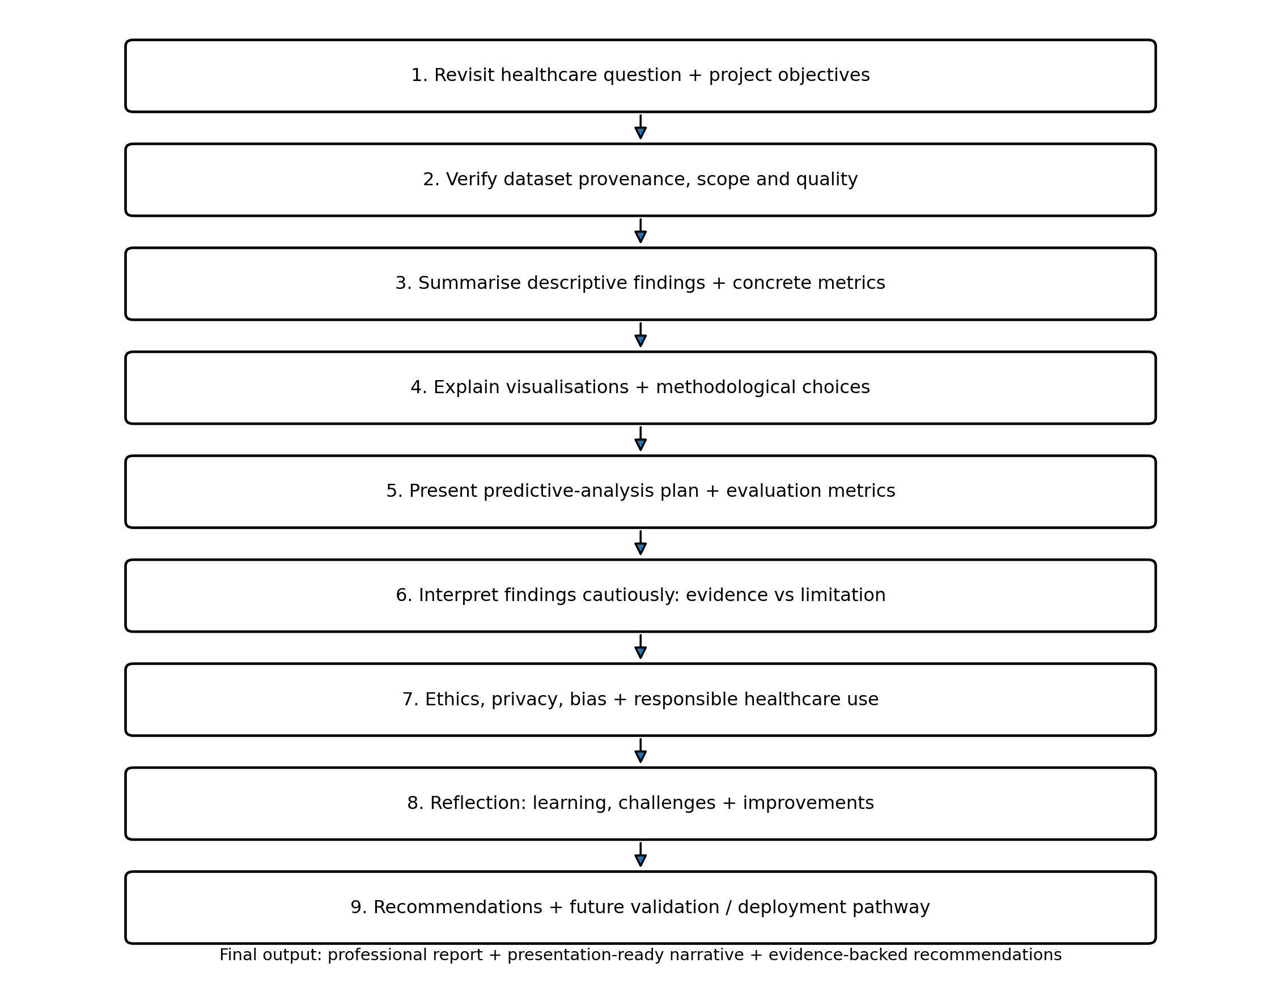
Figure 3. Final end-to-end presentation and reflection workflow.

8. Predictive Analytics: What Was Planned and What Must Be Reported
The Week 4 strategy proposed Logistic Regression, Decision Tree and Random Forest models with stratified validation and an untouched test set. The final report must distinguish between a model that was actually trained and evaluated in the project and a model that was only planned.
Metric | Formula | Why included | Final reporting rule
Accuracy | (TP+TN)/(TP+TN+FP+FN) | Overall classification correctness. | Report only from the actual project run.
Precision | TP/(TP+FP) | How many predicted positives were correct. | Useful when false alarms have resource costs.
Recall | TP/(TP+FN) | How many actual positives were detected. | Important when missed cases matter.
F1 | 2×Precision×Recall/(Precision+Recall) | Balances precision and recall. | Useful when both error types matter.
Specificity | TN/(TN+FP) | Ability to identify negatives. | Useful alongside recall.
ROC-AUC | Area under ROC curve | Threshold-independent ranking measure. | Report actual cross-validation/test result.
PR-AUC | Area under precision-recall curve | Useful when positive-class performance is important. | Report actual result where computed.
No project-specific model performance number is fabricated in this report. If the Week 4 models were executed, their actual confusion matrices and metrics should replace the 'report only if reproduced' placeholders. If they were not executed, the correct final presentation is to report the predictive workflow as a proposed analytical stage rather than claiming model performance.

9. Original-Work Evidence: Reproducible Analysis Snippets
# Target distribution
target_counts = df["target"].value_counts().sort_index()
target_pct = (target_counts / len(df) * 100).round(2)
# Missingness
missing = df.isna().sum()
missing_pct = (missing / len(df) * 100).round(2)
# Category summary
cp_counts = df["cp"].value_counts().sort_index()
# Numeric summary
numeric_summary = df[["age","trestbps","chol","thalach"]].describe()
# Model evaluation after an ACTUAL fitted model:
from sklearn.metrics import confusion_matrix, classification_report, roc_auc_score
cm = confusion_matrix(y_test, y_pred)
print(classification_report(y_test, y_pred))
print("ROC-AUC:", roc_auc_score(y_test, y_prob))
This code is designed to produce the evidence shown in the final report. It should be run against the exact project file so that reported metrics correspond to the student's actual analysis rather than a copied benchmark.

10. Reflective Assessment of the Learning Journey
Reflection area | What was learned | Improvement for next project
Planning | A clear problem statement and measurable objectives prevent unfocused analysis. | Define acceptance criteria before touching the data.
Preprocessing | Healthcare data require documented decisions rather than automatic deletion or imputation. | Create automated QA tests earlier.
Visualization | Chart choice should depend on variable type, audience and question. | Use a visualisation checklist before dashboard creation.
Predictive analytics | Model selection must be connected to error costs and validation design. | Run reproducible stratified cross-validation and retain the test set.
Quality assurance | A notebook executing successfully does not prove data quality. | Create a formal release gate and evidence log.
Ethics | Historical public data still require cautious interpretation and privacy-aware communication. | Add ethics and intended-use review at project start.
Communication | Technical results need a narrative that explains what changed and why it matters. | Use a one-minute executive summary plus technical appendix.

11. Challenges Encountered and How They Were Addressed
- Dataset representations can differ: UCI reports the original diagnosis as 0–4, while many analyses use a binary mapping. The final report therefore states the target transformation explicitly.
- Missingness can be represented differently across processed copies. The report distinguishes UCI's general 'missing values: yes' metadata from source-derived counts reported by a specific analysis.
- Healthcare variables have different meanings and scales. The methodology therefore separates nominal categories, binary indicators and continuous measurements instead of applying one generic visualisation method.
- Model metrics can be misleading if the validation design is weak. The proposed workflow uses stratification, training-only preprocessing and an untouched test set.
- The strongest academic improvement is traceability: each reported number should have a reproducible source, calculation or model output.

12. Explicit Ethical Standards for Healthcare Data and Presentation
- Privacy and confidentiality: do not expose patient identifiers or upload restricted health information to public repositories.
- Data minimisation: use only variables necessary for the analytical question.
- Transparency: document the dataset source, target definition, preprocessing, missingness handling and limitations.
- Human oversight: predictive outputs should support appropriate human judgement and should not be presented as autonomous clinical decisions.
- Fairness and representation: report subgroup sizes and avoid generalising results beyond the historical sample.
- Non-maleficence: avoid visual or narrative choices that could cause unjustified alarm or false reassurance.
- Accountability: maintain versioned code, audit evidence and a record of methodological changes.
- Responsible communication: distinguish descriptive association from causation and model prediction from clinical diagnosis.

13. Future Recommendations
Priority | Recommendation | Success measure
1 | Run the complete modelling pipeline on the exact final dataset. | Reproducible notebook + saved evaluation table.
2 | Use nested/stratified validation where appropriate. | No test-set leakage; documented folds.
3 | Perform external validation on a separate population. | Report performance on unseen external data.
4 | Conduct subgroup performance checks. | Recall/precision/F1 reported by relevant subgroups where sample size permits.
5 | Add data-drift monitoring if operationalised. | Defined thresholds and alert procedure.
6 | Maintain a model/data change log. | Every release has version, reviewer and reason.
7 | Improve clinical interpretability. | Feature definitions + explainability method + human review.
8 | Conduct governance review before real-world use. | Documented privacy, ethics and regulatory assessment.

14. Suggested Final Presentation Structure
Slide | Title | Key content
1 | Problem & Objective | Healthcare question, target and intended analytical value.
2 | Dataset | 303 records, 13 features, source and target definition.
3 | Data Quality | Missingness, duplicates, validation and QA controls.
4 | Key Descriptive Findings | 164/139 target split, demographics and clinical-variable ranges.
5 | Visual Story | Chest-pain distribution, numeric distributions and target chart.
6 | Predictive Analytics | Models considered, validation strategy and evaluation metrics.
7 | Ethics & Compliance | Privacy, human oversight, bias, governance and limitations.
8 | Reflection | What was learned, challenges and methodological improvements.
9 | Recommendations | External validation, monitoring, subgroup checks and governance.
10 | Closing | What the evidence supports—and what it does not.

15. Conclusion
The final stage of the healthcare analytics project is not simply a summary of charts. It is an evidence-based explanation of how a healthcare question was translated into data requirements, quality checks, visual analysis, predictive methodology, governance controls and responsible conclusions. The UCI Heart Disease dataset provides a concrete case for demonstrating this process: 303 records, a documented 0–4 diagnosis field commonly transformed into a binary outcome, uneven demographic and clinical categories, and documented missing values. The final presentation should use these numbers to make the analysis tangible while clearly separating source-derived evidence, project-generated results and methodological proposals.
The strongest final message is therefore one of traceability and responsible interpretation: every number should be sourced or reproducibly calculated, every methodological choice should have a reason, every model metric should come from an actual evaluation run, and every healthcare conclusion should acknowledge the dataset's historical scope and limitations.

16. References
- UCI Machine Learning Repository. Heart Disease. DOI: 10.24432/C52P4X. https://www.archive.ics.uci.edu/dataset/45/heart%2Bdisease
- Heart Disease Risk Prediction Using Machine Learning Classifiers with Attribute Evaluators. Applied Sciences, 2021. https://www.mdpi.com/2076-3417/11/18/8352
- World Health Organization. Ethics and governance of artificial intelligence for health. https://www.who.int/publications/i/item/9789240029200
- U.S. Department of Health and Human Services. HIPAA Privacy Rule. https://www.hhs.gov/hipaa/for-professionals/privacy/laws-regulations/index.html
- U.S. Department of Health and Human Services. HIPAA Security Rule. https://www.hhs.gov/hipaa/for-professionals/security/index.html
- FDA / IMDRF. Good Machine Learning Practice for Medical Device Development. https://www.fda.gov/medical-devices/software-medical-device-samd/good-machine-learning-practice-medical-device-development-guiding-principles

17. Academic Integrity Note
Source-derived numerical findings are identified as such. Percentages in this report are calculated directly from documented source counts. No model-performance result is presented as a project finding unless it can be reproduced from the student's actual modelling pipeline. Illustrative methodology is clearly separated from observed/source-derived evidence.

