WEEK 2: DATA CLEANING AND PREPROCESSING METHODOLOGY
Healthcare Heart Disease Analysis
Detailed, measurable and reproducible data-quality framework
Purpose
This report directly addresses the assessment requirements for missing values, anomalies, normalisation, duplicate removal, categorical-data issues, data integrity, Python/Pandas/NumPy methods, a workflow flowchart, concrete numerical examples and documented cleaning decisions.

Evaluator-feedback response
Specific examples, formulas, measurable checks, acceptance rules and pseudocode/code snippets are included. Numerical values used only to demonstrate calculations are explicitly labelled illustrative.

1. Executive Summary
This report defines a systematic data-cleaning and preprocessing methodology for the proposed heart-disease healthcare analytics project. The workflow begins with the raw UCI Heart Disease dataset and establishes quality gates before exploratory analysis or predictive modelling. It covers schema inspection, missing-value profiling, duplicate detection, range validation, anomaly review, categorical consistency checks, treatment decisions, encoding, normalisation/scaling, post-transformation validation and documentation.
Healthcare data require particular care because incorrect values, missing observations and inconsistent coding can change analytical conclusions. The strategy therefore does not automatically delete unusual observations. Each anomaly is flagged, investigated and classified as a valid observation, possible data-entry issue, missing/unknown value or documented transformation.
The methodology is designed to be reproducible with Python, especially Pandas and NumPy, with scikit-learn pipelines used where modelling preparation requires imputation, encoding or scaling.

2. Dataset Context and Cleaning Objectives
The proposed project uses the UCI Heart Disease dataset in its commonly used 303-record, 13-predictor representation. Candidate fields include age, sex, chest-pain type (cp), resting blood pressure (trestbps), cholesterol (chol), fasting blood sugar (fbs), resting ECG (restecg), maximum heart rate (thalach), exercise-induced angina (exang), ST depression (oldpeak), slope, ca and thal, together with the target/goal field.
Cleaning objective | Concrete quality criterion | Evidence
Completeness | Missing count and percentage for every field. | Missingness table.
Uniqueness | Duplicate-row count and percentage. | Duplicate audit.
Validity | Numeric range and categorical-level checks. | Validation report.
Consistency | Category coding and target mapping verified. | Frequency tables.
Outlier control | IQR screening followed by review. | Outlier flag counts.
Transformation integrity | Before/after row counts and summaries compared. | QA table.
Reproducibility | Code and parameters recorded. | Versioned script/notebook.

3. End-to-End Cleaning Workflow
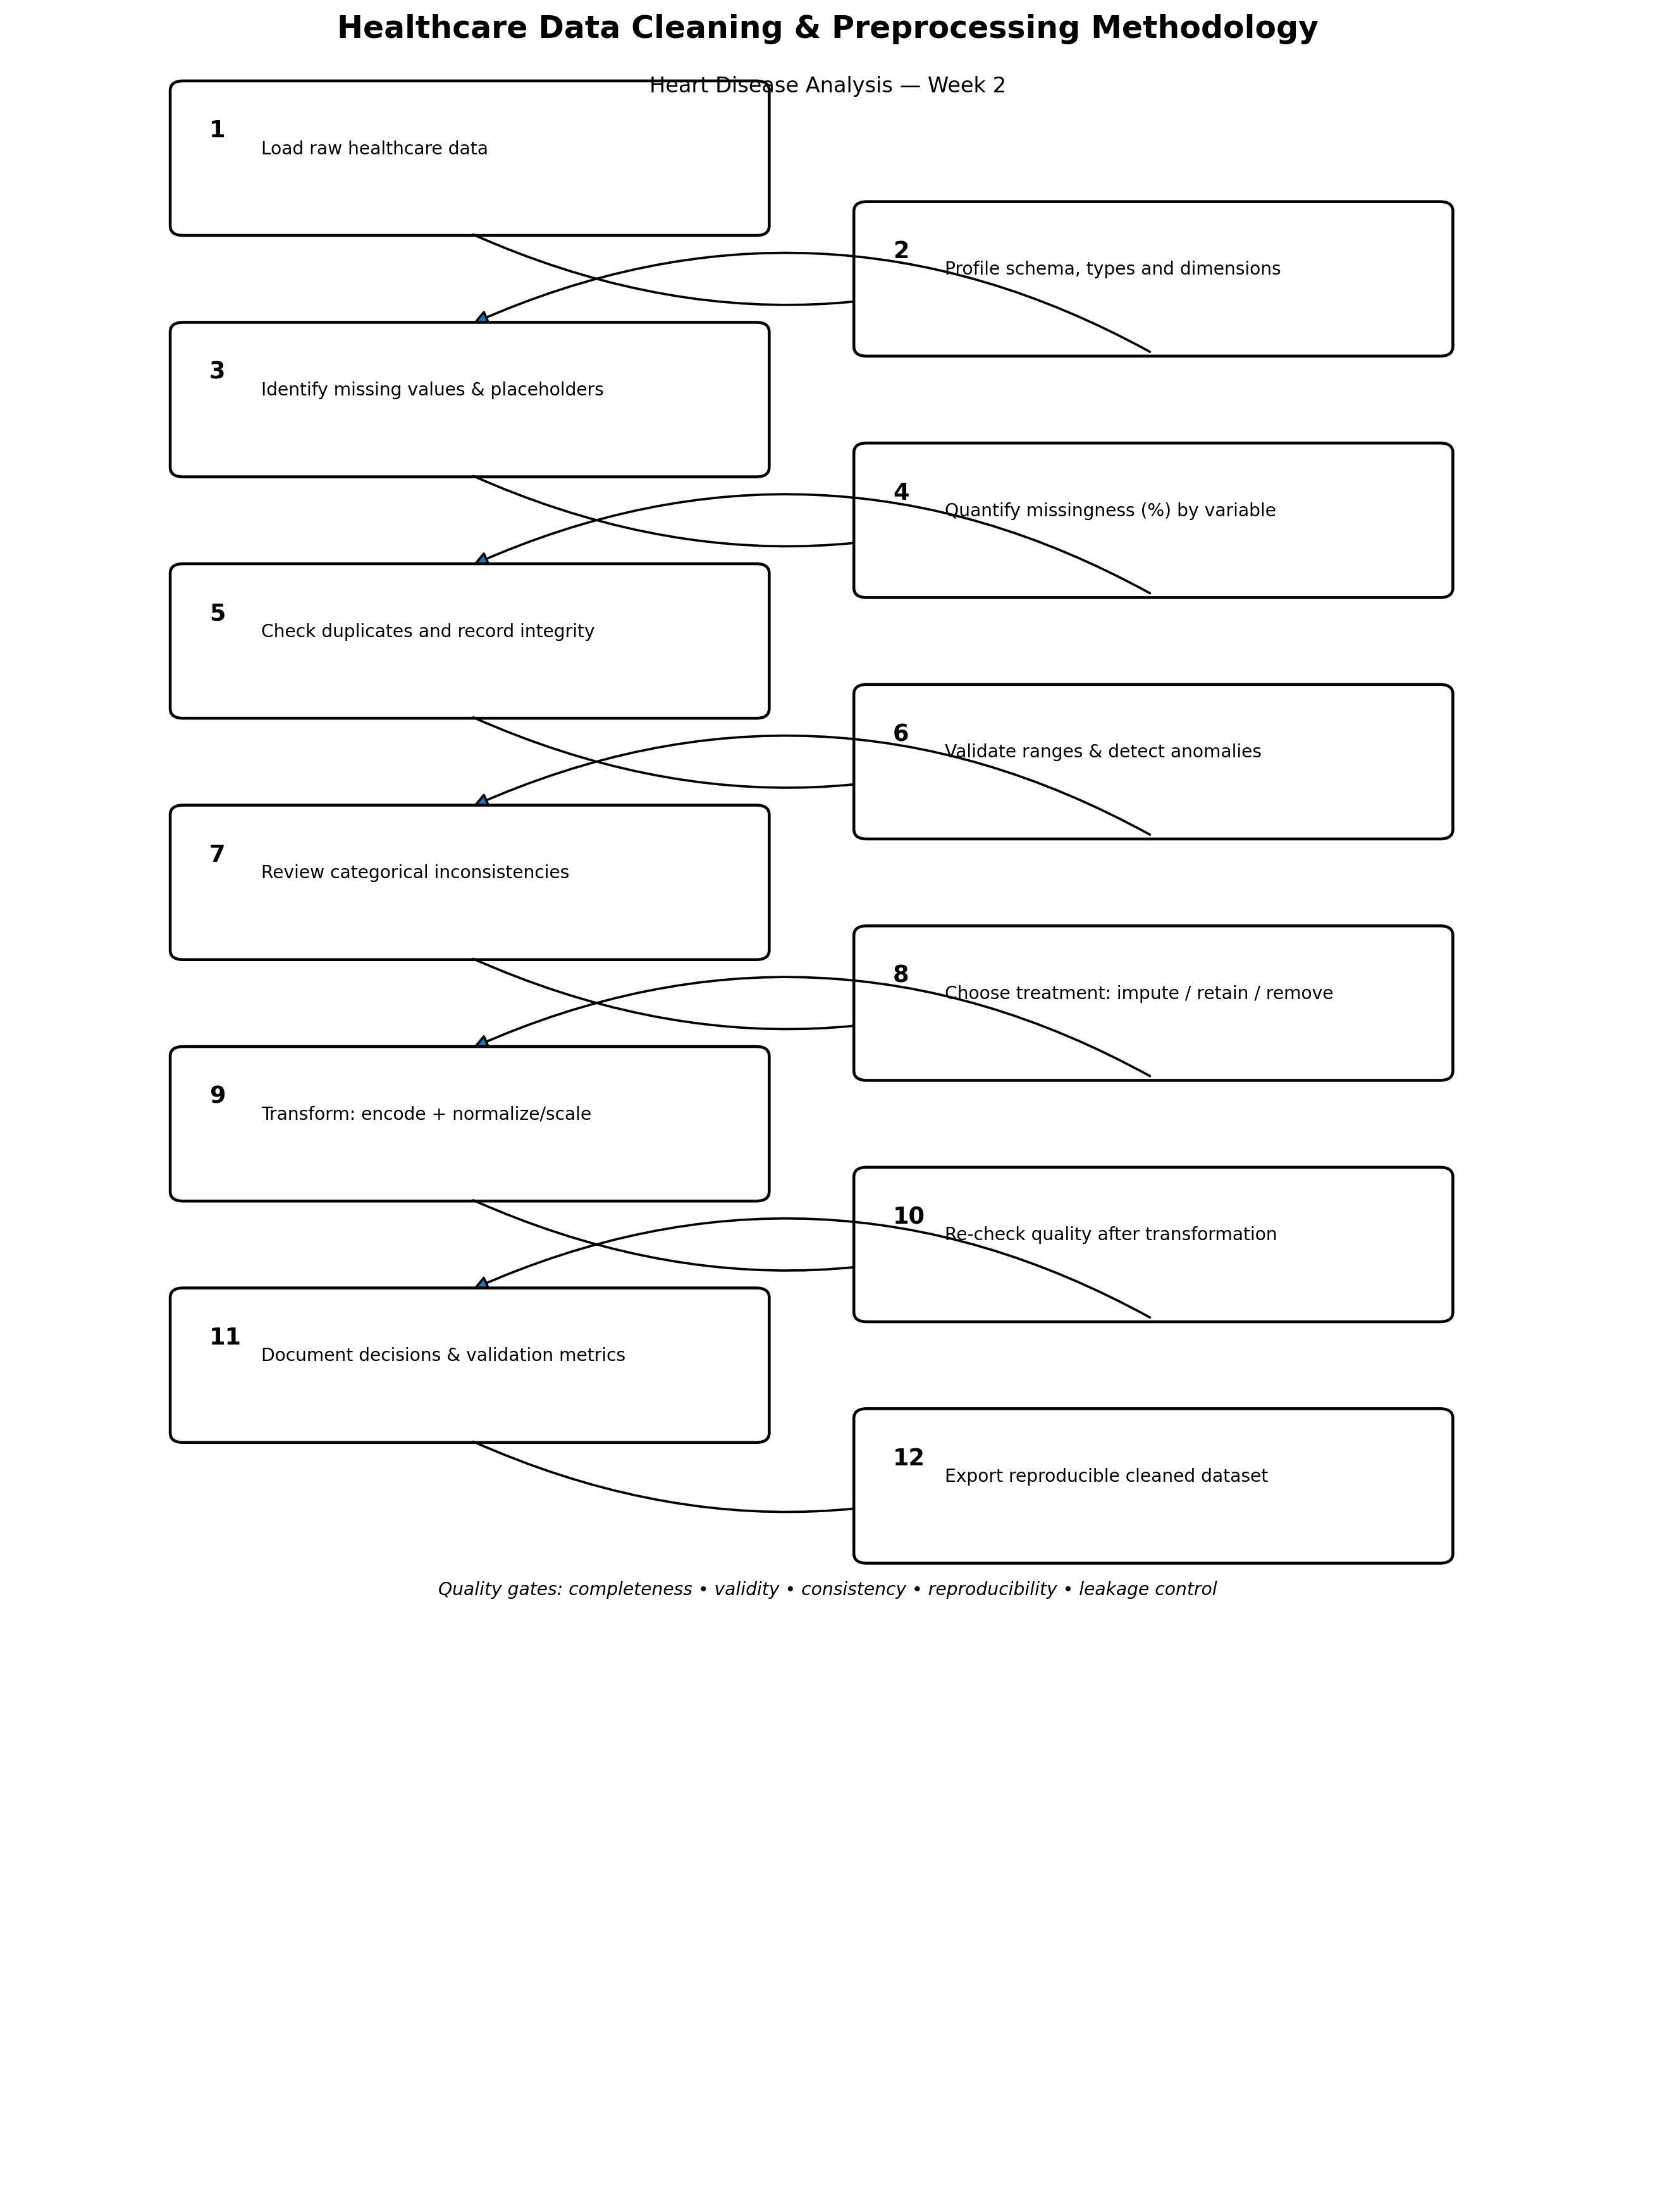
The PNG is also intended to be stored in the GitHub repository as a portfolio visual.

4. Step 1 — Data Loading and Structural Profiling
The raw file is loaded without manual modification. The analyst records dimensions, column names, types and unique values to establish a baseline.
import pandas as pd
import numpy as np
df = pd.read_csv("heart_disease.csv")
print("Rows, columns:", df.shape)
print(df.columns.tolist())
print(df.dtypes)
print(df.nunique())
Metric | Illustrative example | Interpretation
Rows | 303 | Verify against the downloaded file.
Predictors | 13 | Verify the exact schema used.
Duplicate rows | 3 | Requires investigation before removal.
Missing cells | 12 | Calculate by variable and percentage.

5. Step 2 — Missing-Value Analysis
Missingness can appear as nulls, blanks or dataset-specific placeholder codes. Missingness must be quantified before choosing an imputation or removal strategy.
missing = df.isna().sum()
missing_pct = (missing / len(df) * 100).round(2)
missing_report = pd.DataFrame({
"missing_count": missing,
"missing_pct": missing_pct
}).sort_values("missing_pct", ascending=False)
print(missing_report)

5.1 Concrete Missingness Example
Illustrative example only: if `chol` contained 9 missing values among 303 records:
Missing % = (9 / 303) × 100 = 2.97%
Situation | Possible treatment | Metric/check
Very low numeric missingness | Median imputation if justified. | Missing count before/after.
Low/moderate categorical missingness | Most frequent or explicit Unknown if justified. | Category frequencies.
High missingness | Assess usefulness and sensitivity. | Missingness % and sensitivity analysis.
Potentially informative missingness | Consider a missingness indicator. | Indicator frequency.
Missing target | Do not blindly impute. | Resolve/exclude according to target policy.

6. Step 3 — Duplicate Detection and Record Integrity
duplicate_count = df.duplicated().sum()
duplicate_pct = duplicate_count / len(df) * 100
print("Duplicate rows:", duplicate_count)
print("Duplicate %:", round(duplicate_pct, 2))
Illustrative calculation: 3 duplicate rows would equal (3 / 303) × 100 = 0.99%. Duplicates must be inspected because repeated records may represent legitimate repeated encounters rather than accidental copies.
Integrity check | Method | Acceptance rule
Complete duplicate | df.duplicated() | Investigate every duplicate.
Near duplicate | Compare relevant fields if available. | Do not merge without evidence.
Row-count preservation | Compare after every transformation. | Unexpected loss must be explained.
Target integrity | Unique values and counts. | No unexplained target changes.

7. Step 4 — Numerical Validation and Anomaly Detection
Numerical fields should be checked for impossible or suspicious values. Statistical outliers are screening flags, not automatic errors.
numeric_cols = ["age", "trestbps", "chol", "thalach", "oldpeak"]
print(df[numeric_cols].describe().T[["min","25%","50%","75%","max"]])
Q1 = df[numeric_cols].quantile(0.25)
Q3 = df[numeric_cols].quantile(0.75)
IQR = Q3 - Q1
lower = Q1 - 1.5 * IQR
upper = Q3 + 1.5 * IQR
flags = (df[numeric_cols] < lower) | (df[numeric_cols] > upper)
print(flags.sum())

7.1 Concrete IQR Example
Q1 = 120, Q3 = 180
IQR = 180 − 120 = 60
Lower fence = 120 − (1.5 × 60) = 30
Upper fence = 180 + (1.5 × 60) = 270
A value above 270 would be flagged by the IQR rule in this illustrative example. It should then be reviewed rather than automatically deleted.
Anomaly | Example | Decision
Impossible value | Age = -4 | Flag; correct only from a reliable source, otherwise treat as invalid/missing.
Extreme but possible | Unusually high cholesterol | Investigate and retain if plausible.
Unit error | Unexpected blood-pressure unit | Verify source definition before conversion.
Coding error | Unexpected category code | Map only when source documentation confirms meaning.

8. Step 5 — Categorical Data Consistency
categorical_cols = ["sex","cp","fbs","restecg","exang","slope","ca","thal"]
for col in categorical_cols:
print("\n", col)
print(df[col].value_counts(dropna=False))
Problem | Example | Solution
Unexpected code | cp = 7 when expected range is 0–3 | Verify documentation before mapping.
Mixed representation | sex contains 0, 1 and 'Male' | Standardise only after confirming meaning.
Blank strings | thal contains '' | Convert blanks to missing values.
Rare category | One observation in a category | Investigate; do not automatically delete.

9. Step 6 — Encoding Categorical Variables
Nominal categories should generally be one-hot encoded rather than treated as ordered numbers. Ordinal encoding should be used only when an order is documented and meaningful.
from sklearn.preprocessing import OneHotEncoder
encoder = OneHotEncoder(handle_unknown="ignore", sparse_output=False)
encoded = encoder.fit_transform(df[["cp", "restecg"]])

10. Step 7 — Normalisation and Scaling
Scaling is useful for scale-sensitive algorithms such as regularised logistic regression, but is generally unnecessary for tree-based models. Scaling parameters must be learned from training data only.
from sklearn.preprocessing import StandardScaler
scaler = StandardScaler()
X_train_scaled = scaler.fit_transform(X_train_numeric)
X_test_scaled = scaler.transform(X_test_numeric)
Illustrative calculation: if mean = 150 and standard deviation = 20, a value of 190 becomes z = (190 − 150) / 20 = 2.0.

11. Step 8 — Leakage-Safe Preprocessing Pipeline
from sklearn.compose import ColumnTransformer
from sklearn.pipeline import Pipeline
from sklearn.impute import SimpleImputer
from sklearn.preprocessing import OneHotEncoder, StandardScaler
numeric_pipe = Pipeline([
("imputer", SimpleImputer(strategy="median")),
("scaler", StandardScaler())
])
categorical_pipe = Pipeline([
("imputer", SimpleImputer(strategy="most_frequent")),
("encoder", OneHotEncoder(handle_unknown="ignore"))
])
preprocessor = ColumnTransformer([
("num", numeric_pipe, numeric_cols),
("cat", categorical_pipe, categorical_cols)
])
Leakage-control rule
Split first. Fit transformations only on training data; transform validation/test data without refitting. Never allow test-set information to determine imputation, scaling or encoding parameters.

12. Step 9 — Before-and-After Quality Metrics
QA metric | Before cleaning | Expected after cleaning
Rows | Actual raw count | Same unless documented exclusions occur.
Columns | Raw schema | Documented modelling schema.
Missing cells | Count + % | 0 for fields imputed; residuals documented.
Duplicate rows | Count + % | 0 only when confirmed accidental duplicates are removed.
Invalid categories | Count | 0 unexplained invalid categories.
Numeric anomaly flags | Count | Each flag retained, corrected or excluded with reason.
Target values | Unique values + counts | Only documented target classes.
Leakage risk | Not yet assessed | Training-only fitting of transformations.

These metrics provide concrete evidence that cleaning was performed and verified.

13. Complete Cleaning Pseudocode
START
LOAD raw healthcare dataset
SAVE raw dimensions and schema
PROFILE types and unique values
IDENTIFY nulls, blanks and placeholder codes
CALCULATE missing count and percentage
CHECK duplicate records
IF confirmed accidental duplicates:
remove and record count
FOR each numeric variable:
calculate min, quartiles and IQR
flag possible outliers
review flagged values
FOR each categorical variable:
list values and frequencies
verify against documentation
standardise only verified inconsistencies
DEFINE and validate target
SPLIT data into training and testing sets
BUILD preprocessing pipeline
FIT transformations on training data only
TRANSFORM test data without refitting
RE-RUN quality checks
COMPARE before/after metrics
SAVE preprocessing specification
END

14. Pandas, NumPy and Scikit-learn Evidence
Library | Methods/examples | Purpose
Pandas | read_csv, isna, duplicated, value_counts, describe, quantile | Loading, profiling, missingness, duplicates, distributions and categories.
NumPy | np.nan, np.where | Missing representation and conditional flags.
Scikit-learn | Pipeline, ColumnTransformer, SimpleImputer, OneHotEncoder, StandardScaler | Reproducible preprocessing.
Matplotlib/Seaborn | histograms, boxplots, bar charts | Visual validation of distributions and anomalies.

# Missingness indicator example
df["chol_missing"] = df["chol"].isna().astype(int)
# Quality flag example
df["age_quality_flag"] = np.where(
(df["age"] < 0) | (df["age"] > 120), 1, 0
)
print(df.isna().sum())

15. Cleaning Decision Matrix
Issue | Detection metric | Decision | Documentation
Missing numeric | count + % | Justified imputation or retain missing | Variable, rate, method.
Missing categorical | count + % | Mode/Unknown if justified | Category policy.
Duplicate row | count + % | Remove only confirmed accidental duplicates | Rows removed.
Outlier | IQR flag count | Investigate; retain/correct/exclude with reason | Rule and decision.
Invalid category | unique-value audit | Correct only with verified mapping | Mapping.
Scale differences | range/mean/std | Scale for appropriate models | Training-only fit.
Unknown test category | transform check | One-hot encoder ignores unseen levels | Encoder settings.
Target inconsistency | unique target values | Resolve using target definition | Mapping/exclusions.

16. Quality Assurance Checklist
- Raw data preserved and provenance recorded.
- Row/column counts recorded before transformation.
- Every variable has documented type and meaning.
- Missing values quantified as counts and percentages.
- Duplicates measured and investigated.
- Numeric ranges and IQR flags reviewed.
- Categorical values checked against documentation.
- Target definition verified before modelling.
- Encoding strategy documented.
- Scaling used only where appropriate.
- Transformations fitted only on training data.
- Before/after QA metrics recorded.
- Every exclusion or transformation has a written reason.
- Cleaned data can be regenerated from the raw source and code.

17. 30–35 Hour Work Plan
Task | Hours
Dataset acquisition, provenance and schema profiling | 3
Missing-value and placeholder analysis | 4
Duplicate and integrity checks | 3
Numeric range and anomaly/outlier analysis | 5
Categorical consistency and encoding strategy | 4
Imputation and scaling pipeline design | 4
Leakage control and post-cleaning QA | 3
Documentation, flowchart and evidence tables | 3
Final review and reproducibility check | 2
Total | 31

18. Expected Deliverables
- Detailed Week 2 Word methodology report.
- Professional data-cleaning/preprocessing flowchart PNG.
- Reproducible Python/pseudocode demonstrating proposed methods.
- Before/after quality-metric framework.
- Cleaning decision matrix and risk controls.
- GitHub repository containing the report and flowchart.

19. Limitations
A cleaning methodology cannot determine the clinical correctness of every value without authoritative source information. Statistical outliers are not necessarily errors, and imputation introduces assumptions. The proposed procedure therefore emphasises investigation and documentation rather than automatic deletion. Careful cleaning improves analytical integrity but does not eliminate limitations in sample size, historical context or generalisability.

20. Conclusion
This Week 2 methodology provides a complete and measurable framework for preparing healthcare data for analysis. It directly addresses missing values, duplicates, anomalies, categorical inconsistencies, normalisation/scaling, data integrity, Python/Pandas/NumPy methods and reproducibility. Concrete formulas, acceptance criteria, before/after metrics, pseudocode and code snippets provide the specific evidence requested by the evaluator while avoiding unsupported claims about actual cleaned-data results.

21. References and Technical Resources
- UCI Machine Learning Repository. Heart Disease dataset. https://archive.ics.uci.edu/dataset/45/heart+disease
- Pandas documentation. https://pandas.pydata.org/docs/
- NumPy documentation. https://numpy.org/doc/
- Scikit-learn documentation. https://scikit-learn.org/stable/
- World Health Organization. Ethics and governance of artificial intelligence for health. 2021. https://www.who.int/publications/i/item/9789240029200
Academic integrity note
Illustrative numerical examples are explicitly labelled. Dataset-specific values should be calculated from the actual downloaded file during implementation, not substituted with illustrative values.

