WEEK 4: PREDICTIVE ANALYTICS STRATEGY AND MODELING PLAN
Healthcare Predictive Analytics Using the UCI Heart Disease Dataset
Detailed strategic plan • hypothetical modeling framework • evaluation methodology

1. Executive Summary
This report presents a structured predictive analytics strategy for a healthcare scenario involving the identification of patterns associated with heart disease status. The plan is designed around the UCI Heart Disease dataset, using the commonly analysed Cleveland subset of 303 patient records and 13 clinical features. The purpose is not to make clinical diagnoses, but to demonstrate how a reproducible machine-learning workflow could investigate whether routinely recorded patient characteristics contain useful predictive information.
The proposed target is a binary outcome: disease absent versus disease present, created from the original heart-disease target representation. Candidate predictors include age, sex, chest-pain type, resting blood pressure, cholesterol, fasting blood sugar, resting ECG, maximum heart rate, exercise-induced angina, ST depression, slope, number of major vessels and thalassemia-related information. The report defines data requirements, preprocessing, feature engineering, candidate algorithms, validation, evaluation metrics, expected hypotheses, implementation pseudocode, risks and ethical safeguards.
Because the assignment asks for a hypothetical modeling plan, the numerical model-performance values in this report are explicitly illustrative acceptance examples rather than claims about a completed model. Actual accuracy, precision, recall, F1-score, ROC-AUC and confusion-matrix values should only be reported after the exact dataset file has been cleaned, split and evaluated.

2. Problem Statement
Healthcare datasets can contain multiple clinical measurements that are related to cardiovascular risk. A predictive analytics workflow can be used to investigate whether a combination of these variables can classify a patient encounter into a disease-present or disease-absent category. The central analytical question is: Can routinely available clinical variables provide useful predictive information about the binary heart-disease outcome in this dataset?
The model is intended as an analytical demonstration. It should not be treated as a medical diagnostic device, and a model output would require clinical validation, appropriate governance, and qualified human interpretation before any real-world use.

3. Dataset and Data Requirements
The UCI Heart Disease dataset is a publicly available healthcare dataset. The UCI repository describes the commonly used dataset as containing 303 instances and 13 commonly used features, with mixed categorical, integer and real-valued variables and a heart-disease target. The source also documents that identifying information was removed or replaced with dummy values.
Variable | Type | Role | Example interpretation
age | Numeric | Predictor | Patient age in years
sex | Binary | Predictor | Recorded sex category
cp | Categorical | Predictor | Chest-pain category
trestbps | Numeric | Predictor | Resting blood pressure
chol | Numeric | Predictor | Serum cholesterol
fbs | Binary | Predictor | Fasting blood sugar indicator
restecg | Categorical | Predictor | Resting ECG category
thalach | Numeric | Predictor | Maximum heart rate achieved
exang | Binary | Predictor | Exercise-induced angina indicator
oldpeak | Numeric | Predictor | ST depression
slope | Categorical/ordinal | Predictor | Exercise ST-slope category
ca | Discrete numeric | Predictor | Number of major vessels
thal | Categorical | Predictor | Thalassemia-related category
target/num | Categorical target | Outcome | Disease absent/present after binary mapping

4. Analytical Objectives and Measurable Targets
- Build a reproducible binary classification workflow using a fixed random seed and documented preprocessing.
- Compare at least three candidate classifiers: Logistic Regression, Decision Tree and Random Forest.
- Evaluate models using accuracy, precision, recall, F1-score, ROC-AUC and a confusion matrix rather than accuracy alone.
- Use stratified validation so that both outcome classes are represented in training and validation folds.
- Establish an illustrative model-selection rule: prefer a model that meets a predefined minimum recall and has acceptable precision/F1, subject to validation stability.
- Document limitations, data-quality risks, fairness considerations and the distinction between statistical prediction and clinical diagnosis.

5. Hypotheses and Expected Predictions
Hypothesis | Expected pattern | How it will be tested
H1 | A multivariable model will contain predictive information beyond any single variable. | Compare cross-validated multivariable models with simple baselines.
H2 | Chest-pain category, maximum heart rate, exercise-induced angina and ST depression may contribute useful predictive signal. | Inspect coefficients/feature importance only after validation.
H3 | A flexible tree-based model may capture nonlinear relationships that a linear model does not. | Compare Logistic Regression with Decision Tree/Random Forest under the same validation design.
H4 | Changing the probability threshold will change the precision–recall trade-off. | Evaluate multiple thresholds on validation predictions rather than assuming 0.50 is universally optimal.

6. Data Preparation and Leakage Prevention
- Audit column names, data types, target coding, missingness, impossible values and duplicate records.
- Convert categorical fields to explicit categorical representations and document the mapping used.
- Handle missing values using a rule defined before model fitting. For example, median imputation may be used for numeric variables and most-frequent or an explicit category for categorical variables, depending on the missingness pattern.
- Encode categorical variables using one-hot encoding where appropriate. Ordinal encoding should only be used when category order is substantively meaningful.
- Scale numeric variables for algorithms such as Logistic Regression when needed; tree models generally do not require scaling.
- Split the dataset into training and test data using stratification. Example planning split: 80% training and 20% final test, with a fixed random state.
- Fit imputation, encoding and scaling parameters only on the training data. Apply the fitted transformations to validation/test data without relearning parameters.
- Keep the final test set untouched until model selection and preprocessing decisions are complete.
Illustrative calculation: with 303 records, an 80/20 split would produce approximately 242 training records and 61 test records. Exact counts depend on the split implementation and rounding.

7. Model Design
Model | Why include it? | Strength | Limitation
Majority-class baseline | Defines performance of a trivial classifier. | Simple reference point. | Can appear accurate while missing the minority class.
Logistic Regression | Interpretable linear baseline for binary classification. | Coefficients and probability outputs are relatively interpretable. | May miss nonlinear interactions.
Decision Tree | Provides a rule-based nonlinear model. | Easy to visualize and explain. | Can overfit without pruning/depth controls.
Random Forest | Ensemble of decision trees. | Can capture nonlinear relationships and interactions. | Less transparent than a single tree; feature importance needs careful interpretation.

8. Evaluation Framework
Metric | Formula | Purpose
Accuracy | (TP + TN) / (TP + TN + FP + FN) | Overall proportion classified correctly.
Precision | TP / (TP + FP) | Among predicted positives, proportion that are positive.
Recall / Sensitivity | TP / (TP + FN) | Among actual positives, proportion identified.
F1-score | 2 × Precision × Recall / (Precision + Recall) | Balances precision and recall.
Specificity | TN / (TN + FP) | Among actual negatives, proportion correctly identified.
ROC-AUC | Area under ROC curve | Measures ranking discrimination across thresholds.
PR-AUC | Area under precision-recall curve | Useful when positive-class performance is important.

9. Concrete Numerical Evaluation Example
Illustrative only — this worked example shows how the metrics will be calculated after a model is actually evaluated. Suppose a held-out test set produced TP=30, TN=25, FP=10 and FN=5.
Metric | Calculation | Result
Accuracy | (30+25)/(30+25+10+5) | 0.786 = 78.6%
Precision | 30/(30+10) | 0.750 = 75.0%
Recall | 30/(30+5) | 0.857 = 85.7%
F1 | 2×0.750×0.857/(0.750+0.857) | ≈0.800 = 80.0%
Specificity | 25/(25+10) | 0.714 = 71.4%
The example demonstrates why multiple metrics are needed. A model with high accuracy can still have inadequate recall, precision or specificity depending on the class distribution and the cost of different errors.

10. Cross-Validation and Model Selection
The training portion should be evaluated using stratified k-fold cross-validation, for example 5 folds. In each fold, the preprocessing pipeline must be fitted only on the training portion of that fold. Mean and standard deviation of the evaluation metrics should be reported. After model selection, the chosen pipeline can be refit on the complete training set and evaluated once on the untouched test set.
Illustrative acceptance criteria: (1) no evidence of preprocessing leakage; (2) recall ≥ 0.75 on the selected validation criterion; (3) precision ≥ 0.60 where operationally appropriate; (4) F1 ≥ 0.65; and (5) ROC-AUC ≥ 0.75. These are project-planning thresholds, not claims that the dataset will achieve them.

11. Threshold Analysis
A default 0.50 probability threshold should not automatically be treated as the best operational threshold. If the model outputs probabilities, validation predictions can be evaluated at thresholds such as 0.30, 0.40, 0.50, 0.60 and 0.70. The resulting precision, recall and F1-score should be tabulated. The final threshold should be selected according to the documented analytical objective and clinical/operational context, not merely because it produces the highest single metric.

12. Implementation Pseudocode
LOAD dataset
VERIFY schema, target coding, missing values and duplicates
DEFINE binary target
SEPARATE predictors X and target y
STRATIFY train/test split
CREATE preprocessing pipeline:
numeric -> imputation -> optional scaling
categorical -> imputation -> one-hot encoding
FOR each candidate model:
run stratified cross-validation on training data
collect accuracy, precision, recall, F1, ROC-AUC and PR-AUC
COMPARE validation means and variability
SELECT model using predefined criteria
REFIT selected pipeline on complete training data
EVALUATE once on untouched test set
CALCULATE confusion matrix and threshold table
DOCUMENT limitations, ethics and intended use

13. Python Implementation Evidence
from sklearn.model_selection import train_test_split, StratifiedKFold, cross_validate
from sklearn.pipeline import Pipeline
from sklearn.metrics import classification_report, confusion_matrix
X_train, X_test, y_train, y_test = train_test_split(
X, y, test_size=0.20, stratify=y, random_state=42
)
cv = StratifiedKFold(n_splits=5, shuffle=True, random_state=42)
model_pipeline = Pipeline([
("preprocess", preprocessing_pipeline),
("model", LogisticRegression(max_iter=1000))
])
scores = cross_validate(
model_pipeline, X_train, y_train, cv=cv,
scoring=["accuracy", "precision", "recall", "f1", "roc_auc"]
)
model_pipeline.fit(X_train, y_train)
pred = model_pipeline.predict(X_test)
print(confusion_matrix(y_test, pred))
print(classification_report(y_test, pred))

14. Detailed Predictive Analytics Workflow
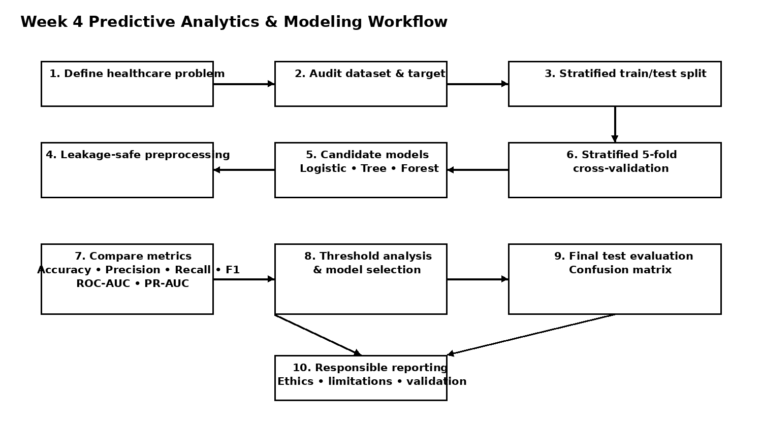
Figure 1. Reproducible predictive analytics workflow for the Week 4 modeling plan.

15. Risks and Mitigation
Risk | Why it matters | Mitigation
Small dataset | 303 records can produce unstable estimates and wide variation between splits. | Use stratified cross-validation; report variability; avoid overclaiming generalisability.
Missing values | Missing clinical fields can bias analysis if handled carelessly. | Profile missingness; document rules; use leakage-safe imputation; perform sensitivity checks.
Overfitting | Flexible models may fit noise in a small dataset. | Use cross-validation, complexity controls and an untouched test set.
Data leakage | Using test-set information during preprocessing can inflate performance. | Fit learned transformations inside the training pipeline.
Class imbalance | Accuracy can hide poor performance on the relevant class. | Report precision, recall, F1, ROC-AUC and PR-AUC.
Feature interpretation | Association does not establish causation. | Describe features as predictive inputs, not causal explanations.
Dataset shift | Historical public data may not represent current populations or practice. | Require external validation before real-world deployment.

16. Ethical and Responsible Use
- Use de-identified/public data only for the educational analysis described here and do not attempt to re-identify individuals.
- Do not treat a model prediction as a medical diagnosis or as a substitute for clinician judgment.
- Document dataset provenance, target definition, preprocessing decisions and known limitations.
- Check whether performance differs across relevant demographic groups where the dataset permits meaningful subgroup analysis.
- Avoid presenting model outputs with unjustified certainty. Communicate uncertainty, validation limitations and the need for external clinical validation.
- Any future collection or use of identifiable clinical data would require appropriate privacy, governance, ethics review and consent processes as applicable to the setting.

17. Tools and Resources
- Python 3.x
- Pandas and NumPy
- scikit-learn
- Matplotlib/Seaborn
- Jupyter Notebook
- GitHub
- UCI Machine Learning Repository

18. Proposed Timeline
Activity | Estimated time | Output
Problem definition and dataset audit | 3 hours | Problem statement and data-quality checklist
Preprocessing pipeline | 5 hours | Leakage-safe transformation design
Baseline and candidate models | 6 hours | Three or more model specifications
Cross-validation and tuning | 6 hours | Validation metric table
Test evaluation and threshold analysis | 4 hours | Confusion matrix and threshold table
Interpretation and ethics | 3 hours | Limitations and responsible-use section
Documentation and GitHub organization | 4 hours | Final DOCX, figures and README
Total planned effort: approximately 31 hours.

19. Expected Deliverables
- Detailed predictive analytics strategy report.
- Documented dataset and target definition.
- Leakage-safe preprocessing methodology.
- At least three candidate model specifications.
- Cross-validation metric table and final test evaluation.
- Confusion matrix and threshold analysis.
- Reproducible pseudocode and Python implementation evidence.
- Workflow diagram and limitations/ethics documentation.
- GitHub repository containing the report and supporting visual assets.

20. Conclusion
This Week 4 plan provides a complete pathway from a healthcare question to a validated predictive-modeling workflow. It combines model selection, data preparation, validation, measurable evaluation criteria, numerical worked examples, pseudocode and responsible-use safeguards. The plan is deliberately explicit about the difference between an illustrative methodology and actual empirical results. Once the exact dataset is processed and models are trained, placeholders can be replaced with reproducible metrics and documented findings.

References
UCI Machine Learning Repository. Heart Disease Dataset. https://archive.ics.uci.edu/dataset/45/heart+disease
Pedregosa, F. et al. (2011). Scikit-learn: Machine Learning in Python. Journal of Machine Learning Research, 12, 2825–2830.
World Health Organization. (2021). Ethics and governance of artificial intelligence for health. https://www.who.int/publications/i/item/9789240029200

